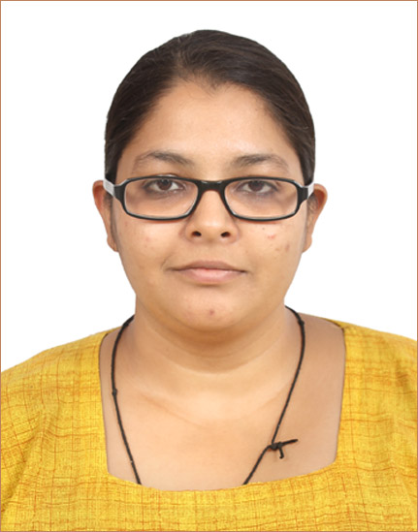
SHIVANGI R. SINGH

401, SUNDARAM STATUS,
BEHIND DEV EXOTICA,
GHUMA MANIPUR ROAD,
GHUMA, AHMEDABAD 380058
GUJARAT (INDIA)

Mobile : (+91)8511031327
Email- ID: singhshivangi7892@gmail.com

Objective … ……………… …

- To apply all of my technical proficiencies and knowledge to my work and thus to serve the
Organization

Educational Qualifications …… …

Passed Bachelor Degree in Commerce from Gujarat University (2013)

Passed higher secondary school certificate examination (H.S.C) from G.S.E.B. March 2010

Passed secondary school certificate examination (S.S.C) from G.S.E.B. in March 2008

Work Experience … …. .

Indian Institute of Hardware Technology, Ahmedabad, (September 2011 to May 2012)

Faculty & Counselor

- Teaching and counseling students regarding the new technologies.
- Basic teaching of computer hardware and networking.
- Plan and achieve the admission targets.
- Organizing the seminars for students in schools and colleges.
- Preparing daily MIS report and keeping track of daily activities.

Shree Raghavendra Technical Pvt. Ltd. 2012 (June to November)

Assistant Business Development Manager

- Handle online business queries from company’s web portal.
- Handling and filling out the tenders on behalf of company.
- Maintaining the basic accounts of the company.
- Maintaining the staff report and keeping track of daily activities.
- Providing support to purchase department (for purchase of machinery tools)
- Handling all the banking activities.
- Providing secretarial support to MD.

Harshal Publications (SAFARI MAGAZINE) (Since January 2013)

Admin Manager

- Providing secretarial support to MD.
- Email drafting and correspondence.
- Maintaining daily MIS report and keeping track of daily activities.
- Providing support to walk in customers.
- Coordinating with customers,
- Handling team of 5 people to provide customer support.
- Entering and maintaining the Subscriptions received for the Magazine.
- Maintaining the stock of the company
- Handling social media marketing.
- Handling and organizing social awareness camp and activities.

Technical Skills ……… …

- Installation, maintenance & troubleshooting of all the hardware components along with the network peripherals.
- Operating Systems installation- Windows XP, Win Vista, Win 7.
- Good knowledge of Ms Office, internet and all the other computer applications.

Administrative & management skills …… …… ….

- Accuracy
- Communication
- Correspondence
- Document Management
- Office Administration
- Office Management

Personal Details …… …… …… ….

- Nationality : Indian
- D.O.B : 7th August, 1992
- Languages : English, Hindi, and Gujarati.
- Marital Status : Unmarried
- Strength : Hard working, good communication skills, high curiosity for
Emerging technologies

