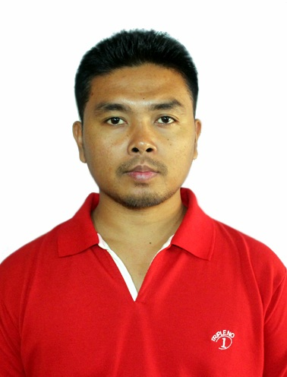
Curriculum Vitae
YENGKHOM SACHIDAANAND SINGH
S/o Y Gambhir Singh
Kakching Mayai Leikai
Community Hall Maning
Kakching Dist, Manipur, India 795103
Email: ysanand1988@gmail.com
Phone: 8787323614

- CAREER OBJECTIVE:
To work with an organization where I can find an environment that is stimulating and full of energy, vitality and freshness and provides me a career path which leads me to excel forever in my workfield.

- ACADEMIC QUALIFICATION:
BE in Mechanical Engineering from SSGB College of Engg. And Tech., Bhusawal.

EXAMINATION | % MARKS | BOARD | YEAR
AISSE( Class 10) | 76.40 % | CBSE | 2003
AISSCE(Class 12) | 59.80% | CBSE | 2006
BE Mechanical | 69.665% | North Maharashtra University, Jalgaon | 2010

- ACHIEVEMENTS:
- Runner up in Table tennis in University level and in college level.
- Participated in Quiz Competition, Essay Competition etc and received applauds for the same several times.

- WORK EXPERIENCE:-
- Six months working experience in Production and Machining, as a production engineer and development engineer at Tulsi Casting & Machining Limited, Sangli, Maharashtra, India. From june 2011 to Dec 2011.

- 6 years and 3 months of Working Experience in G-Tekt India Pvt Ltd, Tapukara, Rajasthan,India as an Assistant Engineer in Production Dept,. from 25 jan, 2012 to 30th April 2018, where we manufacture Honda four wheelers body parts by employing “spot welding” Japanese ROBOTS(Motoman) and Mig welding Robots.

Organization: G-TEKT (INDIA) PVT. LTD.

Designation : Asst. Engineer (weld shop)
Work responsibilities :
- Handling welding line operation.
- Robot teaching for new part development & cycle time measurement.
- Take the necessary backups of robot programmes through CF cards.
- Ensure documentation as per Quality Management System (Production
check sheet, Tip check sheet, M/C check sheet etc.)
- Achieve production target on time with required Quality level.
- Material and consumable item follow up from different department to
avoid any line stoppage
- . Maintain 5’S on shop floor.
- Organizing training for associates for level up-gradation and multi-skill.
- Continues improvement in process and setting time from current status.
- Reduce rework and rejection and cut down losses.
- Manage manpower deployment according to production plan.
- Responsible for productivity of line.
- Implementation of all quality check points as per quality check sheet.
- To execute all required systems like TPM, 5’s, Kaizen, Pokayoka etc.
- Assist the quality team in controlling and maintaining the quality standard either by jig adjustment if required.
- Handling troubleshooting of robots and other machine.
- Analyze rejection & rework along with Line leader and clearing the
rejection.
- Participate in activities during new model devlopement and trials.
- To ensure work on environment,Health & Safety & other continual
improvement.
Tenure : 25th Jan 2012 to 30th April 2018
Company Profile: -
G-TEKT INDIA PVT. LTD. (GTIP) is a new project of sheet metal parts & major supplier of HONDA CARS INDIA LTD. is a largest manufacturer of sheet metal parts by using Spot and Robot Welding, Transfer Press 3000T, Progressive Press 250T & 800T and having consumption of maximum grades of steels 800 tons in a month. G-TEKT is a joint venture of TAKAO 40 %, KIKUCHI 40 % and having 20 % shares of HONDA CARS INDIA LTD (HCIL), and major suppliers of HONDA CARS INDIA PVT. LTD.

- Presently working in JBML-5, Gujarat as an Executive Engg. From 18 December 2018 in BIW Dept(Motoman, Nachi, Abb)

Organization : JAY BHARAT MARUTI LTD.

Designation : Production Executive (BIW)
Work Responsibilities :

- Robot (NACHI) teaching for new part development & cycle time
measurement.
- Handling troubleshooting of Robots and other machines
- Handling welding line operation
- Ensure documentation as per Quality Management System (Production
Check Sheet, Operator Check Sheet, M/C Check Sheet, 4M, PY Check
Sheet)
- Assist the quality team in controlling and maintaining the quality standard
either by jig adjustment if required.
- Analyze rejection and rework along with supervisor and clearing the rejection
- Maintain 5’S on shop floor.

Tenure : 18th Dec 2018 to till date.

- PERSONAL SKILLS:
- Quick learning ability and able to work in a team.
- Good organizing ability.
- Good verbal and written communication skills.
- Able to work under pressure.
- Hard working and confident.

- PERSONAL PARTICULARS:

NAME: Y Sachidaanand Singh
GENDER: Male
MARITIAL STATUS: Married
FATHER’S NAME: Y Gambhir Singh
MOTHER’S NAME: Y Chaoba Devi
NATIONALITY: Indian
DATE OF BIRTH; 24/02/1988
LANGUAGE KNOWN: English, Hindi and Manipuri.

- Declaration: I hereby declare that above given particulars are true to the best of my knowledge and belief.

Date:
Place: kakching Y Sachidaanand Singh

