RESUME

Patel Vipulkumar Sureshbhai 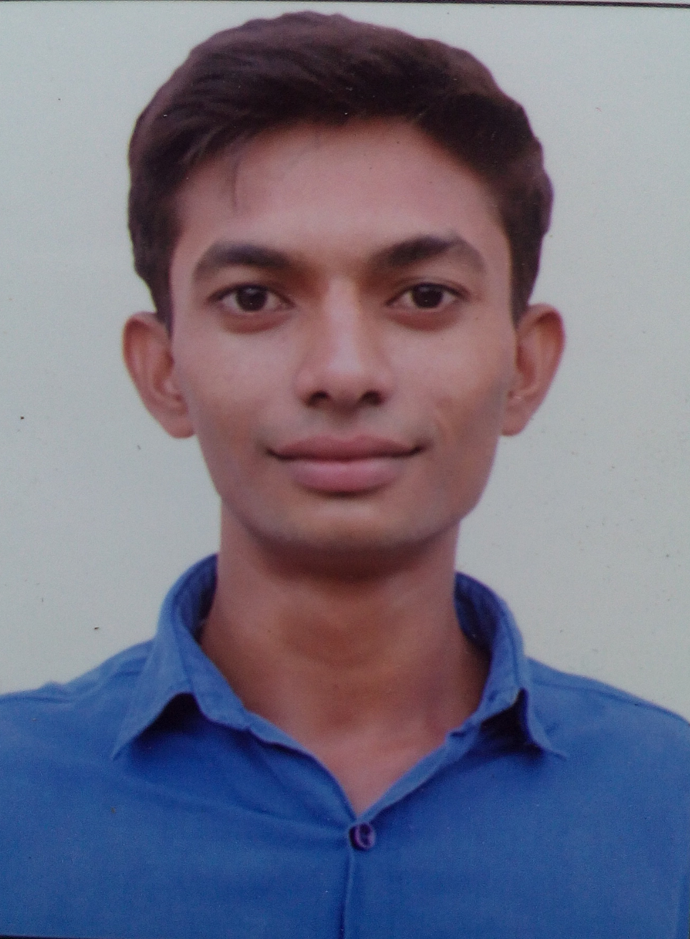 275,MahadevVas,At-Ranasan,
Ta-Chanasma ,Dist-Patan,384225
Contact No.:+917698891088, +917575838445
E-Mail ID: vp27198@gmail.com

CAREER OBJECTIVE :

To have a growth oriented and challenging career, where I can contribute my knowledge and skills to the organization and enhance my experience through continuous learning and team work. Looking for the job role of a mechanical engineer where I can utilize my skills in analytical modeling, system level design, simulations and problem solving.

ACADEMIC QUALIFICATION :

Name of  Examination | Specification | Institution | Board/  University | Year | Result
B.Tec | Mechanical  Engineering | S p i t | G T U | June2017 | 6.78  CGPA
Diploma | Mechanical  Engineering | B s patel | G T U | June2013 | 7.64  CGPA
SSC | Gujarati Medium | H v patel | GSEB | March2010 | 72.92 %

ACADMIC PROJECT OF UDP IN DIPLOMA AND B.TEC :

Project Name : Solar House

Project Name : Design And Development Automatic Stirrup Bending Machine

EXTRA CIRCULAR ACTIVITY :

- Me presentation in RAGGING, school and college level.

- Actively participated in various sports activities for inter school and college.

PROFESSIONAL SKILLS :

- Basic knowledge pro-e software.
- Excellent communication skills in Hindi, English and Gujarati.
- Excellence in MS office and internet surfing.
- Self-Motivated, Honesty.
- Impressive Personality, Presentable

PERSONAL DETAILS :

Sex : Male
Date of Birth : 14 Jan 1995
Nationality : Indian
Languages Known : English, Hindi and Gujarati
Marital status : Married

AREA OF INTREST :

- Production
- Quality & Inspection
- Design

DECLARATION :

I hereby declare that the information furnished above is true to the best of my knowledge and belief.

(Vipul Patel)

Yours Sincerely,

