VIKAS UMARETIYA (Electrical Engineer (Diploma) with 8 years’ ex.) Address: - Vastrapur, Ahmedabad-380015
Mobile: - +918866662101 Skype: - vikas.umaretiya93@gmail.com
Email: - vikas.umaretiya93@gmail.com, vikasumaretiya@gmail.com
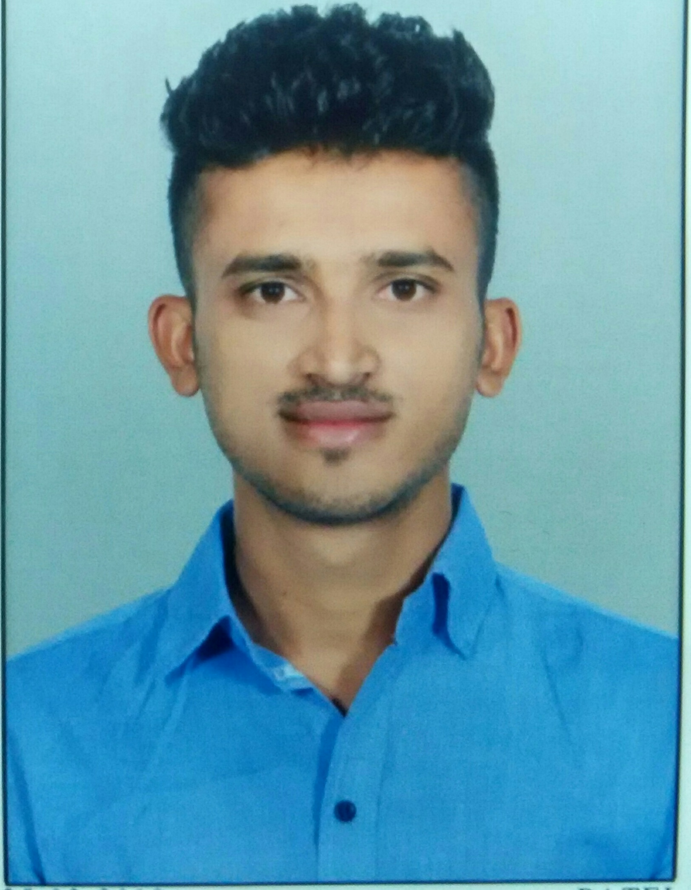

Career Objectives
Seeking a position to utilize my skills and abilities in an organization that offers professional growth while being resourceful, innovative and flexible. I also aspire to gain understanding of various functional domains along with honing my technical skills.

Personal Qualities

Leadership, Negotiation, Initiative, Smart Work, Excellent Grasping and Planning

Technical Knowledge -Electrical
- Operation and maintenance of Substation (22000/433 volts, 66/33/13.8/6.6/.415KV).
- Maintenance 66/13.8 KV,30/40 MVA, 2000 KVA,400KVA Transformer.
- Maintenance of 180 MVA, 18/380 KV GSU Transformer.
- Maintenance of HT & LT panel Switchgear, ACB, VCB, VCU, SF6 Breaker, MOCB, LV Motor
Feeder, MDB, SMPS, GIS Breaker

- Diesel generator operation & maintenance. (4000, 2000, 1500, 1250, 380, 250 KVA)

- Battery bank (3000Ah, 1000Ah, 860Ah) Maintenance and Capacity Test.
- UPS (600KVA, 400KVA) Testing and Maintenance. (Data Center)
- Operation and Maintenance of AUTOMATION PLANT. (PLC Based)
- 33KV/13.8KV Substation SCADA modification Project. (6 month)
- Testing commissioning of 13.8/6.6 KV switchgear, ABB Relay (REF), Control wiring and
Protection Panel Testing & Troubleshooting.
- 34.5/13.8/4.4/.48 KV operation as a switchmen during Refinery shutdown (4 month).
- Operation & Maintenance of HV and LV Motor, Feeder, SW, Transformer, over all in Refinery.

Computer: - PPT, Excel, MS office, Windows, Outlook, E-Permit Holder, PTW etc.

Professional Experience

٭ 2 Years OMAN REFINARY-ORPIC ( Man Power Supply-AL-Nahdha Group-As a Electrical Supervisor) [26-March-2019 to 25-March-2021] ‘Team Leader Mr Mohammad Abri’:- +968
- Operation and Maintenance of 132(GIS)/33(GIS)/6.6/.415 KV Substation
- Operation & Maintenance of PCC, MCC, Transformer (75, 40, 20, 2 MVA).
- Daily arrangement as per Preventive Maintenance Schedule and Keep record of all PM activity.
- Urgent troubleshooting of LV &HV, VFD, Solo Run, fin fan, Pump, Mixer, Actuator, MOV motor as per Refinery process operation requirement.
- HV & LV Motor PM and Troubleshooting.
- ABB (REF-615 & L&T (M comp) Relay Configuration & download any Tripping and Event recode.
- Trouble shouting through DAP server, Ethernet switch for Feeder communication.
- Earth pit, Plant Lighting, Condition monitoring, Provide Electrical Support to Vendor as per Plant Shutdown activity.
- GTG-25 MW, STG-32 MW, EDG-4MVA, Regular Motor PM and Trouble shooting.

٭ 1 Year PROPERY SOLUTION INDIA PVT LTD as a Assistance Technical Manager-Facility (Clint- ADANI Township, AHMEDABAD)[ 2-Apl-2018 to 24 March-2019] Contact 'Technical Manager Mr Smit Raval’:- +919429388398
- Operation and Maintenance of HT & LT panel, 320 KVA DG set, Elevator (Schindler).
- Maintain Utility System as a Hydro pneumatic system, Hydrant pump, Sprinkler Pump, Jokey pump Fire System, Fire alarm system, CCTV, Access System.
- Vendor management and Record , Daily Complaint Report, MIS Report, Routine Maintenance ,Pre monsoon activity as Per Maintenance Schedule.
- Coordination with Clint, Vendor and Customer as per activity.
- Over all technical role & responsibility in Luxury’s Residential Property.

٭ 2 Years Saudi Electricity Company(Manpower Supply- JAL International Company, SAUDI AREBIA ) as Electrical Operation & Maintenance Sr.Technician from( December – 2015 to Feb.-2018)

Contact 'Foreman'Mr.jassim :- +966505871537 & SR.Engineer Mr. Roy :- +966567145644
- 66/13.8 KV Substation (40MVA Transformer, SF6, ACB, MOCB Breaker, Battery bank, Relay,
Testing, Maintenance and Operation).

- Maintenance, testing and Argent Troubleshooting and Technical Problem Solved Skill.

- 180 MVA, 18/380KV GSU Transformer Maintenance.

- 33/13.8 KV Substation SCADA modification project.(Panel Wring, Protection panel Modification) 6
month of 2017
- Testing commissioning of 13.8 KV Switchgear.(4 month of 2017)
- 34.5/13.8/4.4/.48 KV Switchgear, PCC, MCC Panel operation as Turnaround SWITCHMEN (Saudi
Aramco Refinery- Jubil) - 4 month During Shutdown.11/2017 to 2/2018(Elect.Eng. Mr.Sherul Contact
No:-+966542020491)

٭ 6 Month Data Center (Aug.-2015/Dec.-2015)Job As Shift Engineer as Electrical Building facility at Tata Communication ltd.(As Manpower Supply) Andheri, Mumbai ( Contact:- 'Senior leader' Mr. Chandappa Salagare:- 9890170500
- Transformer and Switchgear Maintenance of 22 KV& 433 Volt Power Distribution systems.
- Over all Electrical Maintenance of IDC and BMS System.
- IDC included PAC, Smoke Detector, WLD, AHU and etc Routine Maintenance.

- Operation & Monitoring of 600KVA,400 KVA, 200 KVA UPS,SMPS.

- Operation 2000 KVA(2) Syncronise DG panel,1500 KVA,1200 KVa.

- Daily Utility Report, ( Vendor Managment) Daily Contractor Working Report, MIS, Weekly, Monthly
Report Prepare.

٭ 10 month experience in automation plant in A.J. Blocks PVT ltd ( Plant ), Mumbai.[2014-2015] Contact Electrical Engineer :- Mr.Sandip Dobaria:- +918976633080
- 2000 KVA Transformer and Switchgear Maintenance and Operation.
-Automation panel of SIMENCE series S7-1200, S7-200 etc.
-Maintenances of Sensor and all Electrical PLC control panel.

2 years Larsen&toubro ltd(l&t),Hazira,Surat ( Contact 'S.R.enginner'Mr.Ravindra Patel:-9909949584)[2012-2014]

Department : Electrical maintenance(Man Power Supply)

Designation : Electrical Supervisor

Role & Responsibilities:-

- Electrical maintenance: - Distribution transformer, VCB, SF6, ACB, HT panel, LT panel, DG set.
- Operation and monitoring of substation equipment, LV Distribution for Electrical Heating panel.
- Operation and Maintancence of 400 KVA/600KVA dry transformer.
- DG set panel: - Operation 2000 KVA, 380 KVA, 250 KVA made by Perkins.
- Attend the problems related with Operation, Process and Quality.
=>> Interested Work Profile:- Operations, Maintenance, Controlling, of all type electrical Panel.
=>> Key Skills: - Maintaining Good Inter personnel relationship and troubleshooting abilities & innovative.

Academic Performance

Education
- Degree Engineering in Electrical Running-External
University: - Indian Institute of Engineering (IEI) (AMIE)
Passed paper: - Section-A (6.0 CGPI)
Section-B, last 4 subject remaining

- Diploma Engineering in Electrical

College: - Dr. S. &S.S. Gandhy collage of engineering and technology, Surat (Gov.), Gujarat
University: - Gujarat Technological University
Percentage: - 78.88%

Achievements: -
- Got Distinction in Diploma.
- 3 Month Training in nagar palika at Gandevi (Navsari).
- Electrical Supervisor Certificate with license(Gujarat licensing bord ,Gandhinagar )
- H.S.C.E. Certificate
- Won 3 year college top 10 Scholarship.

School :- 10th L.V.B. high school,keshod
Board: - Gujarat Secondary and Higher seconday Education Board
Percentage: - 78.63%
Achievements: -
- Won 3rd rank in speaking competition BAL URJA RAKSHKDAL.
- Won 3rd rank in chess competition.
- Take part in Science fair in 10th standard.
- Won 1st rank in 3-KM Running competition.

Courses
- Basic computer course (eM-power).
- Spoken English course (SPOKE-Gov.)

Personal Details
- Name: - Umaretiya Vikas Lakshmanbhai
- Date of Birth: - 9thSeptember1993
- Sex: - Male
- Religion: - Hindu
- Marital Status: - Unmarried
- Language Known: - Hindi, English and Gujarati
- Hobbies: - Travelling, Research, Make new electrical project, Read new innovative idea
- Personal Skills-Ability to work effectively in teams and Ability to re-adjust roles in any work situation.
- Hard Worker, Enthusiastic, Qualities, Positive Attitude, Self-confidence, Motivator

Declaration

I hereby declare that the above-mentioned information is correct up to my knowledge and I bear the responsibility for the correctness of the above-mentioned particulars.

-------------------------- Date: -

VIKAS UMARETIYA

