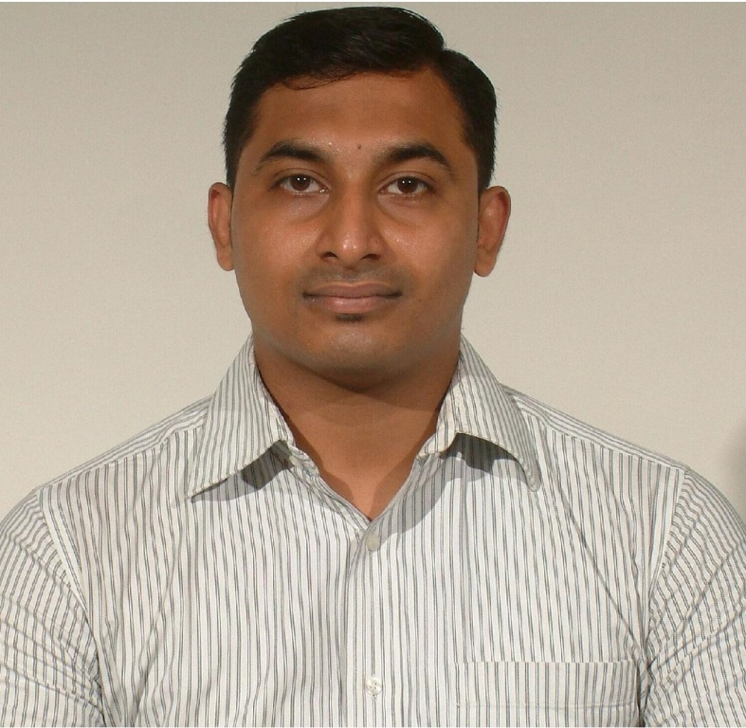

Arjun G Menon
1-Kamalnayan Bungalows, Gala Gymkhana Road, Bopal,
Ahmedabad 380058, Gujarat (India) - Phone : +91 756 798 2166
menonarjung90@gmail.com

Age : 31 years (dob 15 January 1990)

Unmarried

Educational Qualifications : B.Com., MBA

WORK EXPERIENCE: Total … 9 years

From April 2019 onwards working for Yes Bank as Manager – Branch Service Partner at their C.G.Road Branch, Ahmedabad.

- Attend and promptly solve the client’s grievances and queries. Help in executing the operations and operating procedures of the bank. Meet the potential customers, explain them the schemes offered by the bank and provide such schemes. Also a senior service manager taking care of the entire customer requests, complaints of the branch as a whole.

From July 2018 to April 2019_________________________________________________________
Worked for HDFC Bank as a Deputy Manager - Personal Banker in Naranpura Branch, Ahmedabad.

-Act as a primary source of information and documentation for the bank and related branches. Form and execute the operations and operating procedures of the bank

From June 2017 to June 2018________________________________________________________
Worked for HSBC Bank as an Assistant Manager, customer relationship and services in Ahmedabad branch.

-Attend the Indian and Non resident customers, and solve their bank related issues. Explain customers various financial schemes offered by the bank and help them to avail it.

(2)

From February 2014 to June 2017____________________________________________________
Worked for SUNDARAM FINANCE LTD. (a non banking financial company providing vehicle loans) as a Customer Support Executive in their Ahmedabad branch.

-Handling all the back office work of Ahmedabad branch and attending customer queries and grievances.

From September 2013 to February 2014______________________________________________
Worked for SNL FINANCIAL (India) PVT LTD. Ahmedabad
(a company providing data on Insurance, Banking etc around the globe) as a Trainee attached to Insurance Department.

Collecting and providing adequate data on Insurance of U.S. based companies to the customers.

From May 2012 to September 2013
Worked for A Innovative International Ltd. (manufacturer and supplier of innovative products such as CNC Water Jet, Laser and Plasma Cutting machines both in domestic and international markets) as Administrative Executive.

- General office administration
- Travel arrangements for the directors, management team and the visitors
- Co-ordination with marketing department for preparation and participation in the exhibitions in India and abroad.
- Work related to e-tendering, etc

From November 2011 till April 2012
Worked with AZURE KNOWLEDGE CORPORATION, Ahmedabad (a leading service provider of Knowledge Processing & Outsourcing (KPO) to companies in Market Research, Telecom, Banking, Insurance, Healthcare, Automobile, Consumer Goods and Retail Industry sectors) as a Customer Care executive.

Was responsible as Customer Care Representative for BLUE DART.

(3)

Working knowledge in MS Office, MS word, Excel etc

Languages known : English, Hindi, Gujarati and Malayalam (mother tongue)

Salary Drawn: Rs. 5,70,000 pa

REFERENCES :

(1) Mr Rajan C.P.
Administrator
Prakash Higher Secondary School, Bodakdev, Ahmedabad
Phone : 98258 86832

(2) Mr Joseph Abraham
Branch Head
Seaikon India Pvt Ltd., Prahladnagar, Ahmedabad
Phone : 98240 29120

