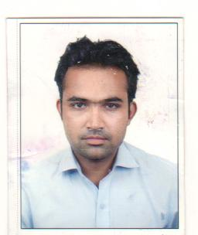

AAMIR MOHAMMAD MALIK

Address: 2509/A MOHAMMAD MANZIL,
SULTAN MOHALLA,
INSIDE PREM GATE,
DARIYAPUR, AHMEDABAD-01
MOBILE NO-9825653725 MAIL ID-aamirmmalik.1990@gmail.com

OBJECTIVE:

- To achieve success in all the fields & grow professionally.

EXPERIENCE

- I have worked as an audio visual operator in (Eswary Multi System)
At Hotel Le Meridian Ahmedabad (3 year)

- I have worked as a Front office executive in Hotel Comfort In Sunset
Ahmedabad (8 month)

- I have worked as a cashier in The Green House restaurant at hotel The House of MG Ahmedabad (1.6 year)

- I have got promoted & working as a supervisor in The Green House restaurant at hotel The House of MG Ahmedabad (1.5 year)

- I have worked as a front office executive in Hotel Marshall The Grand Ahmadabad (2.5 Year)]

- I have got promoted & working as a Front Office Manager in Hotel Marshall The Grand Hotel Ahmadabad (2.4 Year)

- I have worked as a hotel manager in oyo rooms ahmedabad (5 month)

SKILLS

Computer: Proficient in Microsoft Office (Word, Excel, Access, PowerPoint).Knowledge of POS (Ahura restaurant billing software).
Knowledge Of HM Software (Hotel Billing Software)
Operate all tip of A/V Equipment
(Projector /PA System/Mixer/Mikes/ETC)

Language: Fluent in Hindi, Gujarati, English.

EDUCATION:

    - 10th passed from Anjuman Islam High School.

PERSONAL INFORMATION

- Date of Birth : 26th April 1990
- Gender : Male
- Marital Status: Married
- Hobbies : Listening to Music, traveling with Friends & cricket

Declaration:

- I am hard working, confidence with & responsibility candidate.
- I hereby declare that the information written above is true to the best of my knowledge. I look forward to an opportunity with your organization

Yours sincerely,

Aamir Malik

