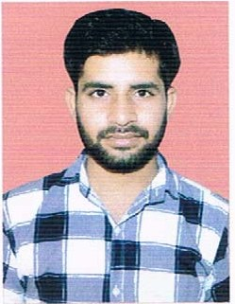

ABHINAV SINGH TIWARI
Add:- Village Purwa Post Padariya
Rewa (MP) 486001
Mobile No. +91 7869442476
Email Id:- abhinavt1998@gmail.com

OBJECTIVE:

I am willing to work in a challenging environment which gives opportunity to utilize my skill knowledge and self to the best and this contribute to the growth of the organization.
QUALIFICATION:
QUALIFICATION | BOARD \ UNIVERSITY | YEAR OF PASSING | PERSNTAGE
10th | MP BOARD | 2013 | 68.33%
12th | MP BOARD | 2015 | 62.80%
BE | RGPV BHOPAL | 2019 | 78.60%

EXPERIENCE:

- Fresher.

PROJECT:

- Minor: fuel level Measurement Techniques
- It is an instrument which measure the level of fluid in tank of vehicle which will reduce the loss of vehicle operator. It is a project on mechatronics application.
- Major: Industrial based chip crusher machine

INDUSTRIAL EXPOSURE:

- Industrial Visit at Suzlon wind power plant

TRAINING:

- CIPET BHOPAL

HOBBIES:

- Driving Bike
- Playing Cricket

PERSONAL STRENGTHS:

- Learning ability
- Flexibility and adaptability
- Critical thinking
- Tolerance
- Godd Communication

PERSONAL PROFILE:

Full Name : Abhinav Singh Tiwari
Fathers Name : Mr. Hansraj Singh Tiwari
Date Of Birth : 02.08.1998
Nationality : Indian
Language : Hindi,English
Gender : Male
Marital status : Unmarried

DECLARATION:

I hereby declare that the above information given is true to the best of my knowledge.

Date:-

PLACE:- Bhopal {Abhinav Singh Tiwari}

