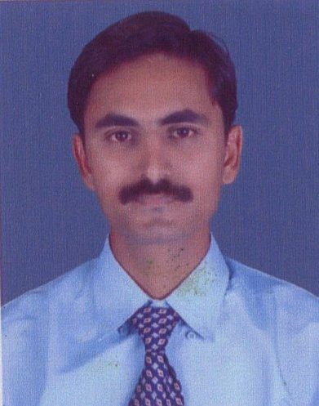

CHIRAG J. GAJJAR (M) 7069712350 C -15 Ambalalpark Soc. Near KMNS Bank, (M) 9714520178
Nr. Shiv Tenement,
Ghodasar
Ahmadabad. – 380050 e-mail – chirag.gajjar81@gmail.com

- Career Objective

To reach the pinnacle of the management echelons by harnessing my business
Acumen and skills Sets, to be the part of the fast growing organization that utilizes
My potential to the best possible extent.

- Work Experience

- Presently working with PATEL ROADWAYS LIMITED as Account Officer. Last 4 years working in this company.

- CMS Collection/Deposit/Branch wise send to Head Office Daily Basis.
- TBB/PAID/TOPAY/Supplementary Out Standing Follow-up with Branches.
- Make Expected Out Standing Plan Every Month & Follow-up with Branches.
- Physical Stock Follow-up with Branches & Send to Head Office.
- Cheque Bounce Follow-up (File Maintain).
- Supplementary Bills Create (File Maintain Serial Wise)
- OBC Collection Follow-up.

- ANGLE FINANCIAL SERVICE PVT. LIMITED Total 2 Years as Relationship Executive

- Customers wise Collection Report Send to Head Office Daily Basis.
- Deposit Renewal of Policy’s Cheque in Birla Sun Life Insurance.
- Follow-up with Customer for them Policy Renewals.
- Create Lead for Our Relationship Executives & Managers in renewal’s file.
- Visit to Customers for Collection Renewals or Some Query in Policy Related.

- VIPUL ART CENTRE (PRAKASH TEXTILE PVT. LTD.) Total 6 Years as a Textile Designer.

- Making Bed-Sheets, Shirts, Kurties, Dress, etc. Design.
- Color Separation in Photoshop.
- Making Design for Rotary & Flat-belt Machine.
- Do the Laser Engraving.

- Education Qualification

- Graduate in Commerce from Gujarat University, (2002).
- Senior Secondary from GSEB (1999).
- Secondary from GSEB (1997).

- PERSONAL DETAILS

Date of Birth : 7th Dec, 1981.
Marital Status : Married.
Mother Tongue : Gujarati.
Languages known : Gujarati, Hindi, English.
Religion : Hindu.
Nationality : Indian.

Yours Truly,

Chirag J. Gajjar

