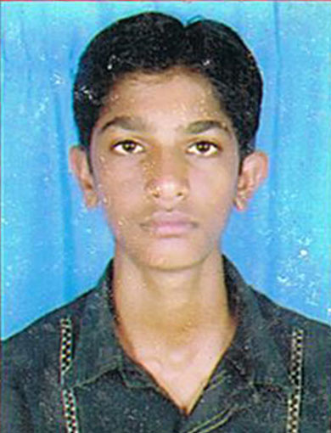
RESUME
DASHRATH C. GOLETAR
dashrathrajput30@gmail.com
Contact No: 9998418825

CAREER OBJECTIVE

Seeking a competitive and challenging career opportunity. Where I can put my technical and communication skills to the best use of the firm and my career.

EDUCATIONAL QUALIFICATIONS

EDUCATION | YEAR OF PASSING | COLLEGE / SCHOOL | UNIVERSITY / BOARD | PERCEN-  TAGE/CPI
DIPLOMA IN ELECTRICAL ENGINEER | 2012 | Government Polytechnic Bhuj | Gujarat Technological University, Ahmedabad | 60.90 %
S.S.C | 2008 | Vinay Mandir Lokniketan high school, Lavana | Gujarat Secondary Education Board. GANDHINAGAR | 71.38 %

PROJECTS UNDERTAKEN

1. DEE Sem VI
Project : Stepper motor control

COMPUTER PROFICIENCY

- Software skill : MS Office
- Operating system: Windows XP, Windows 7
- Internet

LANGUAGES KNOWN

- English, Hindi & Gujarati

INTERESTS AND PERSONAL TRAITS

- Sports, Listening to Soft Music & Playing Games
- Very Optimistic Person having Positive Attitude

EXPERIENCE

- Chamunda Electrical PVT LTD.Palanpur
- I have been doing job at 66-kv Rantila s/s as a Sub station operator since 01th Jan 2012.

PERSONAL DETAILS

Name : Dashrath Bhai

Father Name : Cheharabhai

Date of Birth : 01/06/1992.

Nationality : Indian.
Permanent Add. : At-Po- Lavana
Ta- Deodar
Dist- Banaskantha
Pin-385330

Date: Dashrath Goletar
Place:

