RESUME

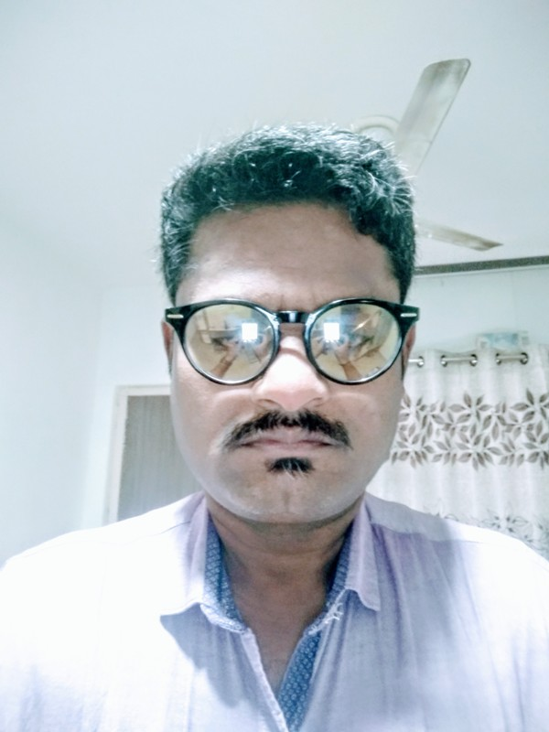 Debendranath .N .Swain
C- 8, PAWAN Apt.
Near Sainath Homeopathic College
Opp Kavir Enclave
Bopal – Ghuma Road
Bopal , Ahmedabad -380058
Mob. No.: 09099965836 , 09586449799
Emil Id : deven.swain1973@gmaill.com

Date of Birth: 30th May 1973

17- years massive experience in Hospitality industry in departments like Housekeeping, F & B Service, Stores as well as Site handling.

Key Skills: Capable of performing in guest house division as well as industrial and institutional catering. Handling of day to day guests and meeting their satisfaction levels. knowledge of Housekeeping as well as store..look after budgeting , cost control .

Current Designation: Operation Manager

Total Years of Experience: 4 years

Education:
- B.Com. in the year 1993.

Languages: Hindi, English , Guajarati, odia .

-: Summary of Skills and Experience :-

Experience:-

1.May – 1999 –oct-2001 : Worked with Radhakrishna Hospitality Services Ltd.(Mumbai )
Job Profile:

Worked as a F & B Service Supervisor for unit KRISHNA Heart Institute for one year

2.Nov -2001 – Aug – 2008 : Worked with Respite Hotel’s pvt. Ltd. ( Ahmedabad )

Worked as F & B Service Supervisor in Feb2000 for their site work at KRISHNA Heart Institute under RESPITE Hotel’s Pvt. Ltd. For 8nyears

3.Sept -2008 – Nov – 2013 : Worked with KRISHNA Heart Institute( Ahmedabad )

Worked as Accounts Executive& facility manager for Unit Krishna Heart Institute for 5 years .

4. Nov – 2013 – till date : Worked with Het chint Hospitalities pvt. Ltd
( Ahmedabad )

Worked as Operation Manger for Hetchint Hospitaites Pvt. Ltd. Till date .
Job Profile

- Looks after 8 units including industrial , institute , Hospital
- Arrange manpower whenever require .
- Make budget ,P&L ,
- On daily basis focus on food cost as well as overhead cost .
- Make checklist regarding grooming &Hygiene .

Strength :-

- Hard work
- Believe in Team work .
- Willingness to take on responsibilities .
- Ability to balance workloads efficiently .
- Ability to learn &process .

Personnel Details :-

Father’s Name :- Narendrakumar Swain

Gender :-Male

Martial Status :- Married .

Hobbies : - Listen Music .

Computer Knowledge:- MS office , ERP 9 .

Reference Person :- Mr. Maheshwar Reddy ( Manager – Hospitlity – Shalby Hospitals Ltd )

Declaration :- All the statements in this application are true & correct to the best of my knowledge .

DATE -29-05-2018

( Mr. Debendranath N . Swain.)

