Hitesh A. Kumbhar  ADD : 104 Prajapati vas, Metal  At. Metal, Post.Nanodara,Ta. Bavla  Dist. Ahmedabad 382220  Mobile No. : 8140194974  haprajapati97@gmail.com  hiteshprajapati97@icloud.com | 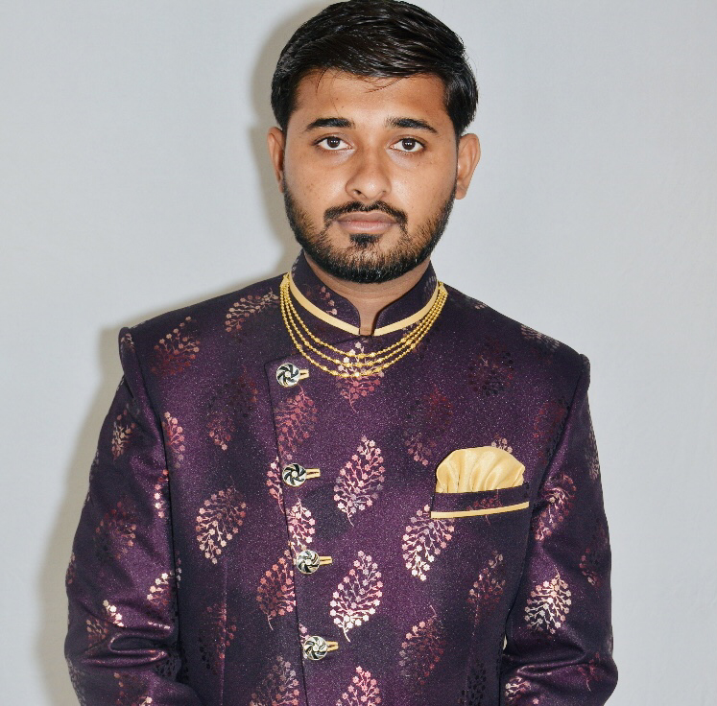

CAREER OBJECTIVE

- To serve my organization in the best possible manner and to continuously evolve as a professional

QUALIFICATION

QUALIFICATION | - S.S.C (G.S.E.B)  - H.S.C. ( G.S.H.E.B )  - S.I Diploma (A.I.I.L.S.G )  - B.A (Gujarat University ) | March 2013  March 2015  June 2016  March 2019

COMPUTER | - Basic Computer knowledge  - complete CCC course in 2013

PERSONNEL PROFILE

PERSONAL DETAILS | - Father’s name: Arvind bhai Amrut bhai  - Date of Birth : 16th April, 1997  - Language Proficiency: English, Gujarati, Hindi  - Nationality : Indian  - Marital status: Married
AREA OF INTEREST | - Corporate and Allied Laws  - Auditing  - Financial
hobbies | - Reading  - Listening and Playing Music  - Playing Cricket  - Travelling

JOB DISCRIPTION & WORK EXPERIENCE

Work Experience | Apollo Hospital Enterprises Pvt. Ltd, Unit: Apollo Pharmacy  Pharmacy Assistant &DEO- June 2020 - Till date  Role:  - Preparing a MIS report on monthly & Daily basis and Submit to higher management  - Credit Bills (MA yojna, Ayushman yojna and other) arrangement and submission to AMC  - Making a claiming Sales Report and submission to AMC & AICPL from time to time  - Making a Daily sales Report and submission to AMC, AICPL & Higher Management.  - Preparing a credit card & Cash Reco on daily basis.  - Income & Exp entry passed in AX software.  - Record keeping of Financial and other documents at lock in key.
Care Children Hospital, Bavla
January 2017 to December 2019
Role:
- Working of Dr consultation Fees of Care Children Hospital Bavla
- Financial & stock audit of pharmacy & Hospital
- Various Forms filing of Insurance companies

DECLARATION

I hereby declare that all the above information and facts are true to the best of my knowledge and belief.

Thanking You.
Yours faithfully,

Hitesh A.Kumbhar

