**RESUME**

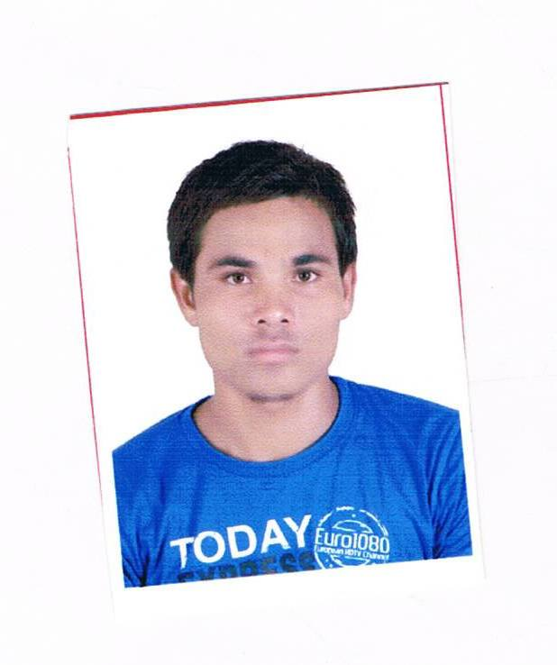

**BIPIN PATEL** **Mobile No: 9879862108**

Patelbipin1010@gmail.com 8140973484

# CAREER OBJECTIVE

To work in a highly functional environment that deals with the sophisticated technologies required by the corporate to improve the efficiency of the product or service that they provide to their customers. A challenging career having great opportunities to learn and get skilled on various technologies and processes where my abilities are utilized to the fullest for the benefit of the organization.

# I strongly believe that some company give chance to me for develop my career so I must to give them best performance for their company.

|  |
| --- |
| PERSONAL Details |

**Name : Patel Bipinkumar Amaratbhai**

**Permanent Address : At&po-Denap**

**Bhagolvalo Madha**

**Ta-visnagar**

**Dist. – Mehsana**

**Pin code no-384323**

**Date of Birth : 02-11-1991**

**Marital Status : Unmarried.**

**Languages Known : Gujarati, Hindi and English**

**Gender : male**

**Nationality : Indian**

|  |
| --- |
| **TECHNICAL SKILLS** |

* **Programming Languages :** PHP , ASP.NET, HTML ,C
* **Database Language** : MySQL
* **Operating Systems** : Windows 98 & Above
* **Others :** Microsoft Office(2003, 2007,2010)

|  |
| --- |
| **EDUCATIONAL QUALIFICATION** |

|  |  |  |  |
| --- | --- | --- | --- |
| Degree | Institute & University/Board | Year of Passing | **Result (%)** |
| S.S.C | G.S.E.B Gandhinagar | March-2007 | 49.62% |
| **H.S.C** | G.S.E.B Gandhinagar | **March-2009** | **55.50%** |
| **FY B.C.A** | **H.N.G.U(University)** | **March-2010** | **66.60%(first)** |
| **SY B.C.A** | **H.N.G.U(University)** | **March-2011** | **73.52%(first)** |
| **TY B.C.A** | **H.N.G.U(University)** | **March-2012** | **69.32%(first)** |

**Academic Project Under Taken :**

**(1)** **Project Title :** Online Exam System (TY B.C.A)

**Front-end :** ASP.NET With C#

**Back-end :** Mysql

**Description :** The system is totali work admine side and this system are

Useful today . This system first display the question

for the Student and student are give the exam and

last few minite are display examer result

**Area of Interest:**

* Web Development
* System Analyst
* Networking
* Computer Opertor

**HOBBIES / INTERESTS**

* **Reading Books, Listening Songs,sports& making new friends**
* **To accept challenges, learn new things.**

**Yours Faithful**

**bipin patel**