**SNEHA SAWARN**

**(ASPIRING FASHION DESIGNER)**

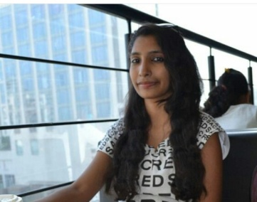

**SKILLS**

FASHION ILLUSTRATION 

DRAPING 

PATTERN MAKING 

GARMENT CONSTRUCTION 

**OBJECTIVES**

TO CONTRIBUTE MY SKILLS AND ASTHETIC IN THE INDUSTRY.

**PROFILE**

AN ASPIRING FASHION DESIGNER WITH A STRONG INTEREST IN PROJECTS WITH CONCEPTUAL THINGKING. FULLY COMMITED TO DESIGNING AND DEVELOPING INNOVATIVE DESIGNS.ALWAYS EAGER TO LEARN MORE TRICKS FROM ANYONE.

**CONTACT DETAILS**

PHONE: 8160141538

EMAIL: [snehasawarn22@gmail.com](mailto:snehasawarn22@gmail.com)

ADDRESS: L/104; 1ST FLOOR,

PARADISE PARK

132 FEET RING ROAD

VINZOL

AHMEDABAD: 382445

**GET SOCIAL**

FACEBOOK <https://www.facebook.com/sneha.sawarn?fref=ts>,

INSTAGRAM

https://www.instagram.com/sawarn_22/

WHATSAPP : 8866847881

**HOBBIES**

SKETCHING

PAINTING

SINGING

**SOFTWARES**

MICROSOFT POWERPOINT 

MICROSOFT WORD 

MICROSOFT EXCEL 

IN DESIGN 

PHOTOSHOP 

ILLUSTRATOR 

**WORKED IN**

IIM CHAOS

VIAJAE UID

**WORKED WITH**

MR.ROCKY S

MR.SHANTANU DAS

MR. ANUJ SHARMA

**EDUCATION**

CLASS X: AIR FORCE SCHOOL JAMNAGAR

CLASS XII: ST. ANN’S HIGN SCHOOL JAMNAGAR

B.DESIGN : UNITEDWORLD INSTITUTE OF DESIGN