CPU Scheduling Simulator
Test Cases & Scenario Documentation

Project Information
Algorithms Tested: SJF, Priority Scheduling
Interfaces: CLI & GUI (CustomTkinter)
Test Modes: Single Execution & Comparison Mode
Predefined Workloads: balanced, conflict, starvation, ties, simultaneous

Test Case 1 — Balanced Workload
Input Processes:
PID | Arrival | Burst | Priority
P1 | 0 | 8 | 3
P2 | 1 | 4 | 1
P3 | 2 | 9 | 4
P4 | 3 | 5 | 2
Results:
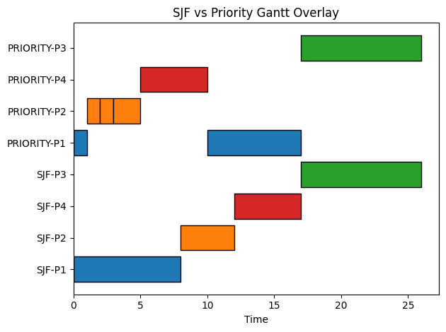
Metric | SJF | Priority
Avg WT | 7.75 | 6.5
Avg TAT | 14.25 | 13.0
Avg RT | 7.75 | 4.25
CPU Util | 100% | 100%

Analysis: Priority scheduling performs slightly better by reducing waiting time for shorter processes.

Insights: SJF didn’t switch between P1 and P2, even though P2 is shorter than P1! This is because P1 arrived before P2, and SJF is not preemptive. In this particular case if SJF was preemptive it would do the same as priority.

Test Case 2 — Conflict Workload
Input Processes:
PID | Arrival | Burst | Priority
P1 | 0 | 20 | 1
P2 | 1 | 2 | 5
P3 | 2 | 1 | 6
Results:
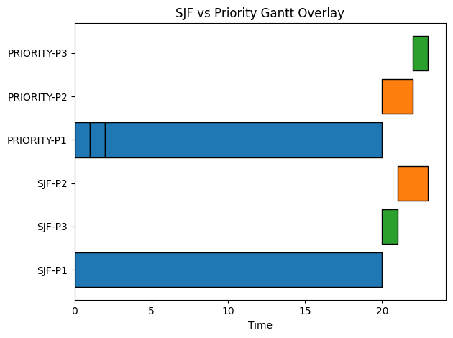
Metric | SJF | Priority
Avg WT | 12.67 | 13.0
Avg TAT | 20.33 | 20.67
Avg RT | 12.67 | 13.0
CPU Util | 100% | 100%

Analysis: SJF performs better due to prioritizing short jobs, while Priority scheduling delays them behind P1.
Insights: Both schedulers perform the same in this case.
However,
SJF continue with P1 because it’s not preemptive.
Priority continue with P1 because it has the highest priority (lowest number)

Test Case 3 — Starvation Workload
Input Processes:
PID | Arrival | Burst | Priority
P1 | 0 | 100 | 10
P2 | 1 | 1 | 1
P3 | 2 | 1 | 1
P4 | 3 | 1 | 1
P5 | 4 | 1 | 1
P6 | 5 | 1 | 1

Analysis: Demonstrates starvation behavior. SJF repeatedly preempts long job P1, while Priority scheduling allows faster completion of high-priority tasks.
Results:
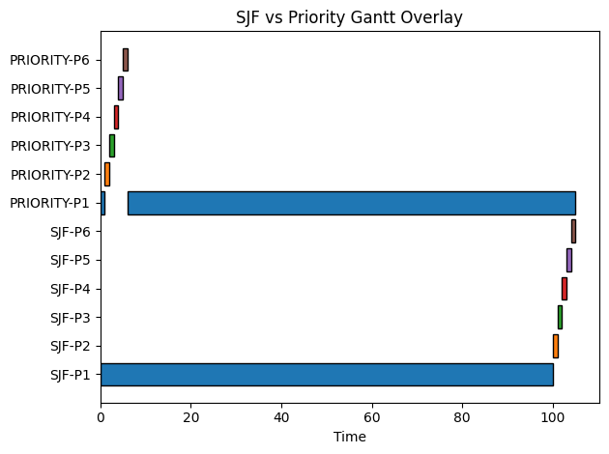
Results:
Metric | SJF | Priority
Avg WT | 82.50 | 0.83
Avg TAT | 100.00 | 18.33
Avg RT | 82.50 | 0.00
CPU Util | 100% | 100%

Analysis
- SJF heavily penalizes long-running process P1 due to repeated preemption.
- Priority scheduling strongly favors short high-priority jobs.
- This workload demonstrates extreme fairness vs efficiency trade-off.
Insights:
Priority scheduling minimizes average waiting time but risks starvation of low-priority tasks.
Zero Response time is not possible in practice, as well as, 100% CPU utilization. This is an optimal case. In practice processes arrive in random times, which by the way you can test it in the application using –-mode random option.

Test Case 4 — Tie Breaking
All processes identical; execution order must follow PID.
PID | Arrival | Burst | Priority
P1 | 0 | 5 | 1
P2 | 0 | 5 | 1
P3 | 0 | 5 | 1

Results: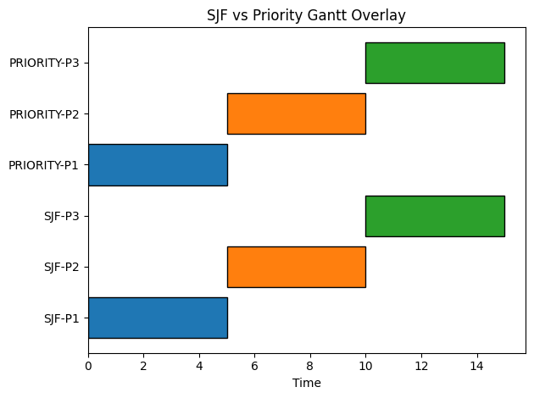

Metric | SJF | Priority
Avg WT | 5.00 | 5.00
Avg TAT | 10.00 | 10.00
Avg RT | 5.00 | 5.00
CPU Util | 100% | 100%

Analysis:
- processes All are identical in arrival, burst, and priority.
- Scheduler must rely on deterministic tie-breaking rule:
  - Priority → Arrival → PID
- Execution order is always:
P1 → P2 → P3

Test Case 5 — Simultaneous Arrival

PID | Arrival | Burst | Priority
P1 | 0 | 10 | 3
P2 | 0 | 1 | 1
P3 | 0 | 2 | 2
P4 | 0 | 8 | 5
Result:
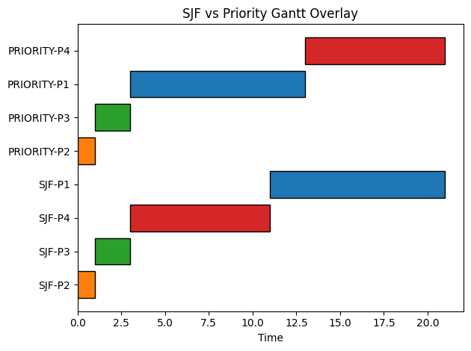
Metric | SJF | Priority
Avg WT | 3.75 | 4.25
Avg TAT | 9.00 | 9.50
Avg RT | 3.75 | 4.25
CPU Util | 100% | 100%

Analysis.
- SJF performs better by selecting shortest job first (P2).
- Priority scheduling slightly increases waiting due to priority ordering.
- Demonstrates advantage of burst-aware scheduling.

Final Summary
SJF/SRTF is optimal for minimizing waiting and response time.
Priority scheduling is better for importance-based task handling.
Trade-off exists between fairness and efficiency.

