Community Giving Platform — System Design
Oct 23, 2026 · @Mikasa

Overview
The group decides where the money goes; AI agents make sure the group sees the right projects, follows the rules, and is not cheated; fixed rules decide every money movement; PayPal moves the money.
What the platform does. Verified projects are listed under categories (Health, Education, Environment, Water). Donors give through PayPal in one of three ways: to a specific project, to a whole category, or through a Giving Agent that donates on their behalf within rules they set. A sponsor-funded matching pool is shared out with two-level quadratic funding, so projects backed by many people get the biggest top-up. Caps stop any single project or donor from dominating.
Four design rules.
- LLMs read and explain; rules decide. No LLM output can move money directly. Every payment passes through a deterministic rules service that re-checks it.
- Humans approve big or unclear actions. Payouts above a threshold and any flagged case wait for an admin.
- Donors control their own money. Mandates, exclusions and per-project limits are enforced, never overridden by an agent.
- Everything is logged with a reason. Every allocation, payout and freeze has an audit entry a donor or judge can inspect.
MVP for the hackathon (3 weeks, hosted URL, working demo). Project listing with admin verification, PayPal sandbox donations with live webhooks, two-level matching with caps, the Giving Agent, the Milestone Payout Agent, the Watchdog Agent, a live leaderboard, and a "where your money went" report. Everything else in this document is marked as stretch or future work.

Architecture
The system has four layers: web apps for people, a core API that owns all money logic, an agent service that does the AI work, and external services (PayPal, Elastic, notifications). Agents never call PayPal for money movements directly; they ask the core API, which runs the rules and then calls PayPal.
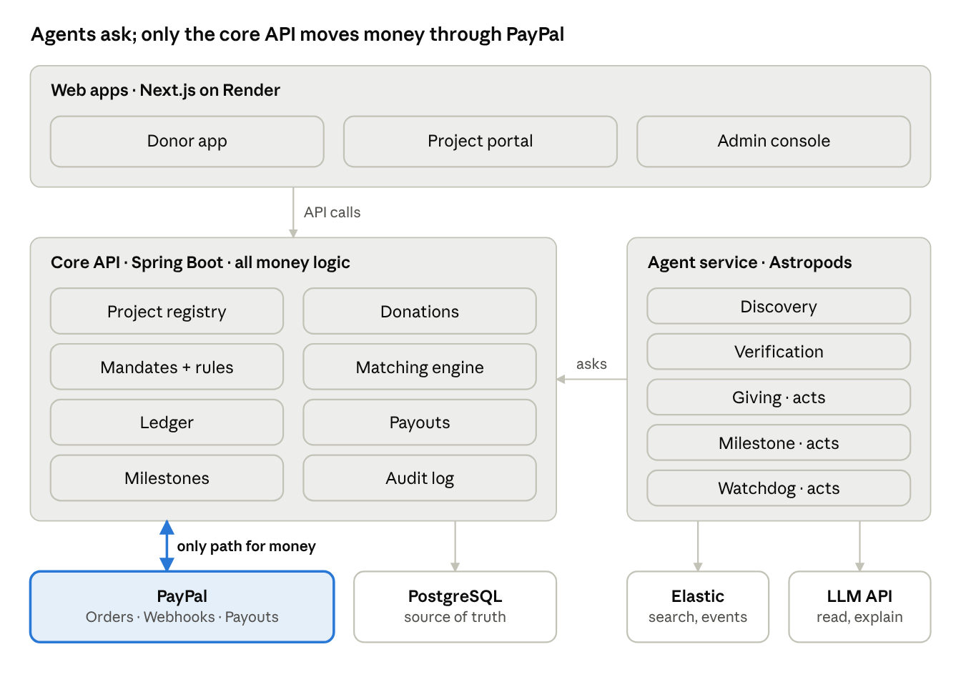
system architecture · 4 layers, 1 money path
Agents read from Elastic and the LLM, but every money action goes through the core API, which re-checks the rules before calling PayPal.
Tech stack (recommended).
Layer | Choice | Why
Web apps | Next.js (React) + AG Grid + Bryntum | One codebase for donor app, project portal and admin console
Core API | Spring Boot (Java) | Team's strongest payments experience; strict, testable money logic
Agent service | TypeScript + PayPal Agent Toolkit + an agent SDK (OpenAI Agents SDK or Vercel AI SDK) | The Agent Toolkit ships for these frameworks; keeps AI code separate from money code
Database | PostgreSQL | Ledger, projects, mandates, rounds; transactions keep money consistent
Search + event stream | Elastic | Project search with tag filters; donation events for the Watchdog
Files | Object storage (Render disk or S3-compatible) | Project documents, receipts, photos
Hosting | Render (apps, API, worker, cron, Postgres) + Astropods (agents) | Hosted URL requirement; agent observability and guardrails
If the team prefers one language, the core API can also be TypeScript (NestJS or Express). Decide this in the first meeting; it changes nothing else in this design.
Sponsor resources and where they fit.
Sponsor | Used for | MVP or stretch
Render | Hosting the web app, core API, agent worker, cron jobs and Postgres; gives the hosted URL | MVP
Postman | Collections for PayPal sandbox calls and our own API; shared test suite; mock server so frontend can start before the API is done | MVP
Elastic | Project search (category, tags, exclusions); donation event index the Watchdog queries; audit-log dashboard in Kibana | MVP
AG Grid | Live leaderboard, admin verification queue, payout review table | MVP
Astropods | Run the three agents with runtime, observability and guardrails; fallback is a Render background worker | MVP if setup is quick, else stretch
Bryntum | Milestone timeline per project (tranches, evidence dates); round schedule view for admins | Stretch
Zapier | Donor monthly reports by email, admin alerts when the Watchdog freezes a project, sponsor pledge reminders | Stretch
APIMatic | Generate an SDK and docs from our OpenAPI spec so partner charities can embed donation widgets | Future
KERNEL | Cloud browser for the Verification Agent to look up a project's public registration page when no API exists; a human confirms the result | Future
Channel3 | Price sanity check in the Milestone Agent (is 40 books at this price reasonable?); coverage of Kenyan prices is uncertain, so test first | Future

Core services
Seven modules inside the core API own all money logic; each has one job and one owner on the team.
Service | Owns | PayPal used
Project Registry | Applications, documents, neutral tags, status (draft, pending review, verified, active, frozen, completed), funding goal and milestones | None
Donations | Create and capture donations; store payer ID as the donor's identity; handle refunds | Orders API (JS SDK buttons), webhooks
Mandates | Donor rules for the Giving Agent: monthly budget, categories, exclusions, per-project max, approval threshold | Subscriptions API (stretch, for recurring budgets)
Matching Engine | Two-level quadratic funding, caps, floor, cluster discount; projections during a round and final results at close | None (pure, deterministic)
Ledger | Every money movement as an entry: donation in, refund, match allocated, tranche released, payout sent; source of truth, reconciled against PayPal | Transactions API for reconciliation
Payouts | Batches of match and tranche payments; one idempotent batch ID per run; retries failed items | Payouts API
Milestones | Tranches per project, evidence uploads, release status | Payouts API (through Payouts service)
Rules that hold across services.
- Donor money always reaches the project the donor chose; only matching money and category money are allocated by the engine.
- One PayPal payer ID counts as one person in matching. Guest card donations count at half weight.
- A refund webhook removes that donation from matching immediately, so donate-then-refund cannot inflate a match.
- Every payout batch uses a deterministic sender_batch_id (for example round-12-match-KES). PayPal rejects a reused ID within 30 days, so a retry can never pay twice.
- Matching money for a project is not paid in one lump: it is added to the project's next milestone tranche, so it is released only with evidence.

Matching engine
The matching pool is shared in two levels: categories first, by how many people support each category; then projects inside each category, by how many people chose each project, with a floor for new projects and caps so no one project dominates. The engine is pure code with no LLM, so the same inputs always give the same result.
Step 0: Clean the inputs.
- One person = one PayPal payer ID. Guest card donations count at half weight.
- Refunded donations are removed.
- Donors in a Watchdog-flagged cluster are merged into one contributor (their amounts are summed before the square root), so a coordinated group counts as one voice.
- Per-person cap: only the first 50 USD a person gives to one project counts toward matching. Larger gifts still reach the project; they just do not buy extra influence.
Step 1: Category shares. For each category c, take each person's total contribution to that category (project donations plus category donations). A category donation counts once here and is never split into small pieces, because splitting would inflate the square roots.
S_c = \Big(\sum_i \sqrt{T_{i,c}}\Big)^2 - \sum_i T_{i,c}, \qquad M_c = M \cdot \frac{S_c}{\sum_k S_k}
T is person i's contribution to category c, M is the round's matching pool and M_c is that category's pool.
Step 2: Project scores inside a category. Only project-specific donations count, because only those donors chose individual projects.
P_p = \Big(\sum_i \sqrt{d_{i,p}}\Big)^2 - \sum_i d_{i,p}
Step 3: Split the category pool. 20% is shared equally among all active verified projects in the category (the floor). 80% is shared in proportion to P. If no project has a score yet, the whole pool is shared equally.
Step 4: Apply caps. No project receives more than the cap (default 30% of its category pool, set per round) or more than its remaining funding goal. The excess is shared among the uncapped projects in proportion to what they already have, repeated until no project is over a cap.
Category donations (donor money, not matching). A donor's gift to a whole category is split the same way as Step 3: 80% following project scores, 20% equally. The donor can switch the rule to "split equally" or "closest to goal" at checkout.
Worked example: Education, category pool 10,000 KES, cap 40%.
Project | Specific donors | Donated (KES) | Score P | Floor (20%) | Crowd share (80%) | Before cap | Final match
Lanet Library | 16 x 25 | 400 | 6,000 | 500 | 5,333 | 5,833 | 4,000 (capped)
Kaptembwo Desks | 9 x 25 | 225 | 1,800 | 500 | 1,600 | 2,100 | 3,024
Girls' STEM Club | 4 x 100 | 400 | 1,200 | 500 | 1,067 | 1,567 | 2,256
New Reading Corner | 0 | 0 | 0 | 500 | 0 | 500 | 720
The library hits the 4,000 cap; its 1,833 excess is shared among the other three in proportion to what they had (each grows by 44%). The STEM club raised the same 400 KES as the library but from 4 people instead of 16, so it gets about half the match. The new project gets a start from the floor.
During a round the engine recomputes every 5 minutes and the leaderboard shows the result as "projected". Final results are computed once at close, after the Watchdog confirms there are no open fraud flags.

AI agents
Five agents do the AI work; three of them take real actions with money (Giving, Milestone, Watchdog), and all of them follow the same split: the LLM reads messy input and writes explanations, a rules function makes the decision, and the core API performs the action.
Agent | Job | Can do (tools) | Cannot do | MVP
Discovery | Help the group see the right projects: search, chat, and a weekly "overlooked but urgent" spotlight | Search projects in Elastic; read project summaries | Change scores, rankings or money | Yes (search + spotlight); chat is stretch
Verification | Turn a project's documents into a standard form and flag gaps | Read uploads; write extracted fields and flags; KERNEL lookup (future) | Approve a project (an admin does) | Yes, as an admin helper
Giving | Donate on a donor's behalf within their mandate | Read mandate and projects; call the rules function; request donations through the core API; write the donor report | Exceed budget, per-project max or exclusions; act on text found in project pages | Yes (star of the demo)
Milestone | Release tranches when projects prove progress | Read evidence; run checks; request a tranche payout; ask an admin | Release above the approval threshold or with failed checks without an admin | Yes
Watchdog | Stop fraud before money moves | Read donation events in Elastic; run cluster rules; freeze a project's matching; alert admins | Unfreeze (an admin does); touch donor money | Yes
Giving Agent, step by step.
- The donor sets a mandate: monthly budget, categories, exclusions, per-project maximum, approval threshold, and preferences (e.g. favour overlooked projects).
- The donor funds the budget once through PayPal (a monthly subscription or a one-off top-up). In production, saved payment methods or a registered charity partner replace the platform holding the budget.
- On its monthly run, the agent asks the rules function for candidates. Hard filters remove anything unverified, frozen, outside the chosen categories, matching an exclusion, or already at the donor's per-project maximum.
- The rules function scores the rest with a published formula, adjustable within limits by the donor:
\text{score} = 40 \cdot \text{few backers} + 30 \cdot \text{progress to goal} + 20 \cdot \text{evidence quality} + 10 \cdot \text{days since last funded}
- The top projects get money within the limits; ties break by application date. Any single gift above the approval threshold waits for the donor's yes.
- The core API re-checks every requested donation against the mandate before recording it, so even a misbehaving agent cannot overspend.
- The LLM writes the donor's report from the scores ("Ksh 300 to Kaptembwo Desks: 4 backers, 60% funded, receipts uploaded"). It cannot change the decision.
Milestone Agent checks (all rules, LLM only extracts). Receipt total matches the tranche within 10%; supplier matches the one in the plan; the photo is not a duplicate of an earlier upload (image hash); the evidence is dated inside the milestone window. All pass and amount below the threshold: release. Anything fails or amount above the threshold: hold and send to an admin with the LLM's summary.
Watchdog rules. Many brand-new payer IDs giving similar small amounts to one project within a short window; the same donors repeatedly backing the same pair of projects (reciprocal backing); a project owner's own payer ID among its donors; a spike of refunds. A rule hit freezes that project's matching (not its donations) and opens an admin case. Exact thresholds are tuned on seeded test data in week 2.
Prompt-injection defence. Project text, documents and receipts are data, never instructions. Agents get the least tools they need; the Giving Agent has no tool that sends money anywhere except through the core API's checked endpoint. Every agent action is logged with its inputs, the rule result and the reason.

Data model
Fourteen tables in PostgreSQL; the target_type field on donations is what lets one design serve project, category and agent donors.
Table | Key fields
donors | id, paypal_payer_id (unique), is_guest, display_name, show_on_leaderboard (default false)
projects | id, owner_id, category_id, title, tags[], status, goal_amount, currency, hide_location, verified_by, verified_at
categories | id, name
project_documents | id, project_id, kind (registration, plan, receipt, photo), file_url, extracted_fields (json), flags[]
milestones | id, project_id, seq, amount, due_date, status (open, evidence_submitted, released, held)
donations | id, donor_id, round_id, target_type (PROJECT, CATEGORY, AGENT), project_id or category_id, amount, currency, paypal_order_id, status (captured, refunded), mandate_run_id
mandates | id, donor_id, monthly_budget, categories[], excluded_tags[], per_project_max, approval_threshold, weight_overrides (json), active
mandate_runs | id, mandate_id, run_at, decisions (json: candidates, scores, chosen, reasons), report_text
rounds | id, name, starts_at, ends_at, matching_pool, project_cap_pct, floor_pct, per_person_cap, status
match_results | round_id, project_id, score, floor_amount, crowd_amount, capped, final_amount, computed_at, is_final
ledger_entries | id, type (donation, refund, match, tranche, payout, fee), amount, currency, project_id, donation_id, payout_item_id, created_at
payouts | id, sender_batch_id (unique), currency, status, items (json), paypal_batch_id
watchdog_cases | id, project_id, rule, evidence (json), status (open, cleared, confirmed), frozen_at, resolved_by
audit_log | id, actor (agent or user), action, inputs (json), rule_result, reason, created_at
Amounts are stored as integers in minor units (cents) to avoid rounding errors; each row keeps its original currency. Elastic holds a copy of projects (for search) and of donation events (for the Watchdog); PostgreSQL stays the source of truth.

Key flows
Five flows cover the whole demo; each ends with a ledger entry and an audit-log line.
1. Donor gives to a project or category.
- Donor opens a project (or a category card) and sees a preview of where category money may go, with an option to edit exclusions.
- The PayPal button creates an order through the core API with the target stored in the order's custom ID.
- Donor approves in PayPal; the core API captures the order and writes the donation and ledger entry.
- The capture-completed webhook confirms it, the event goes to Elastic, and the leaderboard projection updates within 5 minutes.
- Donor sees "your 200 KES unlocked about 1,150 KES of projected matching".
2. Giving Agent monthly run.
- A Render cron job starts the run for each active mandate.
- The agent gets candidates and scores from the rules function, picks projects, and requests donations from the core API.
- The core API re-checks the mandate; gifts above the approval threshold wait for the donor's confirmation.
- Approved donations are recorded exactly like flow 1 (target_type AGENT), so they count for matching as that donor.
- The agent writes the report, which is sent to the donor (Zapier email in stretch).
3. Watchdog freeze.
- Each donation event lands in Elastic; the Watchdog runs its rules every few minutes.
- A rule hit freezes that project's matching, opens a case with the evidence, and alerts an admin.
- The admin clears it (matching resumes) or confirms it (the flagged donors are merged into one cluster for matching, or the project is removed and donations refunded).
4. Round close.
- At the round's end time, new donations go to the next round.
- The engine waits until there are no open Watchdog cases for the round, then computes final match results.
- Each project's match is added to its next milestone tranche, so it is released with evidence (flow 5).
- Results are published on a public results page.
5. Milestone release.
- The project uploads receipts and photos for its current milestone.
- The Verification step extracts amounts, supplier and dates; the Milestone Agent runs its rule checks.
- All pass and below the threshold: the Payouts service sends one batch per currency with a deterministic batch ID. Otherwise the case goes to an admin.
- The payout webhook confirms each item; failed items are retried in a new batch with a new ID.
- Donors who backed the project get an impact update with the evidence.

Safety, privacy and compliance
No donor's money reaches a cause they would object to, no agent can move money outside its rules, and no donor is exposed publicly without opting in.
Sensitive causes.
- Every project carries neutral tags describing what it does ("LGBTQ+ health services", "faith-based hospital", "humanitarian aid, Gaza"); no "controversial" labels.
- Donors can exclude tags for category giving and in their mandate; the rules apply in every direction, for every viewpoint.
- Category checkout shows which projects the money may reach before payment.
- Matching pools can be scoped by sponsors, so a sponsor's money only matches projects in the pools it chose (stretch).
- One eligibility policy for all listings: verifiable registration, lawful where the platform operates, within PayPal's acceptable use policy, sanctions checks for conflict-zone aid, and no funding of violence or hate.
Privacy. Donations are anonymous by default and leaderboard display is opt-in. Public pages show how many people backed a project, never who. Projects can hide their exact location.
Money safety. Mandate limits enforced by the core API, not the agent; human approval above thresholds; deterministic payout batch IDs; refunds removed from matching; a freeze switch per project; every action in the audit log.
Compliance stance for the hackathon. Everything runs in the PayPal sandbox with seeded test data. KYC and payment compliance stay with PayPal. In production the platform would either send donations straight to project accounts (PayPal's multiparty platform, which needs PayPal's approval) or partner with a registered charity, rather than holding funds itself.

Hosting and deployment
Deploy a skeleton to Render in week 1 so the hosted URL works from day one, then ship every merge automatically.
Render service | Runs | Notes
Web service | Next.js donor app, project portal, admin console | Public hosted URL for judges
Web service | Core API (Spring Boot) | Receives PayPal webhooks; only service holding PayPal credentials for money movement
Background worker | Agent service (if Astropods is not used) | Watchdog loop; Giving and Milestone runs
Cron jobs | Giving Agent monthly run; match projection every 5 minutes; round close | Short in the demo (every few minutes) so judges see them run
PostgreSQL | Source of truth | Daily backup on
Astropods (preferred for agents). Each agent is described in an astropods.yml (models, tools, integrations) and run with Astropods' observability and guardrails, which gives a live view of every agent action for the demo. Spend at most one day on setup in week 1; if it is not working by then, run the agents as a Render background worker and keep the same code.
Elastic. Use an Elastic Cloud deployment (check the sponsor offer for credits). Two indices: projects and donation-events.
Secrets. PayPal sandbox client ID and secret, LLM API key and Elastic key live in Render environment variables, never in the repo. The agent service gets a scoped internal token for the core API, not PayPal credentials for payouts.
Postman. One shared workspace: a PayPal sandbox collection (orders, webhooks, payouts), our own API collection with tests, and a mock server from the OpenAPI spec so the frontend can start in week 1.

Plan, demo and open decisions
Three weeks: week 1 gets money flowing end to end in the sandbox and deployed, week 2 adds matching and agents, week 3 is polish and rehearsal with a feature freeze midweek.
Role | Week 1 | Week 2 | Week 3
Payments and core API | PayPal sandbox orders, capture, webhooks; ledger; deploy API to Render | Matching engine with caps and tests; payouts with batch IDs; round close | Reconciliation, edge cases, fix bugs
Frontend | Category and project pages from the Postman mock; PayPal buttons; deploy | Leaderboard (AG Grid), checkout preview, admin queue, mandate setup | Donor report page, polish, mobile check
AI and agents | Agent SDK + PayPal Agent Toolkit hello-world; Astropods trial (max 1 day) | Giving Agent, Milestone Agent, Watchdog rules on Elastic | Prompt-injection test, explanation quality, logs view
Data, demo and pitch | Seed 8 to 10 projects across 4 categories with documents; Elastic indices | Fraud test scenario; demo accounts; draft pitch slides | Demo script, backup video, two full rehearsals
Feature freeze: Wednesday of week 3. After that, only fixes.
Demo script (about 3 minutes).
- Problem in one line: big donors decide where charity money goes; small donors feel powerless and cannot verify impact.
- A donor gives 200 KES to Lanet Library through PayPal; the leaderboard shows its projected match jump.
- Wanjiru's Giving Agent runs on her mandate (education, exclude nothing, favour overlooked projects). It donates, skips a project that breaks her rules, and explains each choice.
- Twenty fake accounts flood one project; the Watchdog freezes its match and opens a case.
- The round closes; the caps visibly stop the library taking everything; the new project gets its floor.
- The library uploads a receipt; the Milestone Agent checks it and releases the tranche through PayPal Payouts.
- Close: "The group decides, agents protect it, rules keep it fair, PayPal moves the money."
Risks.
Risk | Fallback
PayPal payouts or webhooks behave differently in sandbox than expected | Test both on day 1; keep a recorded run as backup
Astropods setup takes too long | Render background worker with the same agent code
Live demo breaks on stage | Backup video of the full flow; seeded data that resets with one command
Scope creep | Everything not marked MVP waits until after the freeze
Matching math bugs | Unit tests using the worked example in this document
Open decisions for the next meeting.
- ☐ Core API language: Spring Boot or TypeScript
- ☐ Owner for each of the four roles
- ☐ Round settings for the demo: cap percentage, floor percentage, per-person cap
- ☐ Whether the Discovery chat makes MVP or stays stretch
- ☐ Exact hackathon submission deadline and judging criteria

