//Initializing the database

-step 1

Install the xammp application, run it and start the apache & mysql on the xampp control panel

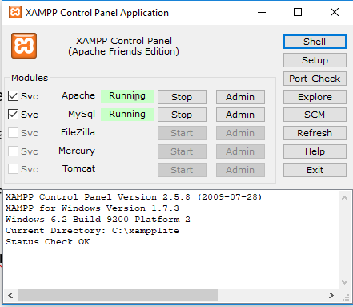

-step 2

#I've attached the help_me_db.sql file, preferably open the sql script using sqlyog

#if you have the xampp running, start the sqlyog, initialize it with username= root and no password

otherwise you may have to change the db_conn.php file under HELP!!!/aura_help_me/CONFIG if you set a password

~ self::$instance = new PDO('mysql:host=localhost;dbname=helpme_db', 'root', '', $pdo_options);~

alter the above line so that it looks like

~ self::$instance = new PDO('mysql:host=localhost;dbname=helpme_db', 'root', '*Password*', $pdo_options);~

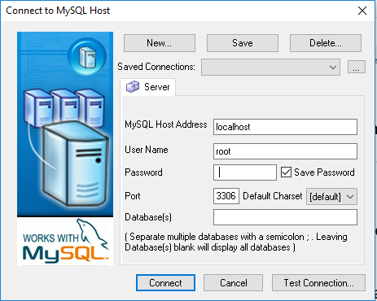

#after a successful connect should get the below screen

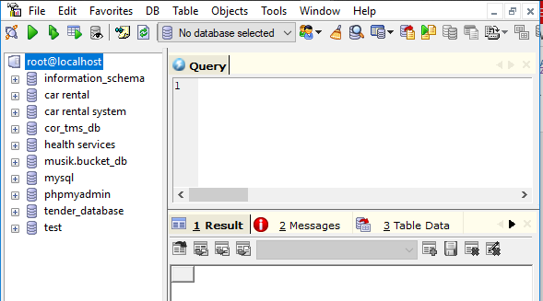

#Almost there, now navigate to DB and select Restore From sql dump, navigate to the helpme_db.sql and execute

#There you go, click on root@localhost and refresh from object browser you can click the helpme_db

#Now we done setting up the DB

//Getting the Application ready

-After installing the xammp , copy the project to C:\xampplite\htdocs and run the project….simply type in localhost/HELP_ME on the browser