Design Document
Aybars Kansu Han
Ahmet adİl AKÇA
EREN BUDAK
ARDA ONAT ACAR

Table of Contents
Task Matrix of Document 1
System Overview 2
System Architecture 2
Technology Stack: 3
Backend 3
Frontend 3
Implementation Details 3
Codebase Structure 3
Backend Structure 3
Frontend Structure 4
Key Implementations 4
Frontend Components 4
Backend Logic 5
Component and API Interfaces 5
Frontend Service Layer Interfaces 5
Backend API Endpoint Interfaces: 6
Visual Interfaces 7
Use Case Support In Design 9
Design Decisions 10
Technology Comparisons 10
Decision Justifications 11
GitHub Commit Requirements 11
Code Implementations & Interfaces 11
Commit History & Contributions 11

Task Matrix of Document
Author | Section(s)
Ahmet Adil Akça | System Overview&Implementation Details
Aybars Kansu Han | Key Implementations&Component and API Interfaces
Eren Budak | Visual Interfaces&Use Case Support In Design
Arda Onat Acar | Design Decisions&Github Commit Requirements

System Overview
Randex is a comprehensive, web-based appointment scheduling and business management platform designed to streamline and modernize the interaction between service providers and their clientele. The primary goal of the system is to replace the inefficiencies and manual overhead associated with traditional, phone-based booking methods by establishing a centralized, real-time digital ecosystem.
Randex caters specifically to service-centric businesses such as barbers, hairdressers, tattoo artists, and beauty centers. It offers a dual-sided value proposition:
- For Business Owners: A robust toolkit to manage services, set availability, control pricing, and oversee their operations from a single dashboard.
- For Customers: A user-friendly interface to effortlessly discover local businesses, browse service catalogs, view provider details, and book appointments in real-time, ensuring a seamless and efficient user journey.
The platform is underpinned by features like role-based access control, real-time availability checking, and comprehensive appointment lifecycle management, ensuring data integrity and a high-quality user experience across all functions.

System Architecture
Layer | Description | Function
Presentation Layer | The client-facing interface (Frontend) | Responsible for handling incoming HTTP requests from users and rendering the corresponding web responses
Business Logic Layer | The core application logic (Backend) | Encapsulates the rules, policies, and algorithms that govern the system's operation, such as appointment conflict resolution, role validation, and service configuration.
Data Access Layer | The bridge to the persistence layer | Manages all read and write operations, insulating the Business Logic Layer from the specifics of the Database Layer
Database Layer | The data persistence infrastructure | The repository where all application data, including user profiles, business details, services, and appointment records, is physically stored and retrieved from disk.

Technology Stack:

Backend
Component | Technology | Role / Purpose
Runtime Environment | Node.js | Provides a high-performance, event-driven, non-blocking environment for server-side execution.
Web Framework | Express.js | A minimal and flexible Node.js web application framework used for building robust APIs and routing.
Database | SQLite3 | Used as the persistence store, offering a reliable, file-based relational database solution.
Authentication | JWT | Employed for secure, stateless user authentication and information exchange.
Configuration | Dotenv | Manages environment variables, separating configuration from code.

Frontend
Component | Technology | Role/Purpose
UI Library | React | Utilized for building the dynamic, single-page user interfaces with a component-based approach.
Build Tool | Create React App | Provides a pre-configured setup for the React application, managing the build pipeline.
Client-Side Routing | React Router | Enables navigation between different components and views within the Single-Page Application (SPA).
API Client | Axios | A promise-based HTTP client used for making asynchronous requests to the Backend API.
Styling | CSS Files | Standard CSS is used for defining the visual presentation and layout of the application components.

Implementation Details

Codebase Structure
The project employs a structured, organized directory layout to separate concerns and enhance maintainability, following the tiered architecture.

Backend Structure
This directory houses the Node.js/Express application, organized by architectural layer:
- config/: Contains configuration files, specifically database.js for managing the SQLite connection and initialization.
- middleware/: Stores reusable functions that process requests, such as auth.js for JWT validation and role-based access control.
- routes/: Defines the API endpoints, with files logically grouped by resource:
  - appointments.js
  - businesses.js
  - reviews.js
  - services.js
- randex.db: The SQLite database file containing the persistent application data.
- server.js: The main entry point file for the backend server.

Frontend Structure
This directory contains the React Single-Page Application (SPA):
- public/: Standard React public directory (e.g., HTML entry point, static assets).
- src/: The main source code directory, further structured by component type:
  - components/: Smaller, reusable UI elements (e.g., Navbar.js and its styling Navbar.css).
  - contexts/: Files managing global state using the Context API, notably AuthContext.js for user authentication state.
  - pages/: The main application views/routes (e.g., Home.js, Login.js, BusinessDetail.js, Appointments.js), each typically paired with its dedicated CSS file.
  - services/: The Service Layer, containing api.js and index.js, responsible for handling all API calls using Axios.
  - App.js: The root component managing application-level rendering and routing.

Key Implementations

Frontend Components
The React frontend is structured into several key components, each with a defined functional scope:
Component | Description
AuthContext.js | Manages and shares the authenticated user's state and profile data across the application via React's Context API.
Home.js | The main landing page, featuring a search bar for business discovery and filtering capabilities.
BusinessDetail.js | A dedicated page providing comprehensive details about a specific business, including its profile, service offerings (listed on the left), an appointment booking form (on the right), and customer reviews (at the bottom). This is the primary booking interface.
MyBusiness.js | The exclusive dashboard for business owners. It allows them to view their current businesses, manage services, and initiate the creation of new business profiles or service entries.
Appointment.js | A component used by both customer and business_owner roles to list and view their respective scheduled appointments.

Backend Logic

Calculating Available Time Algorithm (Conflict Resolution):
- Location: backend/routes/appointments.js
- Endpoint: GET /available-slots/:businessId/:date
- Description: Before an appointment is confirmed via a POST request, or when retrieving available slots, the system executes a critical check. It queries the database (db.get) for any "non-cancelled" appointments (existingAppointment) that share the same business_id, appointment_date, and appointment_time. If a conflict is detected (an existing, active appointment at that slot), the system prevents the new booking and returns a 400 Bad Request error, thereby ensuring no double-bookings occur.

Authorization and Role Control Middleware:
- Location: backend/middleware/auth.js

Description: The system enforces security through a two-layered middleware approach:

auth function: Validates the JWT extracted from the Authorization header. Upon successful verification, it injects the user's ID and role information into the request object (req.user).
requireRole('role_name') function: This subsequent middleware layer checks if the req.user.role matches the expected role (e.g., 'business_owner' for creating a new business). This mechanism ensures that only authorized users can access specific, sensitive endpoints.

Component and API Interfaces

Frontend Service Layer Interfaces
Service | Method | Description
authService | login(email, password) | Sends a POST request to the API for user login, returning a JWT.
 | register(userData) | Sends a POST request to register a new user (customer/business owner).
businessService | getAll(params) | Fetches a list of all businesses, optionally using search/filter parameters (GET).
 | getById(id) | Retrieves the detailed profile of a single business, including its services and reviews (GET).
 | getMyBusinesses() | Retrieves businesses owned by the currently authenticated business owner (GET).
 | create(data) | (Authorized) Submits a POST request to establish a new business profile.
 | delete(id) | (Authorized) Sends a DELETE request to remove a business profile.
serviceService | create(data) | (Authorized) Submits a POST request to add a new service to a business.
 | delete(id) | (Authorized) Sends a DELETE request to remove an existing service.
appointmentService | getMyAppointments() | Retrieves the logged-in user's appointments (customer or business owner list) (GET).
 | getAvailableSlots(businessId, date) | Fetches all available time slots for a specific business on a given date (GET).
 | create(data) | (Customer) Submits a POST request to create a new customer appointment.
 | updateStatus(id, status) | Updates the status (Confirmed, Cancelled, Completed, etc.) of a specific appointment (PUT).
reviewService | create(data) | (Customer) Submits a POST request to post a new review for a business.
 | delete(id) | (Customer) Sends a DELETE request to remove the customer's own review.

Backend API Endpoint Interfaces:
HTTP Method | Endpoint | Access Role(s) | Functionality
POST | /api/auth/register | Public | Registers a new user (customer or business owner).
POST | /api/auth/login | Public | Logs a user in and returns a JWT.
GET | /api/businesses | Public | Lists all businesses (with optional search/filter).
GET | /api/businesses/:id | Public | Retrieves a single business's details (incl. services/reviews).
POST | /api/businesses | business_owner | Creates a new business profile.
DELETE | /api/businesses/:id | business_owner | Allows an owner to delete their own business.
GET | /api/businesses/owner/my-businesses | business_owner | Lists all businesses owned by the authenticated user.
POST | /api/services | business_owner | Adds a new service to a business.
DELETE | /api/services/:id | business_owner | Deletes a service.
GET | /api/appointments/my-appointments | customer / business_owner | Lists the authenticated user's appointments.
GET | /api/appointments/available-slots/:businessId/:date | Public | Fetches available time slots for booking.
POST | /api/appointments | customer | Creates a new appointment booking.
PUT | /api/appointments/:id/status | customer / business_owner | Updates the status of an appointment (e.g., Approve, Cancel, Complete).
GET | /api/reviews/business/:businessId | Public | Lists all reviews for a specified business.
POST | /api/reviews | customer | Submits a new review for a business.
DELETE | /api/reviews/:id | customer | Allows a customer to delete their own review.

Visual Interfaces
The user interface is constructed using React components, each paired with dedicated CSS files for styling and visual design.
- Home.js: The primary entry point, centered on an intuitive search bar for service discovery.
- Login.js: A simple form interface for user authentication via email and password.
- BusinessDetail.js: A comprehensive page showcasing business information (address, hours, images, description) with a clear separation for service listings, the appointment booking widget, and customer feedback.
- MyBusiness.js: The business owner's control panel for managing their portfolio of businesses and service offerings.
- Appointments.js: A list view for tracking and managing personal or business-related appointments.

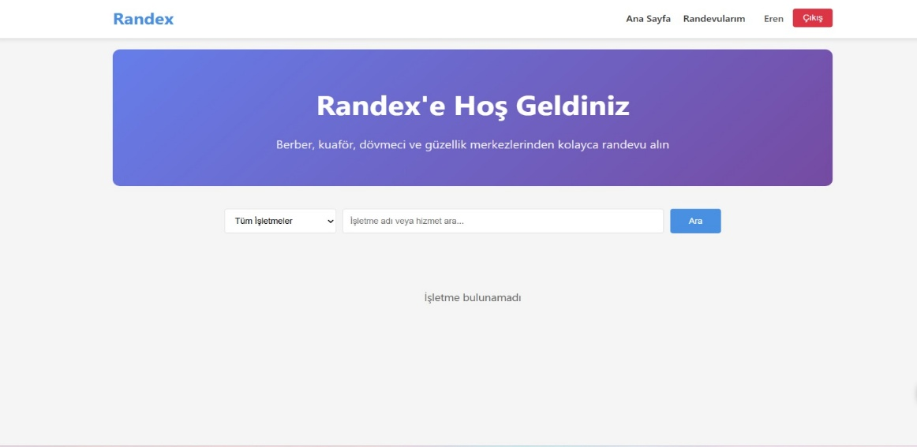
Home

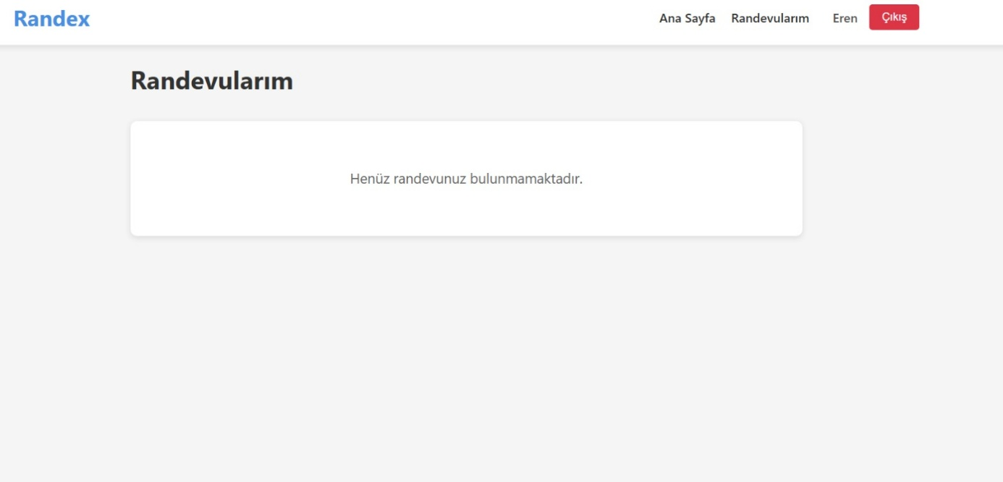
Appointment Management Page
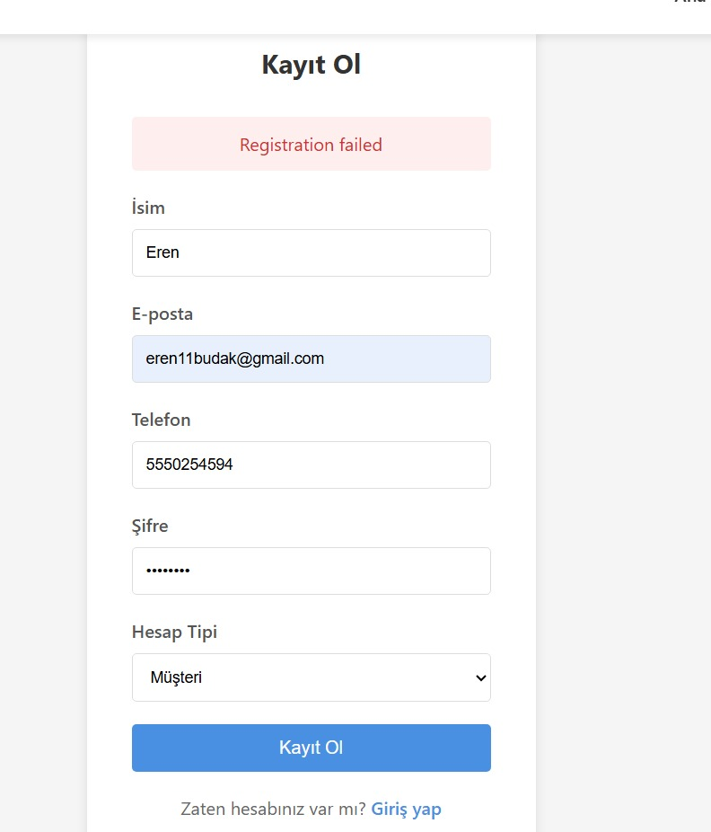
Registration/Login Page
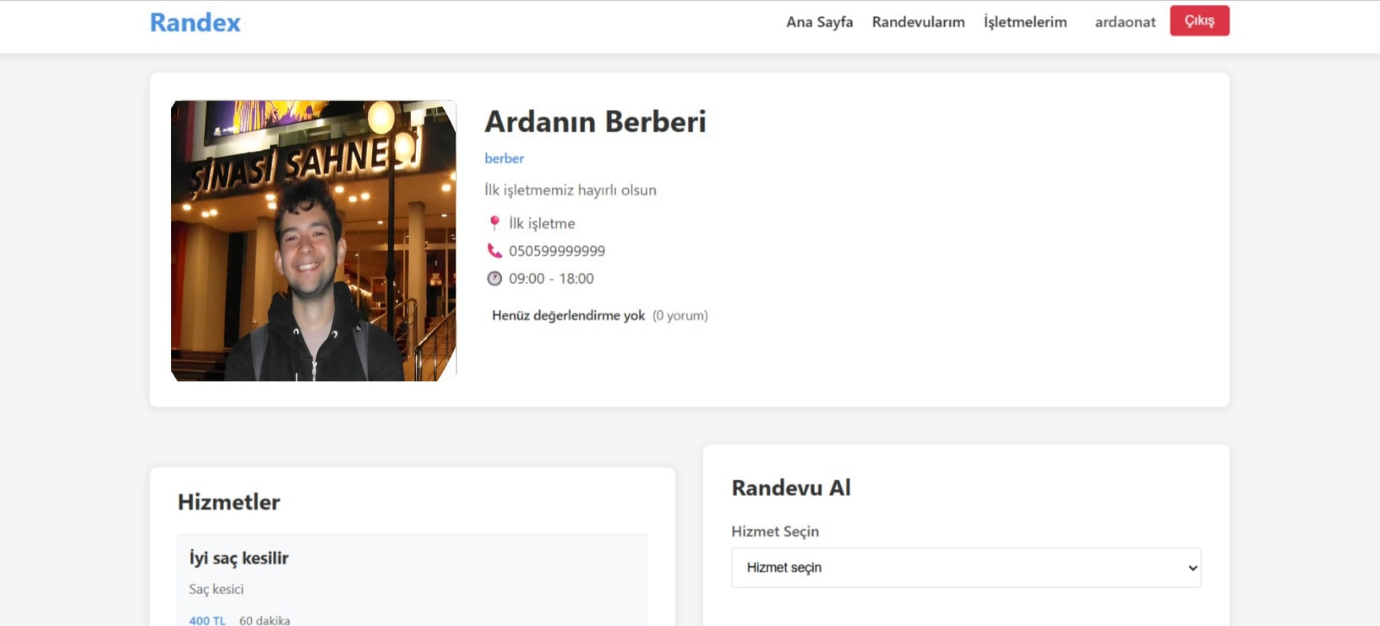
Business and Business Owner

Use Case Support In Design
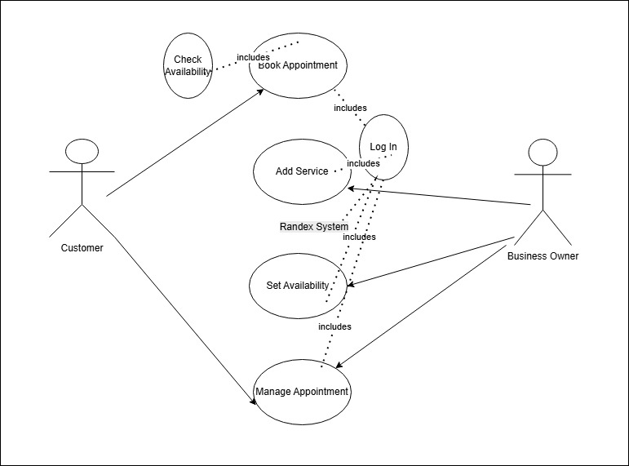
The Use Case Diagram above illustrates the primary interactions between actors (Customer, Business Owner) and the Randex system. The system architecture supports these scenarios through a layered approach, ensuring separation of concerns between the React frontend and the Express backend.

UC-1: Book Appointment
This use case represents the core functionality of the platform.Interaction: The Customer selects a service and a date on the BusinessDetail page. The system first executes the "Check Availability" included use case by calling the GET /available-slots endpoint to calculate valid time slots based on the business's opening hours.Data Flow: When the customer clicks "Book", the frontend sends a POST request with the service_id, date, and time. The backend verifies the JWT ("Log In" included use case) and inserts a new record into the appointments table.State Change: A new appointment record is created with a status: 'pending'.
UC-2: Add Service
This use case allows Business Owners to expand their offerings.Interaction: The Business Owner accesses the MyBusiness dashboard and opens the "Add Service" modal.System Support: The frontend serviceService sends a POST /api/services request. The backend's auth middleware enforces the "Log In" prerequisite and strictly validates that the user has the business_owner role before processing the request.State Change: A new row is added to the services table, linked to the business via business_id. The frontend state updates immediately to display the new service in the list.

UC-3: Set Availability
This use case allows Business Owners to define their working hours, which drives the availability logic.Interaction: The Business Owner updates the "Opening Time" and "Closing Time" fields in the MyBusiness profile form.Data Flow: The businessService sends a PUT request to the /api/businesses/:id endpoint.Impact: These values are stored in the businesses table. This data is critical for UC-1, as the "Check Availability" logic relies on these specific time ranges to generate valid slots for customers.
UC-4: Manage Appointment
This use case handles the lifecycle of an appointment (Confirmation or Cancellation).Interaction: Both actors interact with the Appointments page. A Customer can "Cancel" a pending request, while a Business Owner can "Confirm" or "Complete" it.System Support: The frontend calls PUT /api/appointments/:id/status. The backend updates the specific record after verifying ownership.State Change: The appointment's status field in the database transitions from 'pending' $\rightarrow$ 'confirmed' or 'cancelled'. The UI reflects this change instantly by updating the status badge color (e.g., from yellow to green).

Design Decisions

Technology Comparisons
To justify our final technology stack, we compared the following tools.
Database Management System: SQLite3 vs. MongoDB
- SQLite3 (Selected): A Relational Database Management System (RDBMS) that adheres to a fixed schema and uses SQL for data manipulation. It is serverless and stores data in a single file (randex.db), making it highly portable.
- MongoDB (Alternative): A NoSQL, document-oriented database that stores data in flexible, JSON-like format (BSON). It is designed for high scalability and unstructured data but requires a dedicated server instance.
Frontend Framework: React.js vs. Vue.js
- React.js (Selected): A library developed by Facebook that utilizes a virtual DOM and JSX (JavaScript XML). It promotes a "Learn Once, Write Anywhere" philosophy and relies heavily on JavaScript logic within components.
- Vue.js (Alternative): A progressive framework that separates concerns more strictly using an HTML-based template syntax. It is often cited as having a gentler learning curve due to its separation of template, script, and style.

Decision Justifications
Justification for SQLite3 We selected SQLite3 over MongoDB primarily due to the relational nature of our data. The Randex system relies heavily on structured relationships—specifically, linking Customers to Appointments, and Appointments to Services and Businesses. An RDBMS enforces referential integrity (Foreign Keys) natively, which is crucial for preventing orphaned appointment records. Furthermore, SQLite's file-based nature simplifies the development and submission process, removing the overhead of configuring a MongoDB Atlas cluster or local instance.
Justification for React.js We chose React.js over Vue.js to leverage its robust ecosystem and the flexibility of JSX. Given that our team is implementing complex state management for user authentication (via AuthContext.js), React's Context API provided a seamless native solution without needing external libraries like Vuex. Additionally, the component-based architecture of React allowed us to efficiently modularize UI elements such as the Navbar and BusinessDetail views, facilitating parallel development among team members.

GitHub Commit Requirements
In compliance with the assignment specifications, all development artifacts, documentation, and design assets have been version-controlled and uploaded to the team's GitHub repository.

Code Implementations & Interfaces
The complete source code for the Randex platform is available in the repository. This includes:
- Backend Implementation: Located in the backend/ directory, containing the Express.js server, API routes (e.g., appointments.js, services.js), and the SQLite database connection logic.
- Frontend Implementation: Located in the frontend directory, comprising all React components (pages/, components/) and service integration layers.
- Visual Interfaces: The CSS files defining the visual style are committed alongside their respective components.
Commit History & Contributions: The repository history reflects the incremental development of the project. Commit messages follow a standard format to clearly indicate the addition of features, bug fixes, and documentation updates. Contributions from all team members—Aybars Kansu Han, Ahmet Adil Akça, Eren Budak, and Arda Onat Acar—are visible in the commit logs, verifying individual participation in the project's lifecycle.

