**TRF Level 2 2022 Task Report**

Task No.:2

Title: astable multivibrator using ic555

Name: Vaishnavi Ramchandra davari

GR No.:12110729

E-mail ID: Vaishnavi.davari21@vit.edu

**INDEX**

|  |  |
| --- | --- |
| 1. | Introduction |
| 2. | Working methodology |
| 3. | Insights |
| 4. | Circuit Diagram (if any) |
| 5. | Result |
| 6. | References |

1. INTRODUCTION

This is template of task report. In this, describe your task.

Hardware : ic555 time,3 resistors,2 capacitors ,DC power supply of 5v,LED, Swich

(Components in the circuit)

Software: Proteus ,Eagle

(Software used)

2. WORKING METHODOLOGY

(Mention steps taken to complete the task)

(Explain the working of the circuit, algorithm, equations, calculations, simplication, etc)

Working of the circuit/ Algorithm/ Flowchart/ Equation:

* 555 timer IC in an Astable mode can be used to produce a very stable 555 Oscillator circuit for generating highly accurate free running waveforms whose output frequency can be adjusted by means of an externally connected RC circuit consisting of just two resistors and a capacitor.
* Pin 1 is grounded; pins 4 and 8 are shorted and then tied to supply**+Vcc**, Output (**Vout**) is taken frompin 3
* pin 2 and 6 are shorted and then connected to ground through the **capacitor C to ground** terminal, pin **7** is connected to supply**+ VCC** through a resistor R1
* Between pin 6 and 7 a resistorR2 is connected. At **pin 5** either a bypass capacitor (to bypass noise signals) of 0.01uF is connected or modulation input is applied.

Voltage across the capacitor at any instant during charging period is given as,vc=VCC(1-et/RC)

The time taken by the capacitor to charge from 0 to +1/3 VCC

1/3 VCC = VCC (1-et/RC)

The time taken by the capacitor to charge from 0 to +2/3 VCC

or t2 = RC loge 3 = 1.0986 RC

So the time taken by the capacitor to charge from +1/3 VCCto +2/3 VCC

tc = (t2 – t1) =  (10986 – 0.405) RC = 0.693 RC

Substituting R = (RA + RB) in above equation we have

THIGH = tc = 0.693 (RA + RB) C

 TL0W = 0.693 RB C

*The duty cycle, the ratio of the time tc during which the output is high to the total time period T is given as*

% duty cycle, D = tc / T * 100 = (RA + RB) / (RA + 2RB) * 100

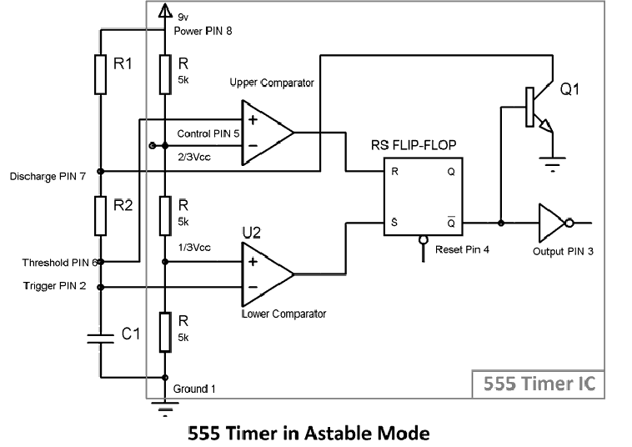

3. INSIGHTS

(Problems (errors) faced while completing the task)

1.determining the values of resistors and capacitors being used.

4. CIRCUIT DIAGRAM (if any)

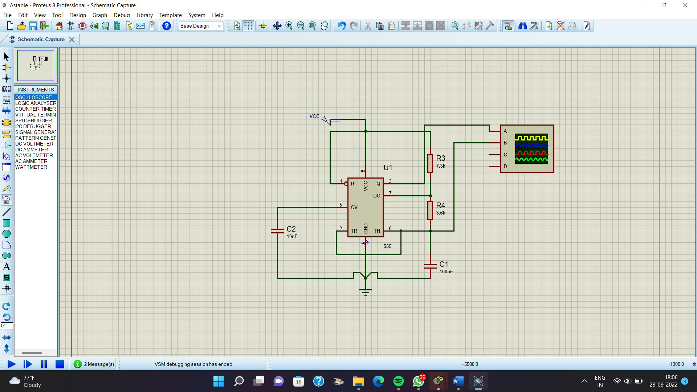

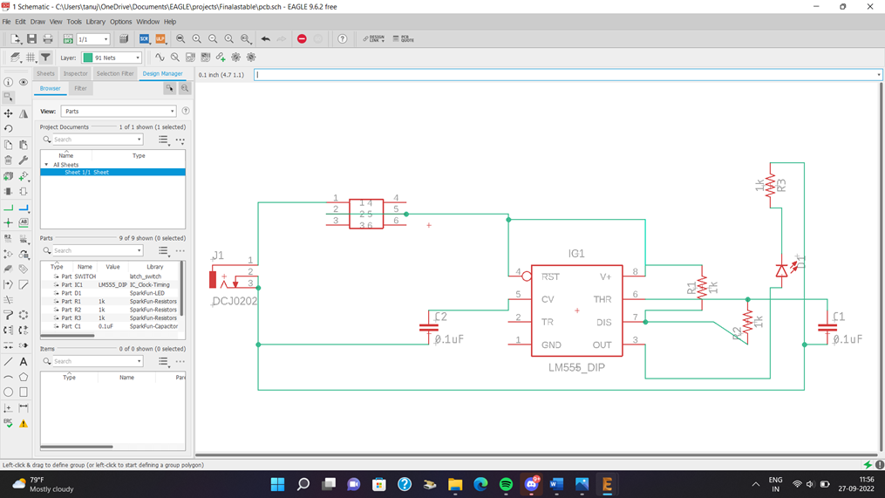

5. RESULT

(Attach Screenshot of Simulations, Output, Design, etc)

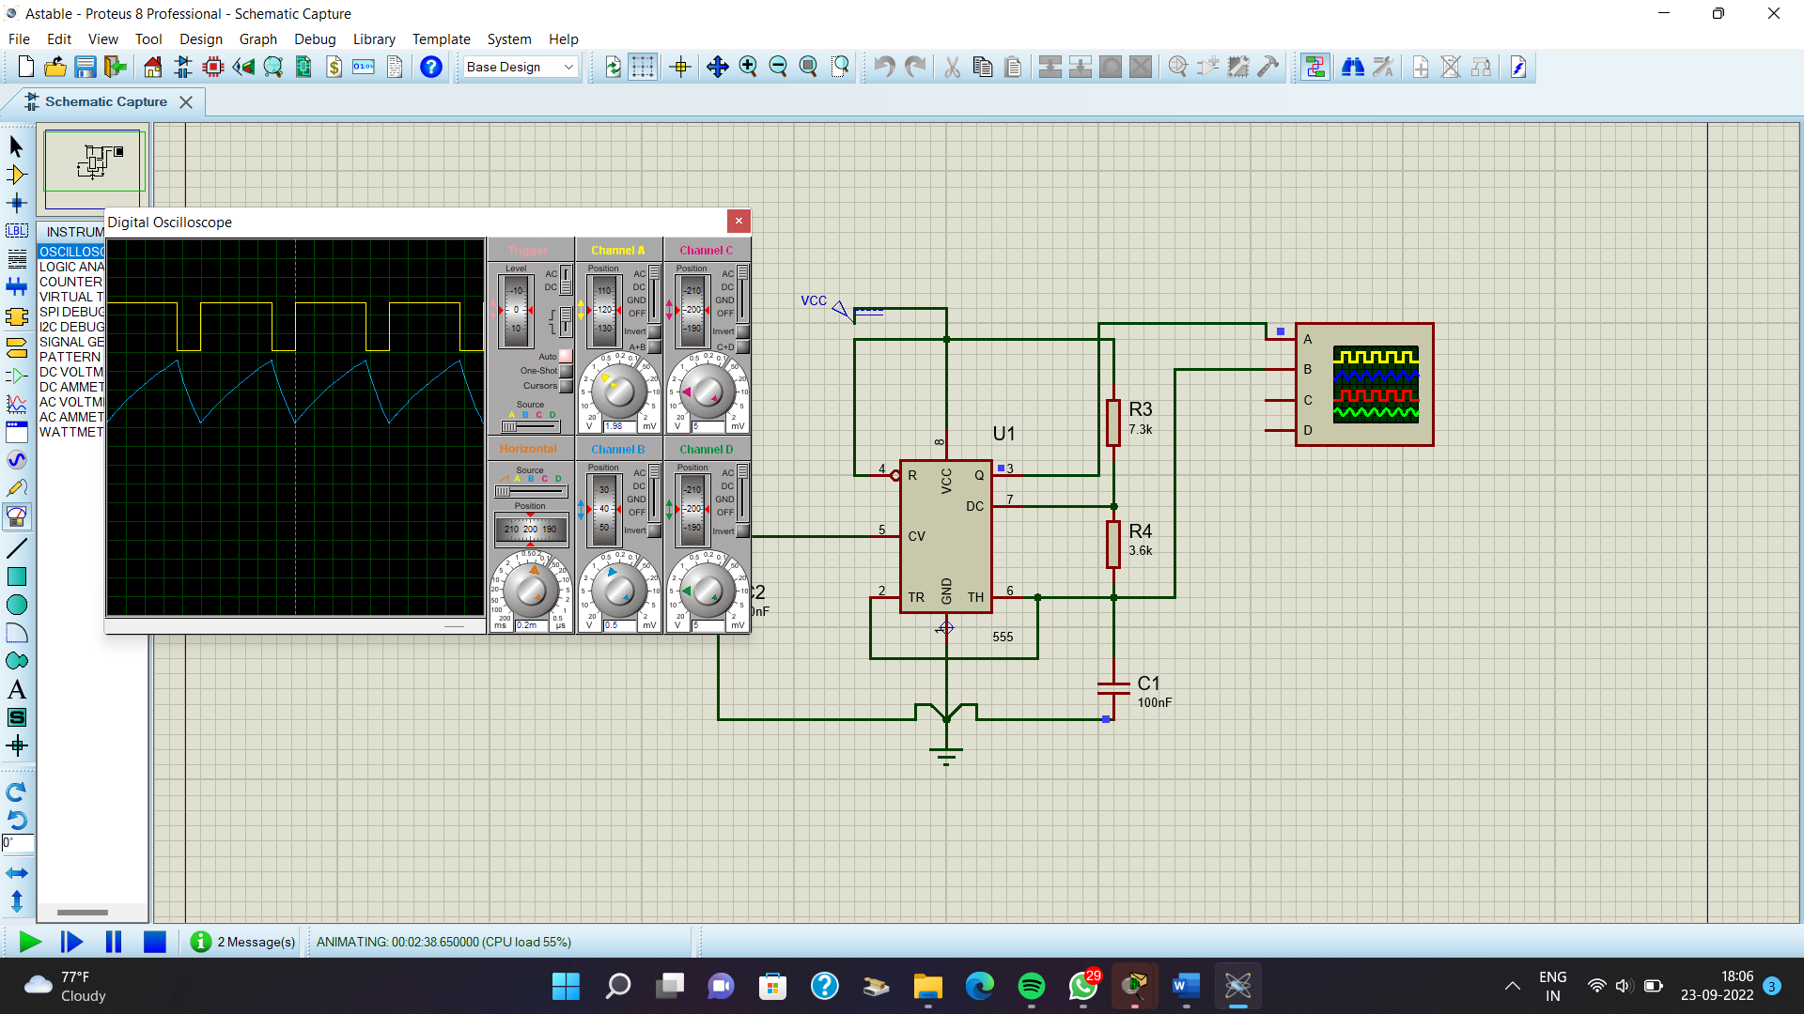

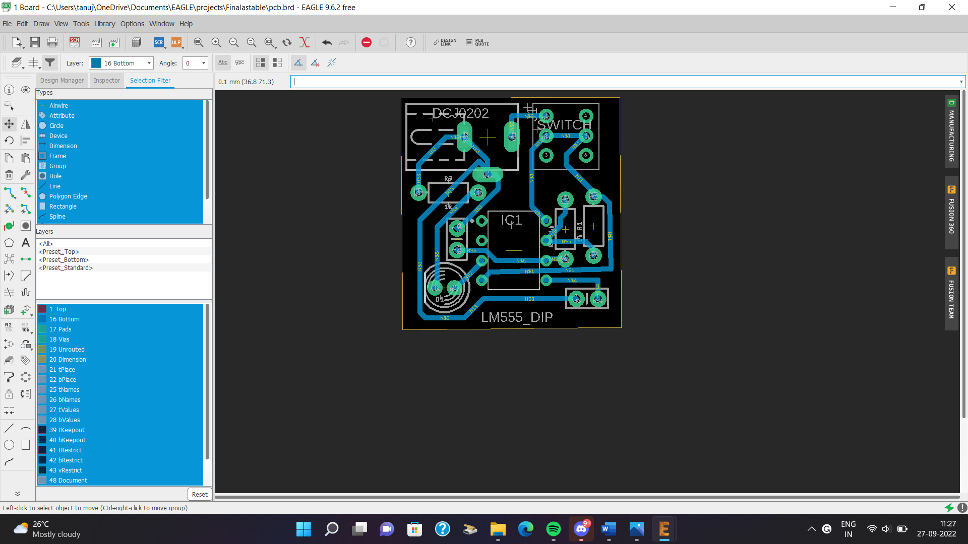

6. REFERENCES

(datasheets, sites that you used to complete the task)

[Astable Multivibrator using 555 Timer (circuitstoday.com)](https://www.circuitstoday.com/555-timer-astable-multivibrator#:~:text=An%20Astable%20Multivibrator%20can%20be%20designed%20by%20adding%20two%20resistors,output%20terminal%20(pin%203))

<https://datasheetspdf.com/pdf-file/477283/ETC/IC555/1>

https://www.youtube.com/watch?v=iJYm_BGqa1A