**Name: Aditya Ramnath Nawale**

**Proogramming-05**

**No Change Condition:**

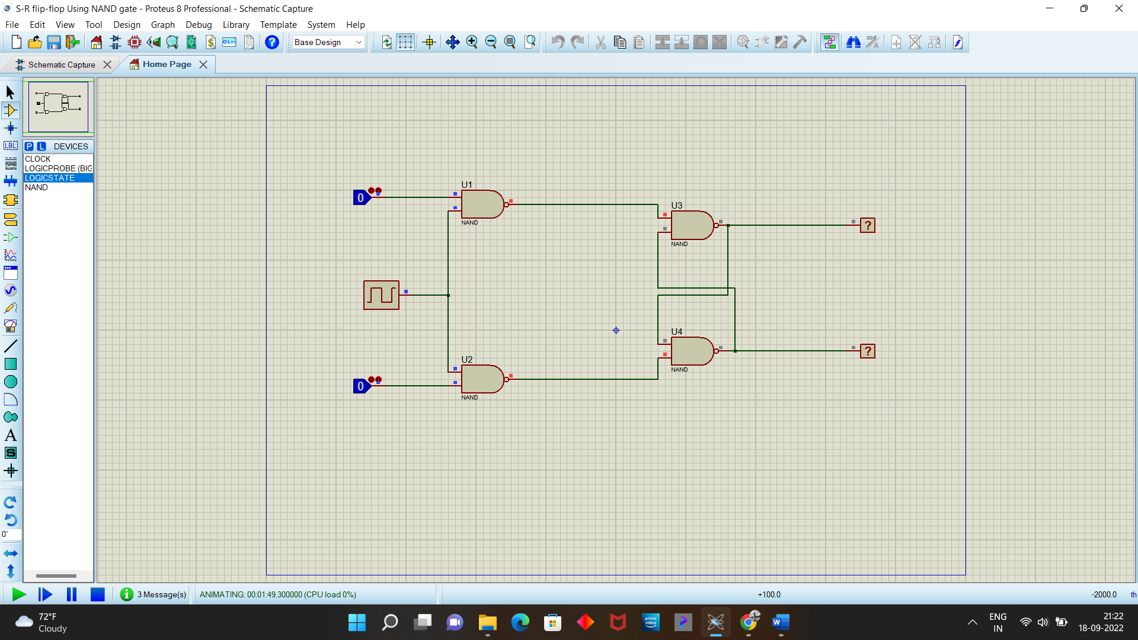

**Reset/Clear condition:**

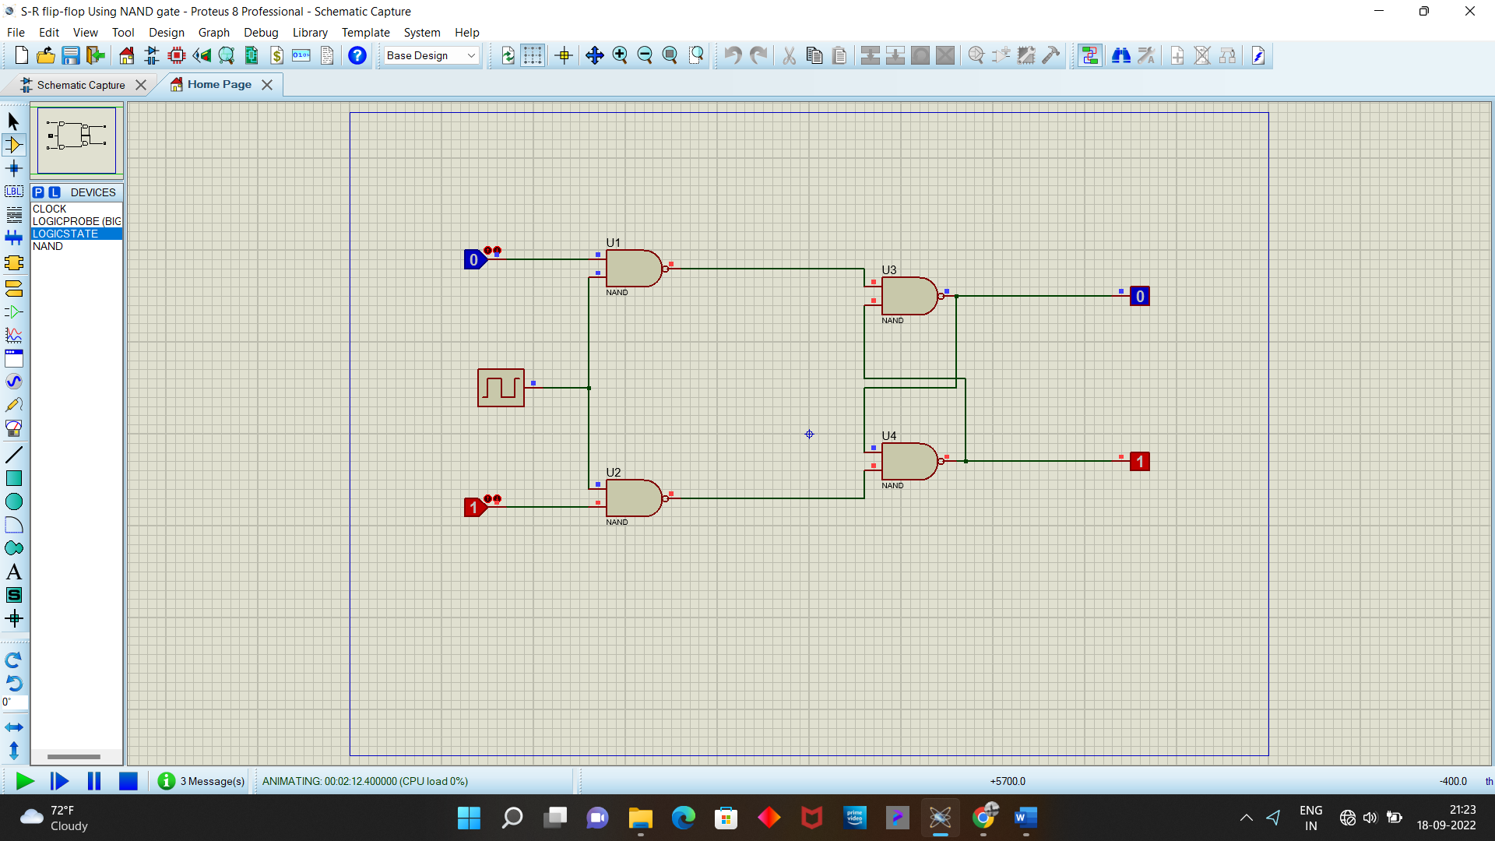

**Set condition:**



**Race around state:**

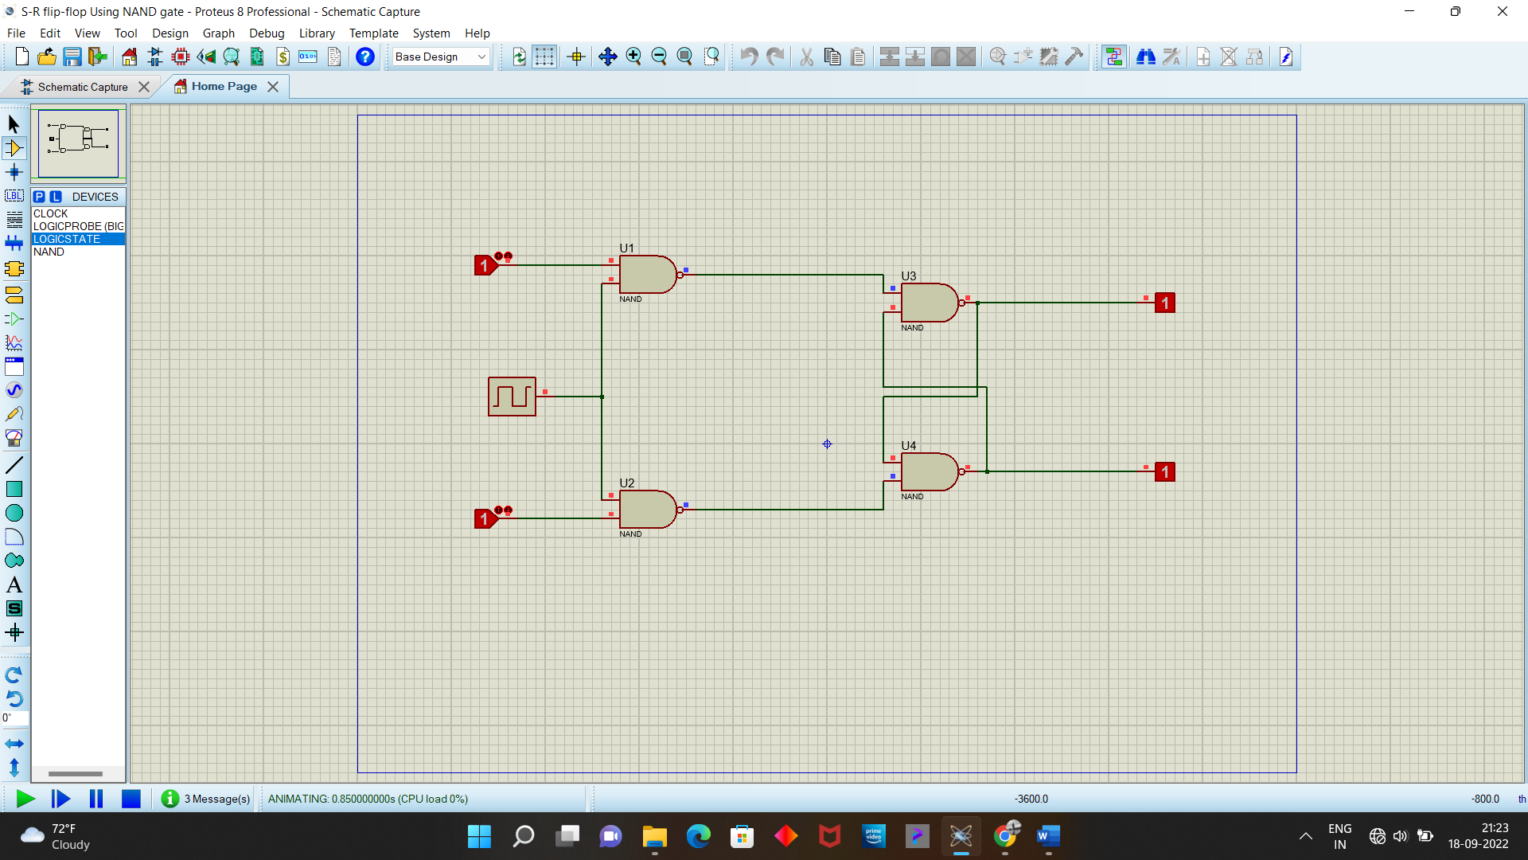

**For clock at 0:**



