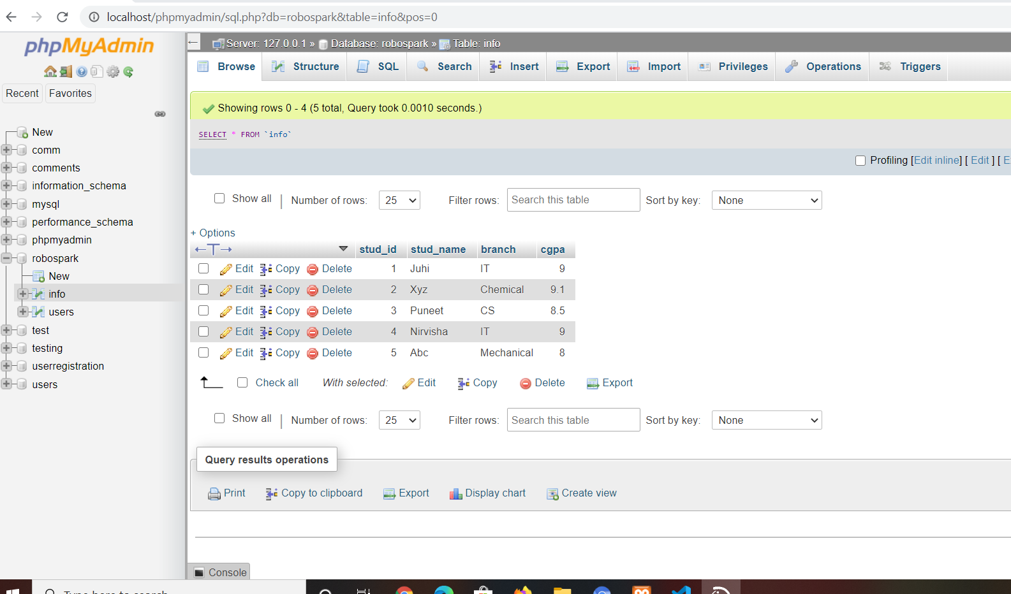

**This is the screenshot of the database we have created for student information.**

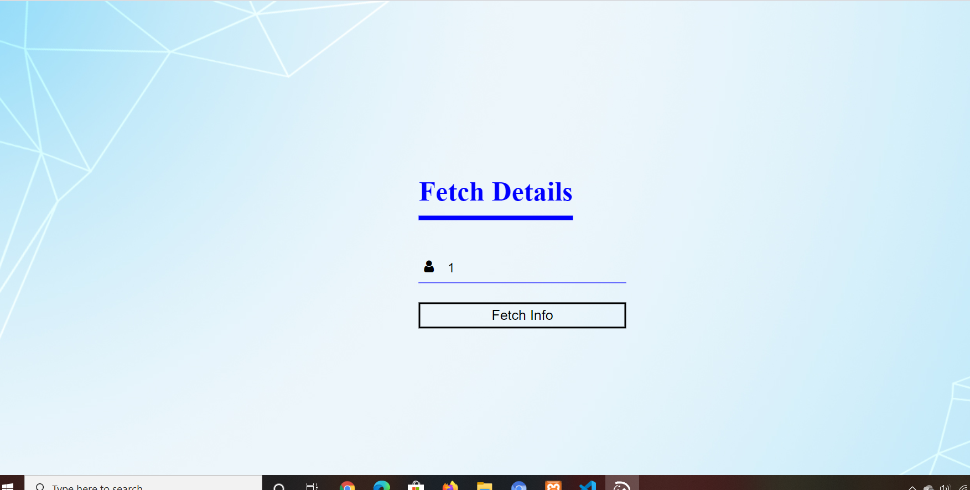

**The above is the page where the user id has to be entered.**

**Enter the id as shown above and click on fetch info so that we are directed to the page which will display the student info as follows…**

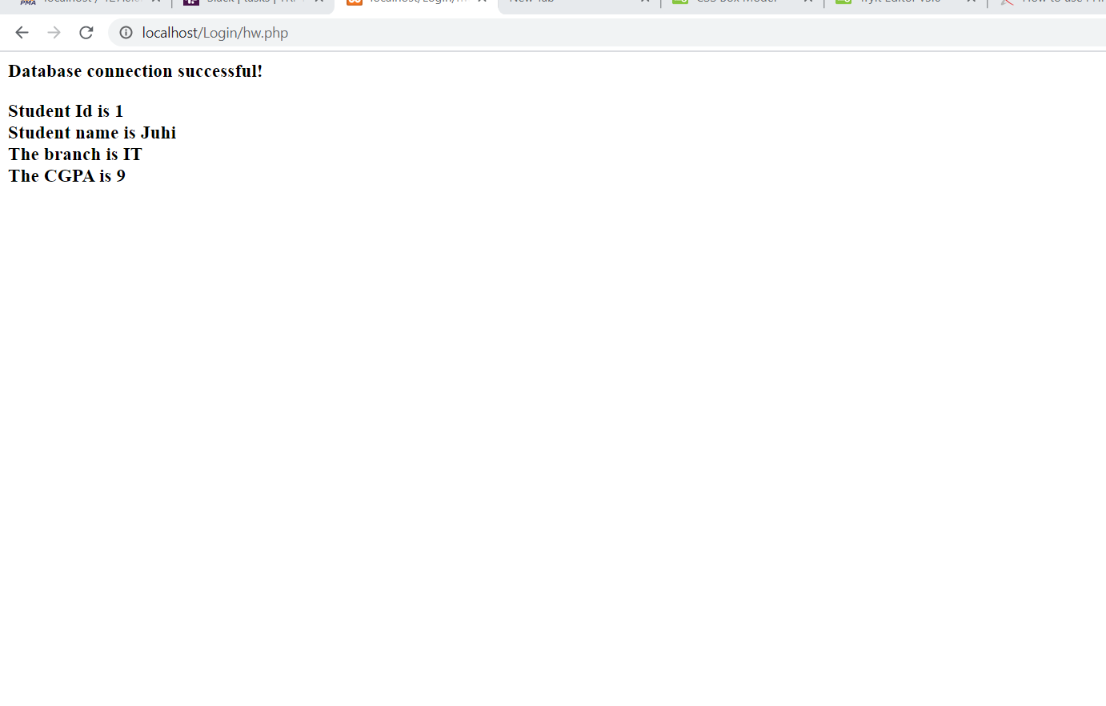

**Similarly we can retrieve information of any student record record stored in the database using the primary key which is stud_id**

**Record for stud_id , say 4 , is shown below**

