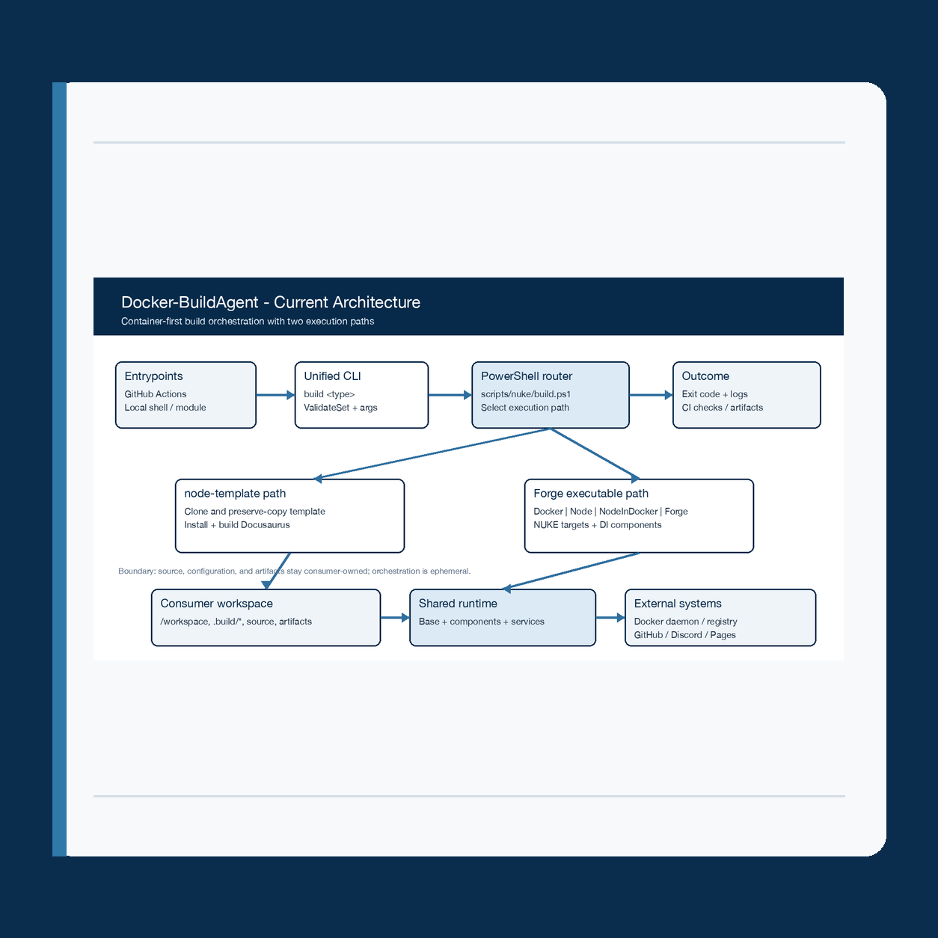

Docker-BuildAgent
Architecture coherence, release integrity,  and operational readiness |  | Prepared by Codex  August 2026

Contents

Executive summary 2
At a glance 2
Introduction 2
Key findings 3
Context and conditions 3
Patterns in the evidence 3
Implications 3
Recommendations 4
Conclusion 4
Appendix 5
Notes 5
Evidence sources 5

Executive summary
Docker-BuildAgent has a clear product idea: one versioned container exposes a unified build <type> interface over a reproducible CI toolchain. Five routes cover Docker, Node.js, combined Node-and-Docker, template-based documentation, and changelog work; shared NUKE components provide configuration, service adapters, versioning, and release behavior.
The design is strongest at its container boundary and weakest at integrity edges. The node-template route bypasses compiled Forge while documentation still describes a removed NodeTemplate project. Docker login, push, and tag failures can be swallowed, and CI runs only Common.Tests while its narrative promises every test project. The platform is useful, but it is not yet a fully evidenced release system.

At a glance
- Strength: a stable container-first boundary separates consumer source and configuration from the versioned toolchain.
- Risk: routing, documentation, solution topology, and CI coverage describe different effective systems.
- Priority: make external side effects fail closed, then align contracts, tests, and secret-safe observability.

Introduction
This assessment examines the repository as a maintainable build platform: entrypoint and build routing, compiled Forge projects, shared services, configuration files, CI workflows, documentation, and release paths. It evaluates internal coherence, failure behavior, evidence quality, and operational readiness rather than visual interface quality.
Evidence was inspected from the current checkout at commit d17ba5d8ca9a4b92be892646691c57d1db364831. No live registry, GitHub release, deployed documentation, or production invocation was exercised; recommendations therefore distinguish source-confirmed behavior from operational proof that is still missing.

Key findings
The repository contains several deliberate safeguards: one public build command, dry-run gates, dependency-injected services, and separation between continuous image publication and official manual or tag-based releases. Those choices form a strong base, but their guarantees are weakened by drift and inconsistent error contracts.

Context and conditions
The public router accepts five build types. Four resolve to separate compiled NUKE executables; node-template instead executes a PowerShell clone, preserve-copy, install, and build workflow. Consumers own the mounted workspace, configuration, credentials, and artifacts; the image owns toolchain packaging and orchestration, while Docker, registries, GitHub, Discord, and Pages remain external systems.

Patterns in the evidence
Across the codebase, the intended pattern is explicit validation followed by direct side effects. Most process failures stop the target, yet DockerService catches login, push, and tag failures without rethrowing. Generated .build/.build.env is deleted in the normal completion callback, and logging paths expose full Node command text plus a Discord webhook suffix. CI has five test projects available but invokes only Common.Tests.

Key takeaway. The public boundary is coherent; the evidence and failure semantics behind it are not yet equally coherent.

Implications
A release can report successful Docker publication after an ignored registry failure, abrupt termination can retain a secret-bearing environment file, and documentation or tests can validate a topology that is no longer executable. Without a structured run manifest, measurable thresholds, and full test execution, maintainers must reconstruct incidents from logs that may themselves expose sensitive material.
Theme | Observation | Implication
Contract coherence | Five-type CLI; node-template is PowerShell-only while specs still show a compiled project. | Consumers and maintainers can rely on a topology that does not exist.
Failure integrity | Docker login, push, and tag errors are ignored; env cleanup depends on normal completion. | False success, partial publication, and residual secret-bearing files are possible.
Verification and observability | CI runs one of five test projects; command and webhook data reach logs; no run manifest or SLO is defined. | Regressions, exposure, and release incidents are harder to detect and reconstruct.

Recommendations
Sequence the work by release risk: first eliminate false-success and secret-retention paths, then reconcile the executable contract, and finally add durable operational evidence.
- Make publication and cleanup fail closed. Propagate Docker registry errors, reserve simulation for explicit adapters, guarantee .build/.build.env deletion in a finally path, and add contract tests for every external side effect.
- Reconcile the executable contract. Choose the intended node-template topology, generate or validate CLI documentation against source, fail CI on drift, and execute all five test projects plus an integration dry-run.
- Establish secret-safe operational evidence. Redact arguments, tokens, and webhook values; emit a structured run manifest; assign measurable build and release gates; and record image, release, and rollback verification.

Conclusion
Retain the container-first boundary and component-composed Forge design. They provide a useful separation of responsibilities and a credible path to repeatable builds without introducing a hosted scheduler or persistent job service.
Do not expand build types or release automation until the three recommendation groups are evidenced in CI. The readiness criterion is not more documentation; it is agreement between the router, solution, generated contract, test matrix, logs, and observed release outcomes.

Appendix

Notes
Scope: current repository source and configuration at commit d17ba5d8ca9a4b92be892646691c57d1db364831, inspected August 21, 2026. The embedded docs-template application was treated as a consumer and deployment payload, not as the Build Agent runtime architecture itself.
Method: read-only comparison of public entrypoints, actual project inventory, runtime services, tests, workflows, and written contracts. This report does not claim runtime, registry, deployment, performance, or security-test proof beyond the cited repository evidence.

Evidence sources
- Execution: Dockerfile; scripts/nuke/bin/build; scripts/nuke/build.ps1; scripts/nuke/nuke-helpers.psm1; Forge.sln.
- Runtime integrity: forge/Common/Base.cs; Services/DockerService.cs; Services/NodeService.cs; Notifications/DiscordNotifications.cs; Components/IGitHubComponent.cs.
- Contracts: README.md; PSModule.specs.md; PSModule.requirements.md; scripts/powershell-module/Docker-BuildAgent.psm1.
- Delivery: .github/actions/tests/action.yml; workflows/ci.yml, build.yml, docs.yml, release.yml, and release-tag.yml.

Evidence note. No implementation changes were made. Live images, releases, Pages output, and rollback behavior remain to be verified.

