Docker-BuildAgent

Current-State System Design

STATUS  Draft |  | OWNER  The-Running-Dev maintainers |  | LAST UPDATED  August 21, 2026

Authors | Unassigned (repository-derived draft)
Reviewers | Maintainer, operations, security
Related docs | README.md; architecture/*; PSModule.requirements.md
Scope | Image, routing, Forge, configuration, side effects, CI, releases, and docs.

1. Abstract
Docker-BuildAgent is a containerized CI build environment that packages Node.js, PowerShell, .NET SDKs, Docker CLI/Buildx, GitVersion, NUKE, templates, and compiled Forge executables. A consumer mounts a repository at /workspace and invokes build <type>. Four types route to independent NUKE executables; node-template follows a dedicated PowerShell workflow.
The system is an ephemeral orchestrator, not a hosted build service. It persists no queue or job database and depends on the mounted workspace, a reachable Docker daemon, package registries, GitHub, and optional Discord notifications. This RFC describes repository state at the cited commit; it does not certify live images or deployments.

2. Goals and Non-Goals
Goals | Non-goals
Reproducible CI toolchain in one versioned image. | General-purpose application runtime or hosted build API.
One build <type> contract across five workflows. | Persistent scheduler, queue, cache, or job database.
Composable, testable build targets and service adapters. | Arbitrary untrusted-code isolation inside the agent.
Dry-run validation and explicit release promotion gates. | Exactly-once external side effects or automatic rollback.

3. Background and Problem Statement
The repository evolved from local scripts into a multi-build Forge solution and unified container command. Current implementation and documentation have drifted: several pages still describe a NodeTemplate .NET project that is not in the solution, and CI comments overstate the test projects actually executed. Without a current baseline, maintainers can misread execution and release behavior.
The consumer repository owns source, configuration, credentials, and produced artifacts. The image owns the toolchain and routing; Forge owns target ordering and adapters; Docker, registries, GitHub, Discord, and GitHub Pages remain external. The governing invariant is explicit side effects: dry-run and release gates must make every publish, tag, and notification path visible and fail-safe.

4. System Architecture

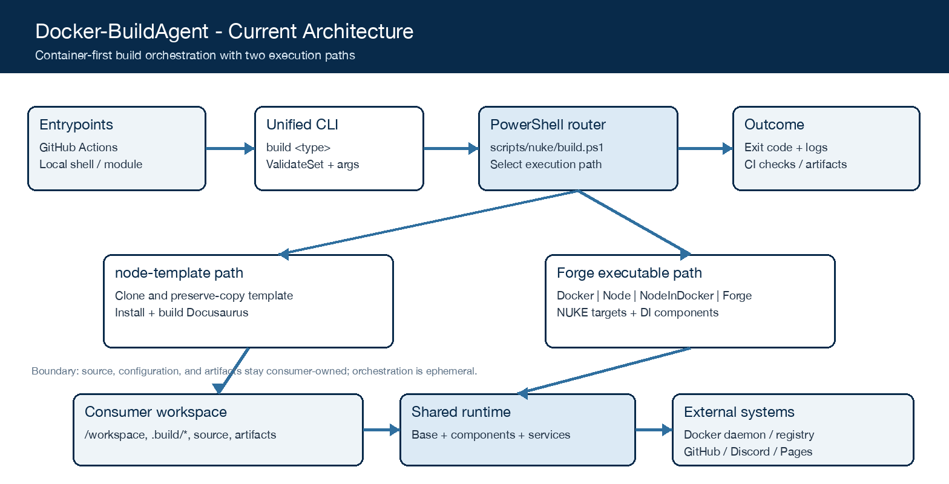
Figure 1. Docker-BuildAgent execution paths and ownership boundaries.

Core components

Component | Responsibility | Primary storage | Failure behavior
Image + entrypoint | Packages toolchain; exposes build <type> and exit status. | Dockerfile, /nuke, /workspace | Image build or router failure returns nonzero.
node-template workflow | Clone, preserve-copy, install, and build documentation. | Workspace + remote template | Safe-command failure stops; clone directory is recreated.
Forge executables | Run Docker, Node, NodeInDocker, or changelog target graphs. | Mounted repo + .build files | Assertions/process exits stop; side effects can remain partial.
Components + services | DI-backed Node, Docker, Git, GitHub, notification operations. | In-memory params + external tools | Most failures propagate; Docker push/tag catches exceptions.
GitHub workflows | Test, validate, publish images/releases, and deploy documentation. | Actions, GHCR, Pages, artifacts | Failed jobs block dependents; current tests action runs Common.Tests only.

5. Request Lifecycle
- A CI job, local script, or PowerShell-module caller supplies a build type, workspace, optional Docker endpoint, and build arguments; container usage mounts the project at /workspace.
- PowerShell ValidateSet rejects unsupported types. The module can validate keys against generated parameters.json; the router normalizes the type, forwards remaining arguments, and adds --root when absent.
- The router optionally loads set-environment.ps1. Forge generates .build/.build.env from .build.env.map, loads GitVersion and repository metadata, hydrates typed parameters, and initializes dependency injection.
- node-template clones and preserve-copies a template before package install/build. Other types select a matching DLL and execute its NUKE target graph: Node, Docker, NodeInDocker, or Forge changelog.
- No central durable pre-write exists. State changes occur directly in the mounted workspace, local Docker image store, registry, Git tags/releases, documentation artifacts, and CI artifact storage.
- Targets call Node/package-manager processes, Docker, Git, GitHub, and Discord. Process failures normally terminate the build; no cross-system retry or timeout budget is defined, and Docker push/tag exceptions are currently swallowed by DockerService.
- The build deletes its generated .build/.build.env on normal completion, emits console logs and an exit code, optionally sends a notification, and lets GitHub Actions publish checks, coverage, images, releases, or Pages artifacts.

6. API and Data Contracts

Primary data contract

Field | Type | Required | Description
type | enum string | Yes | Selects one of five router paths.
workingDir/root | path | Resolved | Consumer root; default current directory; forwarded as --root.
nukeArgs | string[] | No | Forwarded; NUKE hydrates typed fields and secrets.
.build.env.map | line map | No | Creates transient .build/.build.env.
.app.env.map | line map | No | Creates root .env for Node builds.
.build.scripts | ordered lines | No | Ordered commands; default install then build:prod.
.build.copy | ordered paths | No | Paths copied from workspace to artifacts.

Contract guarantees

- The router resolves exactly one build type per public invocation, adds an explicit root, and fails environment generation when a mapped required value resolves empty.
- NUKE target dependencies define step order. The system has no persisted job ID, attempt ledger, transaction boundary, or exactly-once side-effect guarantee.
- GitVersion output, repository URL, branch, commit, image tags, and release tag are captured when repository metadata is available; CI retains its own run and artifact identifiers.
- The mounted repository and its .build files are authoritative inputs. Generated environment files and artifacts are derived; documentation and parameters.json can drift unless regenerated and checked.
No versioned machine-readable schema for the unified build CLI is published. The PowerShell module can generate optional parameters.json metadata from C# parameter classes; it is not a complete runtime schema.

7. Consistency, Idempotency, and Replay

Each invocation is a new ephemeral run. CLI parameters are hydrated once, but file-backed scripts and copy lists are read during their targets and are not snapshotted. Docker uses mutable latest plus a GitVersion tag; GitHub releases are created or updated; Git tags are force-created/pushed. These behaviors support repeatable automation but do not provide transactional or exactly-once semantics.
Scenario | Expected behavior | Reasoning
Repeated invocation | Rebuilds outputs; latest/version tags and releases may be replaced or updated. | No global idempotency key; Git tag push uses force.
Required input/tool fails | Environment validation, assertion, or nonzero process exit stops the run. | Workspace/artifacts may be partial; there is no transaction.
External side effect fails | GitHub release fails the target; notification errors only log; Docker push/tag may be swallowed. | Current failure semantics are inconsistent and need review.
Configuration changes mid-run | Hydrated CLI values stay in memory; file-backed inputs can change before their target reads them. | No immutable input snapshot or replay manifest exists.

8. Security and Privacy Considerations

- Treat the mounted workspace as trusted code: .build.scripts, PowerShell files, package scripts, and Dockerfiles execute with the container's tools and may reach the mounted Docker daemon and CI credentials.
- NUKE [Secret] parameters and Docker invocation logging suppression protect common paths, and the module hides forwarded values. Gaps remain: NodeService logs command arguments and DiscordNotifications logs a webhook substring.
- Credentials arrive through CI secrets, environment mappings, or parameters; there is no internal secret store. .build/.build.env is written inside the workspace and removed only on normal cleanup, so abrupt termination can leave it behind.
- DryRun suppresses push/tag/release/notification side effects unless ForcePush or ForceNotifications is enabled. Official release creation is isolated to manual and tag workflows; force switches require privileged review.
- The agent stores no end-user database. Source, logs, images, releases, Pages output, notifications, and coverage remain subject to the retention and access policies of the workspace, registry, GitHub, and Discord; coverage artifacts retain 30 days.

9. Operational Readiness
Signal | SLO or alert | Owner | Launch gate
Test/build completion | GitHub Actions job success; no numeric SLO defined. | Maintainers | Required
Build duration | No threshold; capture workflow duration before setting one. | Maintainers | Recommended
Push/release failure | Any unhandled publish failure must fail the job; no alert window defined. | Release owner | Required
Contract/docs drift | No automated drift threshold; CLI, solution, and docs must agree. | Maintainers | Required
Release integrity | Dry-run plus image/tag/release verification; no cadence defined. | Release owner | Required
Rollout constraint: PR validation and docs build -> main image publish without GitHub release -> manual/tag official release; rollback selects a prior immutable image tag subject to registry retention.

10. Alternatives Considered

Alternative | Why it was considered | Why it was not selected
Direct host toolchains | Fast local iteration and no container startup. | Environment drift; remains a development path, not the CI contract.
One monolithic executable | Single binary and target surface. | Weakens build-type isolation and does not match node-template's current script path.
Nested Docker daemon | Stronger daemon isolation from the host. | Extra storage, startup, networking, and privilege complexity; socket/DOCKER_HOST is current.
Release on every main push | Maximum automation and immediate release notes. | Conflates continuous image publication with official releases; current workflows separate them.

11. Open Questions
- Should node-template remain a special PowerShell workflow, or should it return as a compiled Forge project and all architecture pages be reconciled to that decision?
- Should DockerService stop swallowing login, push, and tag exceptions outside an explicit simulation/test adapter so production side effects fail closed?
- Which measurable build-duration, success-rate, release-integrity, and documentation-drift thresholds should be adopted, and who owns each alert?
- Should registry and GitHub credentials be separate parameters, and what redaction policy must cover command arguments, generated env files, and webhook URLs?

12. Decision and Next Steps
Adopt this RFC as a repository-derived current-state baseline, not as approval of its gaps. Retain the container-first boundary and component-composed Forge design; then prioritize fail-closed side-effect reporting, contract/documentation synchronization, complete CI coverage, and secret-safe logging before expanding build types or release automation.
Milestone | Deliverable | Exit criteria
M1 | Baseline and drift reconciliation | CLI, solution, and docs inventory agree; removed-project references are resolved.
M2 | Failure and secret-handling hardening | Publish failures propagate; token roles split or documented; logs pass redaction tests.
M3 | Complete validation and observability | All test projects and integration dry-runs run; owners and measurable gates are approved.
M4 | Release-governance proof | Manual/tag release, artifact verification, and prior-tag rollback are exercised and recorded.

Source snapshot: commit d17ba5d8ca9a4b92be892646691c57d1db364831 (July 24, 2026). Repository evidence was inspected on August 21, 2026; live registry and deployment state were not verified.

