Data Structures (Technical Stack)
Team No: 5

Members of Team:
https://docs.google.com/spreadsheets/d/1HR6HHfBEPMOguQO8D3tXN4K_SydUTnXzZbehxPSGvqY/edit#gid=0

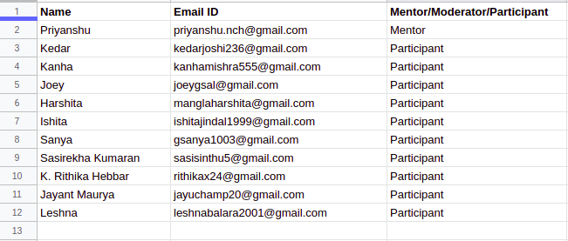

Procedure: We will first focus on learning all data structures concepts topic-wise and will be solving problems based on them simultaneously.The problems will range from beginner level to intermediate level(competitive programming) and the level of problems will be dynamic and will be changed as per the response of team. The resources for learning and questions for practice will be taken from various websites like GeeksForGeeks,Hackerearth,HackerRank, Codechef,Codeforces etc. And other youtube channels.After covering all the major topics, we will build a project which will be built from scratch using the concepts learned. The main motive of the program will be to have a good grasp of all the fundamental concepts of Data Structures and Algorithms.

Schedule:
(Note: It can be changed later depending upon the progress of the participants)
--->(1st June to 15th June):
*Team interaction
*Report preparation
*C++STL/Java Collections

--->(15th June to 30th June):
*Introduction to Data structures
*Basic Number Theory(GCD etc.) and Maths required in Competitive programming
*Bitwise operators
*Arrays
*Strings
* Stack and Queues Implemention

--->(1st July to 10th July)
*Applications of stack and queues and problems based on them
*Linked Lists (Singly and doubly linked lists, circular linked list) implementation and problems based on them
*Priority Queues
*Time and Space complexity analysis

--->(11st July to 20th July)
*Searching algos (Linear and binary search)
* Sorting algos (Bubble, Merge, Quick,Selection,Heap sort etc.)
*Intro to recursion and divide and conquer approach

--->(21st July to 30th July)
*Hashing
*Greedy approaches
*Dynamic programming

--->(1st August to 10th August)
Trees and Graphs

(11th August onwards)
Final Project

