C-DISC TECHNOLOGIES
Website Content
Developer Handoff
A page-by-page content specification for the PEN Foundation website
PURPOSE
This document consolidates the strongest language already refined across C-DISC brochures, pitch decks, company summaries, project communications, and the existing website draft. It is a content handoff, not a website redesign or direct website edit.

Prepared for: Website Development Team
Prepared: 9 August 2026
Primary message
PEN Foundation is the patented, zero-excavation foundation system that installs in hours, carries load immediately, and helps suitable low-rise buildings rise faster with far less disturbance to the land.
Content principle
Repeat a small set of memorable ideas consistently: Dig. Pour. Wait. / Hours, not weeks. / Zero excavation. / Immediate load-bearing. / Engineered for the ground and the structure. / Faster. Stronger. Greener.

HOW TO USE THIS DOCUMENT

Navigation and implementation rules

Recommended website order
Home → About → Engineering → Applications → Projects → Research → Gallery → Contact → FAQs. The FAQ working section is intentionally placed last for founder review.

What is final versus what needs checking
Headlines, positioning, story flow, benefit language, process language, application framing, project narratives, and calls to action are drafted for use. Figures listed in the verification box below must be reconciled once and then reused everywhere.
VERIFY ONCE BEFORE PUBLISHING
1) current deployment and project counts; 2) final installation-time statement; 3) carbon boundary and figure; 4) current patent status wording; 5) exact load-capacity and enhancement-factor range; 6) final phone, email and social links; 7) whether BMTPC, BIS and CSIR-SERC should be stated as “under progress”.

Voice and guardrails
Authoritative, educational, practical and engineering-led. Write clearly enough for a developer or homeowner while retaining technical credibility. Avoid “revolutionary”, “zero carbon”, “works in every soil”, “replaces all foundations”, universal capacity claims, or wording that suggests BMTPC/BIS approval is complete.

Visual direction
Retain the premium engineering language already established: deep teal/navy, warm cream, muted steel tones and restrained gold. Use real installation photography, cutaway models, soil/root analogies, test evidence and project imagery. Avoid generic stock construction visuals where project evidence exists.

PAGE 1 | HOME

The fastest route from curiosity to project assessment
HERO
Instant Foundation for Modern Buildings
30 days of construction. Less than one day for the foundation.
Zero excavation. Immediate load-bearing.
Validated through NIT Calicut, IIT Kanpur and GRIHA-linked evidence.
PRIMARY CTA
Request a Project Assessment

SECONDARY CTA
Watch the Installation

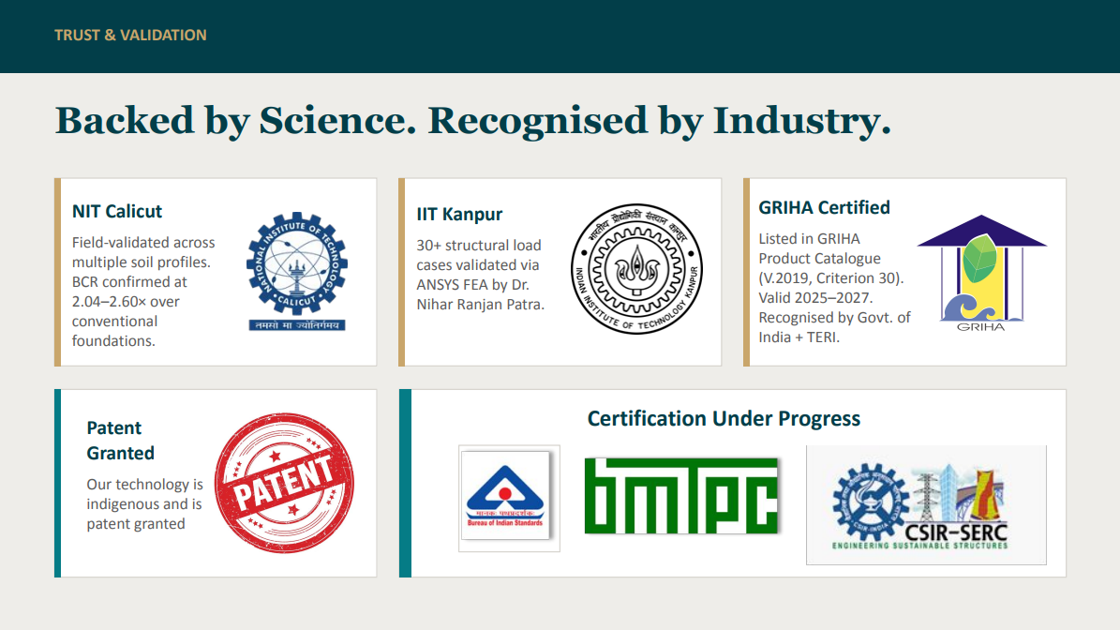
Existing draft reference: trust and validation panel. Update any status wording after the final verification pass.

PAGE 1 | HOME

Credibility strip and the problem

Credibility strip headline
Engineered. Tested. Supported.

Credibility strip supporting line
Research, incubation, grant support and industry collaboration behind the Pre-Engineered Nail Foundation, spanning national institutes, government innovation programmes and climate-focused ecosystems.
DEVELOPER NOTE
Use institution logos as a supporting strip. Group them by role where possible: Research / Incubation / Support / Certification. Do not imply that every logo is a technical validator.

PROBLEM SECTION
For a century, a foundation meant digging, pouring and waiting.
PEN drives four engineered nails instead, and carries the load the same day.

Section headline
Three weeks of your programme are spent waiting for concrete to cure.

Body copy
A conventional cast-in-situ footing has to be excavated, formed, reinforced, poured and then left to cure before the structure can move forward. PEN Foundation changes that sequence. A factory-made node is positioned at ground level, engineered nails are driven into qualified soil, and the completed point is ready to receive the structure without an on-site curing cycle. The result is a faster programme, less wet work, less site disruption and a foundation process that works with the land rather than removing it.
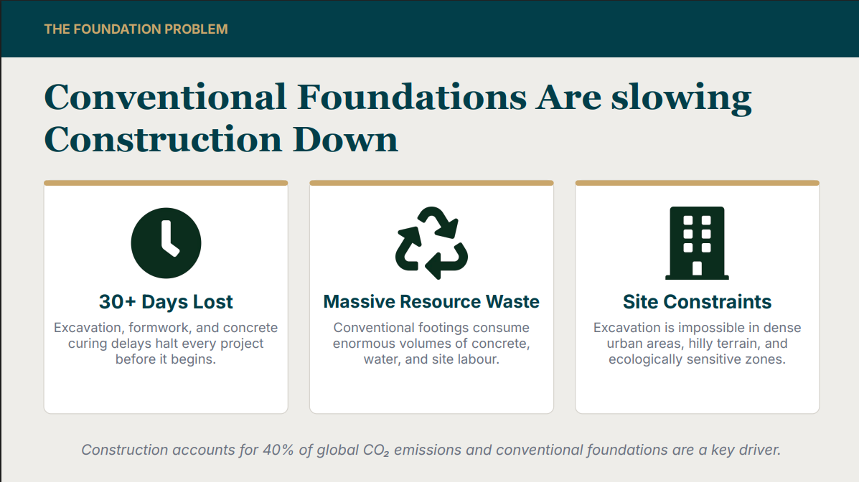
Existing draft reference: problem framing. Replace generic figures with the approved project-wide statements above.

PAGE 1 | HOME

What PEN is and why it matters
PRODUCT DEFINITION
One precast node. Four engineered nails. Ready to build.

Body copy
PEN Foundation, the Pre-Engineered Nail Foundation System, is a patented, biomimetic foundation inspired by the way tree roots distribute load through soil. A high-strength precast node sits at ground level and transfers structural loads through four inclined steel nails driven into the surrounding soil. The system is designed for the project’s soil, structural loads and layout, then installed without excavation, formwork or on-site foundation curing.

Supporting explanation
A conventional footing concentrates load beneath a concrete mass. PEN distributes load through four inclined paths that engage a three-dimensional volume of soil. The design is compact at the surface but active below it, using soil-structure interaction rather than relying only on the footprint of the node.
CORE PROOF POINTS
- Zero excavation, preserving soil layers, drainage paths and terrain.
- Installed within hours, with no foundation curing wait.
- Immediate readiness for superstructure connection after approved installation.
- Substantially lower concrete and water use than conventional RCC footings.
- Soil- and load-qualified design supported by testing, simulation and field deployment.
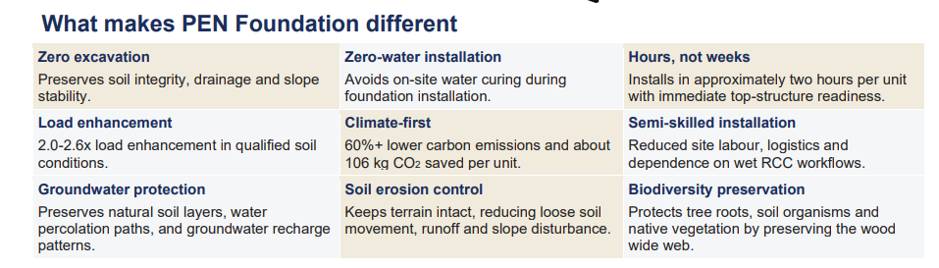
Existing draft reference: nine differentiators. Use as a content source, not necessarily as the final web layout.

PAGE 1 | HOME

Four steps from project enquiry to structure
PEN is specified for the project, not sold as an unqualified off-the-shelf footing. The layout, number of points and installation configuration follow from the ground and the structure.

01 Assess
We review the project location, structural system, column reactions, site access and available soil information. Where required, soil suitability is established through appropriate field or geotechnical inputs.

02 Engineer
Our engineers develop the foundation layout and configuration for the approved project loads and qualified soil conditions. Point count, position, nail geometry and embedment are selected as part of the design process.

03 Install
The precast nodes are positioned, the engineered nails are driven into the soil and the system is completed in accordance with the approved installation method. There is no excavation, formwork or on-site foundation curing cycle.

04 Build
Once installation and quality checks are completed, the superstructure can connect to the node and construction can continue without the conventional foundation waiting period.
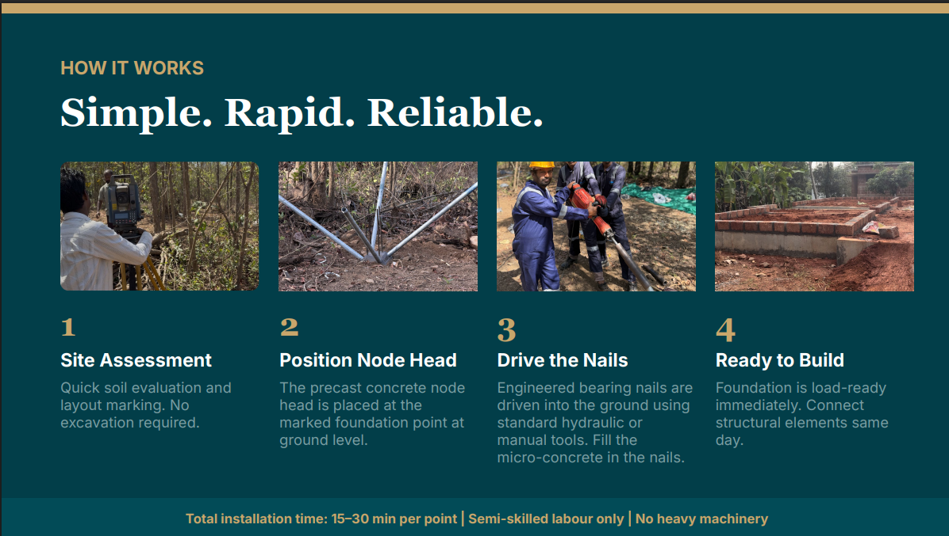
Preferred visual sequence from the attached draft. Retain the four-stage photography, but remove hard installation-time claims from the graphic until verified.

PAGE 1 | HOME

Applications and project value
Where PEN Foundation is being specified
PEN suits suitable low-rise structures where foundation points repeat, the programme is tight, access is constrained, or the ground should remain undisturbed.

Residential
A hassle-free foundation sequence with fewer wet-work dependencies, less site congestion and installation that follows the approved plan without a month-long footing cycle.

Commercial
Faster foundation completion can bring the structure and the revenue-generating asset forward, while keeping the site cleaner and reducing programme uncertainty.

Eco-resorts and farmstays
Zero excavation helps preserve tree roots, soil structure, slopes and the natural character guests come to experience. Earlier project completion can also bring operations and revenue forward.

Modular and prefab
A foundation process aligned with factory-made structures: fast, repeatable, precise and capable of supporting relocatable design strategies where engineered accordingly.

Low-span industrial
Repeated column grids and schedule-sensitive delivery make suitable sheds and light industrial structures a strong application for a pre-engineered foundation system.

Ground-mounted solar
A future application pathway focused on faster repetitive installation and reduced concrete, water, spoil and site disturbance. Publish as an application under development or project-qualified use until the solar-specific product and economics are fully validated.
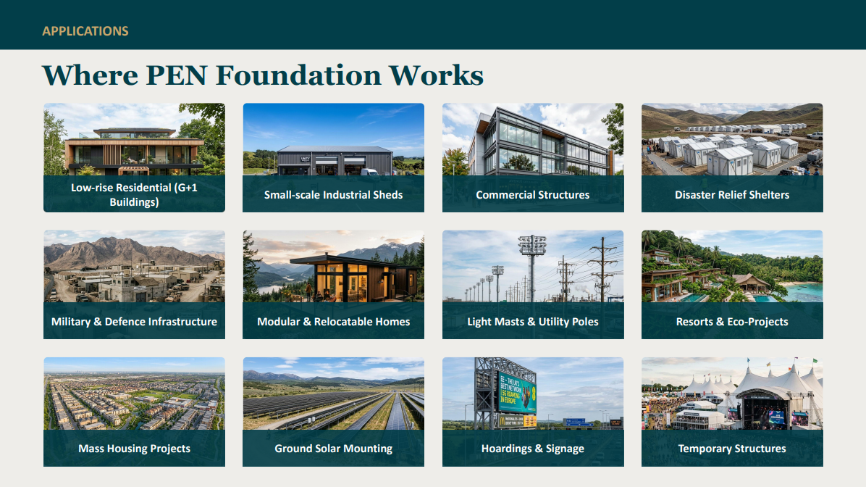
Existing applications reference. Remove Rehabilitation Housing from the featured set. Add the Bengaluru farmhouse as a real deployment story.

PAGE 1 | HOME

Impact calculator and closing conversion
What could PEN mean for your project?
A foundation that gives time back to the programme and leaves more of the land intact.

Calculator input
Use built-up area in sq. ft. as the primary input, not foundation-point count. Show project type only as a supporting selector.

Illustrative output
A typical 1,000 sq. ft. low-rise structure may require approximately 16–20 PEN units, subject to the structural layout, soil and design. At approximately 106 kg CO₂e avoided per unit, this corresponds to an indicative 1.6–2.1 tonnes of avoided emissions. Show this only with the approved carbon boundary and a clear “indicative, not a design or quotation” note.
REMOVE
The current cost-savings output. Cost is too project- and site-dependent for a generic public calculator.

CLOSING CTA
Tell us about your project. We will tell you whether PEN fits.
Share your location, proposed structure, drawings and available soil information. Our engineering team will review the project and respond with whether PEN Foundation is suitable, what further inputs are required, and the next step for assessment.
CTA
Request a Project Assessment

PAGE 2 | ABOUT

The question, the people and the purpose
HERO
We questioned the one thing construction never did.
Buildings became taller, smarter and faster. The foundation beneath them largely remained excavation, concrete and waiting.

Opening story
C-DISC Technologies began with a simple belief: if every part of construction continues to evolve, the foundation should too. That belief became years of first-principles engineering, research, prototyping, testing and real-world deployment. The result is PEN Foundation, a manufactured foundation system designed to make suitable low-rise construction faster, less disruptive and more resource-efficient.

01 Every change begins with a question
We did not begin by asking how to make a conventional footing slightly better. We asked whether excavation, on-site concrete and a long curing cycle should still be the default for every suitable low-rise structure.

02 Nature had already shown the principle
Tree roots do not depend on one heavy mass beneath the trunk. They distribute load through multiple paths and stabilise the system by engaging the surrounding soil. PEN translates that biomimetic principle into an engineered foundation system.

03 Engineering earns trust through evidence
A new foundation system must do more than sound plausible. PEN has progressed through research, simulation, prototyping, laboratory and field testing, independent assessment and deployment. The work continues through product development, certification and standardisation pathways.

PAGE 2 | ABOUT

Company identity, values and founders

Who we are
C-DISC Technologies Pvt. Ltd., the Centre for Development of Innovative & Sustainable Construction, is a deep-tech construction company developing engineered systems for a faster, lower-impact built environment. Our flagship innovation, PEN Foundation, addresses the foundation layer where schedule, material use, labour and site disturbance begin.

Our vision
To make foundations a manufactured, engineered and data-informed part of modern construction, enabling buildings to rise faster while disturbing the land less.

Our mission
To develop, validate and scale foundation systems that are practical for Indian soil conditions and project economics, supported by rigorous engineering, qualified installation and continuous field learning.
VALUES
- The ground is the truth. Soil, loads and field evidence decide the solution.
- Speed is a result of discipline. Repeatability comes from engineering, manufacturing and installation control.
- Every person is load-bearing. Ownership is distributed across the team, just like load in the system.
- Truth must survive audit. Claims must remain traceable to tests, calculations and project records.
- Learning is scheduled. Every deployment should improve the product, process and standard.
FOUNDERS

Jeesh Venmarath | Founder & CEO
A chartered civil engineer with more than two decades of construction experience, Jeesh leads C-DISC’s vision, product adoption and industry execution. His work began with a frustration familiar across projects: construction kept evolving, but foundations remained slow, wet and excavation-heavy.

Kala C. P. | Co-Founder & CTO
A civil engineer and technical leader, Kala leads the engineering development, product refinement and quality systems behind PEN Foundation, translating field realities into a repeatable construction technology.

Hemanth Chodisetti | Co-Founder & CGO
Hemanth leads growth, strategic partnerships, market development and scale-up, building the ecosystem required to take PEN from validated innovation to a widely adopted foundation category.

PAGE 3 | ENGINEERING

Make the invisible mechanics understandable
HERO
One node. Four load paths. A foundation engineered to work with the ground.
Explore the components, soil interaction, load transfer and validation behind PEN Foundation.

System overview
A high-strength precast node receives the structure at ground level. Four inclined steel nails extend into the soil and transfer load through their embedded length. Grout completes the soil-nail interface, while the project-specific layout distributes structural reactions across the approved foundation points.
COMPONENT CALLOUTS
- Precast node: manufactured and quality-controlled before reaching site.
- Engineered steel nails: inclined to engage a wider three-dimensional soil volume.
- Penetration tip: supports controlled driving through the qualified ground profile.
- Grout interface: locks the nail to the surrounding soil along its embedded length.
- Connection: transfers the superstructure reaction into the node and nail group.
DEVELOPER NOTE
Keep exact dimensions, grades, standards and model codes inside an expandable Technical Specification panel or downloadable datasheet. Public page copy should explain the mechanics first.

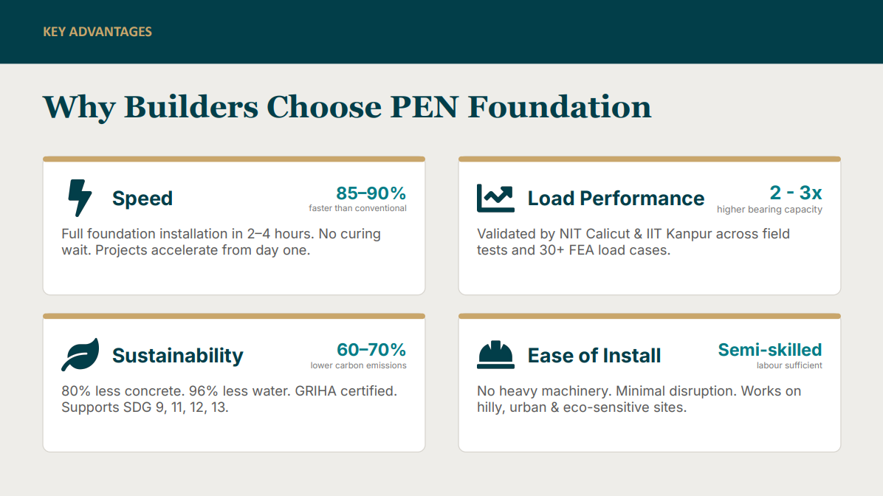
Existing advantage panel. Use verified ranges only and qualify all performance by soil and approved design.

PAGE 3 | ENGINEERING

Load transfer, design logic and suitability

How load moves
Load from the structure enters the precast node and divides across four inclined nails. Each nail transfers force into the surrounding soil through its embedded interface. Because the nails spread outward, the system engages a soil volume larger than the node’s surface footprint.

Why the batter matters
The opposed nail geometry creates multiple load paths and supports resistance to vertical and lateral actions. The final geometry and embedment are project-specific and must follow the approved engineering design and installation method.

Designed for the site
PEN is not selected from building area alone. Structural reactions, soil conditions, groundwater, slope, access, durability exposure and the proposed superstructure all influence suitability and configuration.

Where caution is required
Expansive soils, uncontrolled fill, highly aggressive exposure, severe rock profiles and other challenging conditions require specific investigation and may require a modified solution or make PEN unsuitable. The website must never imply universal soil compatibility.
ENGINEERING CTA
Have drawings or soil data? Send them to our engineering team for a preliminary suitability review.

PAGE 4 | APPLICATIONS

Organise by customer outcome, not only building type
HERO
Built for projects where time, access and the land matter.
PEN Foundation is engineered for suitable low-rise structures that need a faster, cleaner and less disruptive foundation process.

Low-rise homes
For G+0, G+1 and other approved low-rise structures, PEN simplifies the foundation sequence by reducing excavation, wet work, labour coordination and curing dependency.

Commercial and institutional buildings
For schedule-sensitive buildings, an immediately load-ready foundation can help move the structure, fit-out and opening date forward.

Eco-resorts and farmstays
For terrain-led hospitality, zero excavation helps protect root systems, slopes, drainage and the visual character of the site.

Modular and relocatable structures
PEN aligns with the speed and precision of factory-built structures, removing the mismatch between a fast superstructure and a slow cast-in-situ foundation.

Low-span industrial structures
For sheds and repetitive grids, a manufactured foundation point can reduce on-site complexity and make the installation sequence more repeatable.

Special and emerging applications
Ground-mounted solar, utility supports, compound walls, emergency shelters and defence or remote infrastructure should be shown as project-qualified or development applications unless backed by completed application-specific validation.
FEATURED APPLICATION STORY
Replace Rehabilitation Housing with the Bengaluru farmhouse: a remote-site project where labour availability and programme speed mattered, and PEN Foundation installation was completed within the planned rapid sequence.

PAGE 5 | PROJECTS

Evidence in the ground
HERO
Built across soils, seasons and states.
Real projects. Real constraints. Foundation decisions shaped by the site.

Project-card format
Each project card should follow one repeatable structure: Project / Location / Building type / Foundation challenge / Why PEN / Scope / Outcome / Evidence available. Avoid invented savings or performance numbers.

Black Langur Resort | Wayanad, Kerala
Challenge: an eco-sensitive, forested and sloping site where excavation could disturb tree roots, soil and terrain. Why PEN: a zero-excavation foundation approach aligned with the project’s environmental intent. Outcome: foundation installation with minimal site disturbance, supporting construction while preserving the character of the land.

Startup Eco-Ashram | Kudal, Maharashtra
Challenge: deliver PEN at commercial scale outside its initial Kerala deployments and across a new site context. Why PEN: repeatable manufactured foundation points, rapid installation and reduced wet work. Outcome: a major deployment that helped move PEN from pilots toward repeatable commercial delivery.

Devagiri College Library | Kozhikode, Kerala
Challenge: install foundations in a constrained institutional context while limiting disruption. Why PEN: compact equipment, minimal excavation and an engineered installation sequence. Outcome: the completed structure received the SSMB 2024 Best Commercial Steel Structure recognition.

Bethel Residency | Kozhikode, Kerala
Challenge: deliver a low-rise residential foundation through a faster and less site-intensive process. Why PEN: reduced excavation and curing dependency, with engineered points supporting the approved structure. Outcome: a built residential reference for the PEN system.

Bengaluru Farmhouse | Bengaluru region, Karnataka
Challenge: remote-site execution, labour constraints and a time-sensitive programme. Why PEN: a rapid, low-wet-work installation process with reduced dependency on excavation and prolonged site activity. Outcome: foundation installation completed within the planned rapid execution window, enabling the structure to proceed quickly.
DO NOT PUBLISH PLACEHOLDERS
Remove generic projects such as “Hillside Residence”, “Backwater Eco Resort” and “Utility Solar Array 14” unless they correspond to documented CDISC projects with approved images and data.

PAGE 6 | RESEARCH

Proof before promotion
HERO
Engineering claims should begin with evidence.
Explore the testing, analysis, research collaborations and standardisation work behind PEN Foundation.

Research overview
PEN Foundation has been developed through a combination of first-principles engineering, academic research, numerical modelling, laboratory investigation, field load testing and monitored deployment. Each method answers a different question: how the system carries load, how soil influences performance, how components behave, and how the installation process can be qualified and repeated.

NIT Calicut
Academic research and comparative plate-load testing have supported understanding of soil-structure interaction, settlement and bearing response under tested conditions. Link the relevant M.Tech thesis and approved test summaries.

IIT Kanpur
Technical mentorship and research collaboration support structural and geotechnical development, load-case evaluation and the pathway toward broader design methodology and standardisation.

Independent testing and modelling
Use a clear evidence library for NABL-accredited test reports, full-scale field tests, ANSYS/FEA or NURBS analyses, PLAXIS studies, material characterisation and life-cycle assessment. State what each document demonstrates, not only that it exists.

GRIHA and life-cycle evidence
Present the completed GRIHA listing/certification and LCA work separately from certifications or appraisals still in progress. Carbon figures must state the comparison basis and assessment boundary.

Standardisation pathway
BMTPC appraisal, BIS standardisation and other evaluation work should be described as “underway” or “in progress” until formally completed. Provide dates and status updates rather than implying approval.
RESEARCH JOURNAL CONTENT ARCHITECTURE
- Answer-first title and stand-alone summary.
- Key takeaways before long-form explanation.
- Method, evidence, limitations and practical application.
- Author, technical reviewer, source list and disclaimer.
- Internal links to Engineering, Applications, Projects and Project Assessment.

PAGE 7 | GALLERY

Show the evidence visually
HERO
PEN Foundation in the ground, on the test rig and under real structures.
A visual record of installations, engineering, testing, projects, events and recognition.

Recommended filters
Projects / Installation / Testing / Engineering / Drone / Events / Awards / Videos.

Caption format
Project name, location, date, what the image shows, and why it matters. Example: “Black Langur Resort, Wayanad: PEN nodes positioned on a forested slope before nail installation, preserving the surrounding terrain and root network.”

Media rules
Prioritise real CDISC imagery. Remove duplicate photographs, generic stock images and files without context. Video thumbnails should state duration and content, such as Installation in 60 Seconds, Full Project Sequence or Field Load Test.
ACCESSIBILITY
Every image needs descriptive alt text. Avoid alt text such as “project image” or “PEN photo”. Describe the engineering or project evidence visible in the frame.

PAGE 8 | CONTACT

Make the next step easy and engineering-led
HERO
Tell us what you are planning. We will tell you whether PEN fits.
Connect directly with the PEN Foundation engineering team for project evaluation, technical documentation, a product presentation or an installation demonstration.

Form introduction
Share the minimum information needed for a useful first review. We will not treat an enquiry as a confirmed application until the project loads and soil conditions are assessed.
RECOMMENDED FIELDS
- Name, company and role
- Phone and email
- Project location
- Project type and approximate built-up area
- Number of storeys and structural system
- Current project stage
- Drawings / column reactions / soil report upload
- Primary objective: speed / low disturbance / difficult access / modularity / sustainability / other

Response expectation
Our team will review the information and respond with initial suitability, missing inputs and the recommended next step. Avoid promising an instant design or quotation from the public form.
PRIMARY CTA
Request a Project Assessment

SECONDARY OPTIONS
Call an Engineer / Download the Brochure / Watch Installation / Download Approved Research

REMOVE OR REWRITE
Generic SaaS phrases such as “integrations, edge cases and more” and any unverified ROI calculator. These weaken the engineering identity of the page.

SHARED COMPONENTS

Header, footer and message consistency

Header navigation
Home / Engineering / Applications / Projects / Research / About / Contact. Gallery may sit under Resources. Use “Projects” as the visible term instead of the vague label “Works”.

Header CTA
Request Assessment. On smaller screens, retain a clear Call button and the project-assessment CTA.

Footer headline
From soil we rise. Faster. Stronger. Greener.

Footer support line
Patented foundation technology for suitable low-rise construction, engineered to install faster and disturb the land less.

Footer links
Explore: Home / About / Engineering / Applications. Evidence: Projects / Research / Gallery. Connect: Contact / Phone / Email / LinkedIn / YouTube. Replace all “#” social placeholders with verified URLs before launch.

Preferred repeated phrases
Use these consistently across pages: “zero excavation”, “hours, not weeks”, “immediate load-bearing”, “engineered for the soil and structure”, “less concrete, water and site disturbance”, and “project-qualified”. Repetition is intentional and should build memory.

Spelling and terminology
Use British/Indian English consistently: stabilise, behaviour, programme, galvanised. Use “PEN Foundation” on first reference, then “PEN”. Define PEN once as “Pre-Engineered Nail Foundation”. Avoid switching among nail foundation, pile, footing and base without technical context.

PUBLISHING CONTROL

Single source of truth for claims
Claim area | Approved public wording | Control
Positioning | Patented, zero-excavation Pre-Engineered Nail Foundation for suitable low-rise construction. | Use broadly.
Installation | Installs within hours, with no on-site foundation curing cycle. | Use this until one exact duration is approved.
Load readiness | Ready for approved superstructure connection after installation and quality checks. | Avoid an unconditional “instant” engineering guarantee.
Carbon | Approximately 60% lower GWP / about 106 kg CO₂e avoided per unit. | Publish only with comparison basis, boundary and source.
Material | Substantially less concrete and water than conventional RCC footings. | Use exact percentages only where the comparison model is stated.
Performance | Soil-qualified enhancement demonstrated through testing. | Use exact range only with the relevant test context.
Validation | Supported by NIT Calicut research/testing, IIT Kanpur-linked technical work, independent testing and GRIHA evidence. | Describe each institution’s actual role.
Status | BMTPC appraisal and BIS standardisation are in progress. | Never imply completed approval.
Suitability | Every project requires review of loads, soil and site conditions. | Repeat near calculators, specifications and forms.

FINAL WORKING SECTION | FAQS

Reserved for founder-led refinement
STATUS
Keep the FAQ as the final website section and the final section in this handoff. The questions below are the recommended structure only. Final answers should be refined separately in the same voice as the approved pages above.

THE SYSTEM

What is PEN Foundation?
[Founder review and final answer to be inserted.]

How is PEN different from a conventional RCC footing?
[Founder review and final answer to be inserted.]

Why is it called pre-engineered?
[Founder review and final answer to be inserted.]

What is PEN Foundation made of?
[Founder review and final answer to be inserted.]

Is PEN a pile foundation?
[Founder review and final answer to be inserted.]
SUITABILITY AND ENGINEERING

What building types can use PEN Foundation?
[Founder review and final answer to be inserted.]

What soil conditions are suitable?
[Founder review and final answer to be inserted.]

How is load capacity determined?
[Founder review and final answer to be inserted.]

Can PEN be used for G+2 or taller buildings?
[Founder review and final answer to be inserted.]

What happens in rocky, expansive or high-water-table soil?
[Founder review and final answer to be inserted.]

Who signs off the final design?
[Founder review and final answer to be inserted.]
INSTALLATION AND DELIVERY

What happens from first enquiry to installation?
[Founder review and final answer to be inserted.]

How long does installation take?
[Founder review and final answer to be inserted.]

What equipment and labour are required?
[Founder review and final answer to be inserted.]

When can the superstructure work begin?
[Founder review and final answer to be inserted.]

What quality records does the customer receive?
[Founder review and final answer to be inserted.]
DURABILITY, SUSTAINABILITY AND COMMERCIAL

How is corrosion and durability addressed?
[Founder review and final answer to be inserted.]

How much concrete, water and carbon can PEN reduce?
[Founder review and final answer to be inserted.]

Can PEN components be recovered or reused?
[Founder review and final answer to be inserted.]

How is a project priced?
[Founder review and final answer to be inserted.]

What information is required for a preliminary assessment?
[Founder review and final answer to be inserted.]

SOURCE MATERIAL USED

Existing content consolidated, not recreated from scratch
- Website Content draft.docx, including the seven embedded screenshot references and founder annotations.
- CDISC Technologies Summary.pdf and CDISC Technologies Summary(3).docx.
- C-DISC Build3 PR & FAQ.pdf.
- C-DISC Technologies 6-Pager(1).pdf and the commented version.
- CDISC PEN Foundation Brochure(1).pdf and PEN Foundation Brochure.pdf.
- CDISC Technologies Pitch Deck(6).pdf.
- The live website structure reviewed on 9 August 2026: Home, About, Engineering, Applications, Projects, Research, Gallery and Contact.
- Previously refined C-DISC messaging and documented content guardrails from founder communications.
HANDOFF COMPLETE
The development team should implement page by page, preserve the repeated message architecture, and return only unresolved claims or missing assets for founder confirmation.

