**Properties of Decomposition-**

The following two properties must be followed when decomposing a given relation-

## ****1. Lossless decomposition-****

Lossless decomposition ensures-

* No information is lost from the original relation during decomposition.
* When the sub relations are joined back, the same relation is obtained that was decomposed.
* Every decomposition must always be lossless.

## ****2. Dependency Preservation-****

Dependency preservation ensures-

* None of the functional dependencies that holds on the original relation are lost.
* The sub relations still hold or satisfy the functional dependencies of the original relation.

## ****Types of Decomposition-****

Decomposition of a relation can be completed in the following two ways-

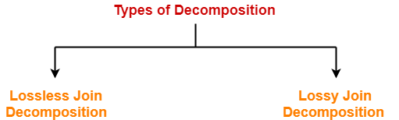

**1. Lossless Join Decomposition-**

* Consider there is a relation R which is decomposed into sub relations R1 , R2 , …. , Rn.
* This decomposition is called lossless join decomposition when the join of the sub relations results in the same relation R that was decomposed.
* For lossless join decomposition, we always have-

|  |
| --- |
| **R1 ⋈ R2 ⋈ R3 ……. ⋈ Rn = R** |

where ⋈ is a natural join operator

**Example-**

Consider the following relation R( A , B , C )-

|  |  |  |
| --- | --- | --- |
| **A** | **B** | **C** |
| 1 | 2 | 1 |
| 2 | 5 | 3 |
| 3 | 3 | 3 |

**R( A , B , C )**

Consider this relation is decomposed into two sub relations R1( A , B ) and R2( B , C )-

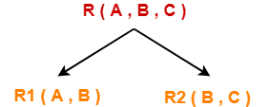

The two sub relations are-

|  |  |
| --- | --- |
| **A** | **B** |
| 1 | 2 |
| 2 | 5 |
| 3 | 3 |

**R1( A , B )**

|  |  |
| --- | --- |
| **B** | **C** |
| 2 | 1 |
| 5 | 3 |
| 3 | 3 |

**R2( B , C )**

Now, let us check whether this decomposition is lossless or not.

For lossless decomposition, we must have-

**R1 ⋈ R2 = R**

Now, if we perform the natural join ( ⋈ ) of the sub relations R1 and R2 ,we get-

|  |  |  |
| --- | --- | --- |
| **A** | **B** | **C** |
| 1 | 2 | 1 |
| 2 | 5 | 3 |
| 3 | 3 | 3 |

This relation is same as the original relation R.

Thus, we conclude that the above decomposition is lossless join decomposition.

### ****NOTE-****

* Lossless join decomposition is also known as **non-additive join decomposition.**
* This is because the resultant relation after joining the sub relations is same as the decomposed relation.
* No extraneous tuples appear after joining of the sub-relations.

## ****2. Lossy Join Decomposition-****

* Consider there is a relation R which is decomposed into sub relations R1 , R2 , …. , Rn.
* This decomposition is called lossy join decomposition when the join of the sub relations does not result in the same relation R that was decomposed.
* The natural join of the sub relations is always found to have some extraneous tuples.
* For lossy join decomposition, we always have-

|  |
| --- |
| **R1 ⋈ R2 ⋈ R3 ……. ⋈ Rn ⊃ R** |

where ⋈ is a natural join operator

## ****Example-****

Consider the following relation R( A , B , C )-

|  |  |  |
| --- | --- | --- |
| **A** | **B** | **C** |
| 1 | 2 | 1 |
| 2 | 5 | 3 |
| 3 | 3 | 3 |

**R( A , B , C )**

Consider this relation is decomposed into two sub relations as R1( A , C ) and R2( B , C )-

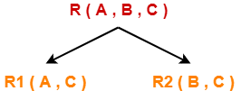

The two sub relations are-

|  |  |
| --- | --- |
| **A** | **C** |
| 1 | 1 |
| 2 | 3 |
| 3 | 3 |

**R1( A , B )**

|  |  |
| --- | --- |
| **B** | **C** |
| 2 | 1 |
| 5 | 3 |
| 3 | 3 |

**R2( B , C )**

Now, let us check whether this decomposition is lossy or not.

For lossy decomposition, we must have-

**R1 ⋈ R2 ⊃ R**

Now, if we perform the natural join ( ⋈ ) of the sub relations R1 and R2we get-

|  |  |  |
| --- | --- | --- |
| **A** | **B** | **C** |
| 1 | 2 | 1 |
| 2 | 5 | 3 |
| 2 | 3 | 3 |
| 3 | 5 | 3 |
| 3 | 3 | 3 |

This relation is not same as the original relation R and contains some extraneous tuples.

Clearly, R1 ⋈ R2 ⊃ R.

Thus, we conclude that the above decomposition is lossy join decomposition.

### ****NOTE-****

* Lossy join decomposition is also known as **careless decomposition.**
* This is because extraneous tuples get introduced in the natural join of the sub-relations.
* Extraneous tuples make the identification of the original tuples difficult.