Crop3D-Mobile Software User Manual

The software of Crop3D-Mobile was developed using the Python GUI package, PyQt5, which allow the software application to be executed on different operating systems such as Windows and Mac OS.(Here we only provided a .exe executable file on GitHub).

1. Getting Started

Operating System: The Crop3D-Mobile software can be run on Windows 10 PC.

Installation: Download the zip file from Github, unzipping the file in the folder where you put it in, then you can run the software through double clicking on the .exe file.

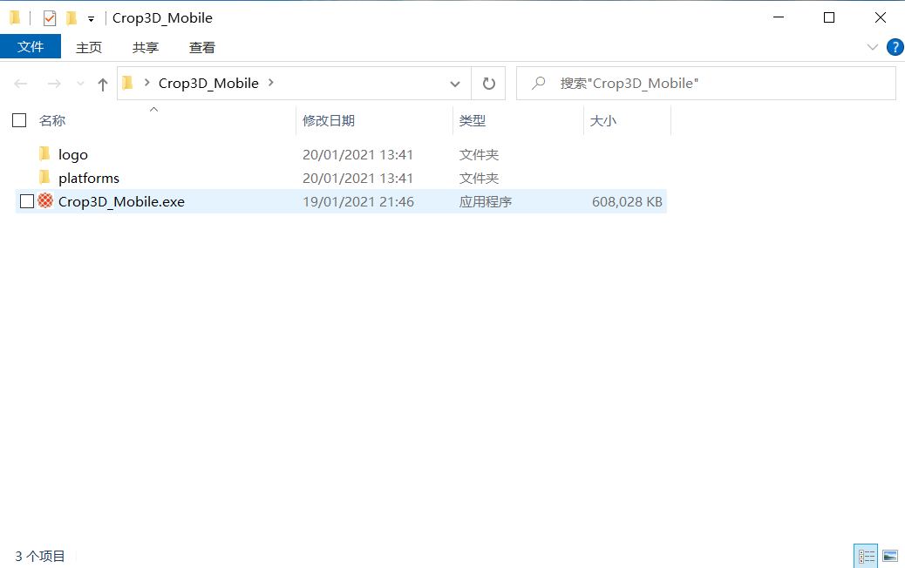

Figure 1

Technical Support: Crop3D-Mobile software is designed to be as simple as possible to use. If you encounter any problems during the use of the software, please contact the email: [ji.zhou@njau.edu.cn](mailto:ji.zhou@njau.edu.cn); [ji.zhou@niab.com](mailto:ji.zhou@niab.com)

1. Running the Software

Figure 2 is the interface of Crop3D-Mobile software.

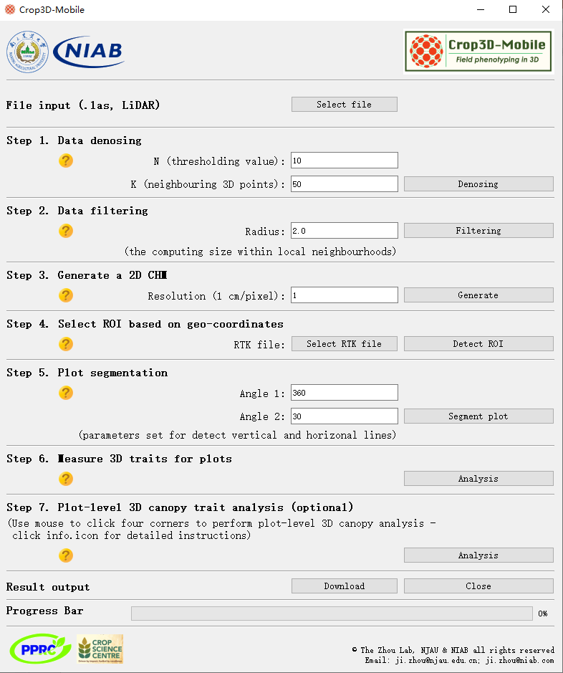

Figure 2

The required parameters must be entered when running the software, we have given the required default parameters, users can directly use the operation, or fill in the parameters according to your needs.

The workflow of the Crop3D-Mobile software is divided into 5 parts: data input section, data preprocessing section, plot segmentation section, traits analysis section and data output section.

1. Data Input

In the data input section, users can use the ‘select LiDAR file’ button to select the file which need to be processed (see Figure 3 (a). This section automatically create a folder named ‘Result-\*\*-\*\*-\*\*’ (\* represent the date, see Figure 3 (b)), where the files generated by the software workflow will be saved (see Figure 3 (c)).

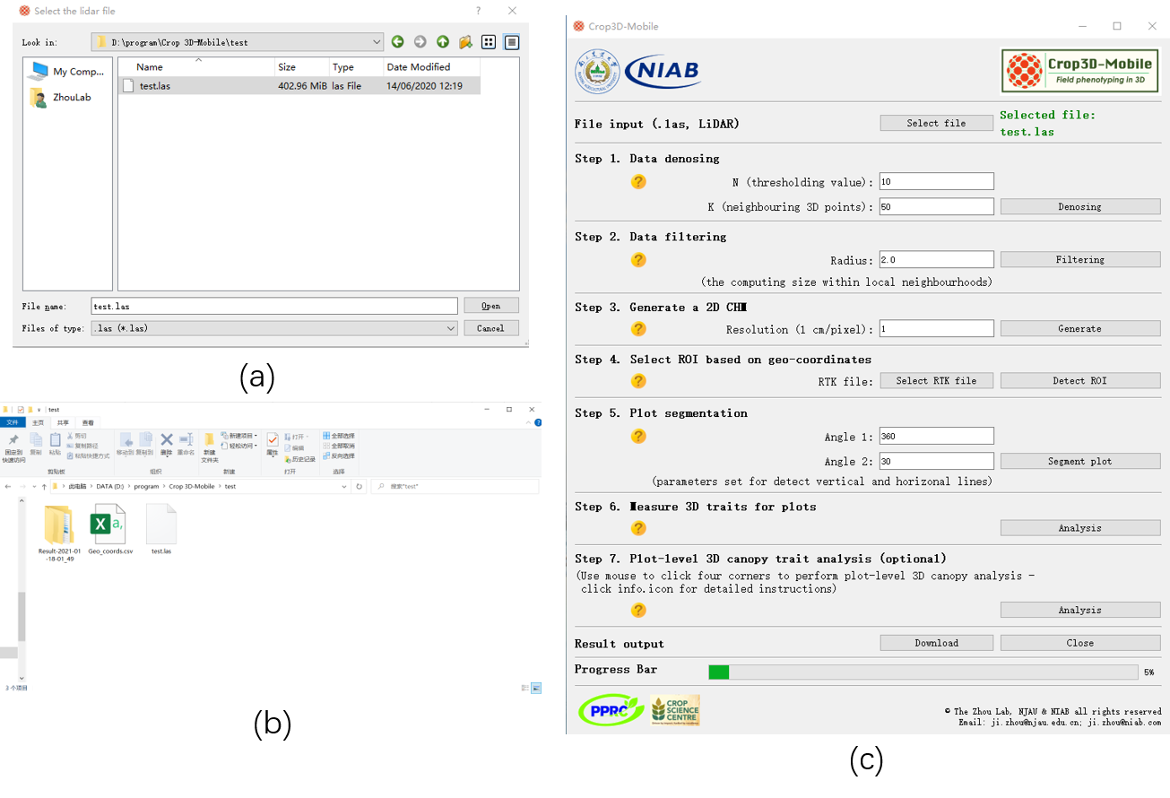

Figure 3

1. Data preprocessing

In the data preprocessing section, perform denosing and filtering processing on the selected LiDAR point cloud file. In denosing processing, we need to input the required parameters N and K (default setting is 10 and 50), after that press the ‘Denosing” button to get the denosed LiDAR point cloud file. The filtering process is similar to the denosing process. It should be noted that the default value of the required parameter ‘Radius’ is 2, and it output the filtered LiDAR point cloud file via ‘Filtering’ button. When the steps are completed separately, we can press the ‘Display result’ button to display the point cloud file (see Figure 4, among them, Figure (a), (b) are the visualization results of denosing and filtering. Figure (c) is the software interface operation diagram).

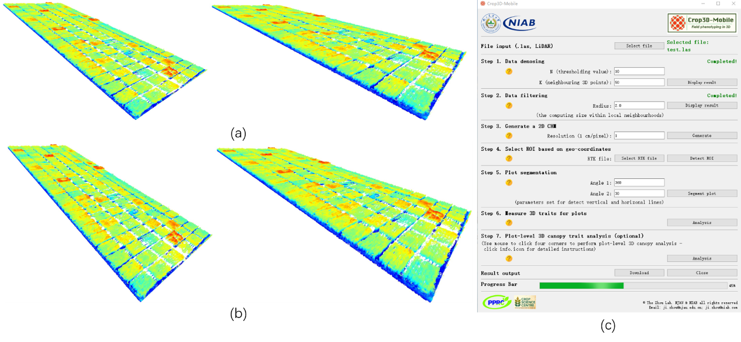

Figure 4

1. Plot segmentation

In the plot segmentation section. Firstly, use the output filtered LiDAR point cloud file to create a 2D CHM file (see Figure 5(a)). In this processing the default setting of required parameters ‘Resolution’ is 1. Secondly, press the ‘Generate’ button to get the CHM (.tif) file, use ‘Display result’ button to display it (see Figure 5(b)). Before segment the plot, users need to select the ROI first. Here we provide a RTK file (.csv), which can select by pressed the ‘Select RTK file’ button. Via press the ‘Define ROI’ button to acquire the image of ROI. Press the ‘Display result button to display the ROI image. Thirdly, segment the plot. The default setting of the required parameters (Angle 1, Angle 2) is 360 and 30. After press the ‘Generate’ button we can get the image of the segmented plot, display it use ‘Display result’ button (see Figure 5 (c)). Figure 5 (d) is the software interface operation diagram

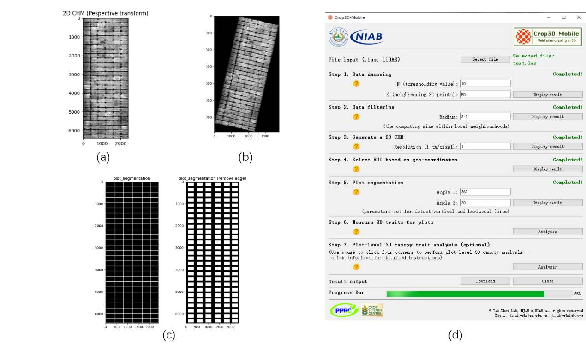

Figure 5

1. Traits Analysis

In the traits analysis section, users obtain the different traits, just press the ‘Analysis’ button. It create a new folder which contains the images of plots and different plot level traits (.csv), another folder contains the plot index (.csv). When users measure the plot-level 3D canopy trait, after click the ‘Analysis’ button, it will pop-up a window for selecting plots (see Figure (a)). Uses should follow the rule to select a plot: up-left, up-right, low-left and finally low-right corner points. Figure 6 (b) is the running interface.

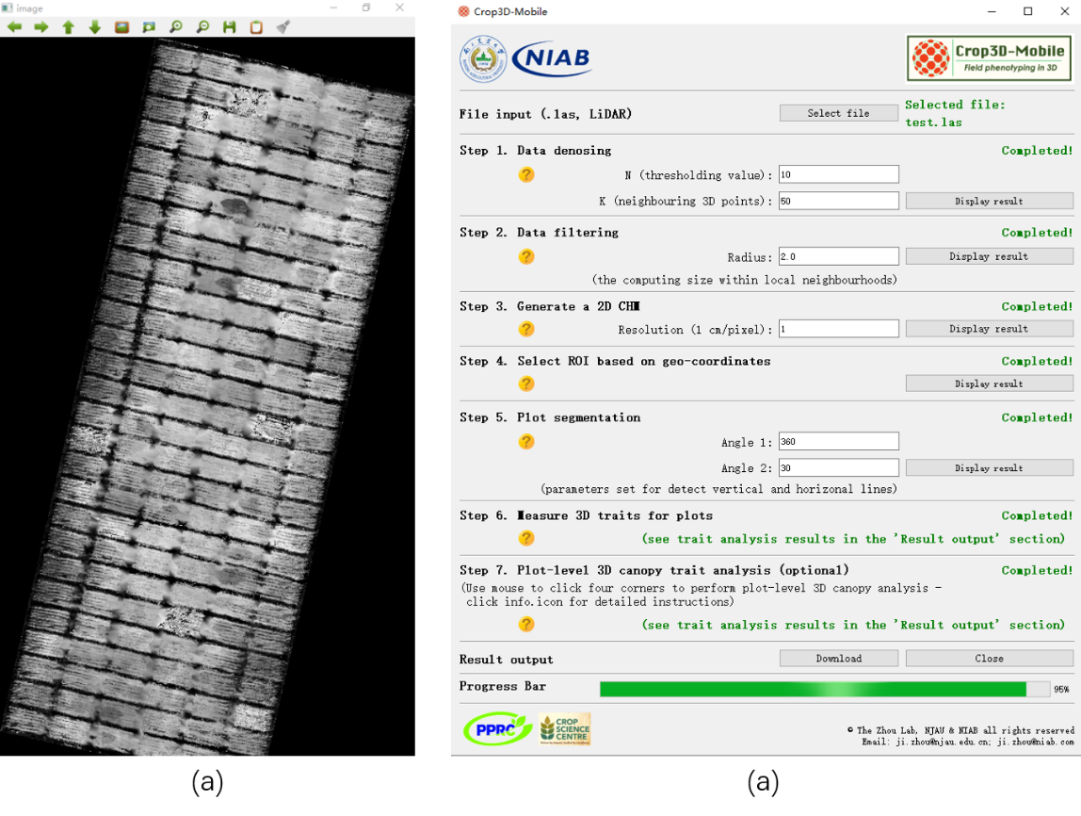

Figure 6

1. Output Data

In the data output section we provide a data packaging function. After press the ‘Download’ button, the zip file named after the data will be saved in the directory where the test file is located (see Figure 7.1).

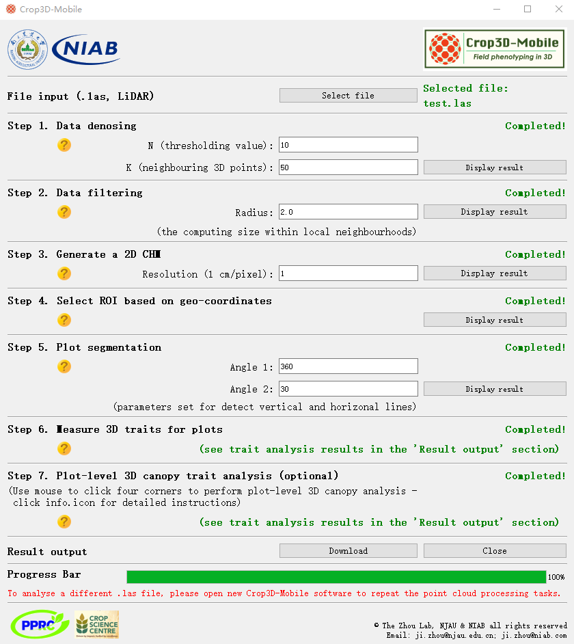

Figure 7.1

Here we provide a test LiDAR file for users to testing software. When the workflow of the software is finished, users can open the folder to see the detailed result data (the directory is where the analyzed data is located). Figure 7.2 is the detail of the output folder.

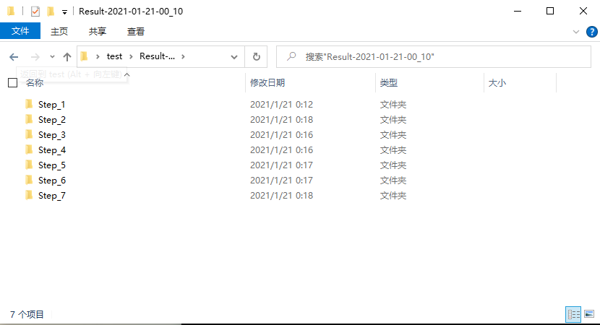

Figure 7.2