**CMSC203 Assignment 0**

Class: CMSC203 CRN 38511

Program: Assignment 0

Instructor: Grigory Grinberg

Summary of Description: (Give a brief description for each Program) A program that requires you to use functions to calculate the volume of a box and the volume of a Sphere.

Due Date: 01/31/2022

Integrity Pledge: I pledge that I have completed the programming assignment independently.

I have not copied the code from a student or any source.

**Complete the following five parts of Assignment 0. Name your file as FirstInitialLastName_Assignment0.docx**

**Part1: Setup GitHub:** Provide the screen shots of your GitHub account with Assignment 0 file is uploaded on GitHub:

**Part 2 -Install JDK, Test java Application from Command Line**

Provide the screen shots from Step 1 and 2 here:

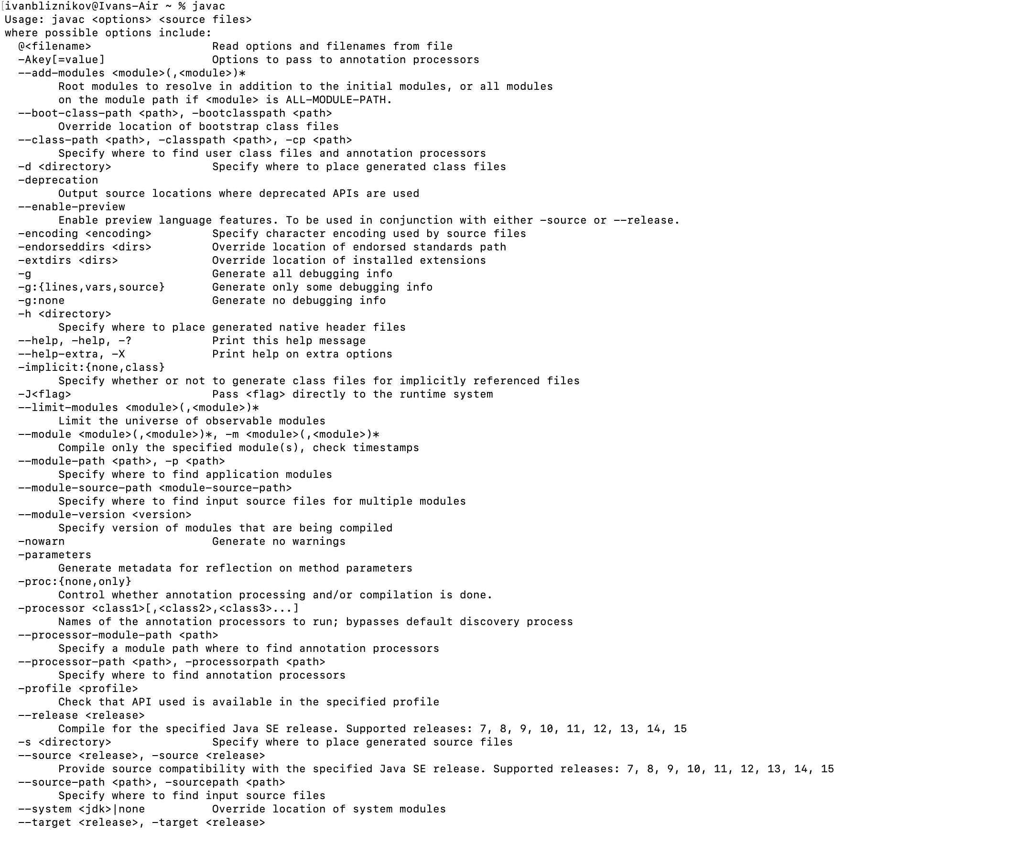

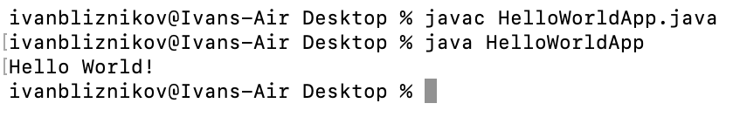

**Part 3 - Install Eclipse, Test Eclipse Java Application**

Provide the screen shots from Step 1 and 2 here:

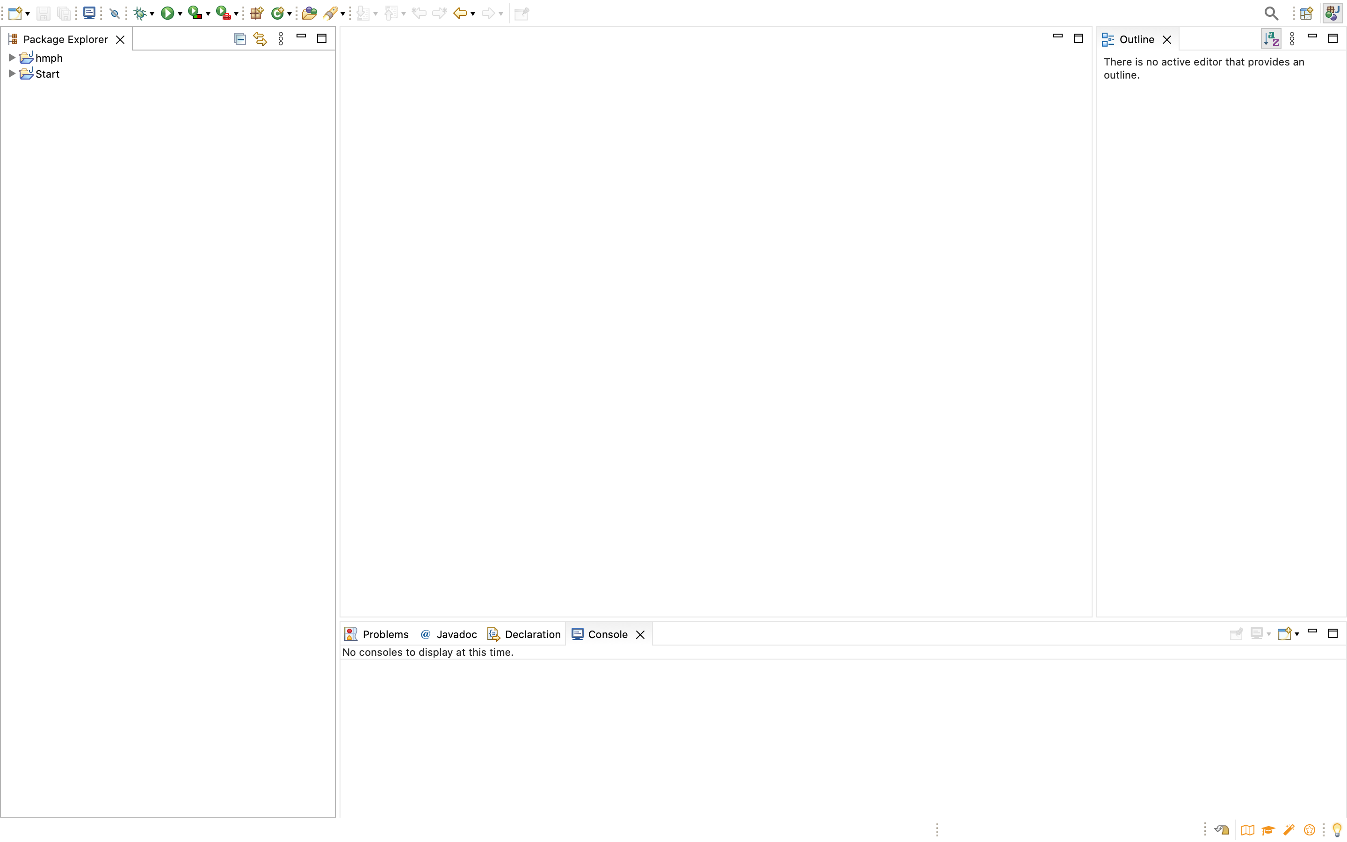

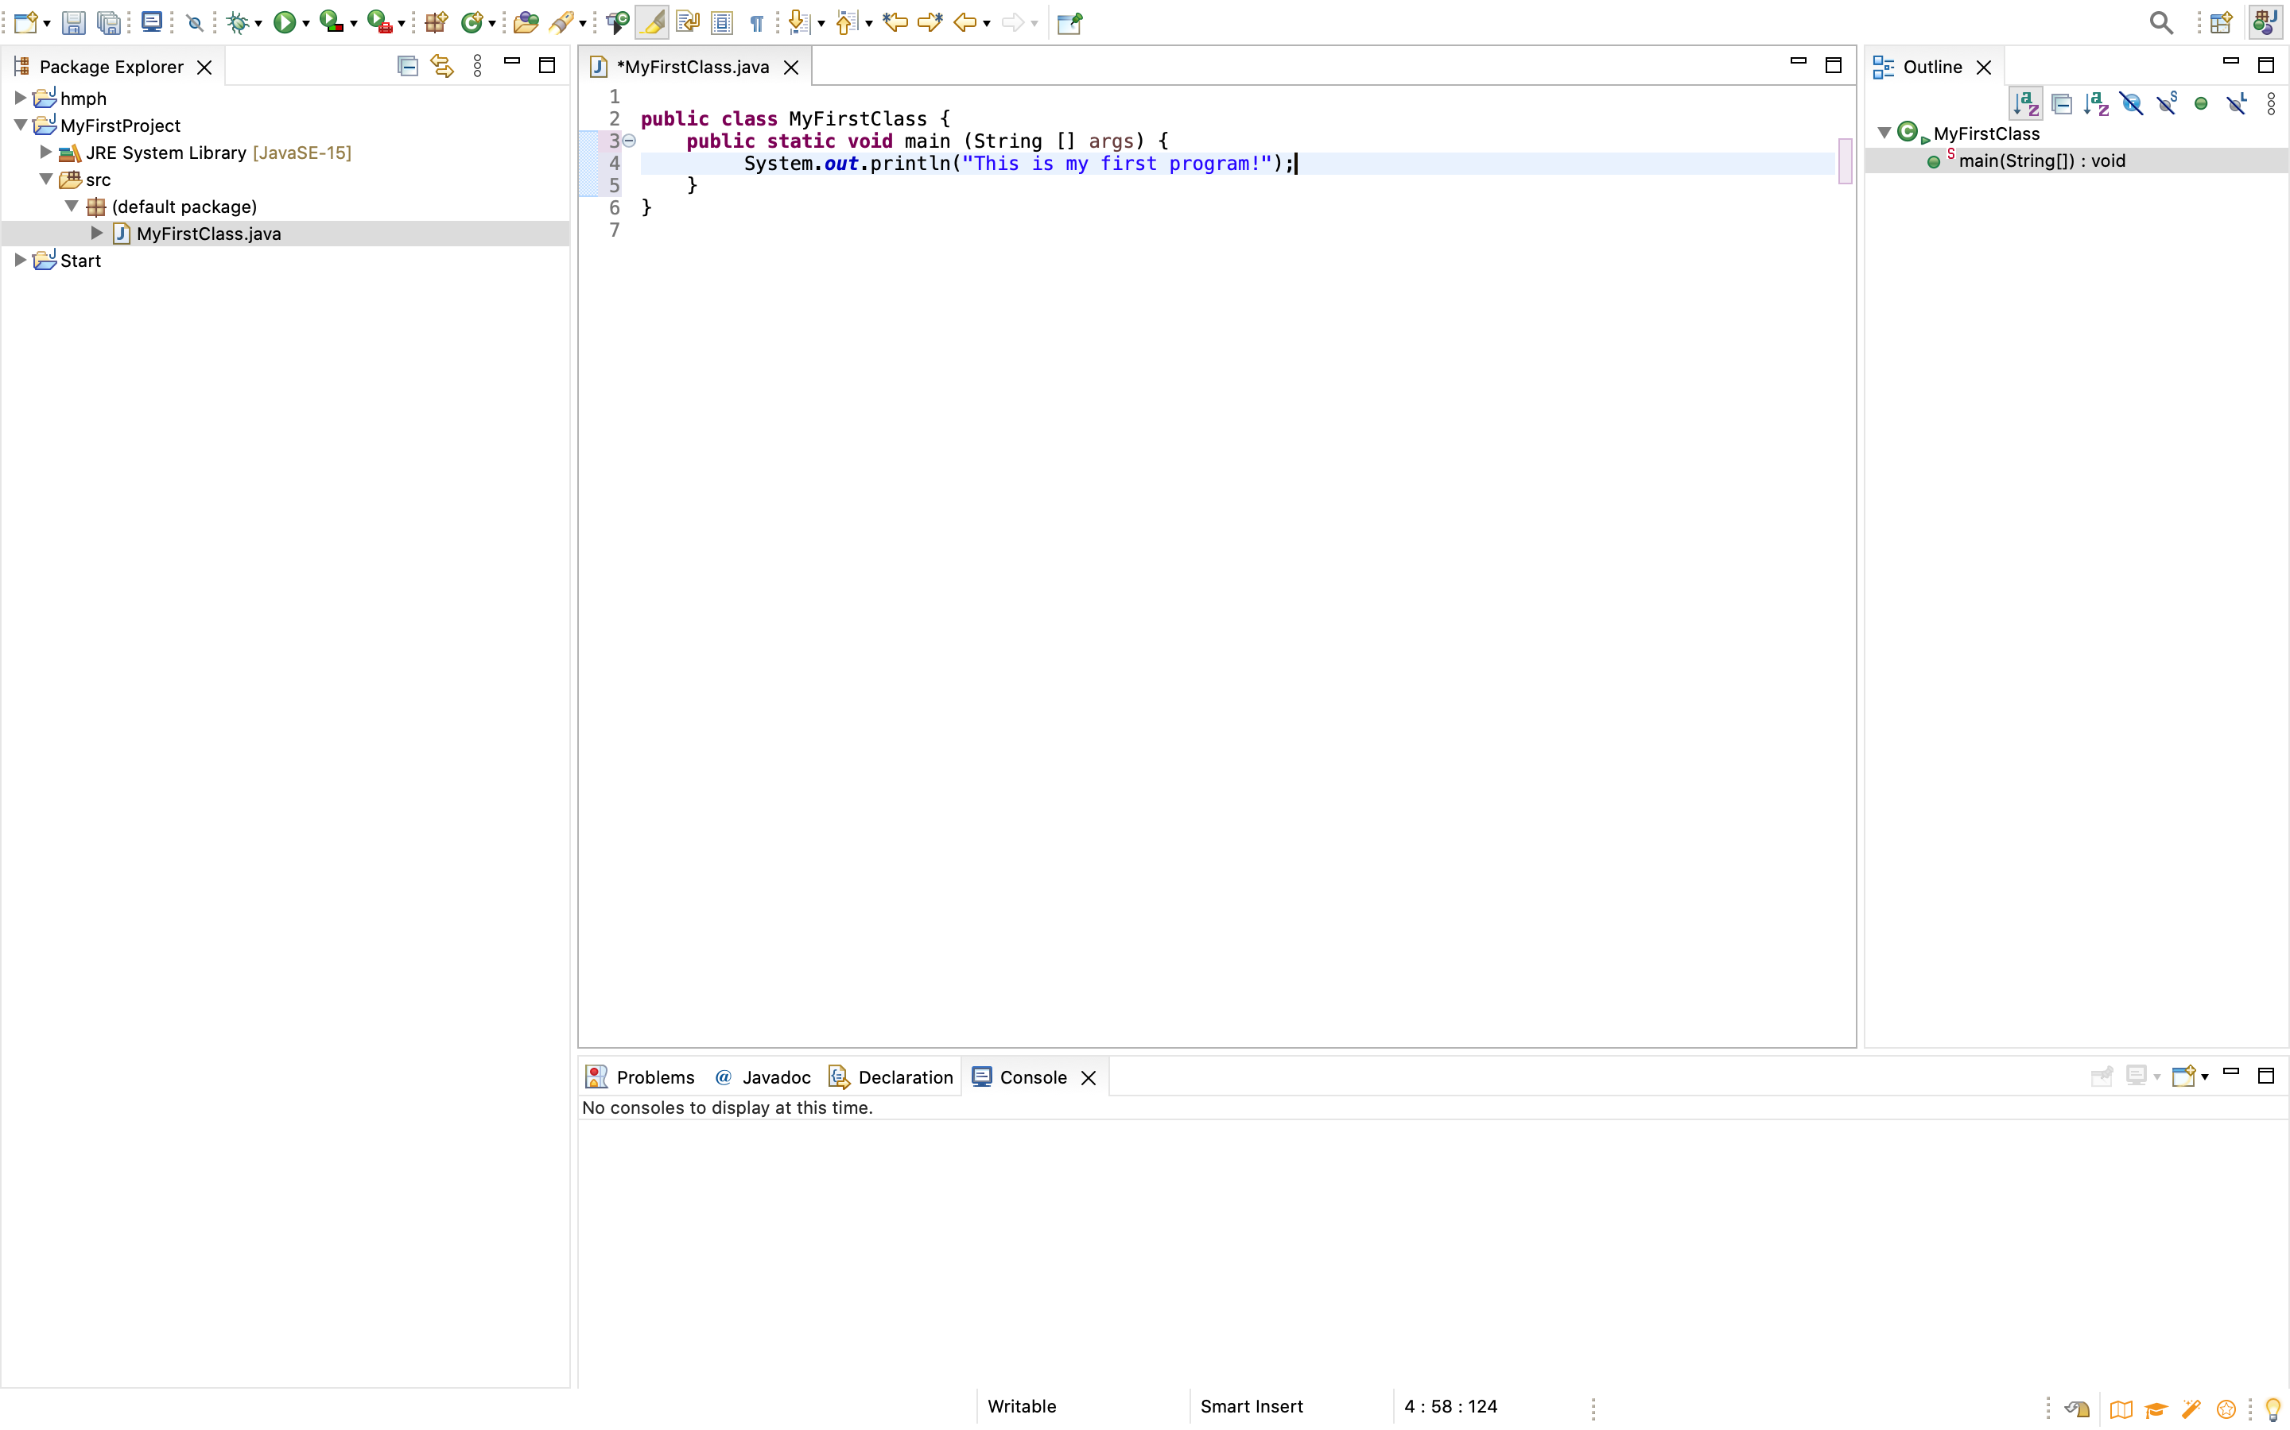

**Part 4 - Install, Setup, Test Junit Program.**

Provide the screen shots showing:

* 1. Eclipse with working JUnit Test example
  2. Project screenshot
  3. Running example screenshot

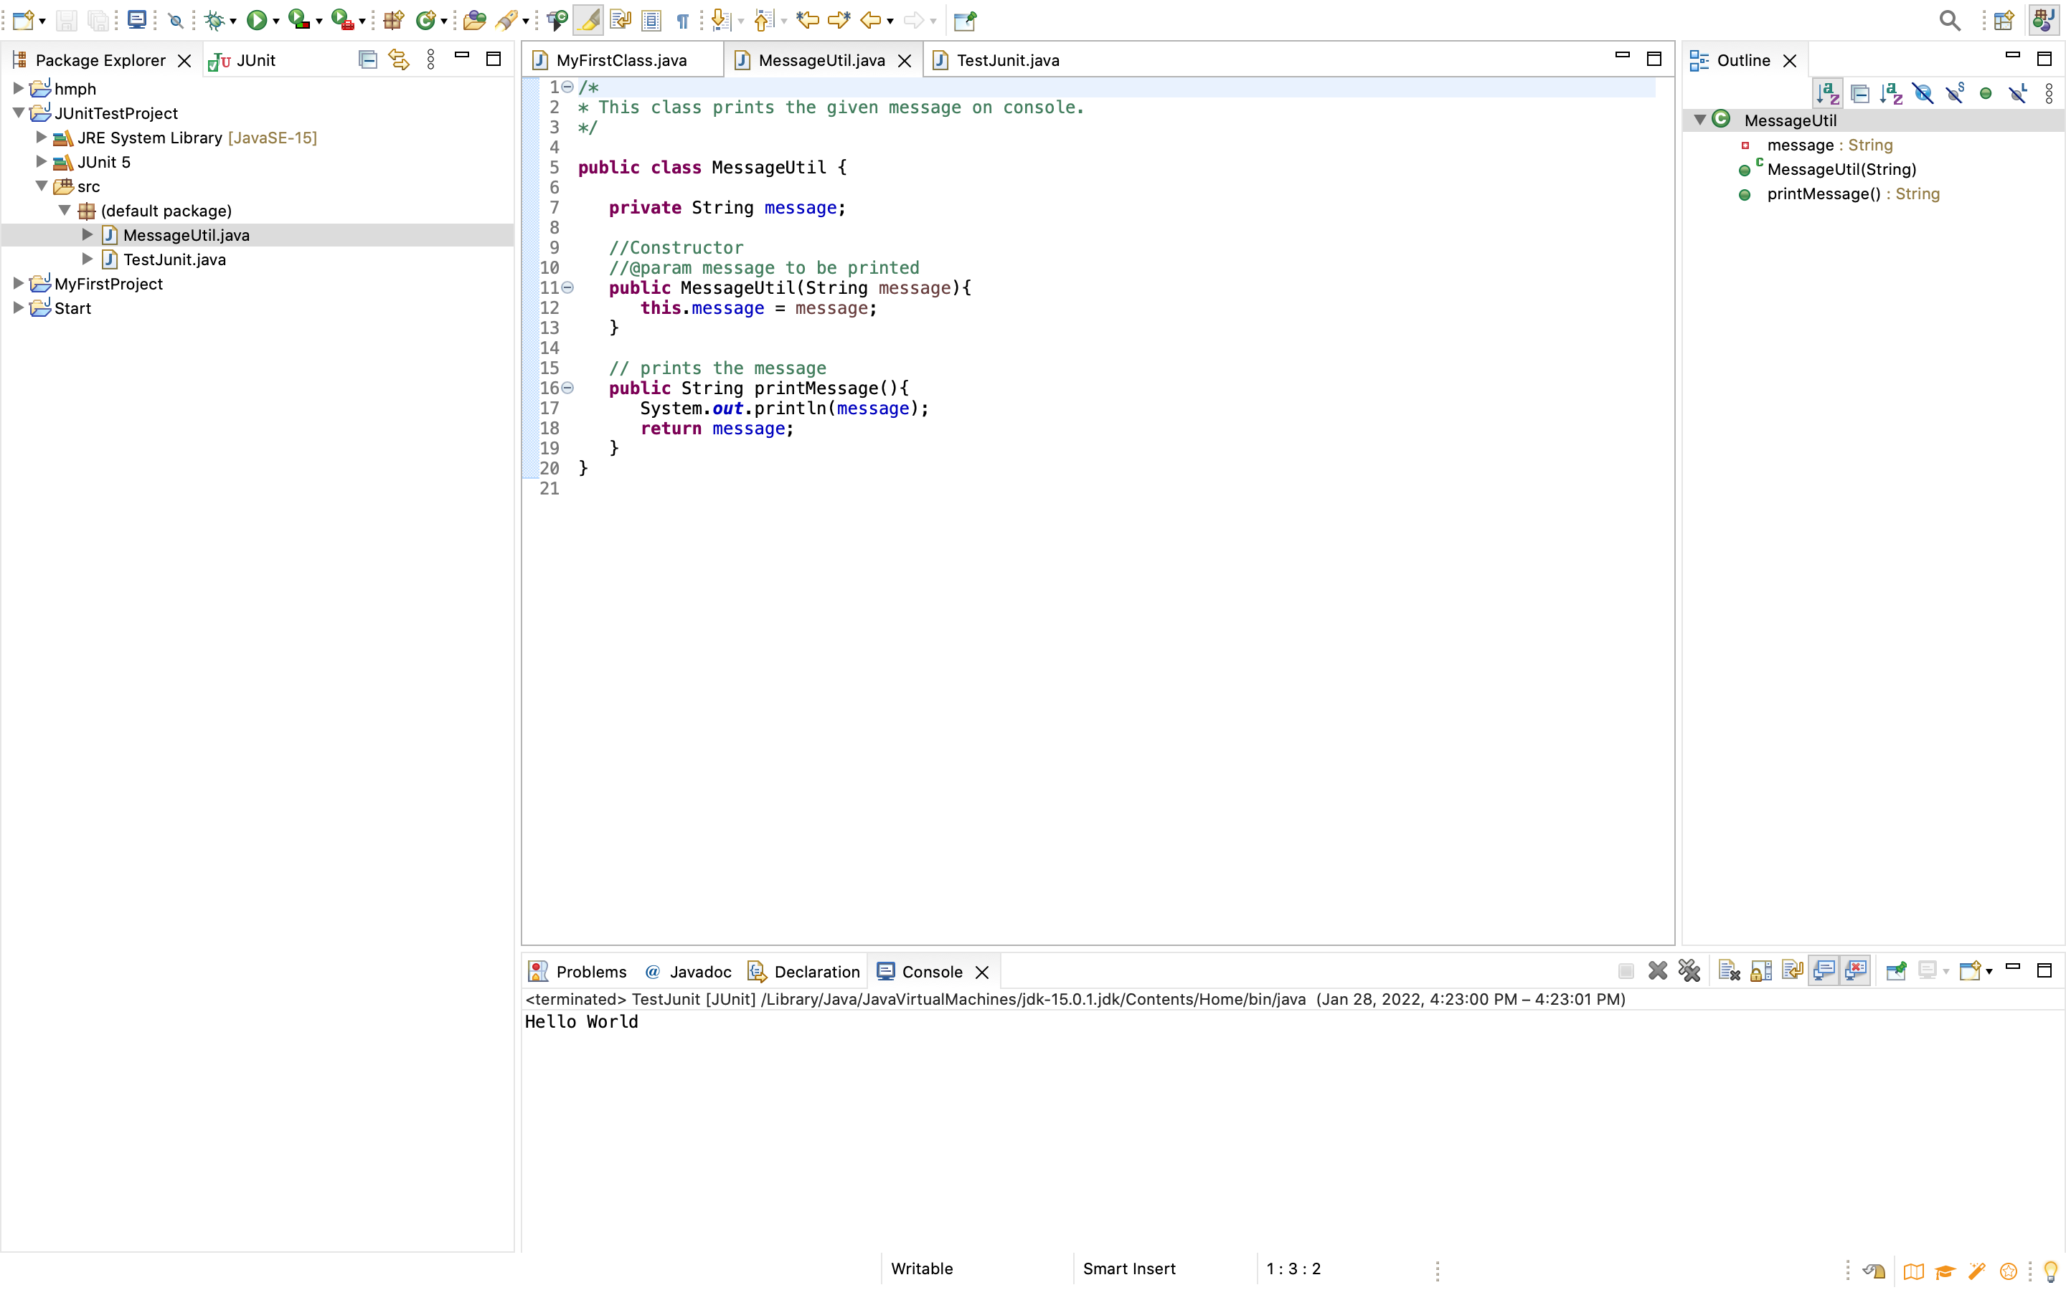

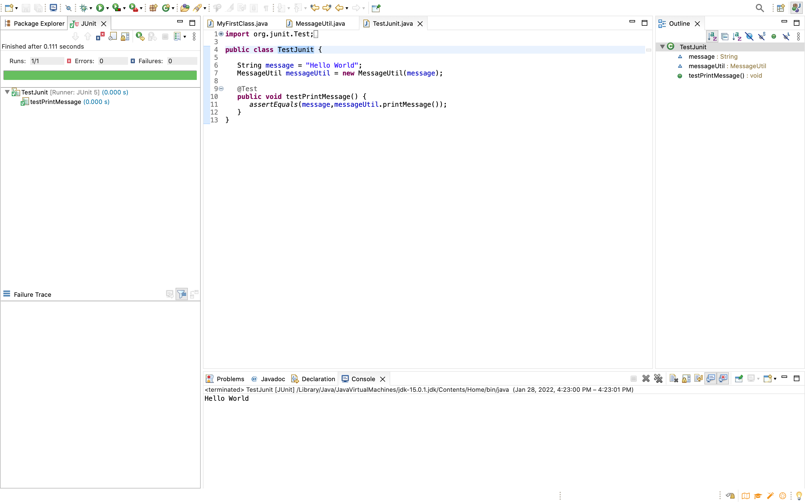

**Part 5 - Install, Setup, and Test JavaFX Application.**

Provide the screen shots showing:

1. JavaFX Project screenshot
2. Running example screenshot
3. Java Source Code File

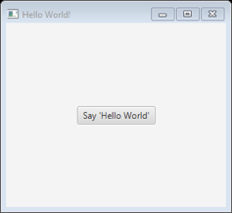

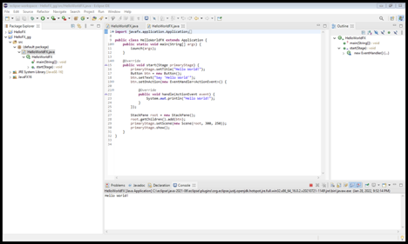

**Lessons Learned** <Provide answers to the questions listed below>**:**

Write about your Learning Experience, highlighting your lessons learned and learning experience from working on this assignment.

What have you learned?

*I learned how to install Eclipse and run programs using it. I learned how to perform the JUnit test and add JavaFX libraries. And lastly, I learned how to run Java apps using the terminal and how to work with directories.*

What did you struggle with?

*I struggled with running Java App from the command line and with running the program that used JavaFX. I also had issues performing Junit tests in Eclipse.*

What parts of this assignment were you successful with, and what parts (if any) were you not successful with?

*I was successful with installing JDK and Eclipse.*

Provide any additional resources/links/videos you used to while working on this assignment.

*I went to a tutoring session and professor Grinberg’s office hours to resolve issues with Junit and JavaFX.*

*I used YouTube and StackOverflow to learn how to change directories on Mac and run programs through terminal.*

**Check List:** <Provide answers to the column Y/N or N/A >**:**

|  |  |  |  |
| --- | --- | --- | --- |
| **#** |  | **Y/N** | **Comments** |
|  | **Assignment files:** |  |  |
|  | * FirstInitialLastName_Assignment0.docx/pdf | **Yes or No** | YES |
|  | * Source java files | **Yes or No** |  |
|  | **Program compiles** | **Yes or No** | YES |
|  | **Program runs with desired outputs related to a Test Plan** | **Yes or No** | YES |
|  | **Documentation file: Screenshots of** |  |  |
|  | * Part1: Setup GitHub | **Yes or No** |  |
|  | * Part 2 -Install JDK, Test java Application from Command Line | **Yes or No** | YES |
|  | * Part 3 - Install Eclipse, Test Eclipse Java Application | **Yes or No or N/A** | YES |
|  | * Part 4 - Install, Setup, Test Junit Program | **Yes or No or N/A** | YES |
|  | * Part 5 - Install, Setup, and Test JavaFX Application. | **Yes or No or N/A** | YES |
|  | * Lessons Learned | **Yes or No** | YES |
|  | * Checklist is completed and included in the Documentation | **Yes or No** | YES |