PROJECT PROGRESS REPORT

CRIME RATE PREDICTOR

SUBMITTED BY
Yashaswi raj ( 17EJCIT090)
Malay Joshi ( 17EJCIT043)

Aakash Khaska ( 17EJCIT001)
Rahul Prajapat(17EJCIT064)

SUBMITTED TO
Ms. PREETI SHARMA


DEPARTMENT OF INFORMATION TECHNOLOGY
JAIPUR ENGINEERING COLLEGE AND RESEARCH CENTER

JUNE, 2021

1

CONTENTS

INTRODUCTION 2

OBJECTIVE 2

LITERATURE SURVEY 4

REQUIREMENT ANALYSIS 7

BLOCK DIAGRM 5

SCREENSHOTS 6

APPROVAL 8

i

PROJECT SYNOPSIS

TITLE: CRIME RATE PREDICTOR

Location: Department of Information Technology

Jaipur Engineering College and Research Center, Jaipur.

1. Problem Statement

Crime rate is increasing now-a-days in many countries. In today's world with such higher crime rate and brutal crime happening, there must be some protection against this crime. Here we introduced a system by which crime rate can be reduced. Crime data must feed into the system. We introduced data mining algorithm to predict crime. K-means algorithm plays an important role in analyzing and predicting crimes. K-means algorithm will cluster co-offenders, collaboration and dissolution of organized crime groups, identifying various relevant crime patterns, hidden links, link prediction and statistical analysis of crime data. This system will prevent crime occurring in society. Crime data is analyzed which is stored in the database. Data mining algorithm will extract information and patterns from database. System will group crime. Clustering will be done based on places where crime occurred, gang who involved in crime and the timing crime took place. This will help to predict crime which will occur in future. Admin will enter crime details into the system which is required for prediction. Admin can view criminal historical data. Crime incident prediction depends mainly on the historical crime record and various geospatial and demographic information.

2. Objective

This Crime Rate Predictor will be a Web app designed to predict and classify criminal activities in an area that will help in preventing and reducing the crime.

ii

The objective of our work is to:
- Predicting crime before it takes place.
- Predicting hotspots of crime.
- Understanding crime pattern.
- Classify crime based on location.
- Analysis of crime.

3. LITERATURE SURVEY

a) Bogahawatte et al.,2013: data mining techniques, clustering, classification
Developed a system named Intelligent Crime Investigation System(ICSIS) that
could identify a criminal based upon the evidence collected from the crime
location.

b) Agarwal et al.,2017: used the rapid miner tool for analysing the crime rate
and anticipation of crime rate.

c) Yu et. al.,2015: used Ensemble of data mining techniques for classification
and crime forecasting

We shall:

- use crime datset available on kaggle.
- Clean, Preprocess and visualize the data and apply different algorithms for
predicting and analysis of crimes. We would then be analyzing the accuracy of different algorithms.

4. Requirement Analysis :

Technologies Used:

- Anaconda Distribution
- Python (Machine Learning)
- Packages Used:
  - Django
  - Pandas
  - Numpy
  - Sklearn
  - Geopy
  - Folium
- HTML 5
- CSS 3
- Bootstrap 4
- Java Script

This Crime Rate Predictor will be a Web app designed to predict and classify criminal activities in an area that will help in preventing and reducing the crime.

5. Block Diagram

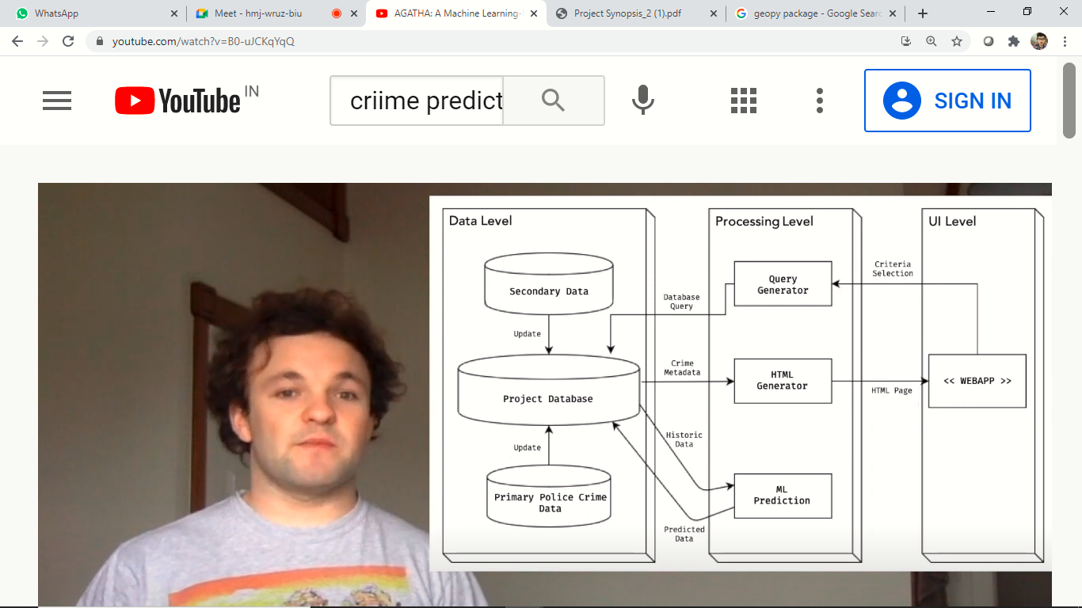

Fig. 1: System Architecture

VI

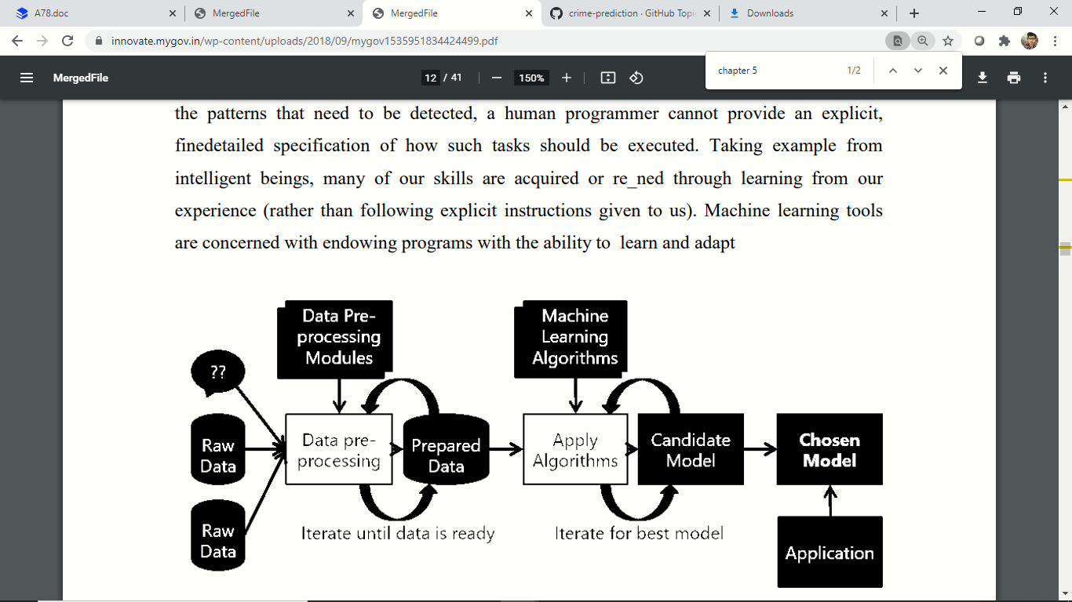

Fig. 1.1 : Machine Learning Process

VII

SCREENSHOTS

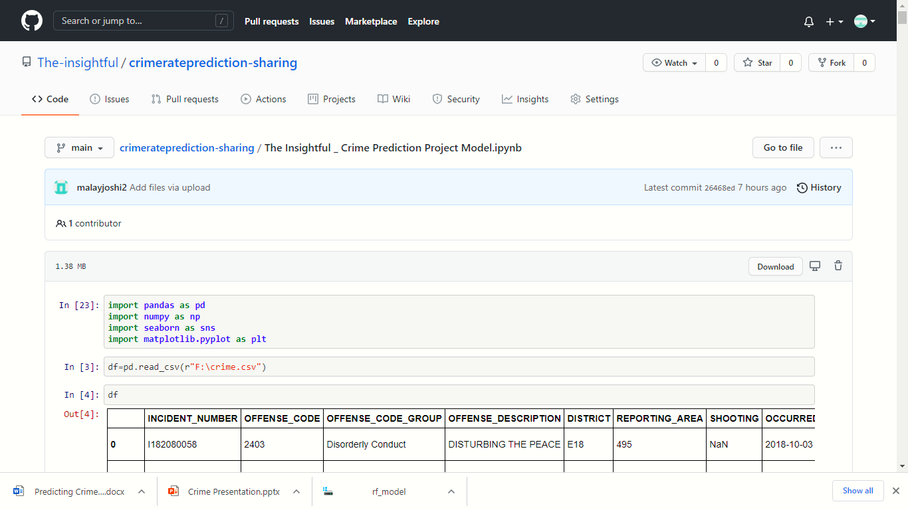

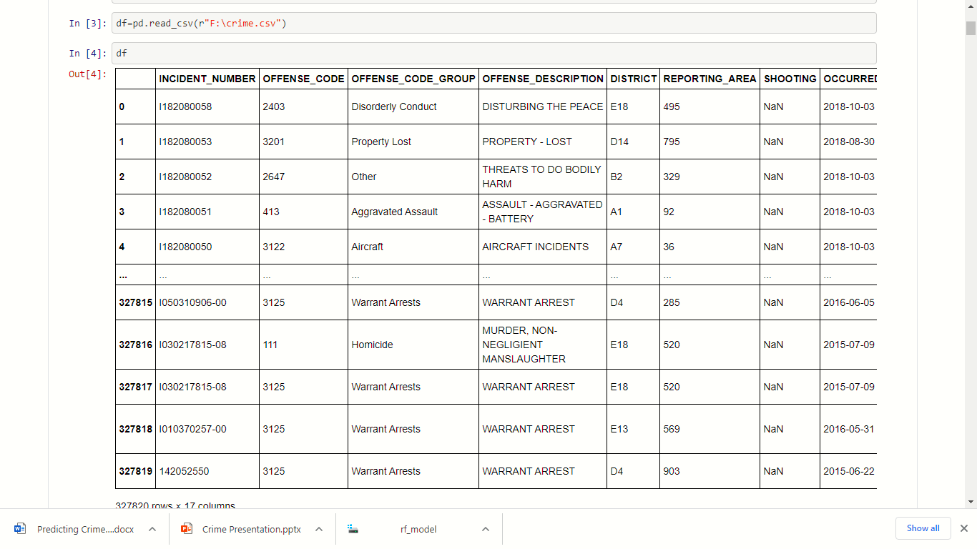

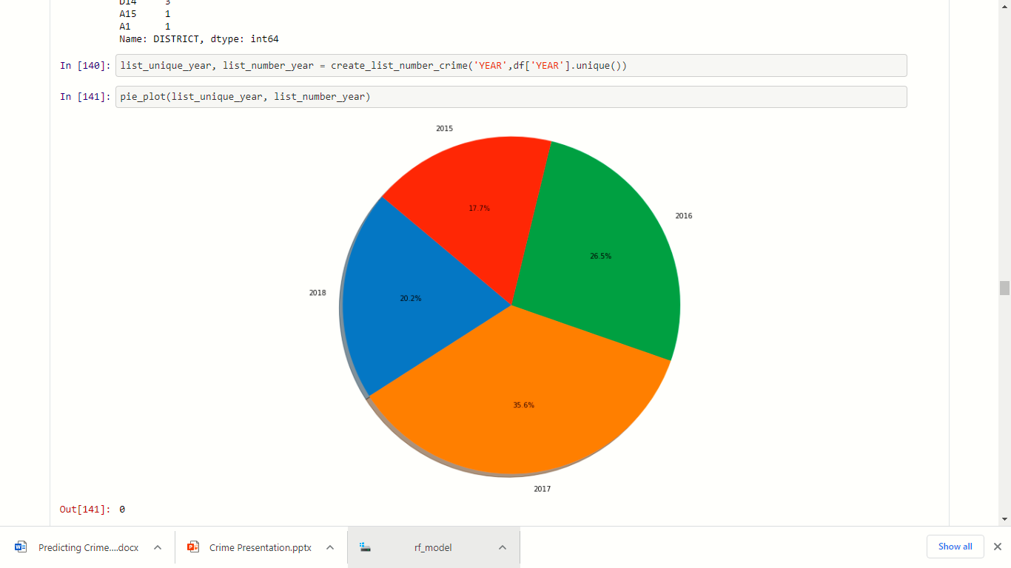

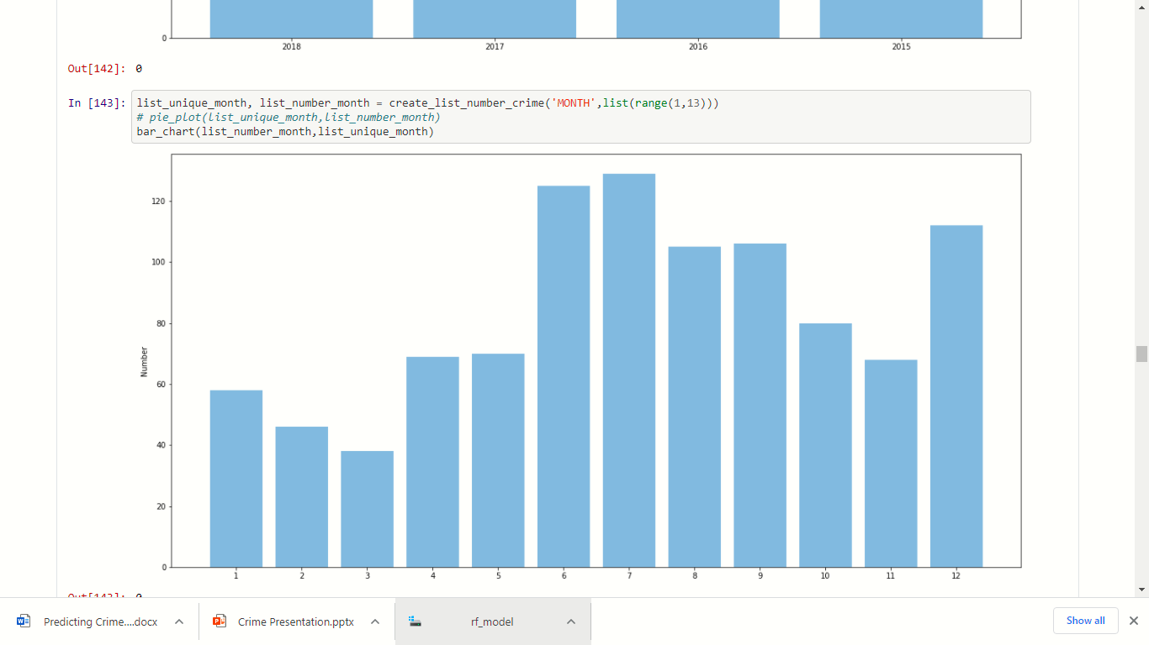

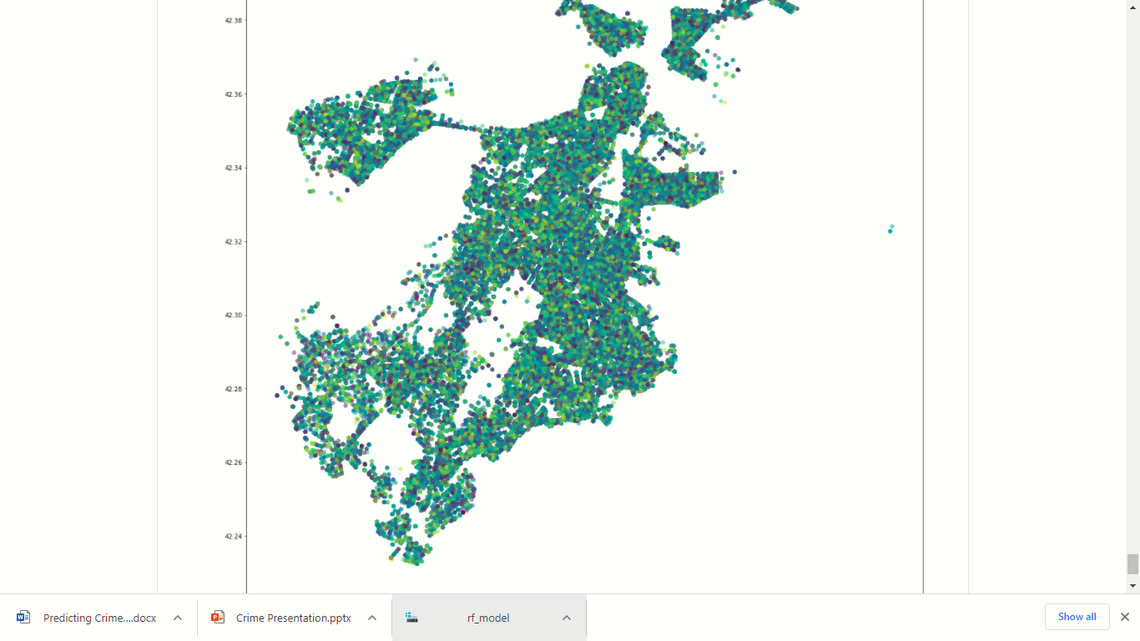
UI Interface Screenshots

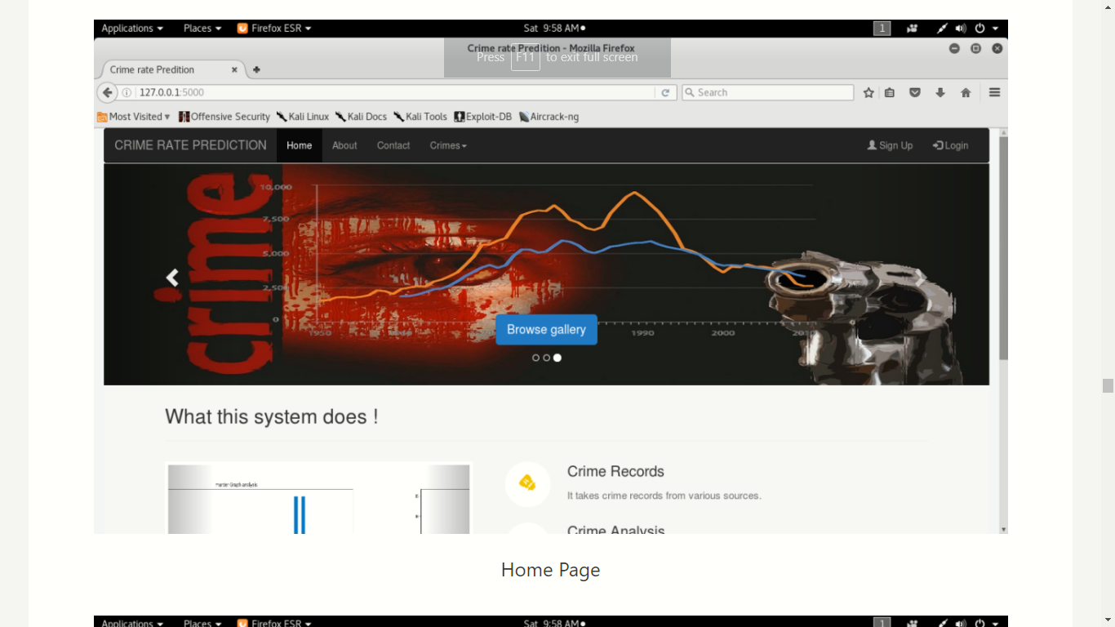
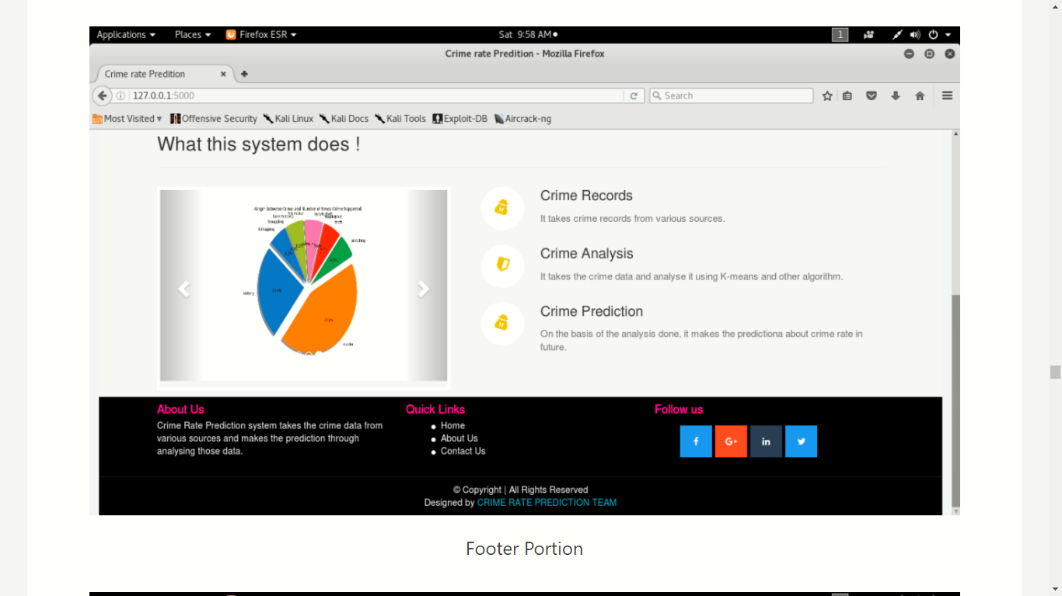

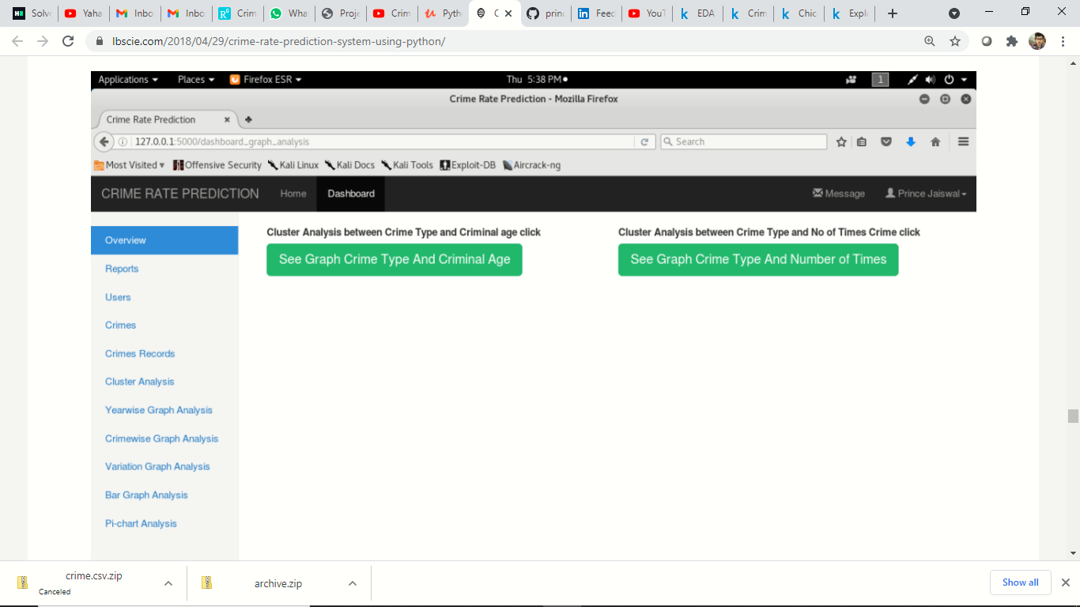

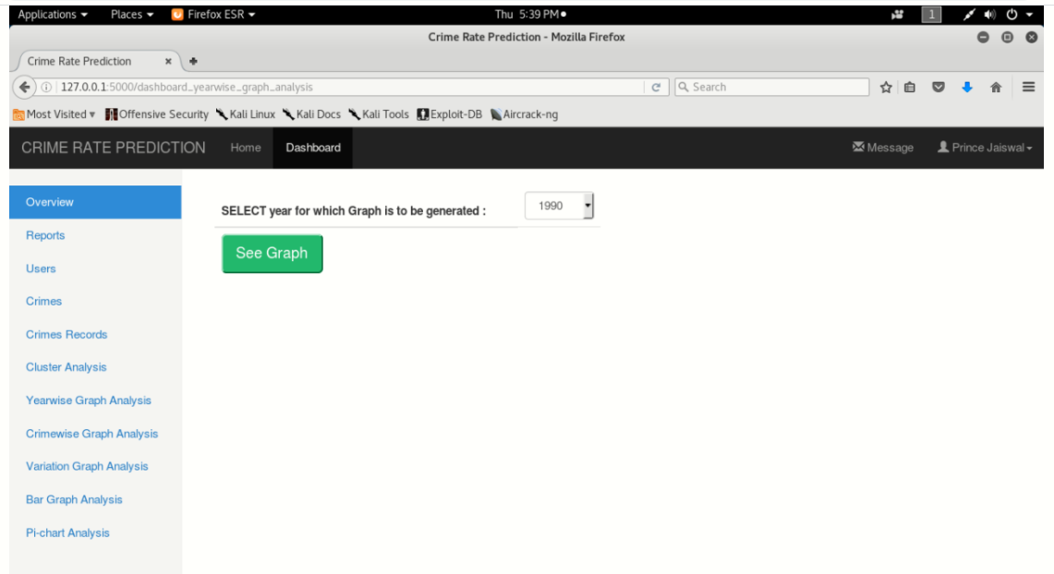

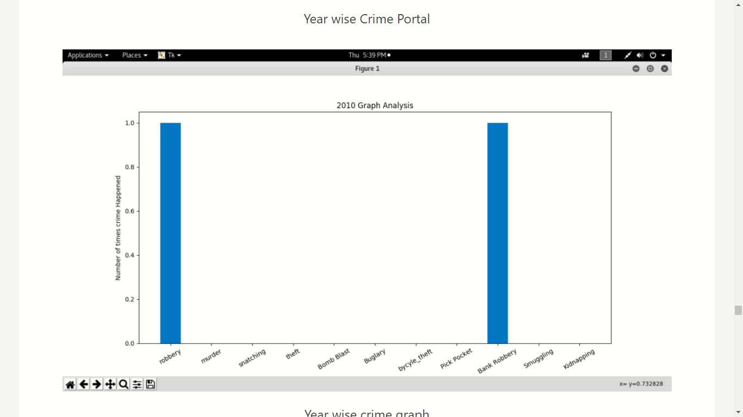

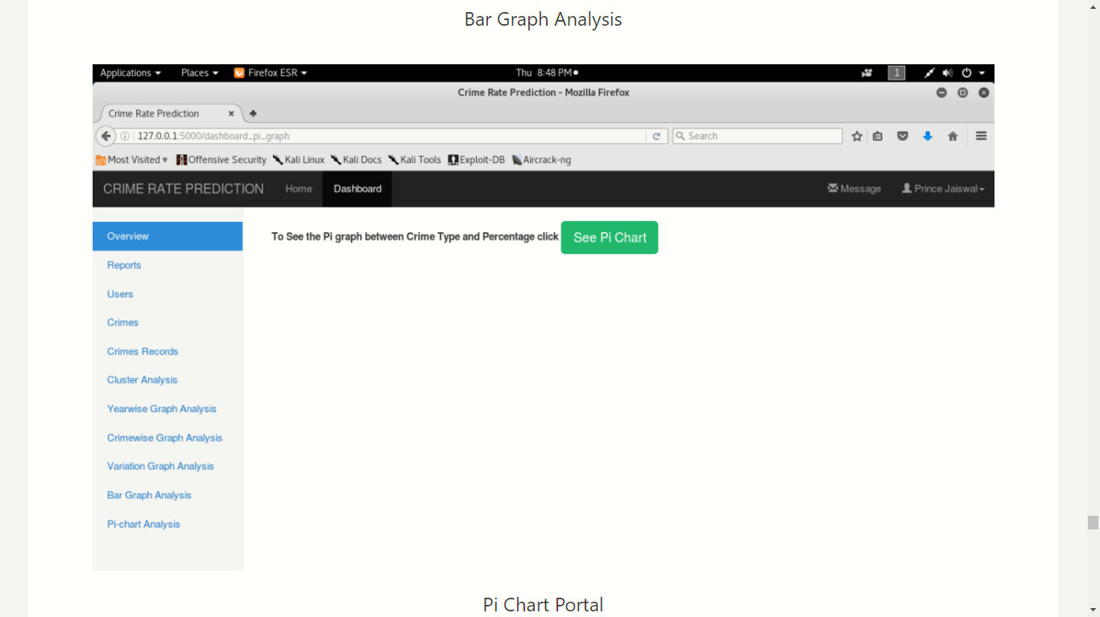

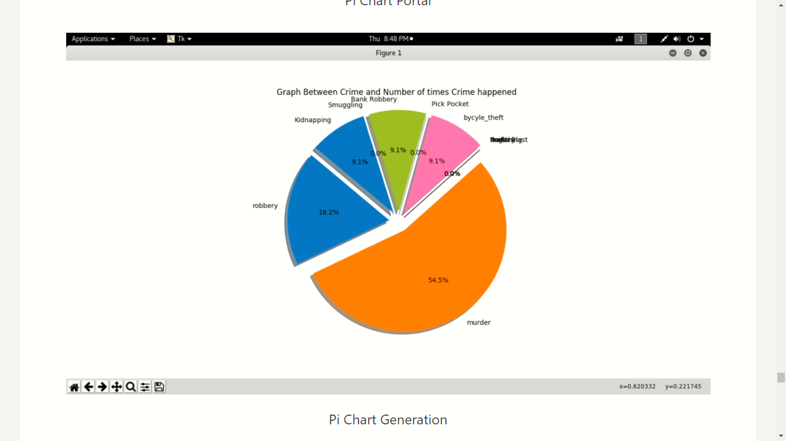

 | PROGRSS REPORT OF PROJECT
Team members :
1.) Yashaswi Raj |  |  | 2.) Malay Joshi
17EJCIT090 |  |  | 17EJCIT043
Dept. of IT |  |  | Dept. of IT

3.) Rahul Prajapat 4.) Aakash khaska

17EJCIT064 17EJCIT001

Dept. of IT Dept. of IT

( …………..)

Outline Approved

(Supervisor)

Name : Ms. Preeti Sharma
Guide Name: Md. Rizwan Khan
Designation : Assistant Professor Department Name :Information Technology
College Name: JECRC , Jaipur

IX

