

**Religious and Spiritual Books**

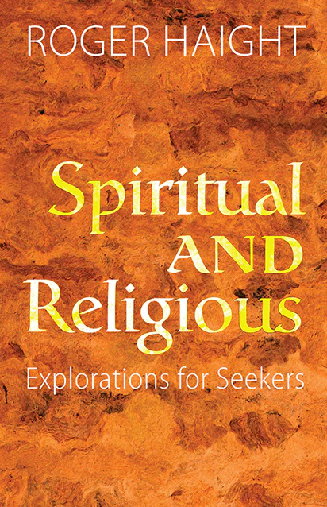

**Description:**

Certainly, there are numerous religious and spiritual books from various traditions that have had a significant impact on people's beliefs, practices, and understanding of the world. Here are some notable examples:

**1.** **The Bible:** The holy scripture of Christianity, divided into the Old Testament and the New Testament. It contains religious teachings, historical accounts, poetry, and moral guidance.

**2.** **The Quran**: The central religious text of Islam, believed to be the word of God as revealed to the Prophet Muhammad. It addresses matters of faith, law, morality, and guidance for personal conduct

**3. The Bhagavad Gita**: A sacred Hindu scripture that is part of the Indian epic Mahabharata. It presents a dialogue between Prince Arjuna and the god Krishna, discussing ethical dilemmas, duty, and spirituality.