

**TABLE CALENDAR**

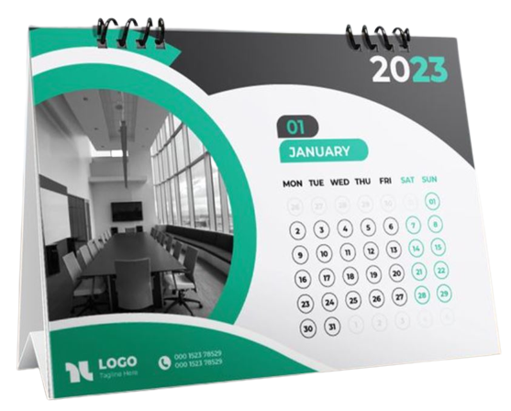

**Description:**

**T**able calendar is a type of calendar designed to be placed on a table or desk for easy reference. It typically consists of a set of pages, each displaying a month

Table calendars are often made with a stand or holder that allows the pages to be **flipped** or **changed** to display the current month or week. They can come in various sizes, formats, and designs, catering to different preferences and needs. Some table calendars may also include extra features like **inspirational** **quotes**, **artwork,** or space for jotting down notes