

**COMICS**

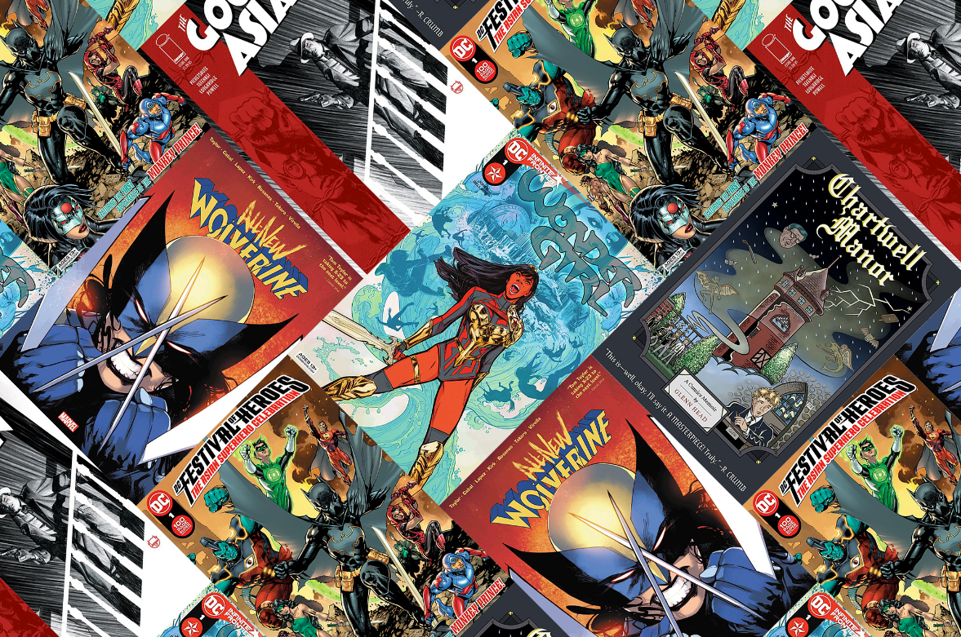

**Description:**

**C**omics is a medium used to express ideas with images, often combined with text or other visual information. It typically takes the form of a sequence of panels of images. Textual devices such as speech balloons, captions, and onomatopoeia can indicate dialogue, narration, sound effects, or other information.

**Sequential Art Form:** In most cases, "comics" refer to a medium of visual storytelling that uses a combination of images and text to convey a narrative. These can range from comic strips in newspapers, graphic novels, webcomics, manga, and traditional comic books. Comics are known for their diverse genres, styles, and subject matter. Communication System: In the realm of computer science and information technology, "COMICS" can also stand for "Communication in Minimal Computing Systems." It's a set of communication protocols and techniques designed for low-resource or minimal computing environments, where traditional networking technologies might be impractical due to limited processing power, memory, or bandwidth