

**NONFICTION BOOK**

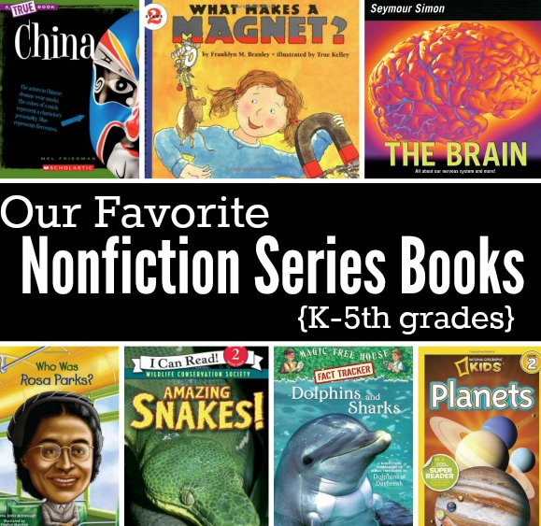

**Description:**

**N**onfiction books are literary works that present factual information, real events, and actual people. They are designed to inform, educate, or provide insight into the real world rather than presenting fictional stories or imaginative narratives. Nonfiction books cover a wide range of topics, including “history, science, self-help, biography, autobiography, memoirs, philosophy, psychology, politics, economics”, and more. Nonfiction books are often written by experts, researchers, journalists, or individuals with specialized knowledge in a particular field. These books aim to provide readers with accurate and reliable information, often backed by research, data, and evidence. They can help readers gain a deeper understanding of the world around them, learn new skills, explore differentperspectives, and expand their knowledge.**Some examples** of famous nonfiction books include "Sapiens: A Brief History of Humankind" by Yuval Noah Harari, "The Immortal Life of Henrietta Lacks" by Rebecca Skloot, "Becoming" by Michelle Obama, "Thinking, Fast and Slow" by Daniel Kahneman, and "The Power of Habit" by Charles Duhigg, among many others.