

**FICTION BOOKS**

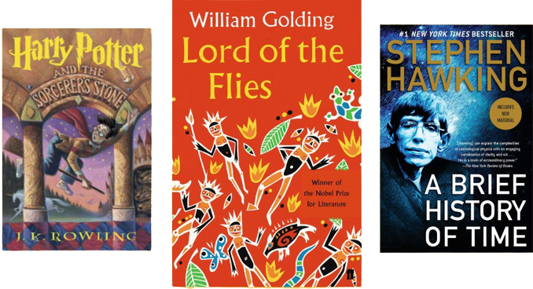

**Description:**

**F**iction books are literary works that are created from the author's imagination rather than being based on real events, people, or facts. These books consist of fabricated stories, characters, and settings, often with the goal of entertaining, inspiring emotions, and providing readers with an escape into imaginary worlds. Fiction books encompass a wide range of genres, including **romance**, **mystery**, **science fiction**, **fantasy**, **historical fiction**, **adventure**, and more. Authors of fiction books use their creativity to develop characters, plotlines, and settings that may not exist in reality. While the stories and events in fiction books are not true, they can still contain themes, messages, and insights that resonate with readers on a deeper level. Fictional narratives can explore human nature, societal issues, philosophical concepts, and emotional experiences. Some well-known examples of fiction books include **"To Kill a Mockingbird"** by Harper Lee, **"**1984**"** by George Orwell, **"Pride and Prejudice"** by Jane Austen, **"The Lord of the Rings"** by J.R.R. Tolkien, **"Harry Potter"** series by J.K. Rowling, and "The Great Gatsby" by F. Scott Fitzgerald. Fiction books offer readers a chance to explore different perspectives, immerse themselves in imaginative worlds, and engage their emotions and imagination in ways that nonfiction books may no