

**NOVELS**

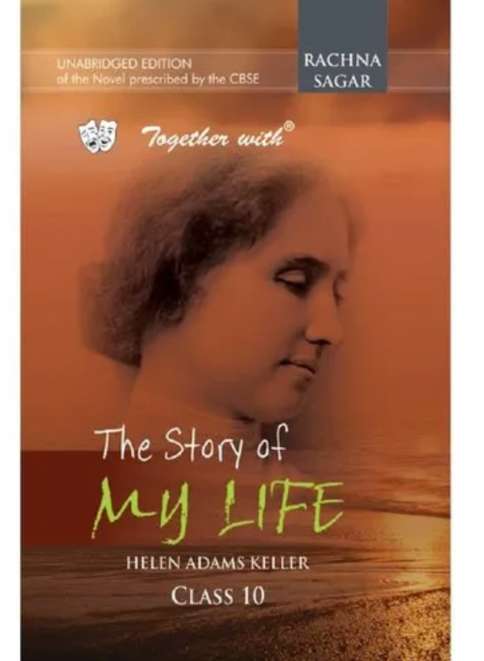

**Description:**

**N**ovel is a literary work of considerable length that presents a **fictional story** in prose form. It is a form of written art that offers a rich and immersive reading experience. Novels are characterized by their ability to capture the complexities of **human experiences**, **emotions**, and **relationships** through the artful use of language and narrative. At its core, a novel is a narrative journey. It transports readers to different worlds, times, and perspectives, allowing them to explore the lives and minds of characters as they navigate challenges, conflicts, and personal growth. Novels often delve deep into the thoughts, motivations, and inner struggles of characters, creating a connection between readers and the fictional individuals they encounter