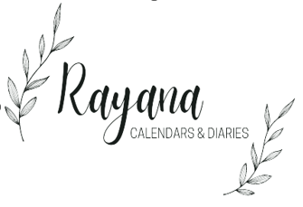

**DIARIES**



**Description:**

Diary is a personal written record of one's thoughts, experiences, feelings, and events that occur over a period of time. It is a form of journaling where individuals document their daily **activities**, **reflections,** and **emotions**. Diaries can serve various purposes, such as providing an outlet for self-expression, capturing memories, tracking personal growth, and even serving as historical artifacts.

Diaries are typically kept in chronological order and are meant to be private, allowing individuals to freely express their thoughts without the fear of judgment. They can cover a wide range of **topics**, from mundane **daily routines to profound life events**. **Some people use diaries as a way to set goals, track progress, and maintain a sense of discipline in their lives**

Here are some following types of **Diaries**

**Travel Diary**: Travel diaries document a person's experiences and observations while traveling. They often include descriptions of places visited, cultural encounters, and personal reflections on the journey.

**Dream Diary:** In a dream diary, individuals record their dreams upon waking. This type of diary can help explore the subconscious mind and patterns in dream content.

**Work Diary:** A work diary is used to record professional activities, accomplishments, challenges, and lessons learned in the workplace. It can be helpful for personal and career development.

**JOURNALS**



**Description:**

The term "Journal" can have multiple meanings depending on the context. Here are a few common interpretations:

**Personal Journal:** A personal journal is a record of one's thoughts, feelings, experiences, and reflections. It is often used as a tool for self-expression**,** self-discovery**,** and personal growth. People might write in a journal to document their daily activities, record their emotions, set goals, and work through challenges. Personal journals are typically kept private and can be handwritten or digital.

1. **Academic Journal:** An academic journal is a publication that contains **scholarly articles, research** findings,andacademic discussions within a specific field of study. These journals are used to share new **research, theories**, and developments with the academic community. They play a critical role in advancing knowledge and facilitating communication among researchers, scholars, and experts.
2. **News Journal:** A news journal can refer to a publication that presents current events, news stories, and analysis. It may come in the form of a newspaper, magazine, or online platform, and it provides readers with information on local, national, and global happenings across various topics.
3. **Medical Journal:** A medical journal is a publication that focuses on medical research, clinical studies, and healthcare-related topics. It is an essential resource for medical professionals to stay updated on advancements in medicine and to learn from the experiences of their peers.

**CUSTOM DIARIES & JOURNALS**

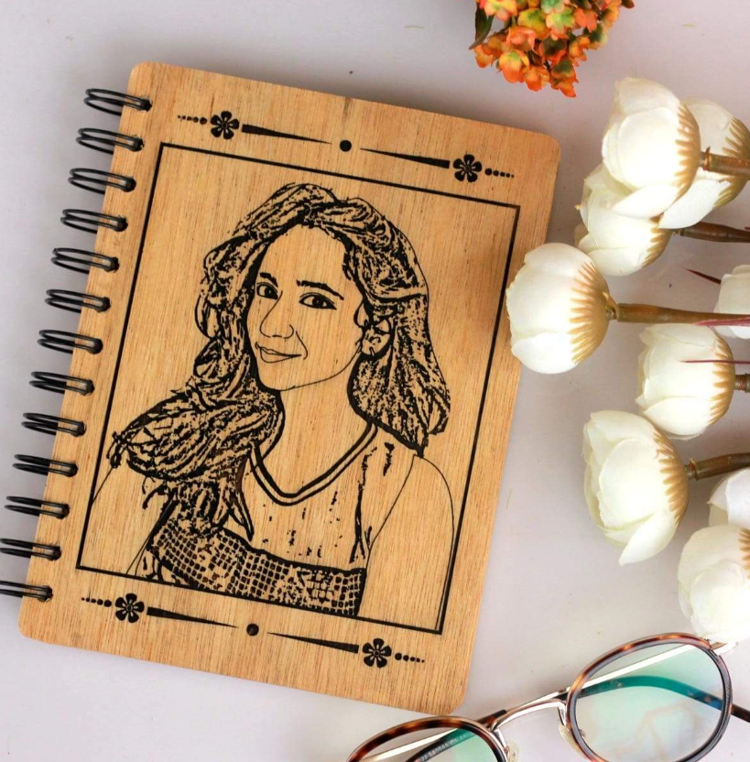

**Description:**

"Custom diaries & Journals" typically refer to diaries or planners that are designed and personalized according to an individual's preferences, needs, or branding. These diaries can be customized in various ways to suit specific requirements. Here are some aspects of customization that are often associated with custom diaries:

Here are some following types of **“Custom Diaries & Journals”**

1. **Cover Design**: You can choose the cover design, color, material, and even add images, logos, or text to make the diary unique and reflective of your personal style or brand.
2. **Size and Format:** Custom diaries & Journals can come in various sizes, such as pocket-sized, A5, A4, etc., as well as different binding options like spiral, hardcover, softcover, and more.
3. **Personalization:** You can often add your name, monogram, or a special message to the diary or journal, making it feel more personal and meaningful.

**Custom diaries & Journals** are popular among individuals who value organization, creativity, and personalization. They can also be used for special occasions like weddings, birthdays, or anniversaries, where you might want to give a unique and thoughtful gift.