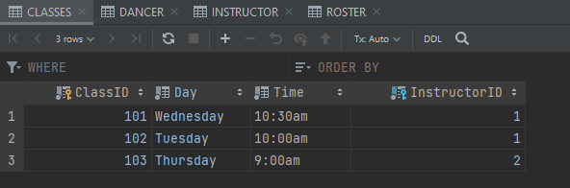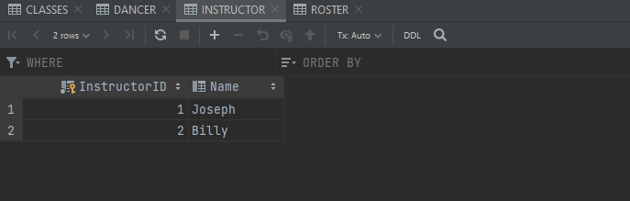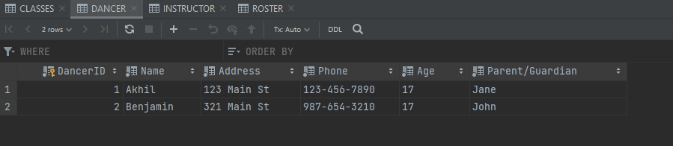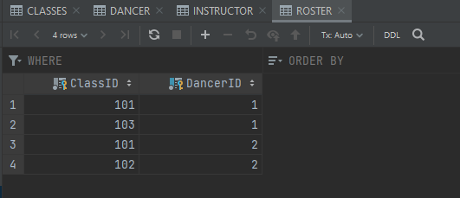

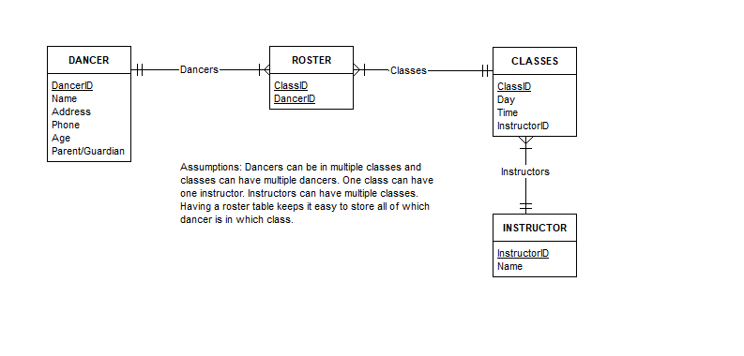

USE TESTSCHEMA09;

SELECT \*

FROM CLASSES

WHERE InstructorID IN (

SELECT InstructorID

FROM INSTRUCTOR

WHERE Name LIKE 'Joseph'

)

;

π ClassID, Day, Time (CLASSES ⨝ σ Name = 'Joseph' (INSTRUCTOR))

