Text

**Bolded text**

Text **bolded**

Green text

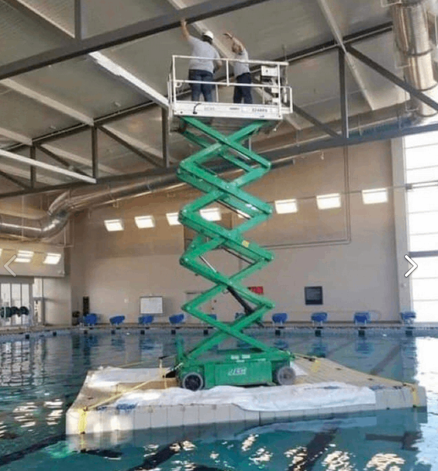

Underline text

*Italic text*

Table below with united cells:

|  |  |  |  |
| --- | --- | --- | --- |
| Cell 1 | Cell 2 | Cell 3 | Cell 4 |
| Cell 5 | Cell 6 | Vertically united cells:  Cell 7  Cell 11  Cell 15 | Cell 8 |
| Cell 9  Cell 13  They united vertically | Cell 10 | Cell 12  And picture here:  ***Swimming cat=\*** |
| Cell 14 | Cell 16 |
| Cell 17 | This cell horizontally united:  Cell 18  Cell 19  Cell 20 | | |

Long text: According to all known laws of aviation, there is no way a bee should be able to fly. Its wings are too small to get its fat little body off the ground. The bee, of course, flies anyway because bees don't care what humans think is impossible.

More text and pictures:

**Bold**

***Bold and italic***

**Bold** and *italic*

Green Colored

Blue *italic* underline colored

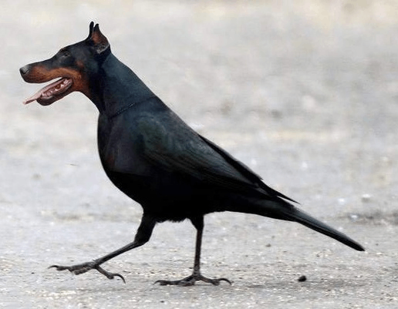

*Blue italic underline colored*



Text

Text too

End