**20BCE1550**

**Samridh Anand Paatni**

**CSE4001 Lab 01**

**PThreads**

**Q1. Display the processors layout of your system.**

The output for the command **lstopo**, after installing the hwloc package:

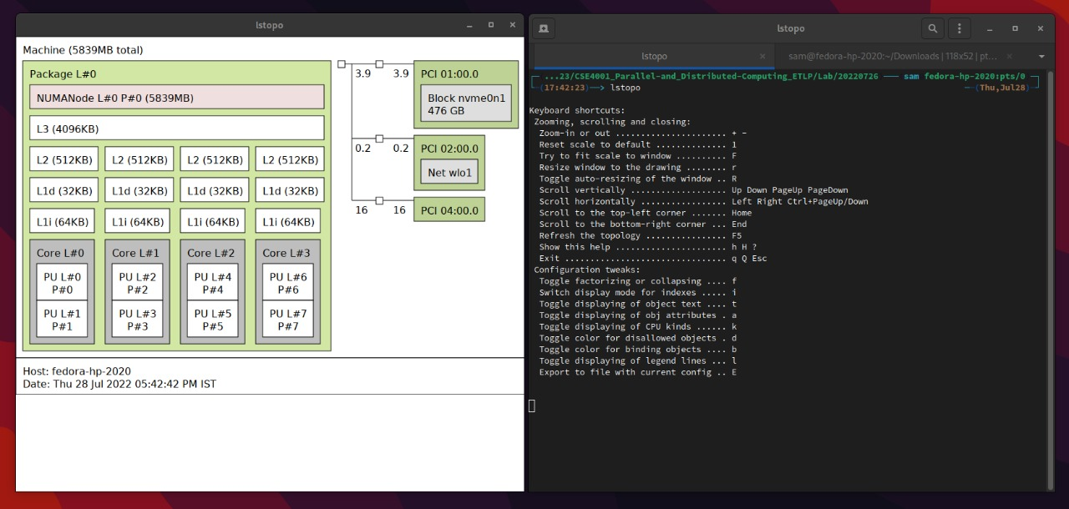

**Q2. Write a multithreaded program in C to create 10k, 20k and 50k threads and measure the time taken for each thread group.**

C Code:

#include<stdio.h>

#include<stdlib.h>

#include<pthread.h>

#include<time.h>

void * void_function(void *message) {}

int main(int argc, char * argv[]) {

    pthread_t * threads;

    int num_threads = atoi(argv[1]); // because the cli argument is an ASCII code

    threads = (pthread_t *) calloc(num_threads, sizeof(pthread_t));

    clock_t t = clock();

    for (int i = 0; i < num_threads; i++) {

        pthread_create(&threads[i], NULL, void_function, NULL);

    }

    for (int i = 0; i < num_threads; i++) {

        pthread_join(threads[i], NULL);

    }

    t = clock() - t;

    printf(

        "took %f seconds to make %d threads\n",

        ((double) t)/CLOCKS_PER_SEC,

        num_threads

    );

    free(threads);

    return 0;

}

Output:

Creating 5000 pthreads resulted in a segmentation fault.

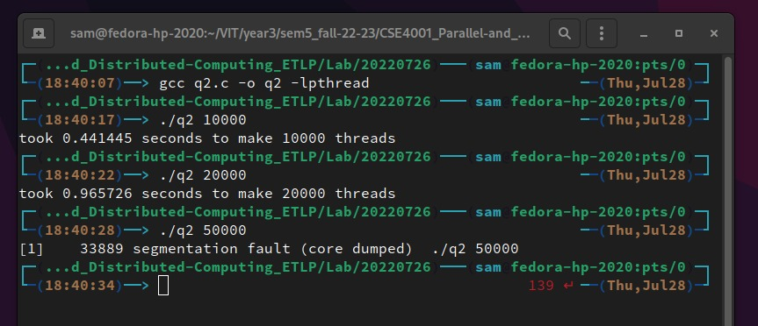

**Q3. Write a program to create 2 threads. Thread 1 has to print “PDC” and thread 2 has to print “lab”.**

C Code:

#include<stdio.h>

#include<pthread.h>

void * message_function(void *message) {

    printf("%s\n", ((char *) message));

}

int main() {

    pthread_t t1, t2;

    char *m1 = "Thread 1: PDC";

    char *m2 = "Thread 2: Lab";

    pthread_create(&t1, NULL, message_function, (void *) m1);

    pthread_create(&t2, NULL, message_function, (void *) m2);

    pthread_join(t1, NULL);

    pthread_join(t2, NULL);

    return 0;

}

Output:

