**20BCE1550**

**Samridh Anand Paatni**

**CSE4001 Lab 12**

**Java RMI**

**Code:**

Adder.java

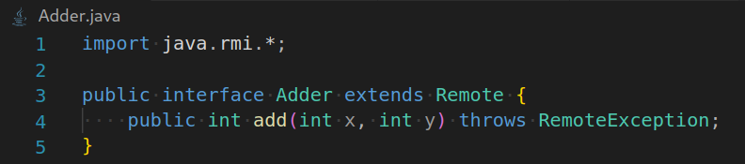

AdderRemote.java

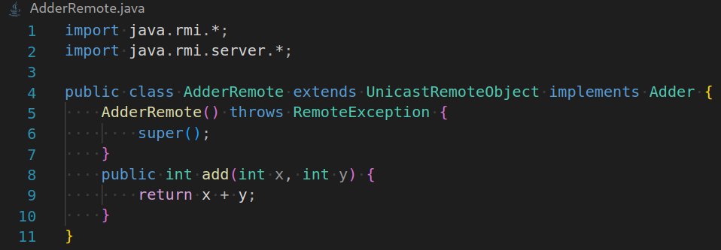

MyServer.java

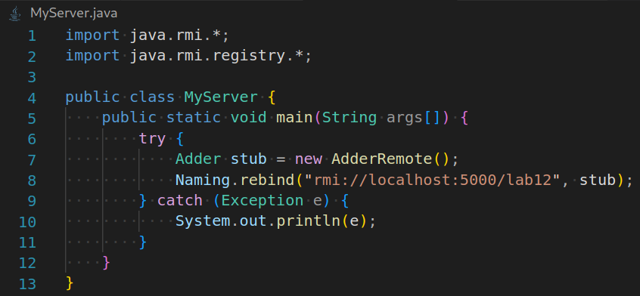

MyClient.java

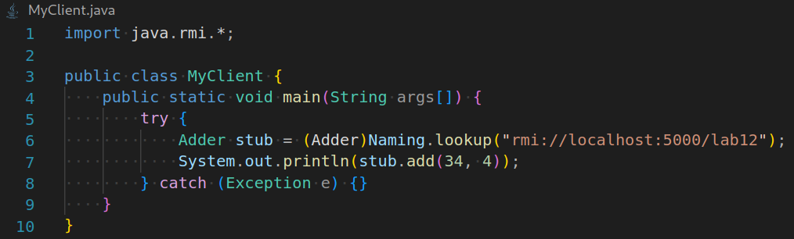

Steps:

1. Create all the files and compile them all:



2. Create the stub and skeleton for AdderRemote:



3. Create the RMI Registry:



4. Run MyServer:



5. Run MyClient:

