**20BCE1550**

**Samridh Anand Paatni**

**CSE4001 Lab 10**

**MPI Collective Communication**

**a:**

**Code:**

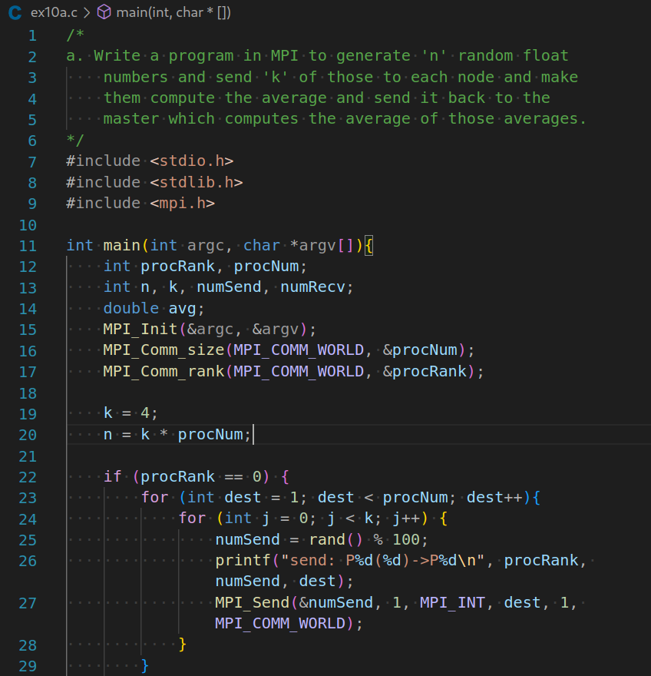

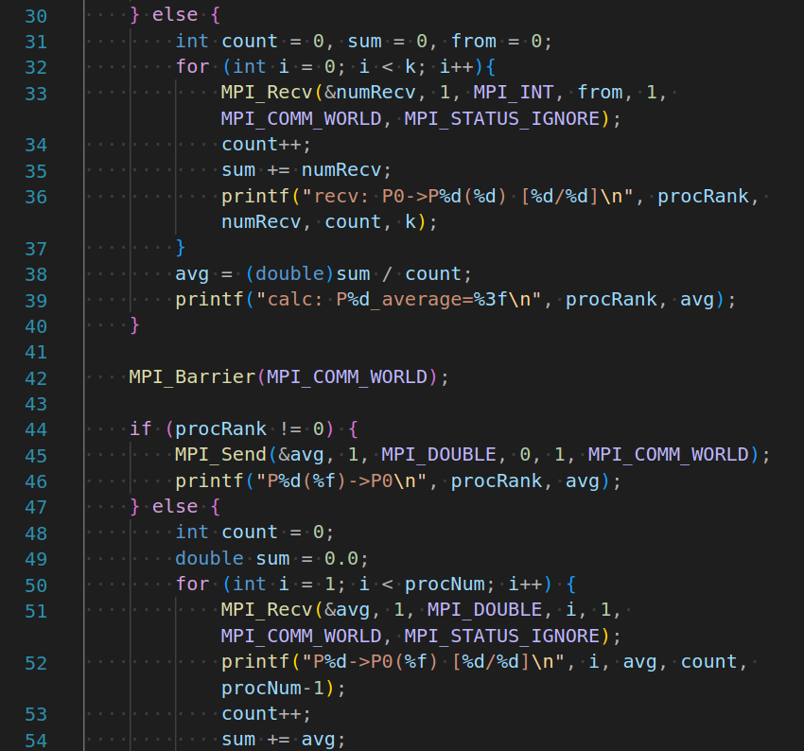

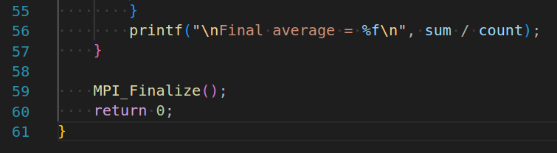

**Output:**

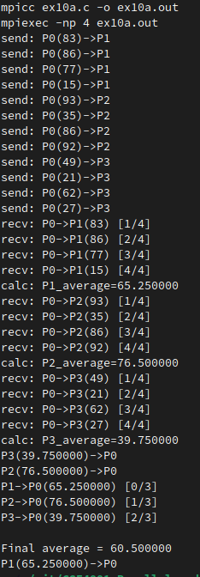

**b:**

**Code:**

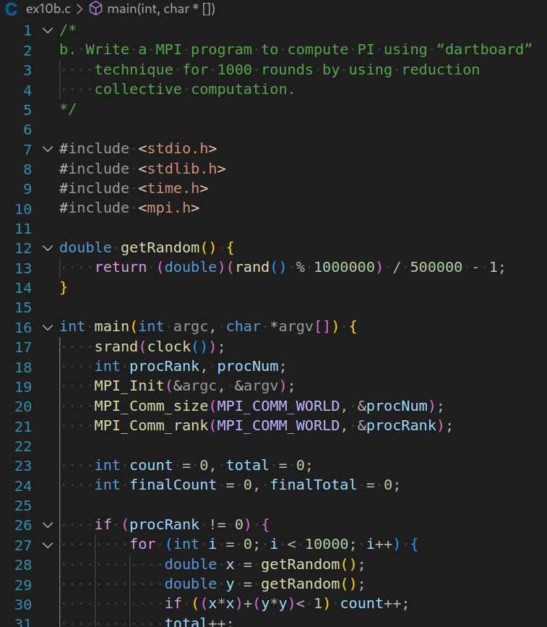

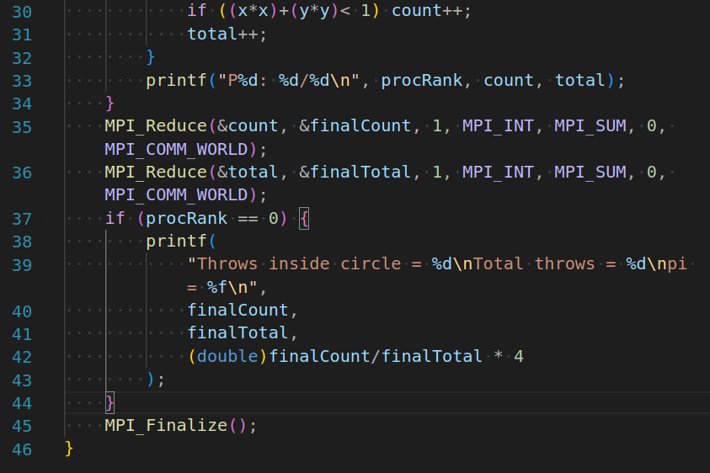

**Output:**

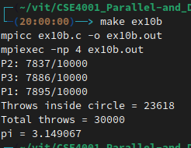

**c:**

**Code:**

**/\***

c. Write a MPI program to perform matrix multiplication

(1000x1000) using scatter and gather routines.

*/

#include <stdio.h>

#include <stdlib.h>

#include <mpi.h>

#include <mpi.h>

#include <stdio.h>

#define SIZE 8

int A[SIZE][SIZE], B[SIZE][SIZE], C[SIZE][SIZE];

void fill_matrix(int m[SIZE][SIZE])

{

static int n=0;

int i, j;

for (i=0; i<SIZE; i++)

for (j=0; j<SIZE; j++)

m[i][j] = n++;

}

void print_matrix(int m[SIZE][SIZE])

{

int i, j = 0;

for (i=0; i<SIZE; i++) {

printf("\n\t| ");

for (j=0; j<SIZE; j++)

printf("%2d ", m[i][j]);

printf("|");

}

}

int main(int argc, char *argv[])

{

int myrank, P, from, to, i, j, k;

int tag = 666; /* any value will do */

MPI_Status status;

MPI_Init (&argc, &argv);

MPI_Comm_rank(MPI_COMM_WORLD, &myrank); /* who am i */

MPI_Comm_size(MPI_COMM_WORLD, &P); /* number of processors */

/* Just to use the simple variants of MPI_Gather and MPI_Scatter we */

/* impose that SIZE is divisible by P. By using the vector versions, */

/* (MPI_Gatherv and MPI_Scatterv) it is easy to drop this restriction. */

if (SIZE%P!=0) {

if (myrank==0) printf("Matrix size not divisible by number of processors\n");

MPI_Finalize();

exit(-1);

}

from = myrank * SIZE/P;

to = (myrank+1) * SIZE/P;

/* Process 0 fills the input matrices and broadcasts them to the rest */

/* (actually, only the relevant stripe of A is sent to each process) */

if (myrank==0) {

fill_matrix(A);

fill_matrix(B);

}

MPI_Bcast (B, SIZE*SIZE, MPI_INT, 0, MPI_COMM_WORLD);

MPI_Scatter (A, SIZE*SIZE/P, MPI_INT, A[from], SIZE*SIZE/P, MPI_INT, 0, MPI_COMM_WORLD);

printf("computing slice %d (from row %d to %d)\n", myrank, from, to-1);

for (i=from; i<to; i++)

for (j=0; j<SIZE; j++) {

C[i][j]=0;

for (k=0; k<SIZE; k++)

C[i][j] += A[i][k]*B[k][j];

}

MPI_Gather (C[from], SIZE*SIZE/P, MPI_INT, C, SIZE*SIZE/P, MPI_INT, 0, MPI_COMM_WORLD);

if (myrank==0) {

printf("\n\n");

print_matrix(A);

printf("\n\n\t * \n");

print_matrix(B);

printf("\n\n\t = \n");

print_matrix(C);

printf("\n\n");

}

MPI_Finalize();

return 0;

}

**Output:**

