**Parallel Programming Basics**

**Sequential Solution:**

We downloaded dd_serial.cpp and Makefile and moved them to the sequential folder. We compiled the file using the command, **g++ -o dd_serial dd_serial.cpp**. We ran the program and measured the run time using the command, **time -p ./dd_serial**.

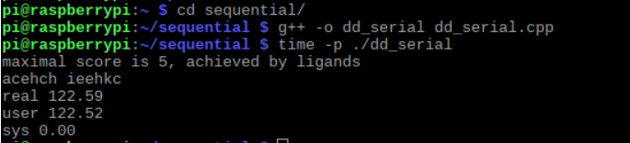

**OpenMP Solution:**

We downloaded dd_omp.cpp and Makefile and moved them to the openmp1 folder. We compiled the file using the command, **g++ -o dd_omp dd_omp.cpp -ltbb -lpthread -fopenmp.** We ran and measured the run time using the command, **time -p ./dd_omp 4 120 1.**

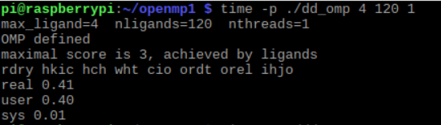

**C++ 11 Threads Solution:**

We downloaded dd_threads.cpp and Makefile and moved them to the cplusthreads1 folder. We compiled the file using the command, **g++ -o dd_threads dd_threads.cpp -ltbb -lpthread. “-ltbb”** makes sure the tbb library is included since a header file from the tbb library is imported in dd_threads.cpp. We ran the program and measured the run time using the command, **time -p ./dd_threads 4 120 1.**

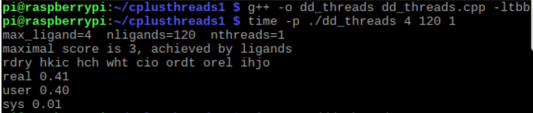

|  |  |
| --- | --- |
| Implementation | Time (s) |
| dd_serial | 122.59 |
| dd_omp | 0.41 |
| dd_threads | 0.41 |

We ran the program and measured the run times using the commands, “**time -p ./dd_omp 4 120 2”,** “**time -p ./dd_omp 4 120 3”,** and“**time -p ./dd_omp 4 120 4”.**

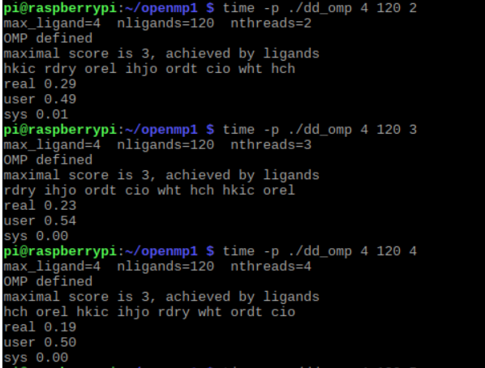

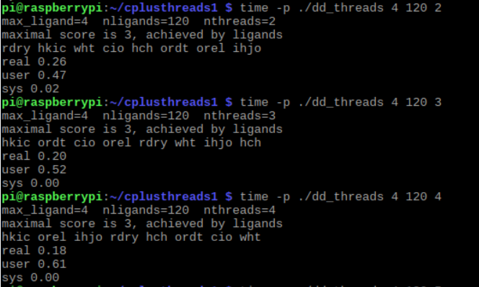We ran the program and measured the run times using the commands, “**time -p ./dd_threads 4 120 2”,** “**time -p ./dd_threads 4 120 3”,** and“**time -p ./dd_threads 4 120 4”.**

|  |  |  |  |
| --- | --- | --- | --- |
| Implementation | Time (s) 2 Threads | Time (s) 3 Threads | Time (s) 4 Threads |
| dd_omp | 0.29 | 0.23 | 0.19 |
| dd_threads | 0.26 | 0.20 | 0.18 |

**Discussion Questions:**

**1. Which approach is the fastest?** The C++ 11 threads solution is the fastest.

**2.** **Determine the number of lines in each file (use wc -l). How does the C++11 implementation compare to the OpenMP implementation?** The serial solution has 171 lines. The C++ 11 solution has 208 lines. The OpenMP solution has 194 lines. The C++ 11 implementation has more lines compared to the OpenMP implementation.

**3. Increase the number of threads to 5 threads. What is the run time for each?**

The run time for the omp solution is 0.16 s, and the run time for the C++ 11 solution is 0.16 s.

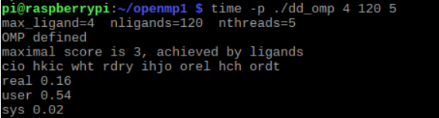

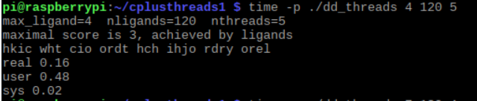

**4. Increase the maximum ligand length to 7, and rerun each program. What is the run time for each.**

The run time for the omp solution is 71.23 s, and the run time for the C++ 11 solution is 41.45 s.

