Chrome Webpage example

Chrome Version 109.0.5414.120 (Official Build) (64-bit)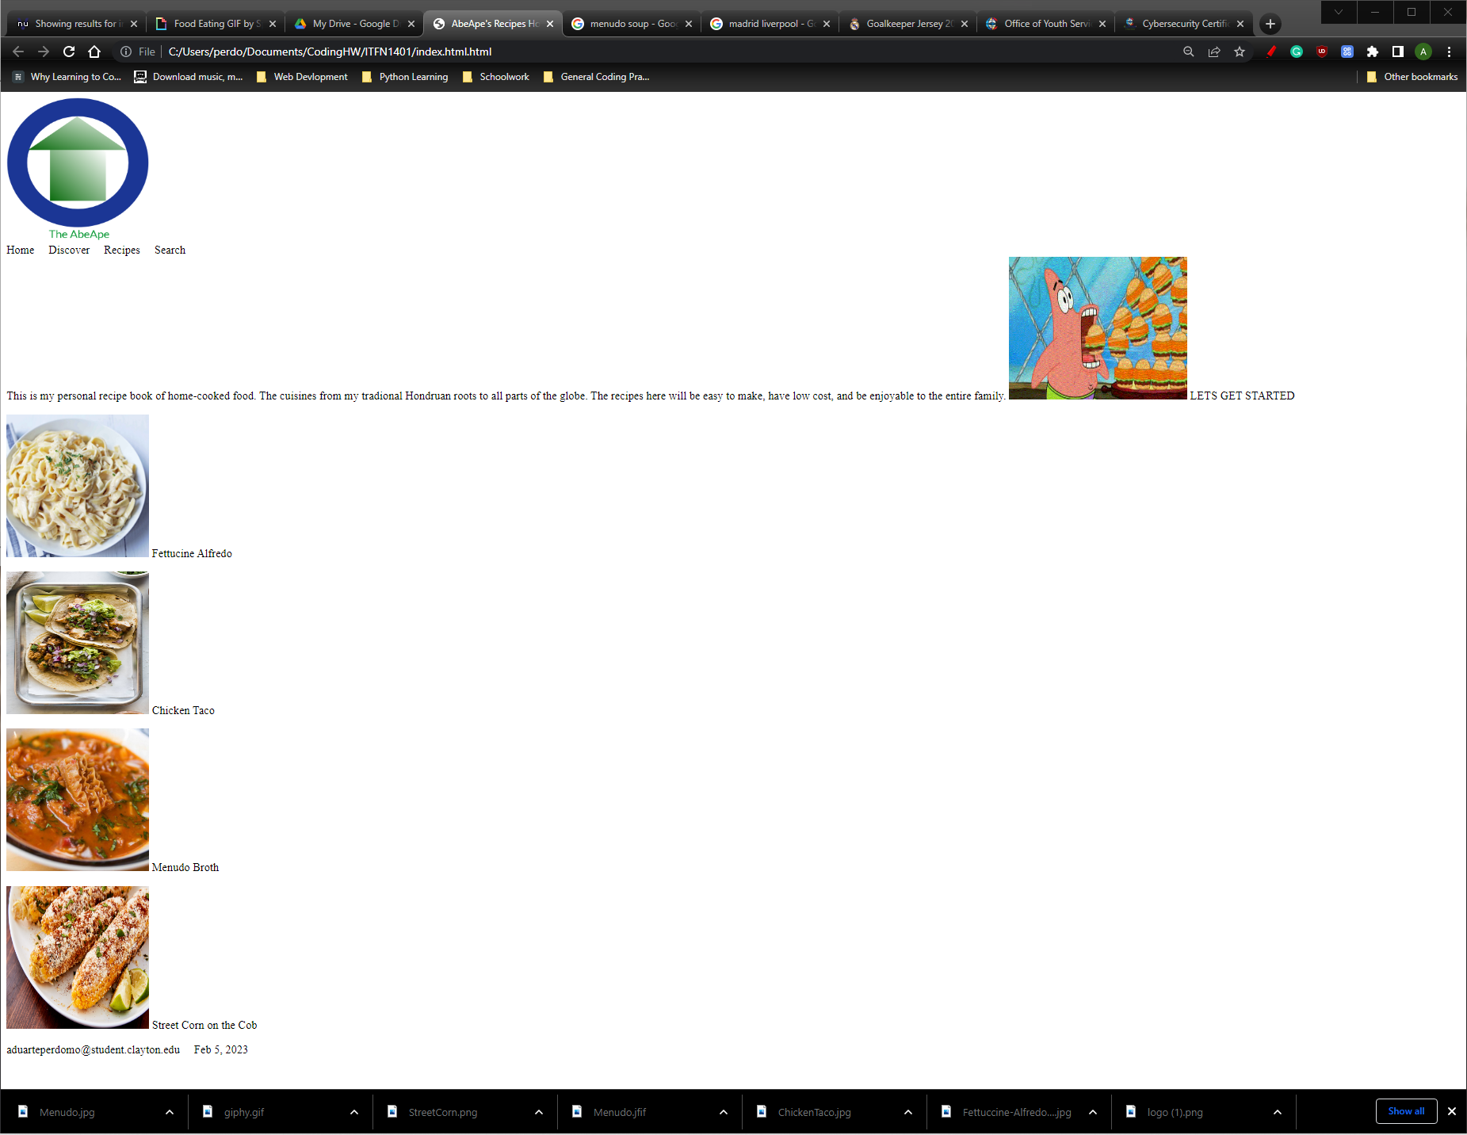

Edge Webpage Example

Edge Version 109.0.1518.78 (Official build) (64-bit)

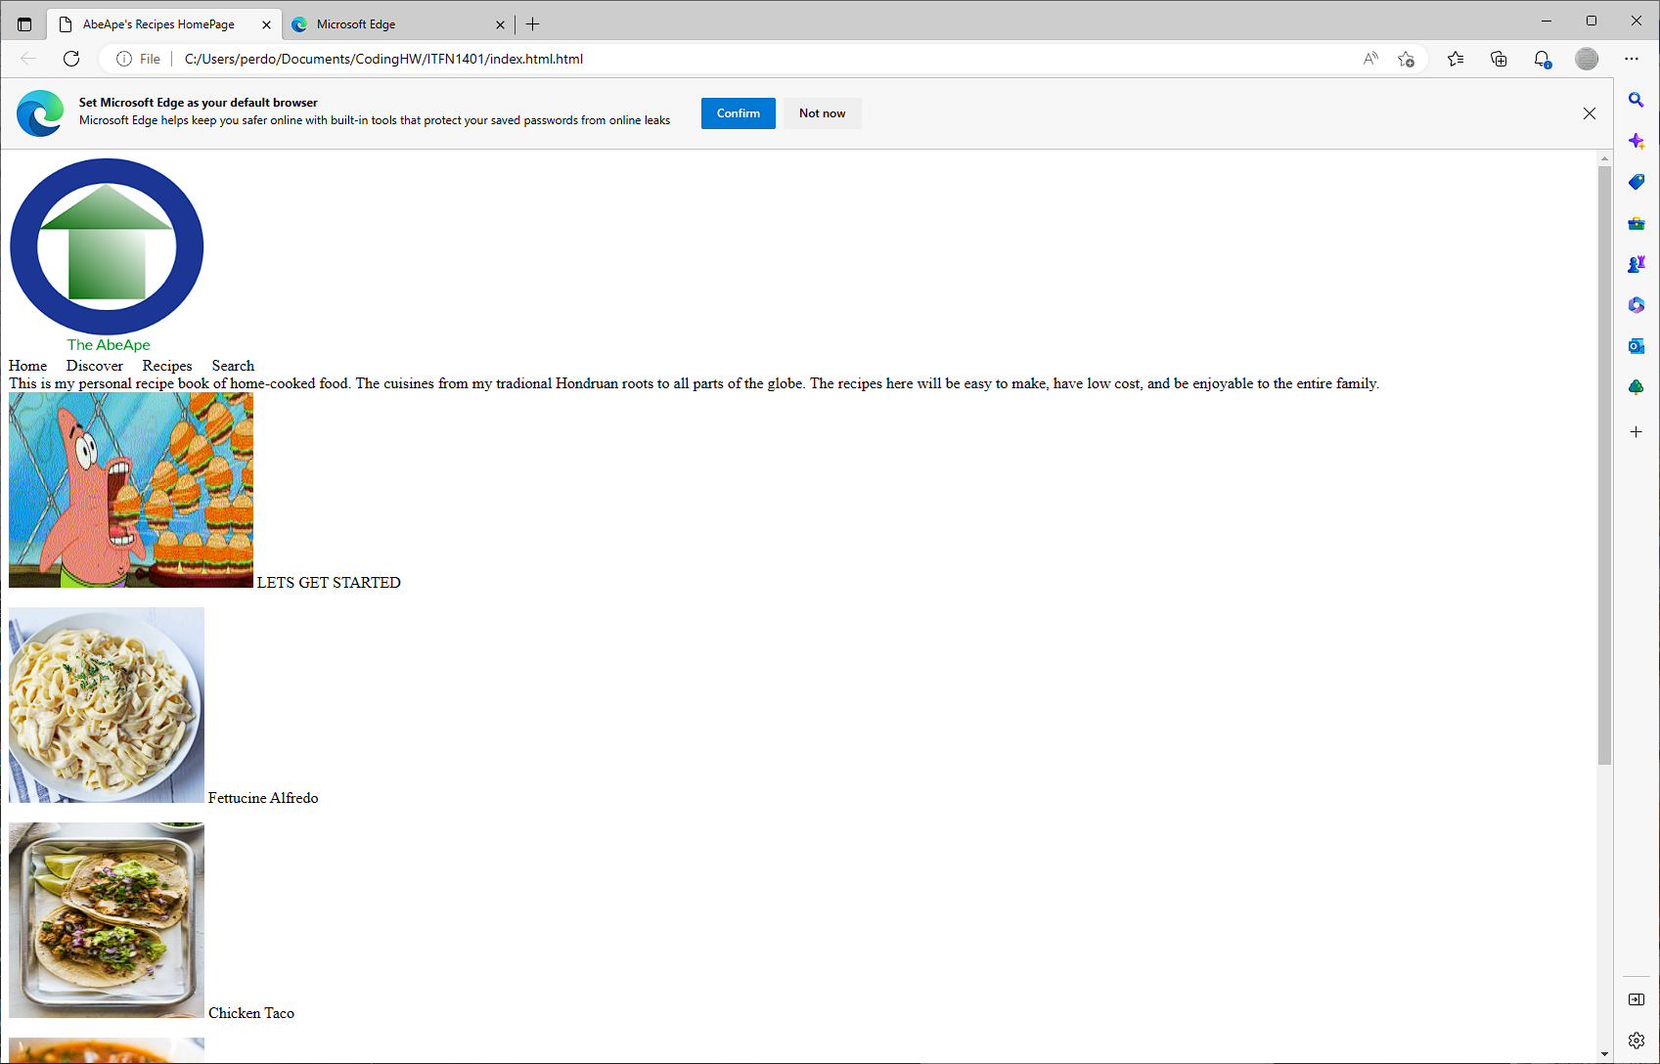

W3 Validator 