Lab 5
Paul Dutton, Brett Rother, Julian Carmona

Part One:
Code is in this zip, please read at thy leisure and reach out with any questions. Most of the code is in lenet.c, with a new struct in lenet.h. Main.c just calls training if needed, validates things with some inputs from the .csv, and then converts the model to int8_t. I didn’t bother saving it, for now, but that would be just one line of code :).

General overview:
There is a new LeNet5Quantized that holds all weights and biases in int8_t. There are also now fields for each weight and bias layer that holds its scaling factor as a float, for conversion back to the original model’s weights (minus quantization loss, of course).

The code and types were also converted to float from double to help it fit on an MSP430 when the time comes. I was trying to use a fancy “#define MYTYPE [float or double]” and some helper wrappers but it got complicated and I hardcoded it to floats. There was no accuracy loss between either version. I hope this is okay, I’ll double (ha) check with Dr. Pan.

For the quantization:

Scaling is found from each layer (we could add functionality to make it per channel, etc) by finding the max abs() of each layer. We then quantize down to int8_t and back to float for forward training using functions that utilize this scaling factor. Each field in the original model is read flat through memory and converted to a new layer.
Finally, we convert our floats to int8_t and save the model with the aforementioned per-layer scaling factors.

Part Two:
Comparison to original model:
Double:

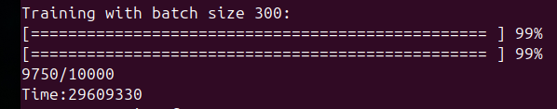
Quantized aware float:

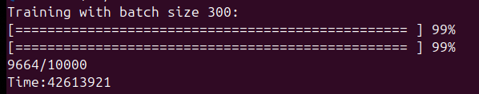
It is slower by about 44%. It stays within 1% of accuracy.

Part Three:
Please view “modeloutweights.txt” for a pretty printed version. Each layer is printed in int8_t with the associated scaling factor for that layer as well.

