3) a )
H=X^T WX, where W is the weight matrix.
Compute the inverse of the Hessian matrix

H⁻1

beta_hat <- c(1, 0.5)
phi_hat <- 0.05

X <- matrix(c(rep(1, 3), rep(1, 3), rep(1, 3), log(c(3, 6, 9))), ncol = 2, byrow = TRUE)

W <- diag(1 / phi_hat, nrow(X))

H <- t(X) %*% W %*% X

H_inv <- solve(H)

covariance_matrix <- H_inv

print(covariance_matrix)

[,1] [,2]
[1,] 0.6700160 -0.6032975
[2,] -0.6032975 0.5482054

3) b)

Given that Yi ~ Poisson(µi), the probability density function of the random variable Yi is:

f(yi|µi) = e^−µi * (µi)^yi / yi!

f(yi|µi) = exp{yi * log(µi) - log(yi!) - µi} = exp{ T(yi) ∙ α - β(µi) + γ(yi) }

where:
T(yi) = yi
α = log(µi)
β(µi) = µi
γ(yi) = -log(yi!)

Therefore, Yi indeed belongs to the exponential family of distributions.

To show that E(Yi) = µi and Var(Yi) = µi, we need to use the properties of the Poisson distribution. The mean and variance of a Poisson random variable are both equal to the parameter λ of the Poisson distribution:

E(Yi) = λ = µi
Var(Yi) = λ = µi

Thus, E(Yi) = µi and Var(Yi) = µi for the Poisson distribution with parameter µi.
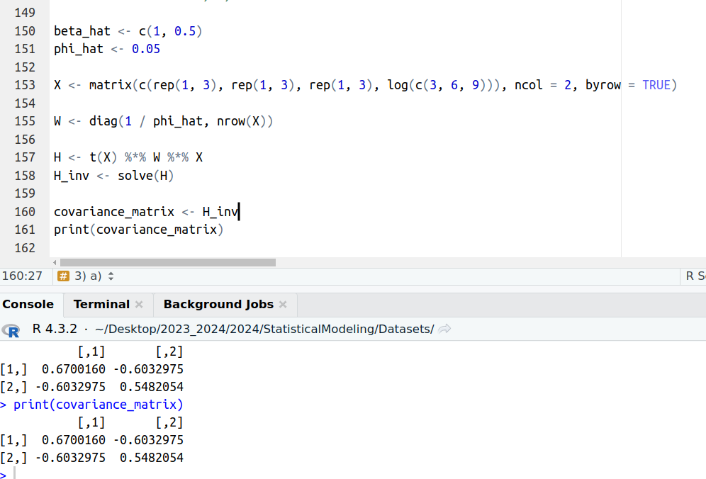

3) b)
Given that Yi ~ Poisson(µi), the probability density function of the random variable Yi is:

f(yi|µi) = e^−µi * (µi)^yi / yi!

f(yi|µi) = exp{yi * log(µi) - log(yi!) - µi} = exp{ T(yi) ∙ α - β(µi) + γ(yi) }

where:
T(yi) = yi
α = log(µi)
β(µi) = µi
γ(yi) = -log(yi!)

Therefore, Yi indeed belongs to the exponential family of distributions.

To show that E(Yi) = µi and Var(Yi) = µi, we need to use the properties of the Poisson distribution. The mean and variance of a Poisson random variable are both equal to the parameter λ of the Poisson distribution:

E(Yi) = λ = µi
Var(Yi) = λ = µi

Thus, E(Yi) = µi and Var(Yi) = µi for the Poisson distribution with parameter µi.

3) c)
Following steps can be followed to construct a prediction interval for a new observation:

1. Fit the Gamma Model β0 and ϕ
2. Calculate the point estimate of the response variable Yf using the estimated parameters.
3. Compute the standard error of prediction (σ_pred) for Yf.
4. Determine the quantiles of the Gamma distribution to construct the prediction interval.

