https://pxdata.stat.fi/PxWeb/pxweb/en/StatFin/StatFin__ton/statfin_ton_pxt_12sc.px/table/tableViewLayout1/

https://pxdata.stat.fi/PxWeb/pxweb/en/StatFin/StatFin__ton/statfin_ton_pxt_111f.px/table/tableViewLayout1/

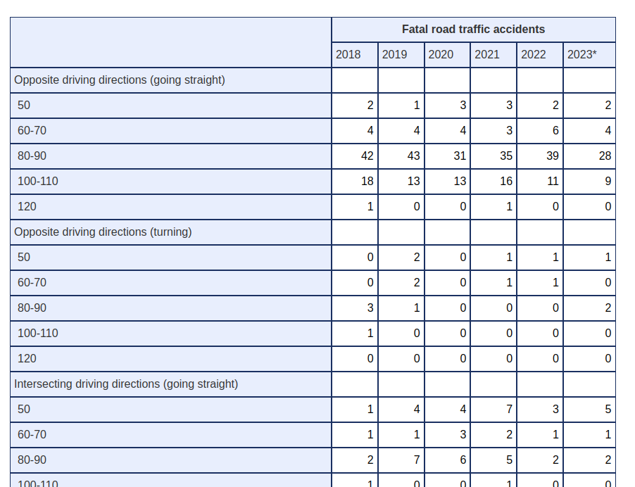
Accident mainly held in Highway and for speed 80-90

