- How do I perform Bouman and Jacobsen's study on my data?
- Calculating the important and relevant values for my data (standard deviation etc) How does their regressions work?
- Have I understood the regressions correctly?
- Do my regressions work as they should?
- How do I test for autocorrelation and heteroscedasticity for the specific regressions?

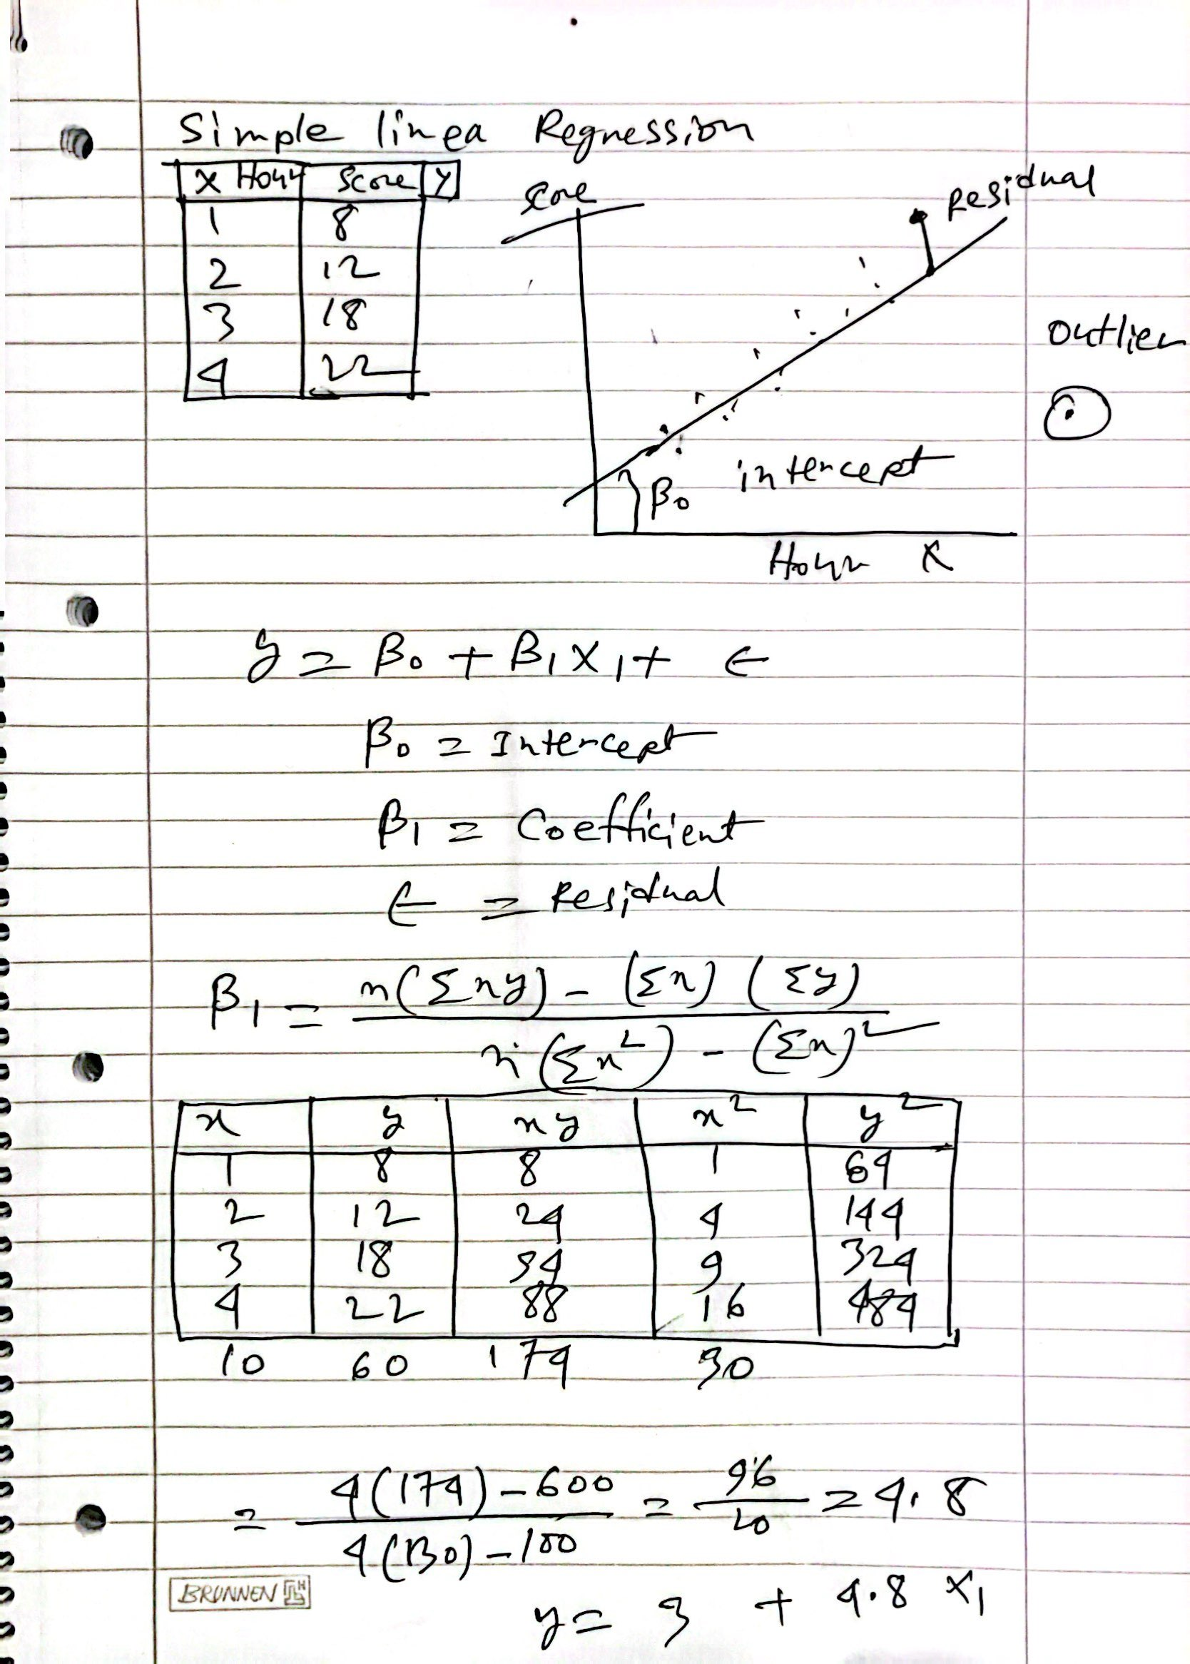

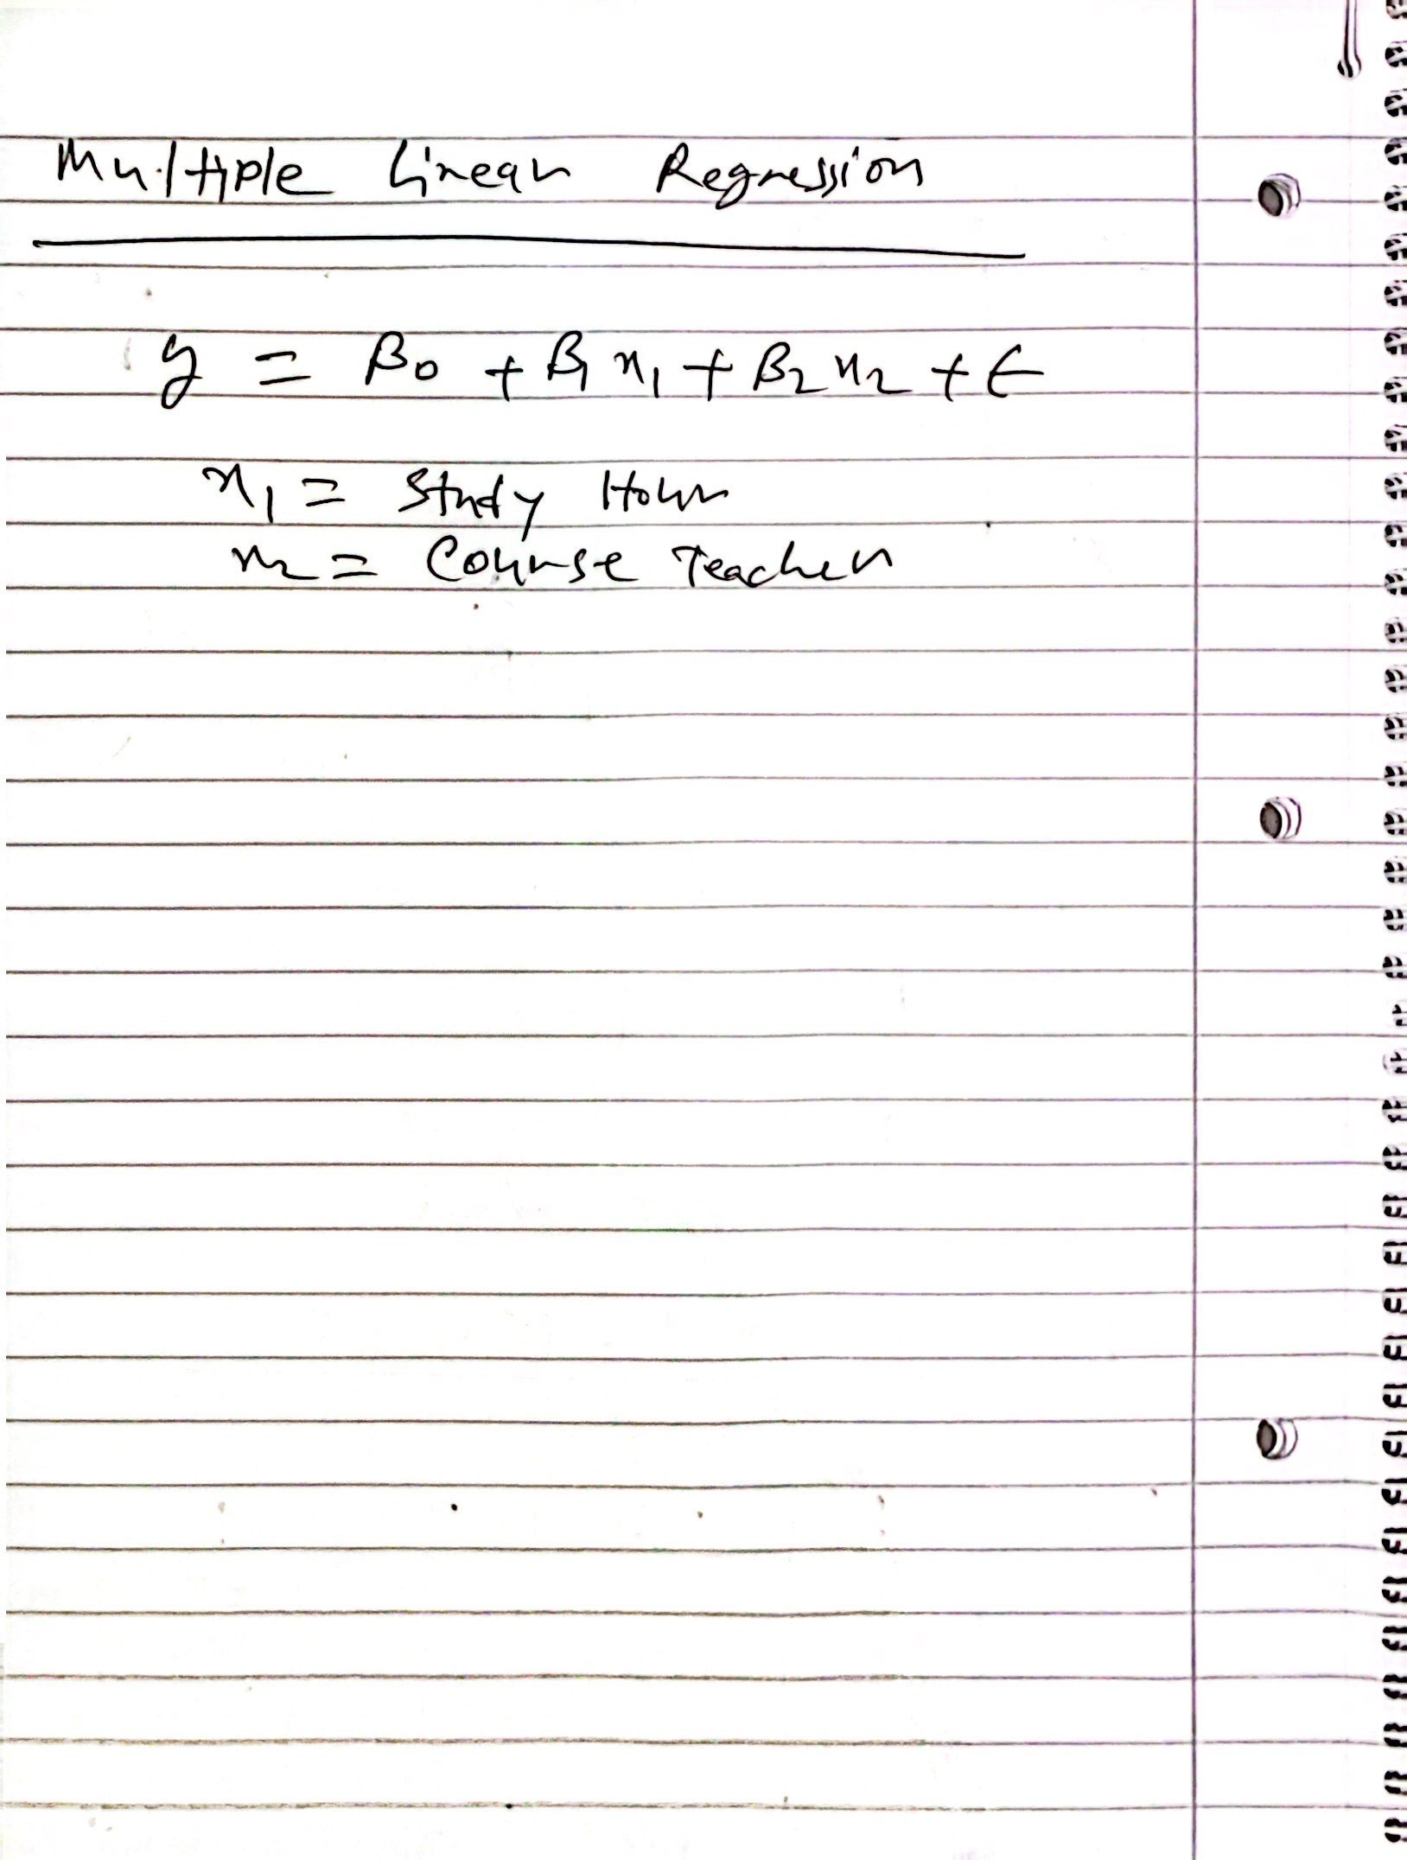

Y = 3 + 4.80x1

R Square = 0.7
Adjusted R Square

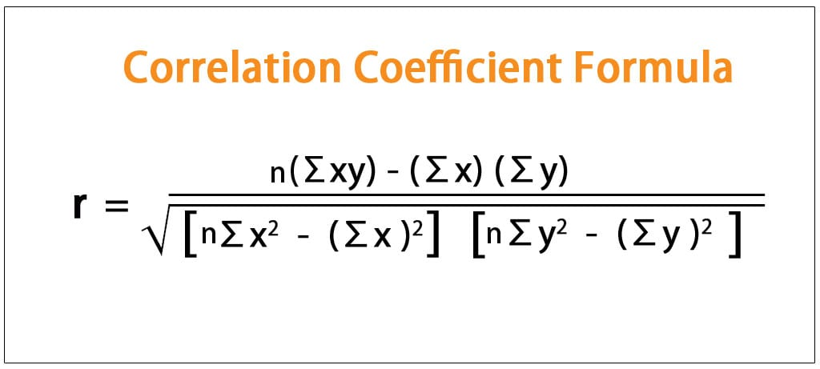

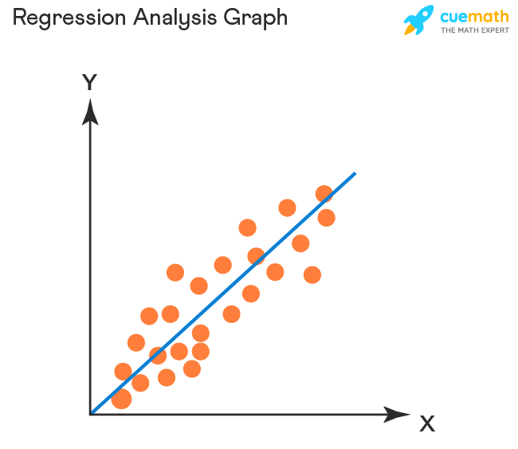

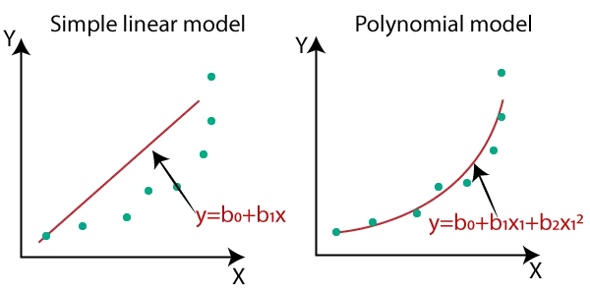
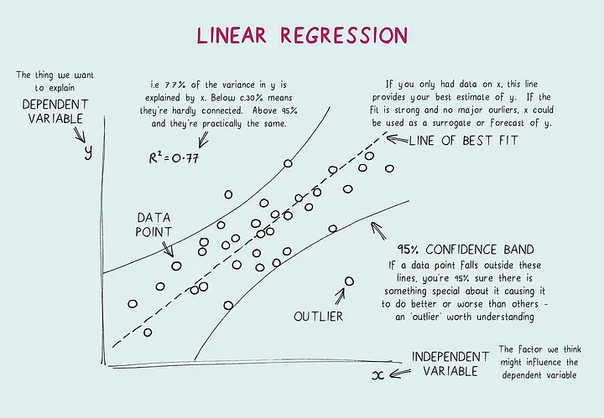
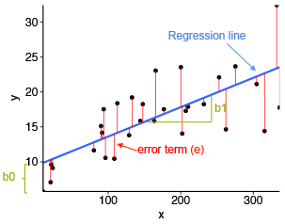

Multiple Linear Regression
House Rent = Interest Rate + Inflation + Location + Facilities/Amenities + Space size
Yearly Rice yield = Soil + Water + Fertilizer

Ice Cream Sales = Temperature + School Holidays + Daily Rainfalls + ? (Unexplained)

R Square = 0.61 it can explain 61 percent of the variation in size.

R-square value tells you how much variation is explained by your model.

Simple Linear Regression:
Test Score = β0 + β1 * Study Hours + ε

Multiple Linear Regression:
Test Score = β0 + β1 * Study Hours + β2 * Prep Classes + β3 * GPA + ε

Hypothesis
Null Hypothesis
- No correlation
- No Difference
- Proposed is not true
- Nothing new

Alternative Hypothesis:
- It has correlation
- Proposal is true
- New Findings is true

If p value is less than 0.05 we reject null hypothesis.

It is believed that a candy machine makes chocolate bars that are on average 5g. A worker claims that the machine after maintenance no longer makes 5g bars.

Ho: Ice Cream = 5gm // Nothing new
H1: Ice cream Not equal to 5gm // Might be greater then 5gm or less than 5 gm

In a class 10 students weight its average weight is 160 pound. We know aver weight is 170 pound.

Ho: weight is 170
H1: weight is not 170

There is no relationship between height and shoe size.

Durbin-Watson Test
H0 (null hypothesis): There is no correlation among the residuals.
HA (alternative hypothesis): The residuals are autocorrelated.

