Regression Analysis

Correlation
Co-efficient of correlation
Regression Analysis
Residuals
Ordinary least squares (OLS)
Standard Deviation
Variance
Covariance

Time Series
Autocorrelation
Stationary
Durbin Watson Test
Heteroscedasticity
Breusch-pagan

2018 – 100 k Euro
2019 – 120 K Euro
2020 – 130 K Euro
2024 – ?

variance = 10
Standard Deviation = square root variance of 10

Time
Height Vs Weight

66.00 140 pound
72.00 145
73.50 160
73.00 190
76.00 ?
82.00 ?

Predict

y = mx
y = m 76

m = y/x = 2.12

y = 2.12 x X 82
= 173 pound

x = Independent
y = Dependent

Ad Vs Sales

10 Euro – 60 Euro
20 Euro – 120 Euro
30 Euro – 180 Euro
60 Euro - ?
100

Predict

y = mx
y , Sale = m

Weight Vs Shoe Size
80 – 46
90 – 48
100 kg ? Show size

Predict

0-1
r = 1

Correlation is a statistical tool that helps to Correlation analysis deals with the association
between two or more variables.

Correlation is the extent to which two variables are related to each other. Typically, people who use this correlation want to know if one or both variables are dependent on or independent of one another. A dependent variable changes whenever the other variable changes, whereas an independent variable doesn't.

Correlation coefficient

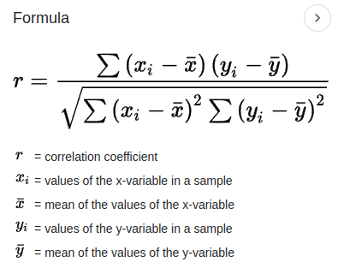

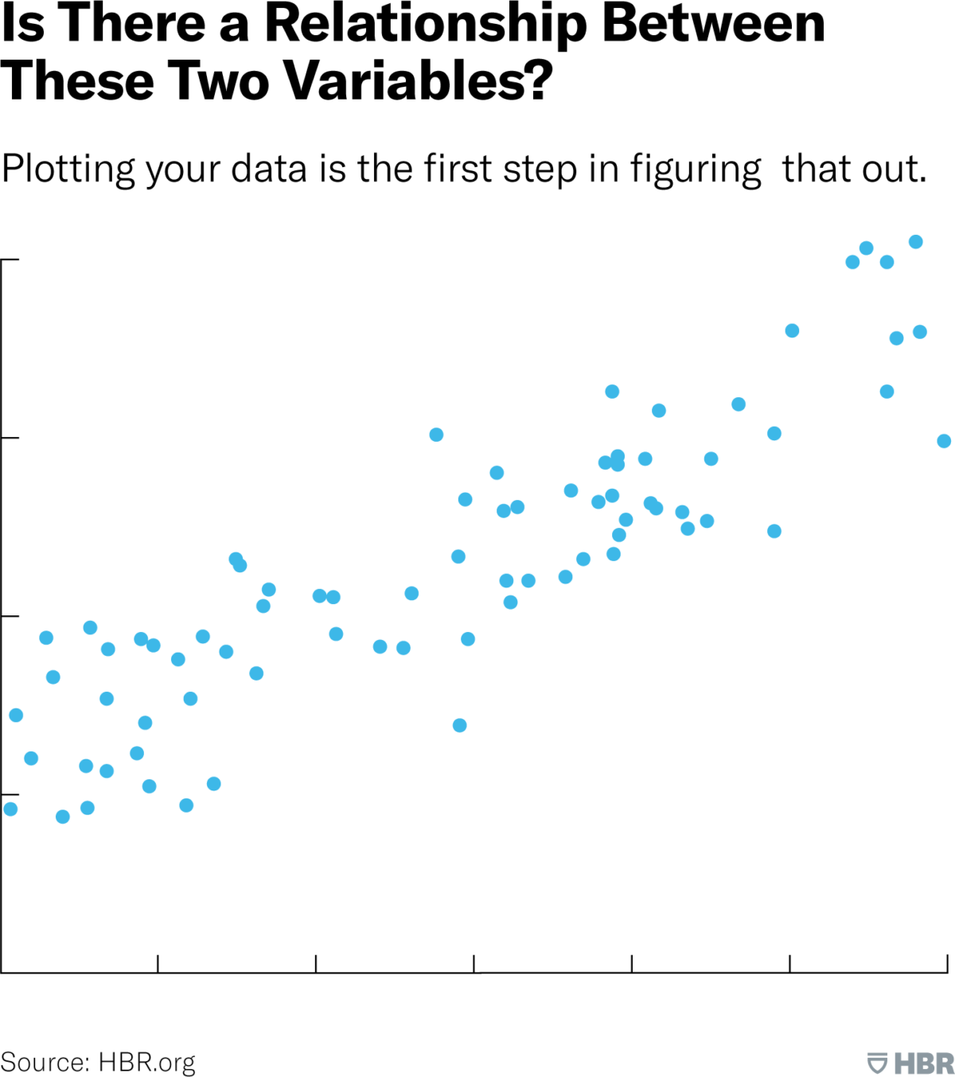

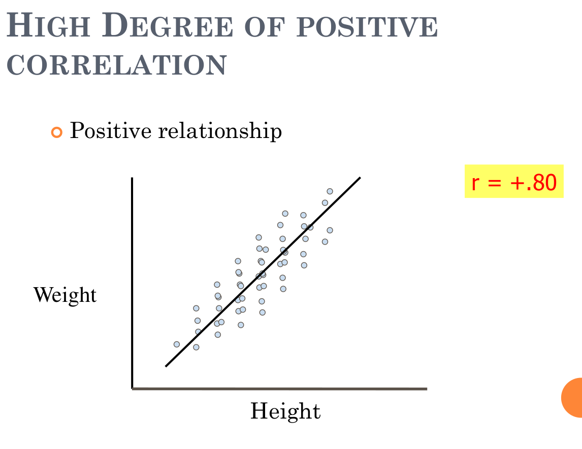

Autocorrelation: Autocorrelation refers to the correlation of a time series with its own past and future values.

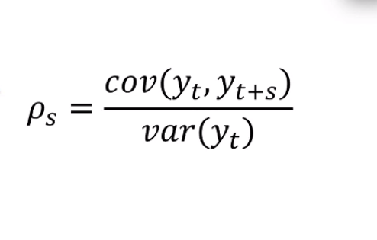

Durbin Watson Test

Used when data are collected over time to detect if autocorrelation is present.

The Durbin Watson statistic is a number that tests for autocorrelation in the residuals from a regression analysis.

It ranges between 0 and 4.

2 means no autocorrelation.
0.2 means positive autocorrelation.
2-4 negative autocorrelation.

Et is the residual figure
T is the number of observations of the experiment.

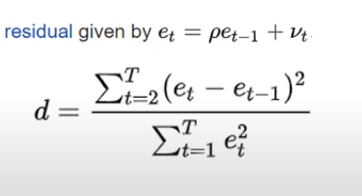

Heteroscedasticity: Unequal variance of the error term.

