

**CSE302: Database Systems (Section - 3)**

**[Summer - 2024]**

**Project Report**

EzyBuy

[EzyBuy(oracle.com)](https://apex.oracle.com/pls/apex/r/zisanahmed/ezybuy222480/home?session=117305293394818)

<https://shorturl.at/gKn0C>

**Submitted by:**

**Student ID**

**Student Name**

**Contribution Percentage**

2022-3-60-225 Redhwan Ahmed Zisan 40

2022-3-60-014 Nasibul Sazid 30

2022-3-60-176 Riya Akter 30

1. E-R Model of the Project

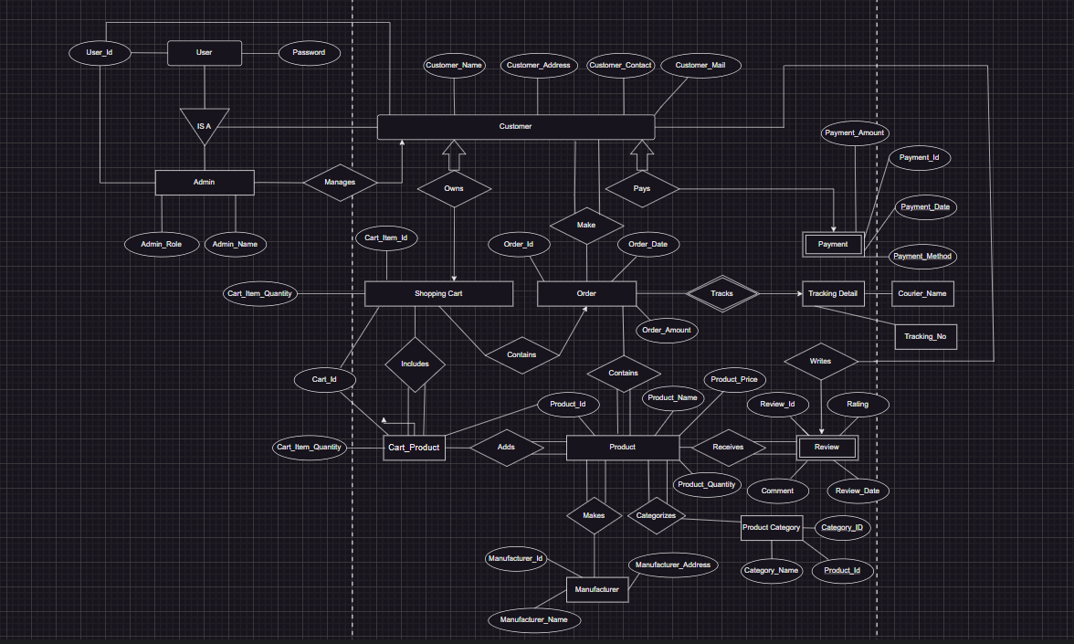

2. Schema Design of the Project

3. Implementation Checklist

Description

Remarks

Page 3

|  |  |
| --- | --- |
| Project ID | **222480** |
| Workspace Name | ZISANAHMED |
| Workspace Email | 2022-3-60-225@std.ewubd.edu |
| Workspace Password | Ewuahmed1234@# |
|  |  |
| Authentication Type | Custom |
|  |  |
| Username | user451 |
| Password | 451 |
|  |  |
| Username | 12 |
| Password | sea |
| Username | user809 |
| Password | Editor |
| Number of Reports with Forms | 4 |
| Number of Reports based on Queries, | 17 |
| Aggregate Queries |  |
|  |  |
| Included any trigger/other feature |  |
| which is not taught in class. If yes, | I have included background image in the login page the background image resembles to the online shopping management system. This is done through using user interface in application definition where I uploaded my logo and then the logo got to be seen in the login page. |
| please explain briefly. |  |
|  |  |
| Write the most unique |  |
| feature/functionality in your application | I have included ads in the home page of bkash which is done through css coding and including the header html in the home page where the path of my image which was in the static application files. |
| or the page of your application that you |  |
| are proud of. Explain briefly. |  |
|  |  |
|  |  |

4. Reports with Forms

|  |  |  |
| --- | --- | --- |
| Page Number and | Form Page Number and | Table |
| Name | Name |  |
| 1 – Details Customer Information | 45 – Customer Details  50 – Customer Orders  95 – VIP Customer  99 – Most Active Customers  101 – Revenue By Product Category | User, Customer,Order, Product_Category, Product, ShoppingCart |
|  |  |  |

|  |  |  |
| --- | --- | --- |
| 56 – Shopping Cart Information | 57 – Cart Details | ShoppingCart |
|  |  |  |
| 59 – Product Category | 61 – WOMEN  63 – MEN  65 – KIDS  67- COSMETICS  69 – ELECTRONICS  71 – HOME APPLIANCES | Product Category |
| **73 – Products** | 75 – Top Selling Products  77 – Low Stock Products  81 – Product Performance | Product, Product Category , Shopping Cart, Review |
| 85 - Orders | created  85 - Orders | Order |

86 - Payment 87 – Payment History Payment

89 – Tracking Details 89- Tracking Details Tracking Details

91 - Review 91 - Review Review

Fig- 4.1 Table Name - Home

Fig – 4.2 View Name – Customer Details

Fig – 4.3 View Name – Customer Orders

Fig – 4.4 View Name – VIP Customer

Fig – 4.5 View Name - Most Active CUSTOMER

Fig- 4.6 View Name – Revenue By Product Category

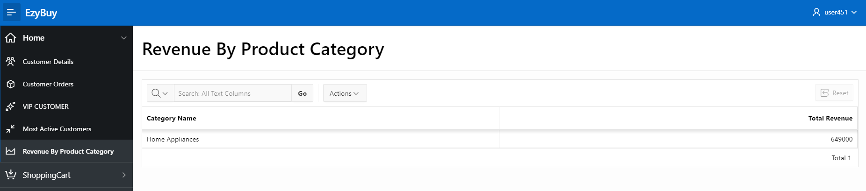

Fig – 4.7 Form Name – ShoppingCart

Fig – 4.8 Table Name – ShoppingCart

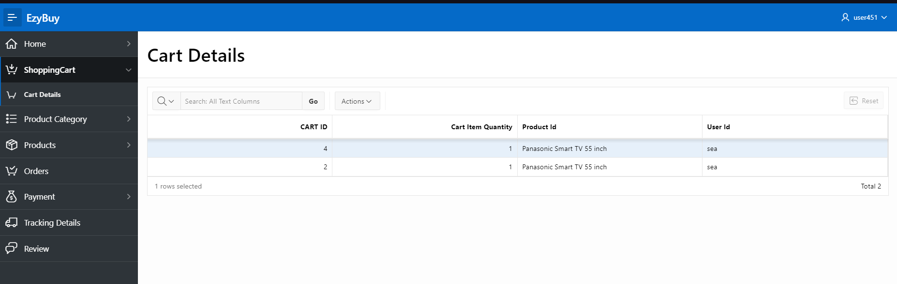

Fig – 4.9 Table Name – Product Category

Fig – 4.10 View Name – Women

Fig – 4.11 View Name – Men

Fig – 4.12 View Name – KIDS

Fig- 4.13 View Name – Cosmetics

Fig- 4.14 View Name – Electronics

Fig- 4.15 View Name – Home Appliances

Fig – 4.16 Table Name - Products

Fig – 4.17 View Name – Top Selling Products

Fig – 4.18 View Name – Low Stock Products

Fig – 4.19 – Product Performance

Fig – 4.20 – Form Name – Orders

Fig – 4.21 – Table Name – Payment

Fig – 4.22 – View Name – Payment History

Fig – 4.23 – Table Name – Tracking Details

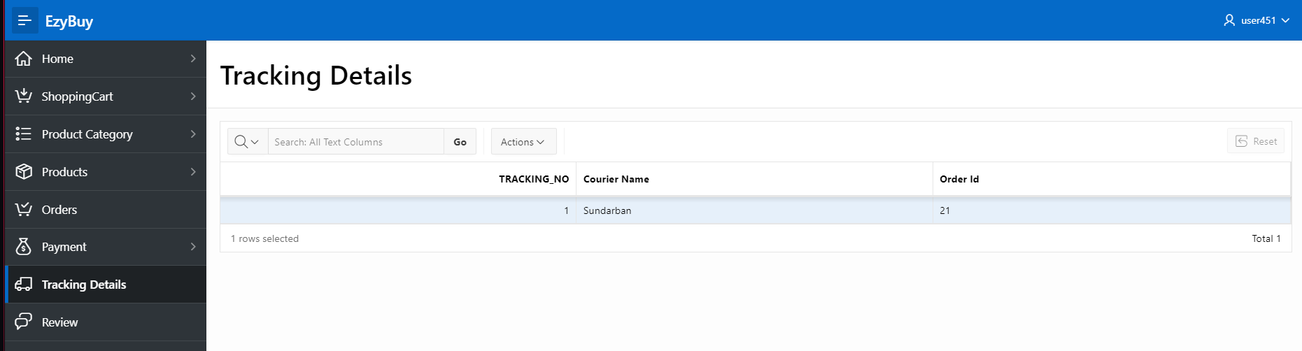

Fig – 4.24 – Table Name – Review

5. Reports based on Multi-Table and Aggregate Queries

|  |  |  |
| --- | --- | --- |
| Page Number and | Query Type | Report description |
| Name |  |  |
| 1 – Details Customer Information | Multi- | It derives information from the user table, customer table,product_category, order, product,review |
|  | table |  |
|  |  |  |
|  |  |  |
| 56 - Shopping Cart Information | Single Table | It shows the form and only the shopping cart details. |
|  |  |  |
| Product Category | Single Table | It shows the products residing in the product category. |
| Orders | Single Table | It shows the form for placing order. |
| Products | Multi Table | It shows product related information from deriving crucial information from multi table like product_category, review , shopping cart |

6. Authorization and User Role Assignment

**User Role Assignment**

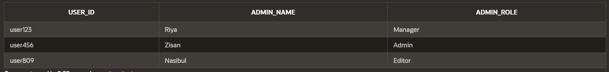

|  |  |  |
| --- | --- | --- |
| User name | Password | Role |
| user451 | 451 | user |
| user456 | 456 | Admin |
|  |  |  |
|  |  |  |

7. Concluding Remarks

Write briefly about your experience during the project development. Write your raw feelings without any fear. I want to hear it! Thank you and Good Luck.

It has been a great learning experience doing the project from the experience of doing the lab assignment truly it was remarkable for me to do a project like this that too in a short semester.

Page 6