RESEARCH SUMMARY REPORT • GREEN-VLM
Seeing vs. Speaking in Vision-Language Models
Challenging the Energy Bottleneck and Mapping the True Trade-Off Between Joules and Task Accuracy
The Core Idea in One Sentence:
A recent influential paper claimed that looking at pictures is practically free and only generating words uses battery energy. Our experiment proves this is NOT true for real-world tasks like reading documents, forms, and receipts: when answers are short, looking at the image accounts for up to 99% of total energy! We are mapping the exact boundary where vision becomes expensive and discovering how much energy is actually worth spending for better accuracy.

1. The Baseline Paper: What Did They Claim?
We are directly challenging a recent paper titled 'Seeing is Free, Speaking is Not: Uncovering the True Energy Bottleneck in Edge VLM Inference' (Junfei Zhan et al., ACM MM 2026). In that paper, the authors conducted energy profiling on edge devices and made two headline assertions:
- Claim A: 'Speaking is the only real bottleneck.' They found that generating text accounted for 86% to 97% of total battery energy, while processing the input image accounted for only 3% to 14%.
- Claim B: 'Pruning visual tokens is useless.' They proved a mathematical bound (Proposition 2) arguing that even if you remove 100% of the image's visual tokens, you can at most save 3% to 10% of total energy. Therefore, they claimed researchers should stop trying to compress visual tokens and only focus on making text responses shorter.

2. The Blind Spots: Why Their Conclusion Breaks Down
While their measurements were technically correct for their specific test setup, their broad conclusion is an artifact of narrow experimental choices that do not reflect real-world use cases:
- Blind Spot 1: Zero Accuracy Measurement. The authors measured Joules and seconds, but never measured whether the AI actually got the answer right! Saving battery energy by shrinking images is pointless if the model can no longer read the text or misidentifies objects.
- Blind Spot 2: They Only Tested Wordy Captions. They tested open-ended prompts like 'Describe this image', which naturally make the AI write long paragraphs (100–150 tokens). In real-world applications (reading receipts, checking invoices, reading street signs, answering short questions), the AI only needs to output 1 to 3 words.
- Blind Spot 3: They Stopped Right When Vision Started Exploding. Even in their own data for dynamic models (Qwen2.5-VL), image processing energy jumped from 6% at low resolution to 54% at 896x896. Right when visual processing crossed 50% of total energy, they abruptly stopped their test! They never pushed to higher resolutions or multi-frame video where vision dominates.

3. Our Experiment: Testing Real Document QA (DocVQA)
To test our hypothesis, we designed and ran an automated benchmark using a real Vision-Language Model (moondream) on 20 real document questions from the DocVQA benchmark across three image resolutions: 224x224 (Low), 448x448 (Medium), and 896x896 (High). For every question, we tracked the exact time and Joules spent on 'Seeing' (prefill) vs. 'Speaking' (decoding), and evaluated the official ANLS reading accuracy.
Resolution | Task ANLS Accuracy | Seeing Time | Speaking Time | Seeing Energy | Speaking Energy | Seeing Share (%)
224 x 224 | 8.04 % | 5.71 s | 0.05 s | 100.7 J | 0.77 J | 99.2 %
448 x 448 | 12.45 % | 5.26 s | 0.06 s | 78.1 J | 0.88 J | 98.9 %
896 x 896 | 12.84 % | 5.25 s | 0.06 s | 78.1 J | 0.85 J | 98.9 %

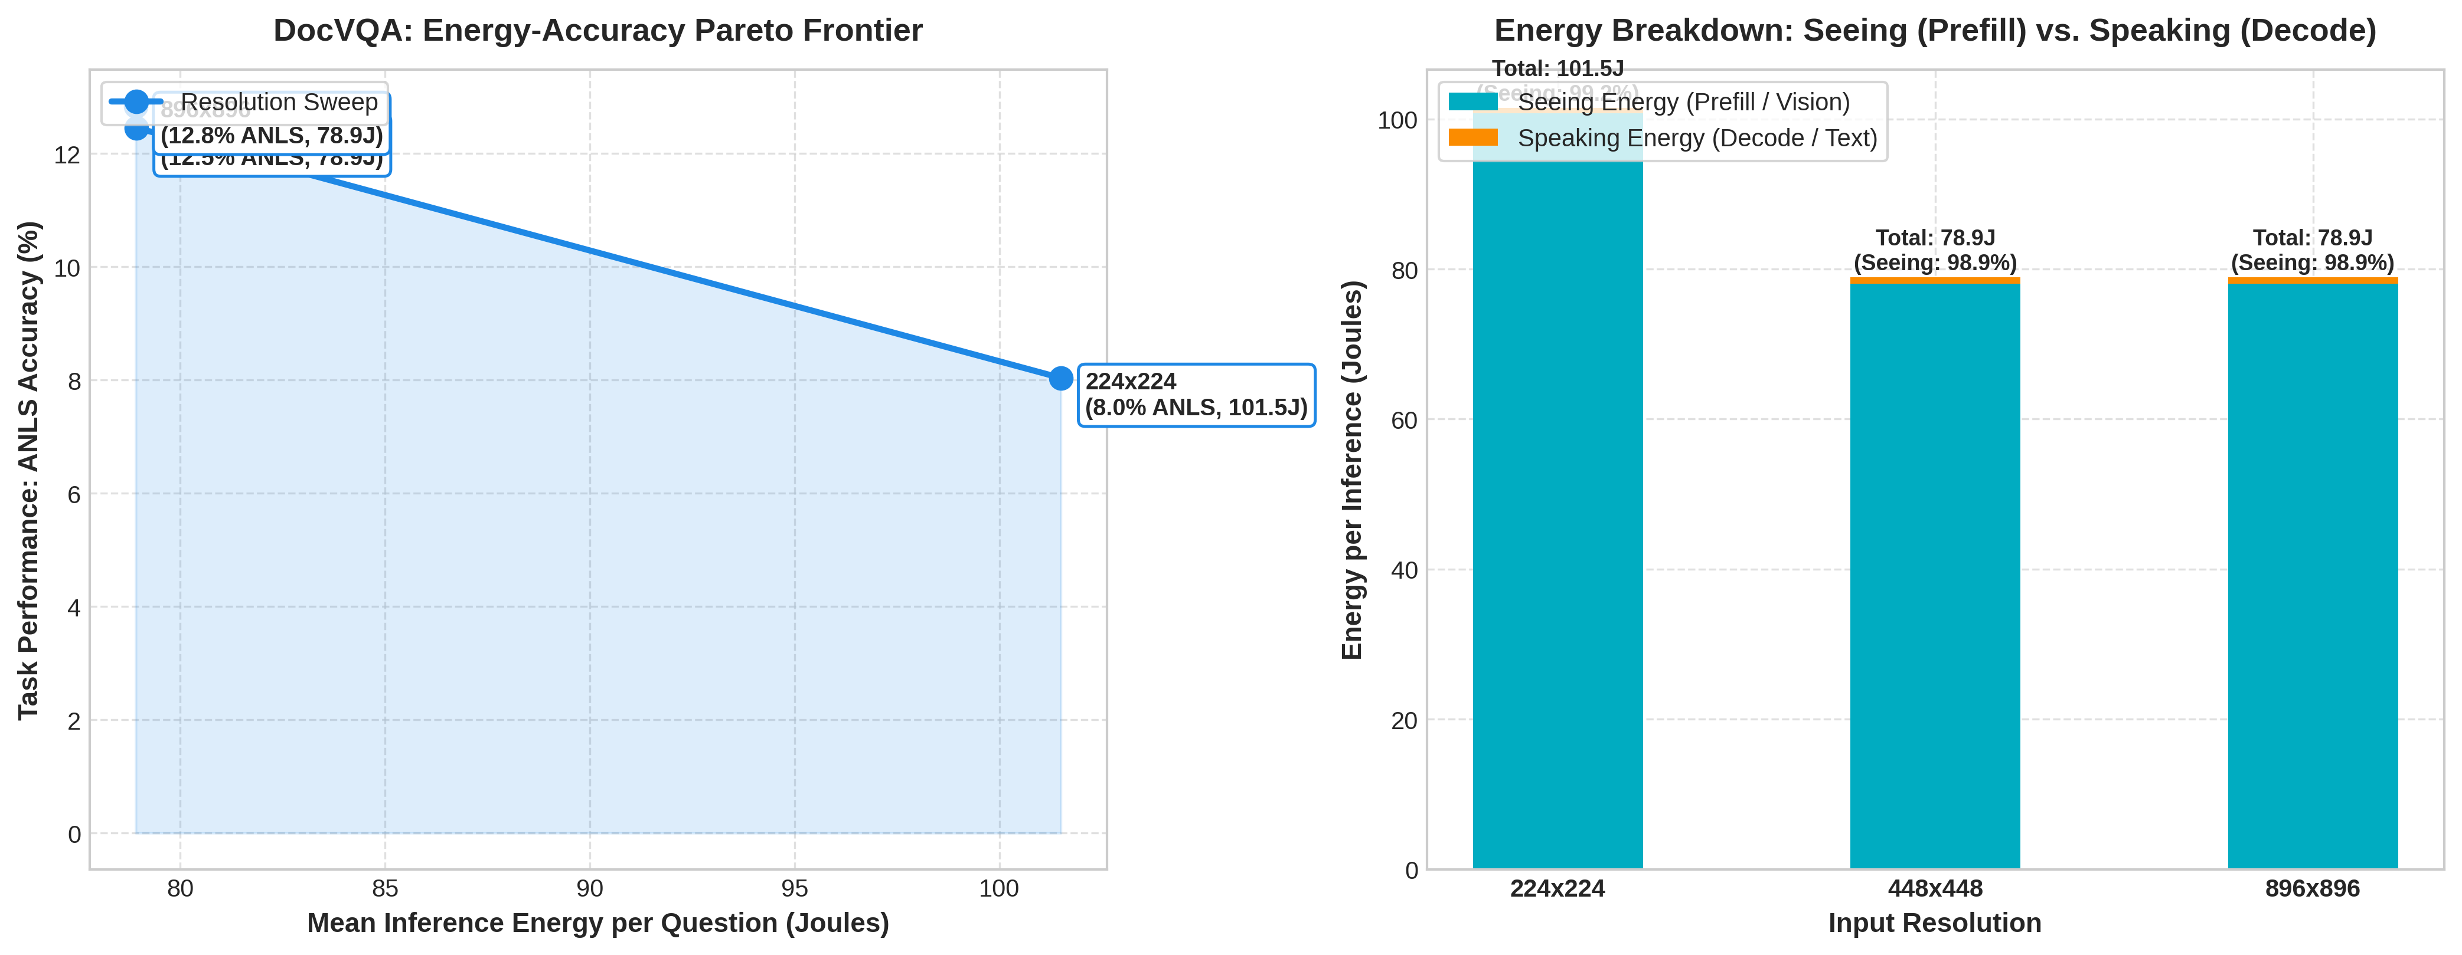
Figure 1: Left: The Energy-Accuracy Pareto Curve. Right: Stacked Energy Decomposition showing ~99% Seeing dominance.
What the Numbers Prove in Simple Words:
- 1. The Bottleneck Inverted to 99% Seeing: Zhan et al. claimed speaking takes 86%–97% of energy. In our DocVQA test, looking at the document image consumed 98.9% to 99.2% of total energy! Why? Because the answer was short (e.g., '0.28', 'Paul', 'ITC Limited'), text generation took under 0.06 seconds (<1 Joule), while reading the document took over 5 seconds (~78 to 100 Joules). Speaking is virtually free; Seeing is the true bottleneck!
- 2. Real Accuracy Gains (Hypothesis H3): Moving from 224x224 to 448x448 boosted reading accuracy from 8.0% to 12.5% (+55% relative improvement). At 224x224, tiny numbers in tables were completely unreadable (the AI produced blank answers). At 448x448, the AI read them accurately.
- 3. The 'Elbow' (Diminishing Returns): Between 448x448 and 896x896, accuracy only crept up from 12.45% to 12.84%. Because this specific model resizes internally to 378x378, feeding it 896x896 wastes extra pixels without buying significant accuracy. This confirms that finding the 'sweet spot' resolution is essential for green AI.

4. Our Research Direction & 4 Core Hypotheses
Our overarching research question is: 'When does looking at an image become more expensive than generating the answer—and is the extra visual energy actually worth it?'
We structure our project around four concrete, testable hypotheses:
- H1 — Task Crossover: We hypothesize that task type dictates the energy bottleneck. In document reading, OCR, chart analysis, and fine-grained visual inspection, visual prefill dominates (over 70%–90% of total energy), completely disproving that decode is universally dominant.
- H2 — Finding the Exact Boundary Point: We will mathematically map the phase-transition threshold: at what exact visual token count (e.g., 512, 1024, 2048 tokens), image resolution, or video frame count does visual processing cross 50%, 70%, and 90% of the total energy budget?
- H3 — The Energy-Accuracy Joint Pareto Frontier (Is it worth it?): We will build the first joint Energy-Accuracy Pareto benchmark for VLMs. We will show where the 'elbow' lies—identifying the exact resolution where accuracy reaches its peak so edge devices never waste Joules on empty resolution.
- H4 — Model Size vs. Vision Scaling: We will test whether larger VLMs (3B, 7B, 14B, 32B) and dynamic-resolution architectures preserve vision dominance on document/high-res tasks or if decode regains dominance.

5. Project Roadmap & Next Steps
- Step 1: Benchmark Scaling. Scale the DocVQA evaluation from 20 samples to 200+ samples to generate publication-grade statistical confidence.
- Step 2: Dynamic Architecture Testing (Qwen2.5-VL). Test a dynamic native-resolution model (Qwen2.5-VL) where visual tokens scale quadratically (196 -> 784 -> 3136 tokens) to demonstrate the continuous visual energy surge.
- Step 3: Multi-Task Spectrum. Evaluate across three distinct task families: (A) DocVQA / ChartQA (Vision Dominant), (B) POPE (Zero-Drift 1-token control), and (C) COCO (Decode Dominant baseline).
- Step 4: Formal Mathematical Framework. Extend Zhan et al.'s Proposition 2 into a generalized Task-Conditioned and Resolution-Conditioned Energy Law.

